Useful MCMS reports for Colony Management 2023

Colony Overview report – This report summarizes all the current and archived colony information. It shows the total number of live animals in a colony and the number of active matings. Also, the age of youngest and oldest animal currently alive.
For the archive records it shows the total number of matings, the average litter size and average litters per mating. The number of homozygous, heterozygous and wild type animals genotyped and the amount of frozen stocks held.

This report can be used to compare colony performance by filtering for the colony prefixes that you want to compare. It can also be used to provide information for breeding calculations or an Animal Passport.

Cage lists – Shows the cages on the shelf currently. Filter for ‘colony prefixes’ ‘in this list’ to find a particular subset of colonies or filter for the Colony Owner (usually the PPL holder) to show all cages for your group.
This report will show you where every cage is housed, the number of animals in a cage, the cage function (mating, stock, stud etc.) and the age of the animals in the cage.
It can be used to find all cages with singly housed animals by setting the filter ‘Animals’ is ‘equal to’ 1
It can be used to manage the older animals in the colony by filtering for ‘Minimum age (weeks)’ ‘is greater than or equal to’ (add age in weeks)

Health records – To show any animals in your colonies with recorded health observations. Set the filters for your PPL or the selection of colony prefixes you are monitoring. Adding the filters ‘End date’ is ‘blank’ will find active health observations, using ‘Life status’ is ‘alive’ will exclude dead animals.

Projected weaning – displays the number of animals to be weaned in a week, can be searched by Colony Prefix or Colony Manager.
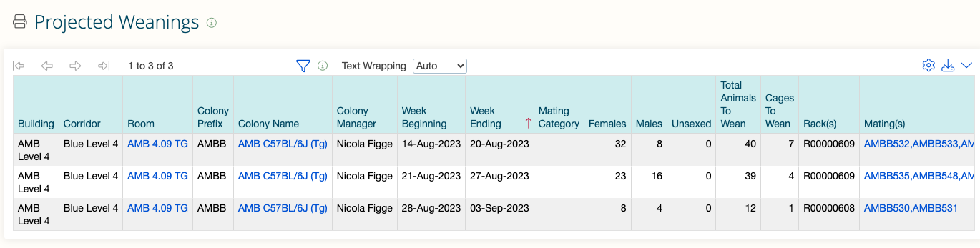

Tasks list with Animal numbers – Lists the husbandry tasks set for a colony. Information includes the status of the task, the start date, due date and completion date. It also shows any instructions given by the requestor and technician comments.

Animal task reservations – Produces a list of animals that have been reserved for use in husbandry tasks or reserved for study plans.

Transnetyx Orders – Shows Transnetyx orders submitted via MCMS. You will only be able to view this report if your account is linked with a Transneyx account on the MCMS.

Saving filters

For any report you run you can save the filters you have set. These are saved to the report page and the Homepage and make it much easier next time you need to run the report.
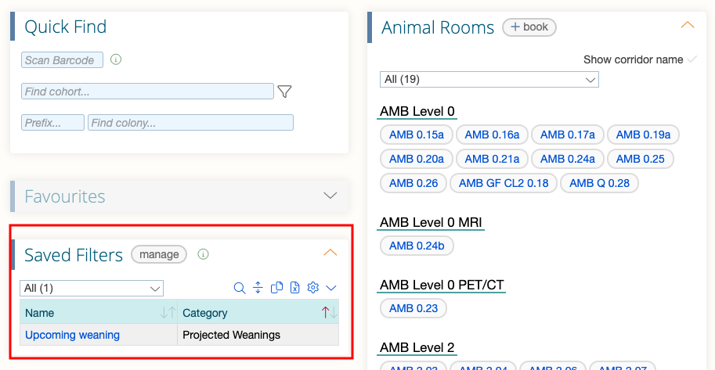

From the report page, set the filters you want to use. In the ‘filter name’ box (above) give the report a name (e.g. Upcoming weaning) and press the save button next to the box.
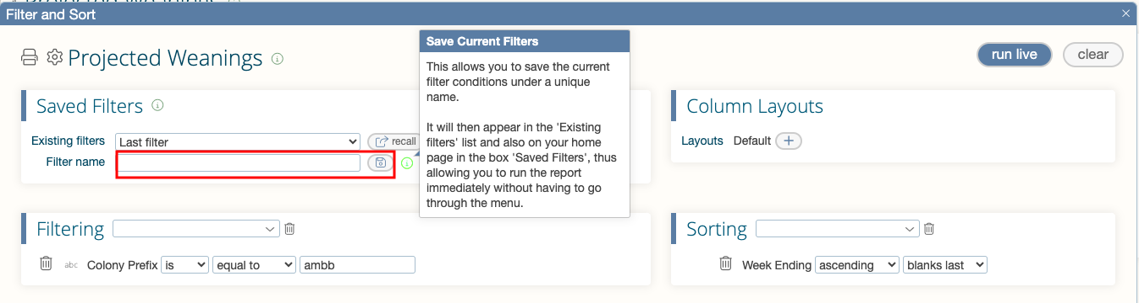

A pop up notification will tell you that the filter has been saved. Clicking on the ‘Existing filters’ menu will show you any filters saved for the report.
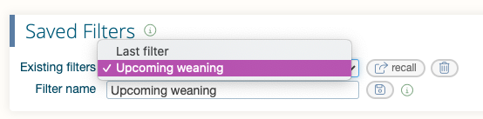

If you need any help finding reports or with the reporting functions, please contact maryann.haskings@admin.cam.ac.uk

