Date: 16/05/2025
Time: 2pm
Present: Gemini Chu (GC), Allan Herbison (AH), Ewan St. John Smith (ES), Alan Graham (AG), Keith Savill (KS), Pilar Browne (PB), Rue Jones-Green (RJG), Elisa Galliano, Jasper Poort, Riccardo Beltramo, Ole Paulsen, Micheal Puaud, Amy Milton, Leonie Pakulat, Ben Jaggs, Kajsa Bigeat
Apologies: Bill Colledge – Leonie Pakulat – in his absence, Sophie Kimpton, Karl Wilson ( available from 3pm to attend)
Mentioned: Karl Wilson (KW),
Minutes: Toni McEvoy

University Biomedical Services User Committee – CAF

- Minutes
The minutes from the last meeting were approved.

- Chair’s Report – (From the Facilities Operations and Management Committee)
The information from the previous user meeting regarding the future of the CAF was passed on to the FOM committee. Alan Herbison (AH) reported the committee were sympathetic with the situation and were keen to support CAF being fully operational. The Caf Users are waiting to see the report that has been written regarding the future plans for the facility. The first draft of this report has been reviewed in depth by the Mouse Hepatitis Virus (MHV) committee where some additional costing options were suggested. When the document is ready AH will send it to all Users to review and discuss. A special user meeting will then be called to discuss the report. AH is sure there is a long-term future of the CAF. Ewan St. John Smith (ES) said that having a facility where regulated and non-regulated animal procedures is vital to the plan. Any building works that takes place must take into consideration the effect it will have on surrounding buildings with regarding to noise and vibrations.

Facility Managers Report.
The report was circulated prior to the meeting.
- Staffing
There have been no changes to staffing since the previous meeting.
- Occupancy
13% Occupancy, a reduction of 4% since the last meeting.
- Equipment – new/needed/problems etc.
There have been some chiller faults. There are three out of four circuits that are operational. A team has been to CAF to assess the work, and they have put a case forward to the contract team in Estates Management regarding the work that needs to be caried out.
- Health, Safety and Security
There was a UBS health and safety (H&S) audit on 8th May. The report for this has not been received. During the H&S walk around there were several personal items being brought into the facility. Staff are not permitted to bring personal items into the facility. This information is included in the staff induction and so this is conscious decision by users. Animal handling DOP’s assessments are now mandatory in order help reduce animal bite incidents. Pm checks will also be included and will be offered following induction for all new users.
- General Administrative Update
Gemini Chu (GC) will circulate a list of all the groups that remain at CAF when the minutes are sent out. As seen below:
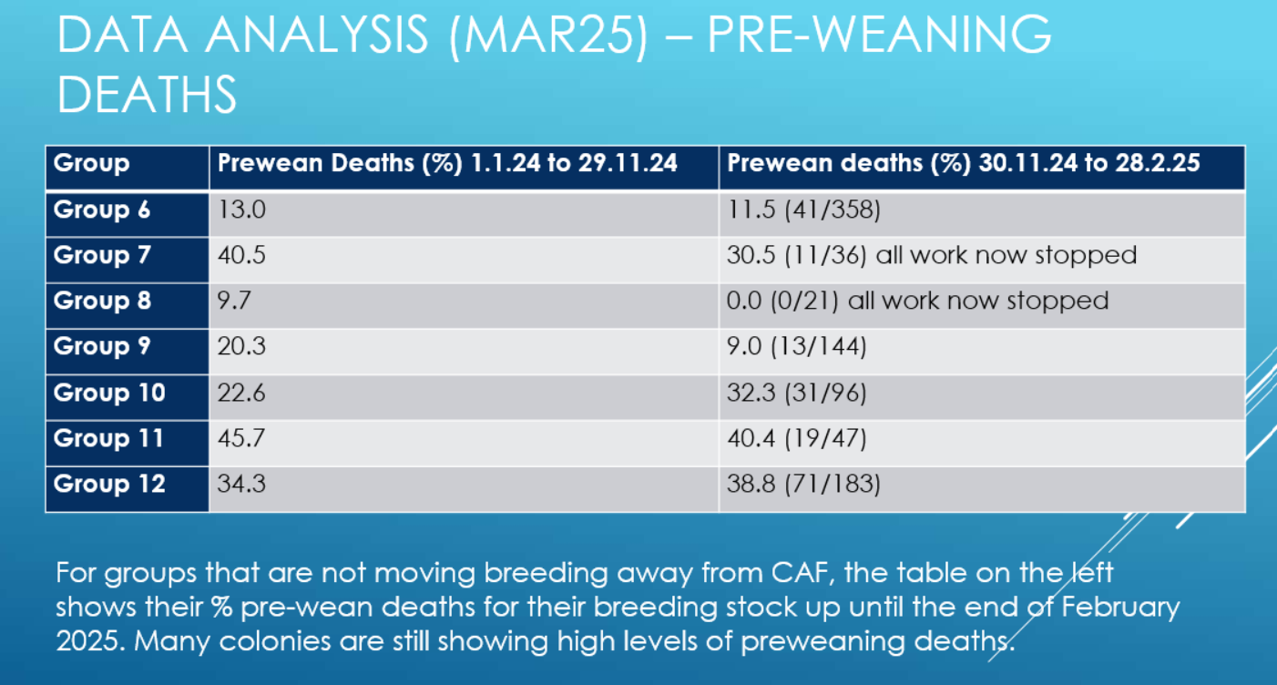

Transfer between Mira and CAF are now frequent, and an email has been circulated reminding users that mice must be at least 6 weeks of age unless a younger age is justified for research purposes. Those that are younger than 6 weeks of ages are being held in a clean area to try and mitigate the risk on MHV affecting the mice, but this is not guaranteed. GC thanked the PI’s who provided feedback on the recent SOP’s regarding improvement to biosecurity and LAA’s for the changing rooms and processing consumables entering the facility. Further updates will be provided.
- Report from AWERB Operations Committee
The PIL assessment forms that are completed when you first access the facility is not an animal handling assessment, this must be completed separately. Please can PI’s ensure their staff are checking their own training records to ensure they are kept up to date.

- Named Veterinary Surgeon Report (NVS)
A report was circulated prior to the meeting. A new NVS will be staring with UBS in June

- Named Information Officer Report (NIO)
A report was circulated prior to the meeting.

- User Matters
ES discussed the camera being used in surgeries. There as an adapter that can be purchased for £4500 that will assist with animal surgery training, in the hope that it will help refine people’s surgery skills and reduce the risk of welfare issues. ES asked if UBS consider sharing the cost of this equipment. ES will speak to Karl Wilson (KW) directly. EG raised a concern about the quality of the surgery microscope in the bigger room. It is also not compatible with many stereotaxic arms. The head of the microscope bumps against the arms. This is causing congestion in the smaller room as everyone is booking this room as they prefer the microscope in there. BJ confirmed that this had not been an issue previously discussed and some users had preference to certain rooms.

- The 3R’s
A report was circulated prior to the meeting.

- Training
Pilar Browne (PB), please make sure all practical skills are assessed with DOPs. Please let the Training Centre know if you need any help updating training records. There is a researcher assessors’ course and a train the trainer course running in June.

- AOB
Nothing additional was raised.

Date of next meeting: 27th October 2025.

