University of Cambridge

University Biomedical Services

Guidance on the Transportation of
Protected Animals
(Rodents)

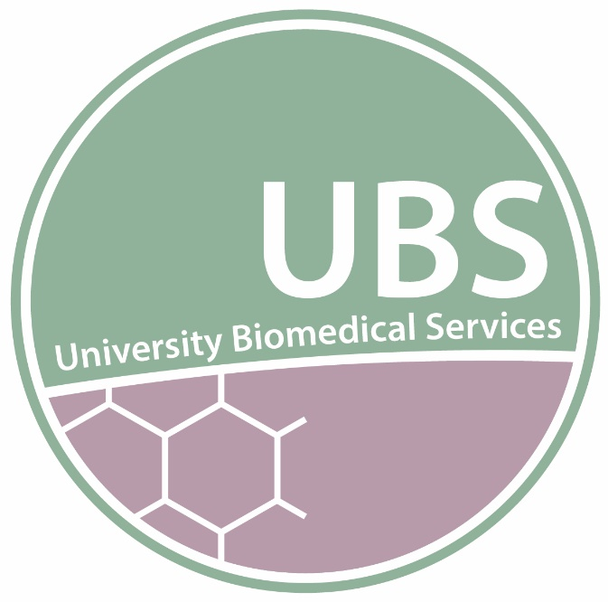

Contents

Introduction

References

Appendices
Documents

Health Status Requirements
Acquiring animals

Import & Export of Animals Overseas
To Overseas Establishments
From Overseas Establishments

Transfer of Animals Within the UK
To UK Designated Establishments
From UK Designated Establishments

Introduction

Movement of Animals – The Law
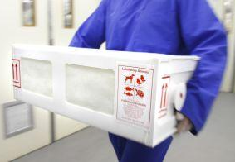
Genetically Altered (GA) rodents are being developed in many research establishments around the world and their use published in peer-reviewed publications. This has created a desire for these animals to be used in similar research programmes and the need for the animals to be transferred between establishments both within the UK and between other countries. The transport of sperm, ova or embryos should always be considered rather than the movement of live animals providing there is the relevant license authority and facilities to reconstitute the line on arrival at the destination.
In the UK the GA animals used in research are protected under the authority of The Animals (Scientific Procedures) Act 1986. The movement of such animals between establishments is strictly controlled under this Act and other associated legislation.
Both the Covid pandemic and the UK exit from Europe pose serious risks for the welfare of animals in transit between countries, for these reasons researchers have been asked not to import or export live animals unless it is absolutely necessary. Where it is absolutely necessary to move animals it is important we undertake thorough due diligence checks. Appendix 1 (Due diligence for animal transport across international borders)
The University of Cambridge must ensure that animals being imported into, and exported from, the UBS facilities comply with these requirements and follow the due diligence guidance to meet the strict health and welfare standards required by the University.
The following notes will assist you in understanding these requirements and the procedures expected to be always followed for the movement of rodents into and out of the University. It is very important that we maintain the continued high welfare and health status of our animal colonies, and adherence to the required legislative requirements.
UBS will work with receiving or sending establishments to choose whichever courier company is deemed the most appropriate for animals’ welfare and meets operational requirements

Movement of Protected Animals
The Law
Animals that are protected under the authority of The Animal (Scientific Procedures) Act 1986 can only be housed and used for experimental purposes within a Home Office Designated Establishment and under the authority of a Project Licence.
In order to comply with the requirements of the Act the movement of such animals must be authorised by the Home Office, by having written authority within the relevant Project Licence to supply and for the destination to have authority to receive animals of that type.
It is the responsibility of the Project Licence holder to ensure that records of movements of protected animals are kept as animals are transferred to or from the authority of their licences.
Additionally, there is legislation controlling the actual transportation of live animals, (Council Regulation (EC) No 1/2005) for animals being imported into the UK from overseas an Import Licence is often required from the Department of Environment, Food and Rural Affairs (DEFRA).
Controls are also in place to protect animals whilst being transported within the UK under Council Regulation (EC) No 1/2005.
In all cases advice must be sought from both the Named Animal Care and Welfare Officer (NACWO) and of the Named Veterinary Surgeon (NVS), before arranging to transfer or receive animals from any external sources.

Transfer of Animals Within the UK
The following guidance will assist in the transfer of Protected Animals between the University of Cambridge and other Designated Establishments in the UK. All requests to transfer animals MUST be made to the Rodent Import and Export Coordinator or the unit NACWO.
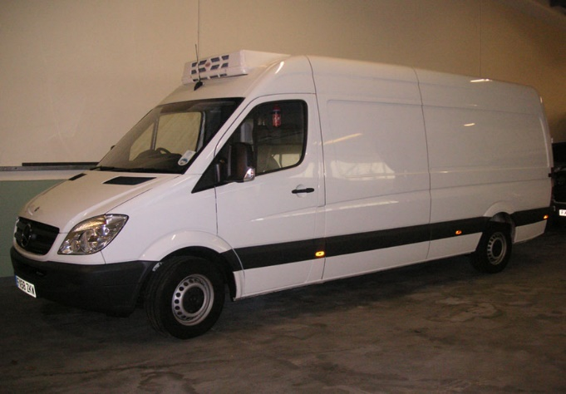

Transfer to UK Designated Establishments
Protected Animals may be transferred to the authority of Project Licences held at other UK Designated Establishments. This can only be done if one of the following authorities is in place:
- A condition authorising the movement is provided on the receiving Establishment Licence.
- A condition authorising the movement is provided on the receiving and supplying Project Licence.

Procedure
- A request to transfer animals from a University Biological Services Unit must be made to the unit NACWO.
- An Animal movement form (Appendix 2) should be completed with as much detail as possible, including:
  - Contact details of the receiving establishment.
  - Strain and Transgenic nomenclature of the animals to be transferred.
  - Number, age and sex of the animals.
  - A grant code to charge the transfer and other essential incidentals.
- The NACWO or rodent Import and Export coordinator will make contact with the receiving establishment to:
  - Provide them with the microbiological health screen of the supplying facility or individual animals.
  - Determine if authority to transfer is provided in the receiving Project Licence and on the Establishment Licence.
  - Determine if authority to transfer is on the supplying Project License.
- If the microbiological health screen is accepted the process of arranging the transport of the animals can begin.
- A specialist, UBS approved licensed courier will be selected and a date arranged for the transfer. All vehicles must be secure and climate controlled.
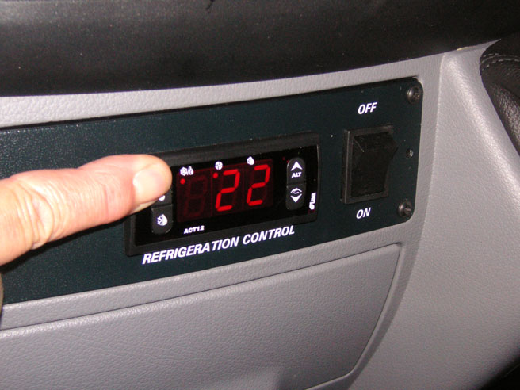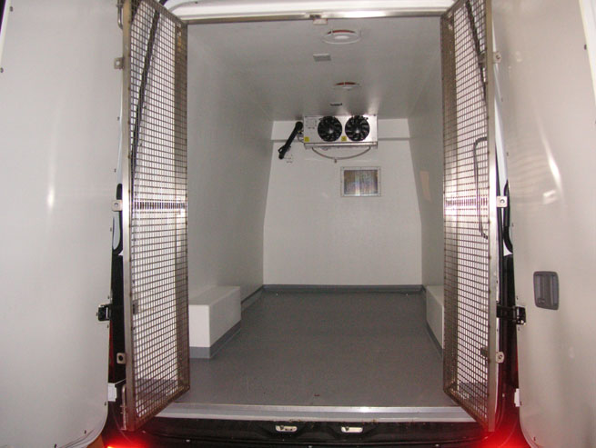
- On the day of transfer UBS staff will box the animals in transport containers, see Appendix 6, label and prepare them for collection. The boxes should contain suitable bedding and nesting material and an adequate provision of food and fluid/gel pack to maintain the animals for longer than the expected journey time.
- The receiving establishment will provide confirmation of safe receipt.

Transfer from UK Designated Establishments
Protected Animals may be transferred to Project Licences held at the University of Cambridge from other UK Designated Establishments. This can only be done if the following authority is in place:
- There is a Project Licence in place authorising the movement, on both the supplying and receiving Project Licences.

Procedure
- A request to transfer animals to a University Biological Services Unit must be made to the unit NACWO or Import and Export Coordinator
- An Animal Transfer Form (Appendix 2) will be provided and should be completed with as much detail as possible, including:
  - Contact details of the source establishment.
  - Strain and Transgenic nomenclature of the animals to be transferred.
  - Number and sex of the animals.
  - A grant code to charge the transfer to.
The NACWO or rodent Import and Export coordinator will contact the supplying establishment to:
  - Request the previous 18 months facility health screens and the screening methodology or that of the individual animals to be transferred.
  - Determine if authority to transfer is provided in the supplying and receiving Project Licence and on the Establishment Licence.
- If the microbiological health screen is acceptable to the NVS & NACWO the process of transporting the animals can begin.

- Contact will be made with the source establishment to begin the transport process. Only specialist, UBS approved, and licensed couriers will be used and a date arranged for the transfer.
- On the day of receipt, the UBS staff will unpack the animals and check their well-being before being placed in home cages. Any welfare or health issues will be reported immediately to the NACWO and NVS
- The receiving unit will provide confirmation of safe receipt or report any issues to the source establishment on arrival and inform the researcher.
- If the microbiological health screen is not acceptable then an alternative solution will be discussed with the research group. This may include sourcing from an alternative establishment, holding animals in a facility of lower health status, using a commercial source, or holding the animals in a quarantine facility for re-derivation and re screening. You must ensure the relevant GA Breeding and re derivation protocols are in the Project Licence that will facilitate this.
- If animals are to be held in a quarantine area and re screened to confirm the health status they will only be released from quarantine on receipt of a satisfactory health report. This cost must be met by the research group.
- Animals should not be disturbed, used for scientific procedures or setup for breeding for at least 7 days to allow acclimatisation, post arrival.
- Animals transferred for tissue collection only can be culled on arrival.

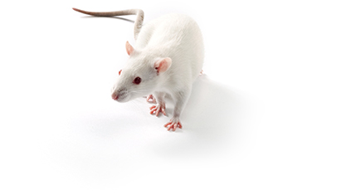
Import & Export of Animals Overseas
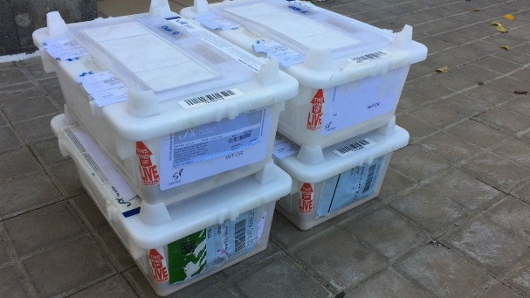
The following guidance will assist in the transfer of Protected Animals between establishments outside of the UK and the University of Cambridge.
All requests to transfer animals MUST be made to the NACWO of the facility or the rodent Import and Export coordinator from where animals are to be transferred from.

Transfer to Overseas Establishments
Protected Animals may be transferred to animal facilities in other countries. This can only be done if the following authority is in place:
A statement authorising the movement is provided on the supplying Project Licence and all legislative requirements of the receiving country are met. (Requirements do vary from country to country so it is important to verify exactly what is needed).

Procedure
- A request to transfer animals from a UBS facility should be made to the unit NACWO or the rodent Import and Export coordinator.
- An Animal Transfer Form (Appendix 2) will be provided and should be completed with as much detail as possible, including:
  - Contact details of the receiving establishment.
  - Strain and Transgenic nomenclature of the animals to be exported.
  - Number, age and sex of the animals.
  - A grant code to charge the transfer to.

The NACWO or rodent Import and Export coordinator will make contact with the receiving establishment to:
  - Provide them with a current microbiological health screen.
  - Determine what other legislative requirements there are, if any.
- A specialist, UBS approved licensed courier will be selected and a date arranged for the transfer. Advice on the documentation required will be provided by the courier or Import and Export coordinator.
- If the microbiological health screen is accepted the process of transporting the animals can begin.
- Depending on the documentation required, which will be country specific, the transfer may require an Export Health Certificate signed by an Official Veterinarian (OV).
- The pre-export health check should be done on the day of export and this certificate must accompany the animals.
- Some countries may require additional documentation; this will be completed as required.
- On the day of transfer UBS staff will box the animals in transport containers, see Appendix 6, label and prepare them for collection. The boxes should contain suitable bedding and nesting material and an adequate provision of food and fluid/gel pack to maintain the animals for longer than the expected journey time.
- The receiving establishment will provide confirmation of safe receipt.

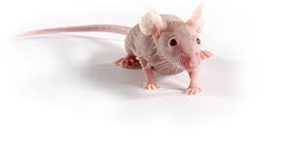
Transfer from overseas establishments
Protected Animals may be transferred to the authority of Project Licences held at the University of Cambridge from overseas animal facilities. This can only be done if the following authorities are in place:
- The Project Licence authorises the movement of animals of that type from outside of the UK.
- A DEFRA Import Licence (Appendix 3) is in place.

Procedure
- A request to transfer animals into the University of Cambridge is made to the NACWO or rodent Import and Export Coordinator.
- An Animal Transfer Form (Appendix 2) will be provided and should be completed with as much detail as possible, including:
  - Contact details of the supplying establishment.
  - Strain and Transgenic nomenclature of the animals to be imported.
  - Number, age and sex of the animals.
  - A grant code to charge the transfer to.
- The NACWO or rodent Import and Export Coordinator will contact the supplying establishment to:
  - Request the previous 18 months facility health screens and the screening methodology or that of the individual animals to be transferred.
- If the microbiological health screen is acceptable to the NVS & NACWO the process of transporting the animals can begin.
- The NACWO or rodent Import and Export coordinator will contact the supplying establishment.
- Only specialist, UBS approved, and licensed couriers will be used, and a date arranged for the transfer. (Appendix 1).
- A DEFRA Import licence (Appendix 3) will be provided prior to the confirmed shipment date.
- The supplying establishment will confirm when animals have been shipped.
- Animals will be received into the UBS facility.
- On the day of receipt UBS staff will unpack the animals and check their wellbeing before being placed in home cages. Any welfare or health issues will be reported immediately to the NACWO and NVS.
- The receiving unit will provide confirmation of safe receipt or report any issues to the source establishment on arrival and inform the researcher.
- If the microbiological health screen is not acceptable then an alternative solution will be discussed with the research group. This may include sourcing from an alternative establishment, holding animals in a facility of lower health status, using a commercial source, or holding the animals in a quarantine facility for re-derivation and re screening. You must ensure the relevant GA Breeding and re derivation protocols are in the Project Licence that will facilitate this.
- If animals are to be held in a quarantine area and re screened to confirm the health status, they will only be released from quarantine on receipt of a satisfactory health report. This cost must be met by the research group.
- Animals should not be disturbed, used for scientific procedures or setup for breeding for at least 7 days to allow acclimatisation, post arrival.
• Animals transferred for tissue collection only can be culled on arrival.

Health Status Requirements
Prior to allowing the import of animals into UBS facilities, the previous 18 months microbiological health screen reports and the screening methodology must be provided including one report from within the last 3 months, by the supplying establishment and approved by the NACWO and NVS. The NACWO and NVS reserve the right to request more detailed Health Screening information, as needed on a case-by-case basis.
The animal’s health status must match or exceed the biosecurity level of the intended UBS facility to be accepted into the destination facility and the health screen report must include the minimum range of organisms as detailed in the FELASA SPF list of excluded rodent pathogens (Appendices 4 & 5), this may be unit specific. Ref: FELASA recommendations for the health monitoring of mouse, rat, hamster, guinea pig and rabbit colonies in breeding and experimental units 2014.

Acquiring Animals
If a health screen of a requested batch of animals is rejected by the NACWO or NVS, they will recommend other methods of acquiring “clean” animals for your research.
This will most likely involve re-derivation of the strain and can usually be carried out either in house or by a selection of companies either in the UK or in the USA. The cost of rederivation varies but a budget allowance of approximately £2000 to £4000 per line should be made.
Cryopreservation services are also available should you wish to protect the health status and continuity of valuable lines of GA animals.

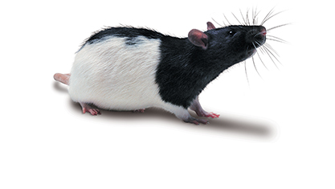

References
The following documents have been referenced during the compilation of these guidelines.
- Council Regulation (EC) No 1/2005 of 22 December 2004 on the protection of animals during transport and related operations and amending Directives 64/432/EEC and 93/119/EC and Regulation (EC) No 1255/97 (legislation.gov.uk)
- FELASA recommendations for the health monitoring of mouse, rat, hamster, guinea pig and rabbit colonies in breeding and experimental units 2014.
https://journals.sagepub.com/doi/pdf/10.1177/0023677213516312

Appendices
The following appendices and documents are used to facilitate the import and export of animals.
Appendix 1: Due diligence for animal transport across international borders)
Appendix 2 Animal Transfer Form
Appendix 3. Example DEFRA Import Licence
Appendix 4, Table 3, FELASA recommended screening list for mice
Appendix 5, Table 4, FELASA recommended screening list for rats
Appendix 6, Transport Box Packing Guidance

Appendix 1
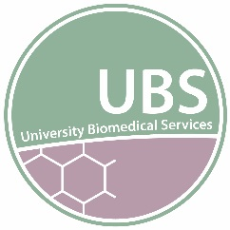
Due diligence for animal transport across international borders
Both the Covid pandemic and the UK exit from Europe pose serious risks for the welfare of animals in transit between countries. For this reason Martin Vinnell wrote to all researchers before Christmas 2020 (see attached) to ask them not to import or export live animals unless it was unavoidable.
Where it is absolutely necessary to move animals it is important we undertake thorough due diligence checks. Below is a list of things the courier company, who undertake to move research animals between countries, should provide you before you agree or sign contracts:
- Provide the journey plan which clearly shows each step of the journey, including all flight changes and modes of transport, and how long the full journey is projected to take from the time the animals leave their departure facility to arrival at their destination.

- Provide information about which UK airport the animals will arrive into or depart from and who will be responsible for the animals from the point of departure until the animals arrive at their destination..

- Written assurance that all animal holding rooms at the arrival, departure and all stops along the journey comply with Home Office Code of Practice: https://assets.publishing.service.gov.uk/government/uploads/system/uploads/attachment_data/file/388535/CoPanimalsWeb.pdf.
In addition, the courier company should provide information about when animals will be loaded onto flights. For example, if the animals are due to leave an airport early in the morning the courier company should check whether the animals will be loaded onto the aeroplane the night before and if so, the courier company should explain what provision will be made to meet the environmental needs of the animals while they are waiting in the aeroplane for the flight to leave.

- Written assurance of the provisions in place for the animals while in transit, e.g. the nature of the transport container, bedding, food and water, biosecurity etc.

- Written assurance from the courier company that they have checked that measures are in place to ensure the pilot knows live animals will be in the hold of the aeroplane.

- Written assurance that all the necessary paperwork to move the animals is in place so that there are no delays at boarders. Ideally copies of this paperwork should be sent to you before animals are moved. Following the UK exit from Europe, it is essential we know this for all movements of animals from EU countries or transiting via EU countries.

- If the journey plan shows stop overs these should be considered carefully because flight scheduling is currently being severely affected by the Covid pandemic.
For this reason, if there were to be a delay between connecting flights (e.g. due to cancelled flights) or an unexpected delay caused by weather conditions, the courier company should provide reassurance, before the journey commences, that they have checked that appropriate provisions are in place to ensure the welfare of the animals should a delay occur.

- Before the animals leave, the courier company must undertake to contact you and provide information about when animals arrive at and leave airports or border check points, when and where animals are held and who will check and who will be responsible for the animals at each stage of the journey.

January 2021


Appendix 2

UBS Animal Transfer form

Sender:
Name
Full Address
Telephone number
Email address
PPL & protocol
Department
MTA Required [please tick]  * Please note – this is the responsibility of the owners of the animals. |  |  | Yes |  | No | Are embryos or sperm available? (If not, please include scientific justification in accompanying email)  Does housing at receiving facility comply with UK code of practice? Yes/No If no, Please justify:
Recipient:
Name
Full Address

Telephone number
Email address
Grant code
PPL & Protocol
Department
New MCMS prefix
Additional information: e.g. specific experimental or breeding info.

Animal Details:
Strain - MCMS  Colony Prefix  ( if Known ) | Sex |  |  | Date of  Birth |  |  | Room | Cage number | Rack Number | ID (e.g. ear notch number)
Strain - MCMS  Colony Prefix  ( if Known ) | Sex |  |  | Date of  Birth |  |  | Room | Cage number | Rack Number | ID (e.g. ear notch number)

To be completed by the Rodent Import/Export Coordinator (All boxes should be ticked)

For transfers within UBS Facilities only please complete section A. For all other transfers please complete Section A & B.

SECTION A
- Health reports have been sent/received and approved by relevant persons.

- Transport has been booked and dates/times for collection/drop off confirmed by both sender/receiver. (if applicable to transfer)

- The sending facility has confirmed the transport boxes will have sufficient food and water to ensure this will cover the whole journey and an additional 2 days in case of any delays.

SECTION B
- The due diligence questions below should be completed by the courier before the animals are sent and kept on file.

- Provide the journey plan which clearly shows each step of the journey, including all flight changes and modes of transport, and how long the full journey is projected to take from the time the animals leave their departure facility to arrival at their destination.

- Relevant persons have approved the journey plan.

- Provide information about which UK airport the animals will arrive into or depart from and who will be responsible for the animals from the point of departure until the animals arrive at their destination.

- Written assurance that all animal holding rooms at the arrival, departure and all stops along the journey comply with Home Office Code of Practice. In addition, the courier company should provide information about when animals will be loaded onto flights. For example, if the animals are due to leave an airport early in the morning the courier company should check whether the animals will be loaded onto the aeroplane the night before and if so, the courier company should explain what provision will be made to meet the environmental needs of the animals while they are waiting in the aeroplane for the flight to leave.

- Written assurance of the provisions in place for the animals while in transit, e.g. the nature of the transport container, bedding, food and water, biosecurity etc.

- Written assurance from the courier company that they have checked that measures are in place to ensure the pilot knows live animals will be in the hold of the aeroplane.

- Written assurance that all the necessary paperwork to move the animals is in place so that there are no delays at boarders. Ideally copies of this paperwork should be sent to you before animals are moved. Following the UK exit from Europe, it is essential we know this for all movements of animals from EU countries or transiting via EU countries.

- If the journey plan shows stop overs these should be considered carefully because flight scheduling is still affected by the Covid pandemic.
For this reason, if there were to be a delay between connecting flights (e.g. due to cancelled flights) or an unexpected delay caused by weather conditions, the courier company should provide reassurance, before the journey commences, that they have checked that appropriate provisions are in place to ensure the welfare of the animals should a delay occur.

- Before the animals leave, the courier company must undertake to contact you and provide information about when animals arrive at and leave airports or border check points, when and where animals are held and who will check and who will be responsible for the animals at each stage of the journey.

Version 1.1 04.10.2022

Appendix 3
Example of a DEFRA Import Licence which are unit specific
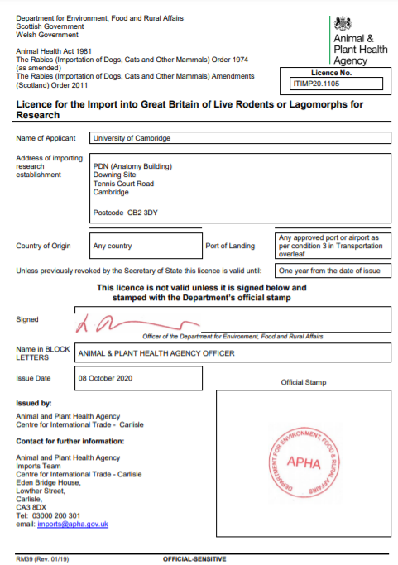

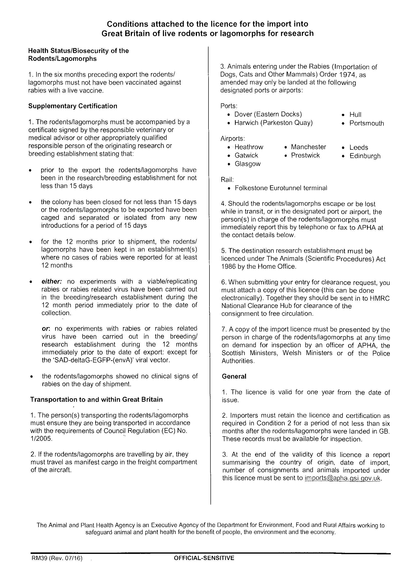

Appendix 4 FELASA recommended screening list for mice

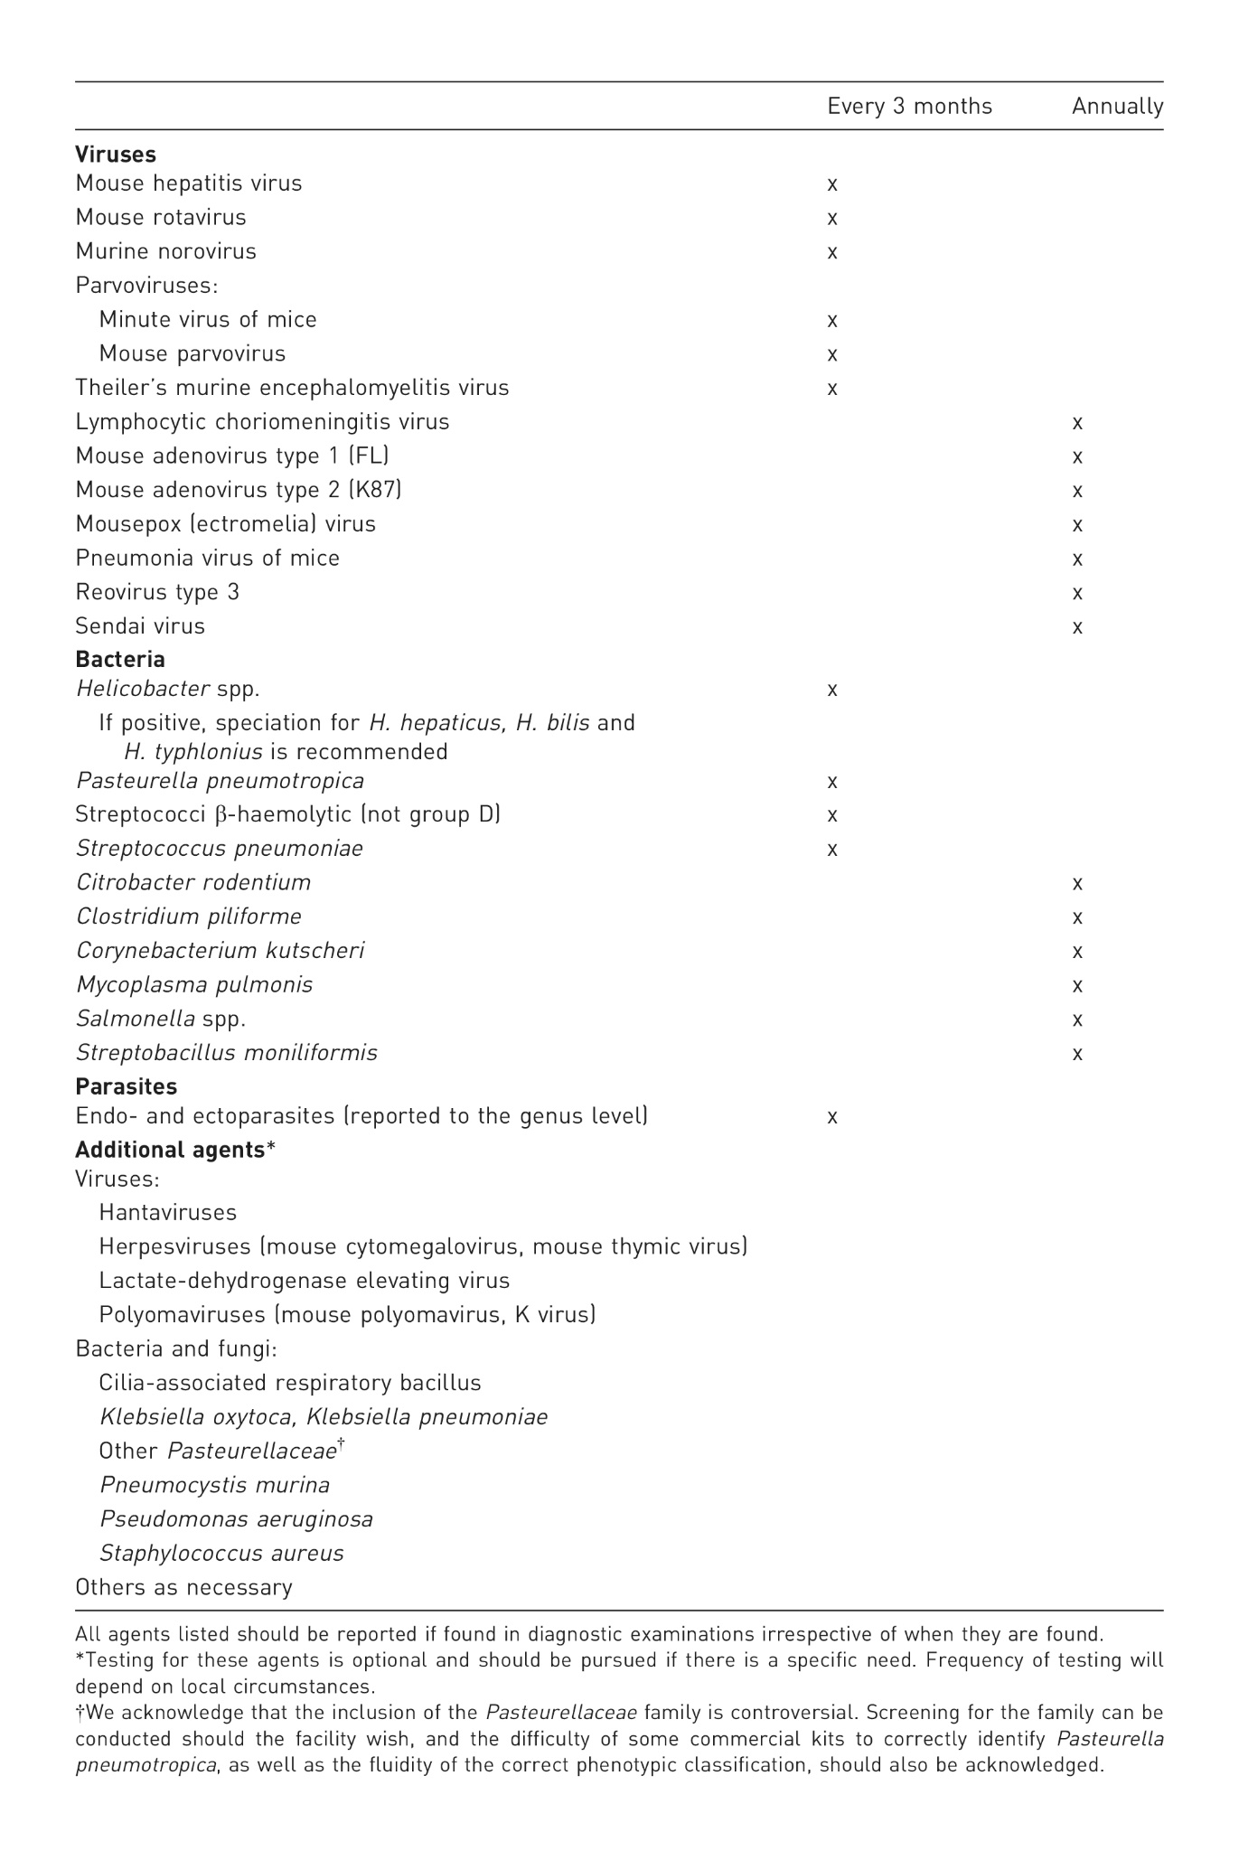
Appendix 5 FELASA recommended screening list for rats

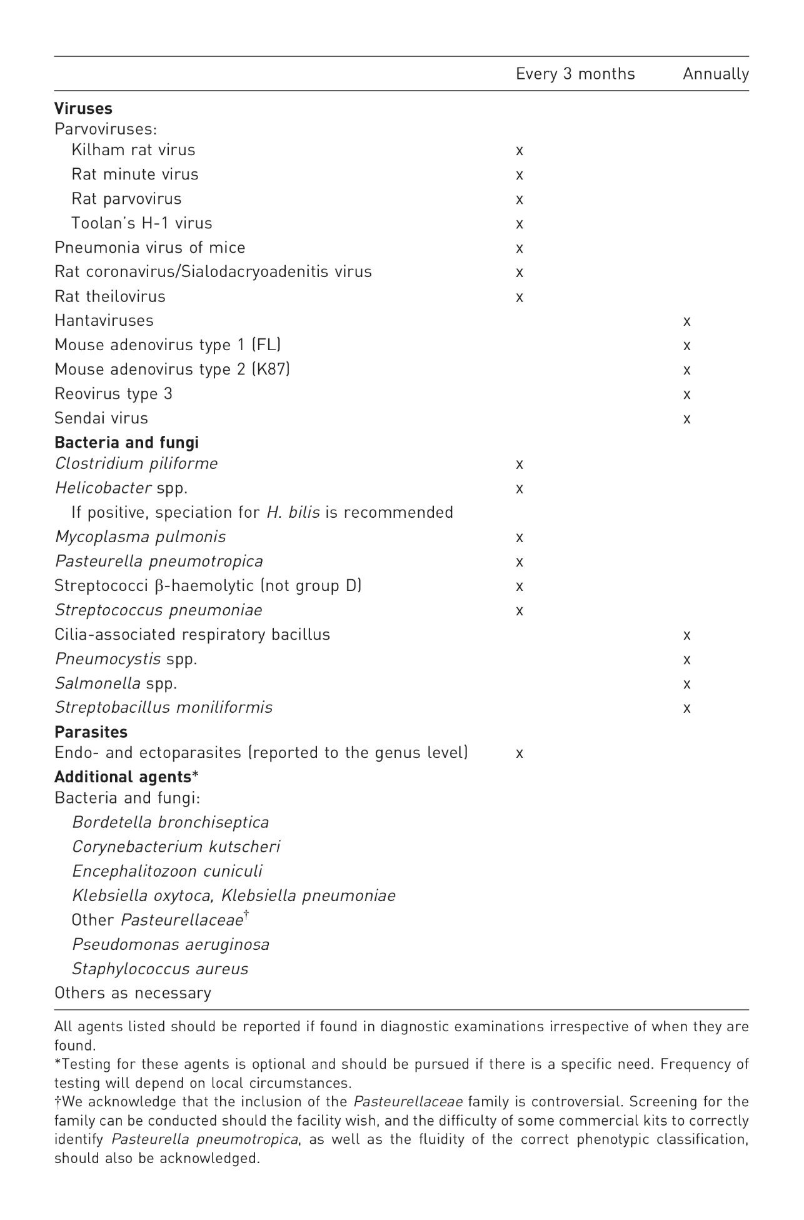

Appendix 6
Transport Box Packing Guidance
Transport Box 1
EMaint Item No. 271PO4F-E
External Size: 560x355x200mm (Internal - floor 545 x 350 x height 195mm)

Options: | without divider (full box) | with divider (half box)
Rats 250g-300g | 6 | 3
Rats 300g-400g | 4 | 2
Rats 400g-600g | 4 | 2
Rats 600g+ | 2 | 1
Mice <30g | 20 | 10
Mice >30g | 18 | 9
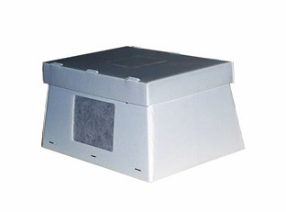

Transport Box 2
EMaint Item No. 271P03F
External Size: 420x290x150mm (Internal - floor 415 x 285 x height 145mm)

Options: | without divider (full box) | with divider (half box)
Rats | Not suitable box | Not suitable box
Mice <30g | 12 | 6
Mice >30g | 10 | 5

Transport Box 3

*Currently not stocked - pending
External Size: 270x270x165mm (Internal - floor 255 x 255 x height 155mm)
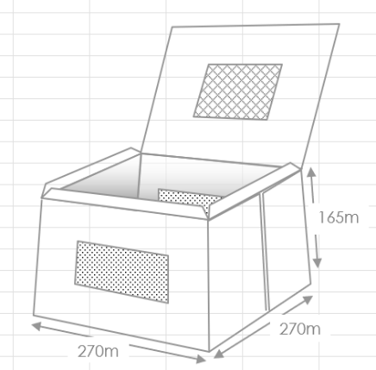

Rats | Not suitable box
Mice <30g | 7
Mice >30g | 5

Transport Box 4
EMaint Item No. 025CF3F
External Size: 230x125x120mm (Internal - floor 215 x 122 x 120mm)

*ONLY for internal movements between UBS approved areas
Rats 250g+ | Not suitable box
Mice <30g | 3
Mice >30g | 2
Nursing Dams | 1 dam with litter
