 | Minutes
 | Minutes

University Biomedical Services Facilities Operations and Management Committee

Wednesday 3rd June 2020 at 14.00pm – 16.00pm

Present: Sue Ozanne (Chair), Martin Vinnell, Bill Colledge, Sarah Howlett, Jenny Nichols, Dino Giussani, Sam Jameson, Alan Graham, Angeleen Flemming, Howard Baylis, Maggie Gentry, Keith Savill, Karl Wilson, Anne-Marie Farmer, David Williamson, Elisabeth Busch-Nentwich, Angela Roberts, David Belin, Pietro Mastroeni, Chloe Hodgkisson (minutes)
No Apologies given

The minutes from the last meeting on 31st January 2020 were agreed as a true representation of the previous meeting.

Action points from the previous minutes;

CH emailed all committee members regarding viewing access of the UBS intranet site. The viewing access was updated for the FOM area on the website and there have been no further reported issues. AF mentioned not being able to view the FOM area from home. AMF explained this might be related to using a home computer rather being on the University network. The Committee were reminded to use their Raven login to gain access to the UBS intranet.

KS explained he received the report from the Fire Brigade at the end of 2019 for the fire incident at CBS on 26th September 2019. There were recommendations about housekeeping and faulty conduit. The affected area was closed following the incident and the CBS building is now shut. The recommendation for going into the new building is that extension cables need to be maintained and checked regularly.

SO questioned KS regarding the request for a frequently asked questions sheet for the AMB. KS said this had not been completed. SO asked this to be done as it was important to have in place.

Action: KS to compose a frequently asked questions crib sheet for AMB.

AMF reported that there has been a huge amount of ASPEL system updates since the last FOM meeting. The system is much better, smoother and easier to use. It has much more functionality to it.

KS confirmed that Managers have been made aware that there needs to be a rating schedule and protocol in place to ensure equipment is checked regularly and PAT tested. The action was raised at the AOC meeting.

- Financial Report – Karl Wilson
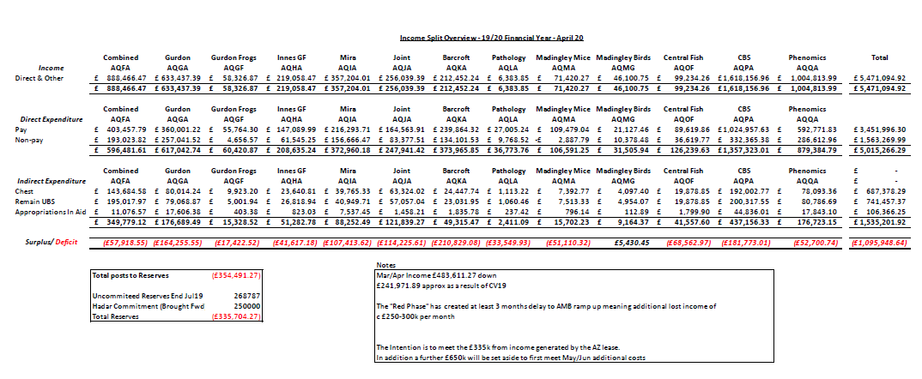

The Committee discussed the UBS Facility trading data. For March and April the combined income based on this time last year is down £484,000. KW explained it is a difficult time due to CBS and Phenomics being shut and work not able to start in the AMB because of the current pandemic and the halting of research when the University moved into the red phase. Therefore whilst activity (and therefore income) has greatly reduced UBS are still paying staff and cover. As a result of this the department income is greatly reduced in the face of similar expenditure.
Because of the reduction of activity and delays opening AMB UBS have incurred considerable costs during the University red phase which are unrecoverable. Following the unprecedented impact of CV-19 and closure of CBS/Phenomics it is recommended that we use an inflationary increase of 18/19 Financial years costs rather than 19/20 actuals to determine next year’s pricing. A well planned and managed return to working safely is imperative in avoiding significant cost increases.

- Summary Occupancy Figures
Biofacility | Total Capacity | March 2020 Occupancy | April 2020 Occupancy | May 2020 Occupancy | May 2020 Percentage Occupancy
Gurdon Rodents | 5510 | 1155 | 1115 | 1171 | 21
Gurdon Frogs | 840 | 634 | 456 | 456 | 43
AMB Level 4 - SOPF Barrier | 4840 | 1378 | 1730 | 1895 | 39
AMB Level 2 - Experimental Barrier | 2000 | 264 | 317 | 361 | 18
AMB Level 0 - Evaluation Barrier | 1760 | 961 | 1561 | 1555 | 88
AMB Fish | 2396 | 601 | 646 | 632 | 26
CAF - Rodent | 3200 | 1628 | 1466 | 1460 | 46
JAF Anatomy - Rodent | 1100 | 115 | 113 | 111 | 10
MIRA - Rodent | 3000 | 882 | 826 | 848 | 28
MIRA - G.Pig | 300 | 0 | 0 | 0 | 0
PDN Fish - 2.8L Tanks | 1944 | 935 | 1039 | 1021 | 53
PDN Fish - 0.8L Tanks | 160 | 87 | 38 | 18 | 11
Madingley Corvids - Aviary |  | 39 | 39 | 39
Madingley Corvids - Cage |  | 0 | 0 | 0
Madingley Cichlids | 36 | 34 | 34 | 34 | 94
Madingley - Rodent | 200 | 51 | 5 | 0 | 0
Barcroft - Chickens |  | 75 | 74 | 74
Barcroft – Pig |  | 0 | 0 | 0
Barcroft - Sheep |  | 142 | 151 | 156
Innes Marmosets - Psychology |  | 10 | 5 | 4
Innes Marmosets - Anatomy |  | 33 | 26 | 29
Innes Marmosets - Breeding |  | 40 | 40 | 40
Innes Marmosets - Stock |  | 98 | 99 | 104

The committee discussed the Occupancy UBS Facilities Occupancy data for March to May 2020.
There is a lot of research being restricted due to Covid-19 so maintaining facilities occupancy has been difficult and as expected most have seen a drop in occupancy. Fish at Madingley remain static.
The staff headcount throughout this period has remained the same. UBS kept agency workers for the first 6 weeks incase people went off due to Covid-19, this allowed flexibility for the staff.
All animals on level 2 of AMB have been moved to level 4 to accommodate the testing facility. Plan is to maintain health status of level 4. Health screening is taking place 3.6.2020.
The occupancy figures are based on cage numbers (so actual animal numbers are different as most cages have more than one animal).
Action - SO requested KS to provide total capacity numbers for the AMB.
Action: Occupancy figures for rodents to be split in to mouse and rat to show figures for each. To be provided for the next meeting.

- Future planning
SO thanked those that sent in comments and queries regarding future planning specifically related to restarting research now that the University had moved to the amber phase. These comments could be broken down into the following:

- Timing of opening facilities and Study Plans.

There are 150 University buildings to re-open. Two tests are required when re-opening a building. Test 1 is checking if the infrastructure is safe. Test 2, the Head of Department HOD) has to confirm with the Users what research can start. UBS has no input with this decision. The HOD must prioritise getting researchers back into the labs in a safe manner, taking into account government guidelines including social distancing and therefore likely occupancy of 25-30 % of normal capacity. In relation to work in Facilities, Researchers had been asked to submit their Study Plans (listed in order of priority) to their Facility Manager by Tuesday 9th June 2020. A decision can then be made as to what can be accommodated and when this will happen. It is estimated that new work could start from June 22nd in most Facilities (perhaps a week later in AMB). Most importantly, UBS need to ensure that everyone is operating safely across the board.
KW reported that Sally Thomas had received over 100 study plans for AMB. KW and KS will be meeting with the Facility Managers to discuss the priority of study plans. BC highlighted that it would be very difficult for Facility Managers to prioritize work of users and that strong support from UBS would be required. This was going to be a particular challenge in facilities where there were users from many departments. The committee agreed that decisions couldn’t be placed fully on the Facility Managers and advised that a working group could be established within a facility to discuss and make decisions regarding Research starting in the facilities and however for example individual use of surgery facilities should be prioritized. The UBSGS is scheduled for 4th July 2020 and appeals against decisions will be referred to that committee if necessary.

Action: Working group to be established in Facilities as required. Working group should be operated such that there are no conflict of interest in the decision making process (e.g. Rat users prioritize mouse surgery work and vice versa).

- Social Distancing
DB raised a query from the CAF User meeting regarding social-distancing in the Facility. The procedure rooms are small so social distancing would be difficult and there were concerns that users would block book rooms. KW confirmed users will not be able to block book out rooms months in advance. SO noted that additional PPE would be required (based on risk assessment) where social distancing was not possible. DB raised concerns that he lost 6 months of work when he had to schedule 1 animals because of the lockdown and that UBS needs to be clearer in the plans of what to do if it happens again. SO noted this had been an unprecedented situation and that there had been a lot of miscommunication at the time of lockdown and that something must to be learnt from this experience. MV reassured the committee that there is now more of an assessment in place and clear procedures of how to deal with this to prevent these problems arising again. Miscommunication is being managed and UBS are looking at better mechanisms for communication.

Action: Discuss surgery social distancing arrangements within working group.

- Out of hours working
There is no change to the out of hours working policy. Less people working in buildings will result in more out of hours working so the committee agreed that it was important that clear policies, risk assessments and SOPs were in place. There may be an increase in shift work and weekend working which will require the cleaning schedule to be reviewed. DB suggested a statement is sought from the Home Office relating to the out of hours’ policy to cover researchers and decrease anxiety MV explained there is no concern regarding working out of hours. Once UBS knows the time and arrangements of work, department is happy to arrange UBS staff to support this. This may mean early morning work and UBS will fit it in when and where possible. Many find it beneficial working out of hours and will not be putting themselves at risk. AMF added that Users needed to be aware of safe working with anesthetics and take into consideration this is signed off by a vet.

- Risk Assessments
Facility Managers are carrying out risk assessments and producing SOP’s for procedure rooms. Every activity will be risk assessed. It will be complex doing a risk assessment in certain areas as people will be doing different things in close proximity therefore good communication between users and UBS staff was critical.
- Staffing
AF queried the UBS staffing levels. KW explained that in order to support the Researchers most UBS staff will be coming back to work. Researchers were advised where feasible to ask UBS staff to undertake tasks that Researchers would normally do themselves to reduce numbers of individuals going into buildings. KW confirmed that costs for this would remain.

- PPE
Committee discussed possibility of two people working back to back in full PPE in the holding rooms. There may be some cross touching of cages and animals. The social distancing rules are in place where possible and the use of PPE FFP2 and FFP3 masks will be reviewed. There are hood and powered respirators for all UBS staff. Disposable masks have been kept for researchers and discussions are on-going regarding the re-use of FFP3 masks (which are designed to protect against animal allergens). SO noted that the University Safety office had published a useful document regarding use of PPE (attached to these minutes)

- AMB update
UBS is optimistic that work can start up to some extent on level 2 AMB where the testing facility was currently operating. KW reported that of the holding 12 rooms on level 2, 9 have been assigned to the Covid testing labs. However the barrier has been maintained so everyone working on level 2 is required change into scrubs. The capacity is 45-50 people testing per shift that means the changing rooms are busy at the beginning and end of the testing facility shifts. Therefore UBS staff and researcers should avoid the changing rooms at that time. The testing facility will be located in AMB until at least the end of July. The outer rooms on Level 2 are untouched so work in that area would be undisturbed. Users will be kept up to date as information is available
As this was a period of rapid transition and continued communication between UBS and users was critical, the committee thought it would be productive to have an additional extraordinary meeting at the end of July/beginning of August.

- Date of next meeting:

- Extra-Ordinary Meeting - Wednesday 5th August at 10.00am - 12.00pm, Virtual meeting using Zoom

- Wednesday 30th September at 10.00am – 12.00pm, venue tbc

