Date: Monday 5th June 2023
Time: 10.30am
At: Virtual via MS Teams
Our Ref: Doc.UBS.FOM.050623

University Biomedical Services Facilitates Operations and Management Committee

Present: Sue Ozanne (Chair), Keith Savill (KS), Karl Wilson (KW), Sarah Howlett (SH), Pietro Mastroeni (PM), Martin Vinnell (MV), David Belin (DB), Alan Graham (AG), Angela Roberts (AR) Howard Baylis (HB), Maggie Gentry (MG), Kate Tansley (KT), Benjamin Steventon (BS), Rahul Roychoudhuri (RR),Toni McEvoy (TM) (minutes)

Apologies: Sam Jameson (SJ), Dino Giussani (DG)

Mentioned within text: Kajsa Bigeat (KB), Nick Dean (ND), Emilia Santos (ES), Gemini Chu (GC), Matt Nolan (MN)

- Matters Arising
- Road map update – This is ongoing. KB is reaching out to heads of departments for some finer details. KB is also looking at any new space requests.
- Action Point: KW to circulate road map
- MCMS working group – This has now been set up. KW has asked for SJ to complete this task
- Table for staffing structure and Numbers – KS is still in the process of completing this
Action point: KSto provide table to add as post meeting note
- The JAF is now closed. AG confirmed there are no animals in the facility but there is still equipment in the facility.

- Chairs Report:
Cage charges were discussed in the UBSGS meeting in February. These will increase by 5.8% (coming onto effect from 1st August this is lower than the rate of inflation of around 12% (with deficit being covered by income from AZ). The new price list has been distributed (and costs updated on X5), and will go out again with the bills at the end of June.
Action point: KW to arrange for new price list to be circulated with June invoices
Occupancy has remained low across the facilities and has not recovered as quickly after the pandemic as previously hoped.
- Financial Report:

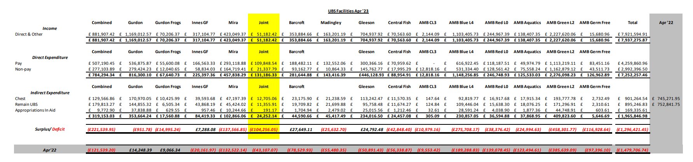
The Barcroft, Innes and Gleeson are now in surplus. MN at Barcroft has been controlling costs very well. One of the things that has come from surplus money is that UBSG have approved the creation of a role for a costing manager. The overall UBS deficit is about £180,000 less that this time last year. There has also been an extra £140,000 put in the the reserves as we’ve had more income from RCUK activity account. As a whole UBS is £320,00 better off that it was this time last year. £180k less deficit plus an extra £140k in reserves = £320k. Issues at Mira due to the pinworm has affected their income. One of the aims for the year ahead is to reduce and preferably stop using temp staff and to have staff in permanent positions. Recruitment and retention will be discussed at the next UBSG meeting. The AZ contract is secure for the next seven years. WC asked what the cost comparison was for an agency staff versus an equivalent grade UBS technician. KW has the figure but didn’t have them to hand but would add them as a post meeting note. WC asked if the UBS salaries can be uplifted as an incentive to apply for the jobs and remain in their roles, to help with agency staff costs. KW explained how difficult this is to do. If wages are uplifted then this would have a knock on affect for the Users as charges would have to be increased which would impact grant costs. RR supports a payrise for the lowest paid techs to improve retention. RR noted that continuously having to train new members of staff was a substatial burden on existing staff.
Action point: KW to provide cost comparison of agency staff versus an equivalent grage UBS technician

- Staffing Report:
There are 167 staff currently employed in UBS, a small increase on the 164 that were employed when the previous meeting took place. There are 12 vacancies being recruited to and there are currently 28 agency staff on the books. At least half of those 28 are being recruited into permanent UBS positions.

DB asked if PhD students who are looking to earn extra money could be used to fill hours in the CAF as at weekends CAF staff don’t have time to weigh food to ensure all the animals are fed and have asked for the food to be weighed on a Friday so it is ready to put in cages. KW said that this could be possible and would look into this further.

Action point: KW to look into possibility of paying PhD students to help with weekend tasks.

- Capital Projects Report:
There is little information about JCBC from Estates Division who are dealing with the issues and KW is not sure of what is going on with the facility currently.

- Requests for new space:
There has been a request from The Open University who are currently in the process of refurbishing their facility. KW thinks they may be asking for more space that we have to offer but will have more detail when he has met with them in the coming weeks.

Action point: KW to report back to the committee at next meeting

- Establishment Licence Holder Report:
MV recently attended the HO ELH meeting and it was reported that the HO are recruiting staff in to the ASRU section. Other establishments are facing issues with times it is taking to process and issue licences. The UoC continues to receive a good level of service from the HO. MV believes that the UoC degree of openness and reporting has contributed to the reputation of the University. The work done around the RCA work has also contributed to the support we receive from them, as they are able to see that we take reporting very seriously.

- Governance and Welfare Report:
The Anatomy facility has closed and therefore has been removed from the PEL. There have also been changes at, AMB, Genetics, JCBC, and Pathology & PDN. Nick Dean has been added to the PEL as a named person.

Licences:
PPLs:

158 PPLs in total
55 licences currently in draft
- 18 amendments
- 37 new licences

PILs:
820 PILs registered at the University.11 are overdue a PIL review.

AWERB:
Number of AWERB Sub-standing meetings | 4
Number of AWERB Standing | 4
Number of virtual AWERB meetings | 5 – used for minor and urgent amendments

Non-Compliance:
PEL_014-AMB Missing Valve- 19th January a breeding cage was found with a missing water valve. Two mice had to be killed, due to poor health. Pre-Action letter received.
PEL_028-AMB Trapped tail- 30th January, a male mouse was discovered trapped by its tail in the lid of the cage, and due to the severity of its tail injury it was culled. Pre-Action letter received.
PEL_035- AMB leaking valve- 5th February, fifteen mouse pups were found dead due to a leaky valve on the automatic watering system causing flooding in a cage. A further mouse pup was also found dead in the cage below, as the water leaking from the cage above caused further flooding. Pre-Action letter received.
PEL-080323 Tail trap 2023-65- 22nd May The enforcement team did not to pursue this based on the information provided, The tail injury was sufficiently monitored and further suffering was minimised by killing the animal. Closure letter received.

Root Cause Analysis (RCA):
Martin has had two letters of advice from the HO. Some cases were not pursued as the HO felt we had put in place systems to prevent these things happening again. Some are outstanding and we are waiting on a response from the HO.

Daily checks –AM check not performed and one animal found dead after multiple checkpoints were not observed- (Letter of Advice received from the HO.

Mice found dead with malocclusion – Two cases submitted to HO. Both are open and under review.

Water not being provided – Four cases – One not pursued by the HO. Three are still ongoing.

Automated watering system valve leaks/cage floods – Five cases - all are under review by the HO.

Food not being provided – Two cases – One ongoing and one under review by the HO.

Appropriate housing– Seven cases – six trapped animals - Two are still under review by the HO, two are ongoing and the HO. is not pursuing two. One animal missing following import is ongoing.

Schedule of premises – Six cases – One incorrect use for procedures - letter of Advice received from the HO.
Five animals held overnight in areas without overnight holding assigned – ongoing.

Significant welfare concerns missed:
One case - One mouse was injured when a cage lid was replaced. The NVS and NACWO were not contacted. The mouse was found dead the following morning – under review by the HO..

Unauthorised procedure: Four cases – One case of multiple blood samples taken that were not allowed, one case of a procedure performed without PPL authority, one case of a procedure performed without competency in place – all three are under review by the HO.

SC18:

PPL Two cases which were microchipping issues resulting in bruising and other adverse effects. These are ongoing.

SC18- Total 145 cases over the last review period
Commonalities and repeated events:
- Tamoxifen problems administered by various routes
- Microchip injection site bruising
- Mis-dosing
- Oral gavage injury
- Tumour growth exceeding limit
- Exceeded weight loss limits

ASRU Meetings:
Since our last meeting, we have had a recent meeting with ASRU via the HOLTIF group. Some of the latest news is as follows:
- A year of Facility Audits and SC18 information provided insights that Named Persons, NVS and NACWO may be unclear about their duties, roles, and responsibilities and that this could be reinforced.
- Piloting a non-compliance reporting form.
- Timelines for handling and processing of licences remains unchanged.
- ASPeL changes to improve functions for Named Persons to make amendments to the PEL, PPL search, Improvement to RoPs, validate content of issued licenses, automated revocation beyond 5 years, and enhanced audit trail.

- Substantive User Matters:
RR gave an update from the recent Gurdon User meeting. There is a high level of staff sickness absences. Occupancy is at around 40%. The Liston group is joining the facility, which will increase cage numbers. There is an ongoing issue with the cage wash and autoclaves but these are being addressed. RR feels there needs to be an improvement in the way UBS communicates with Estates Division (ED). KW informed the committee that communication between UBS and ED has been exemplary. UBS has over seen the installation of two new autoclaves and a new rack washer. The communication issue is not with UBS. KW will be speaking with the UBSG committee regarding a post to manage communications between UBS and Estates Division. RR sent out a user group survey inviting people to give feedback on their experiences. There was positive feedback and several staff members were named for going the extra mile. RR would like to see something implemented to provide performance related endorsements. There was feedback regarding some improvement needed around communication and some felt that UBS should invest technicians time in attending networking meetings where users and techs can get together and get to know about each other’s role so everyone can understand each other better. SO asked if the User survey form can be shared with the FOM committee.

Action point: RR to circulate User group survey

SO asked about the possibility of apprenticeships. KW said this had been discussed but the University will not allow us to do this as they are Ofsted checked and the risks of us not getting exemplary reports is too great. Instead, staff will go through the in-house training scheme with the Training Centre. RR also reported that users feel that the number of cages being charged for should be reflected on MCMS. KW said that this is what should happen and if there were examples when this was not the case to contact him.

HB asked if Non-regulated procedure requests could be renewed every two years rather than annually. MG confirmed that it is now changing to every two years and the whole process is being reviewed to see what can be done to make it run more smoothly. Emilia Santos will be the new chair of the Zoology user meetings.

SO discussed the power outage at AMB. KW said there has been two power outages within 10 days, which lasted a couple of hours. The response from estates regarding this issue has been excellent. This highlighted an issue that this can happen at any time despite being told that this could not happen in the AMB. There are contractors coming in to run some tests to see why this is happening.

SO raised the issue of communication following a formal request to do so from a user. There had been several examples where users had not received important communication and the importance of keeping email lists up to date was highlighted. KW reported that a new member of admin staff had just started and working on getting e-mail lists up to date was going to be one of their first tasks.

DB reported that CAF users are often asked to constrain research so that it matches the pace of the techs. User have been told they are not able to run experiments before 9am because UBS staff have to check the animals before they are allowed to taken for experimentation. However, UBS staff leave at 3pm so are not able to check the animals in the evenings after the procedures have been completed. DB asked if there was any possibility of different shifts be created to cover a longer period during the day when UBS staff cover was inplace DB has been told that animals have to be checked by UBS staff which was impacting on productivity.

Action Point – KS will up issues with GC.

DB has approached GC and asked if a member of CAF staff and GC could attend lab meetings once a term so they can take part in the conversations but DB was told that the times the meetings are held are too late for the CAF staff. DB suggested that more focus on engagement between UBS staff and users would be beneficial One suggestion by DB to facilitate this would be to have opportunities for UBS staff to shadow researchers for the day and vice versa so they can experience each other’s roles. RR suggested that at other institutions joint social events were organised for animal unit staff and users to attend. It was agreed that with the number of staff in all of UBS and the number of users it would be difficult logistically to have an event across all facilities. Therefore, in the first instance something within facilities could be considered. KS said an effort should be made to implement tea talks - KW agreed that refreshments, such as pizza could be provided for attendees.

Action Point: KW/KS to discuss tea talk events with facility managers and user chairs to take ideas back to their committees

There is a working group in the CAF chaired by WC that has been set up to look at the MHV issue within the facility and to work out the best way forward. Users had reported increased numbers of litter losses and small pups which may be related to MHV. KW suggested that the working group focused on the CAF breeding and whether any increase in breeding is affecting the level of MHV. The committee also agreed that it should be explored further if the issue was more common in specific areas/rooms and if there was any potential interaction with the new diet that had recently been brought in to the facility.

Action Point: WC to report findings of working group at next meeting

PM is going on sabbatical and asked if a replacement chair had been found for the Mira user group. Mira had a recent outbreak of pinworm in the rats. Mira was emptied, animals were sent to Madingley and AMB. The building was treated with various chemicals to eradicate the pinworm. The building has now reopened and work is being moved back in. There have been new SOP’s put in place and all staff have had a new building induction.

- Occupancy Figures:
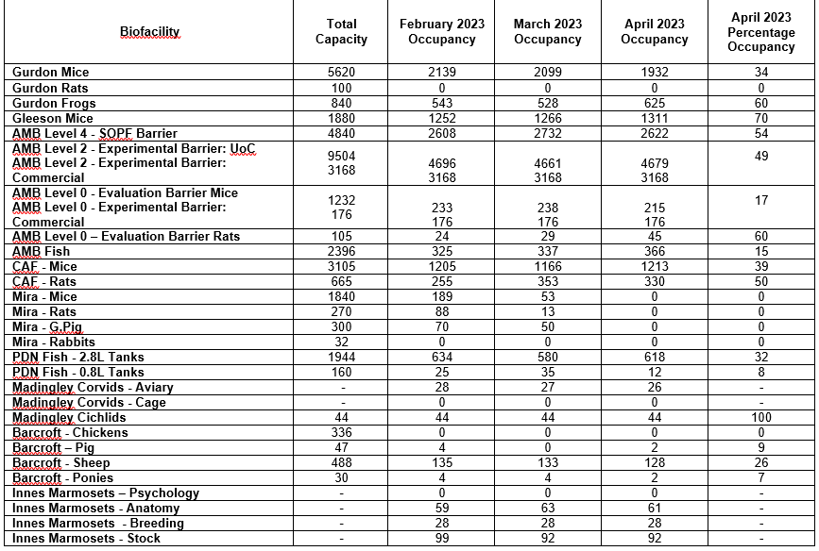

AOB:

Dates of future meetings
Date | Time
Monday 25th September | 11.00 – 13.00

