 | Minutes
 | Minutes

University Biomedical Services Facilities Operations and Management Committee

Monday 7th June 2021 at 10.00am, Zoom Meeting

Present: Sue Ozanne (Chair), Bill Colledge, Jenny Nichols, Sam Jameson, Alan Graham, Claire Buckley, Howard Baylis, Keith Savill, Karl Wilson, Maggie Gentry, Elisabeth Busch-Nentwich, Kevin Mulvihill, David Belin, Sarah Howlett, Hannah Clarke, Chloe Hodgkisson (minutes)

Apologies: Dino Guissani, Pietro Mastroeni, Martin Vinnell

Action points from the previous minutes;

Minutes from the last meeting on 25th January 2021 were discussed and 1 item was amended.
- The leak damage at the Innes facility has not yet been fixed. Once the damage has been fixed it will be re-decorated over the summer.

- Matters Arising

Welcome to Claire Buckley who will be covering for Milka Sarris during maternity leave.
Welcome to Maggie Gentry in her new role as UBS Director for Governance and Welfare.

The AMB frequently asked question sheet is being updated and will be circulated to Users. SEO and Sarah Howlett will review the sheet before it is distributed. Committee agreed it should be uploaded to the UBS website and circulated by email to all current AMB users.

Action: KS to arrange circulation to AMB users once update is complete

No date has yet been confirmed for the next UBS Briefing. The committee agreed it is useful to have the briefings to allow effective communication between UBS and the Users. It was decided to reduce the Briefing to 30 minutes.

Action: KS/KW to agree date for UBS briefing at the end of September 2021 and ensure all PIL and PPL holders are sent the invitation link.

MCMS working group is yet to be organised by UBS but KW reported that Mary Ann Haskings was arranging individual training sessions on request.

- Chairs Report – Sue Ozanne

The last UBSGS meeting in February was cancelled.

- Financial Report – Karl Wilson

The Committee discussed the finance data for the 20/21 financial year.

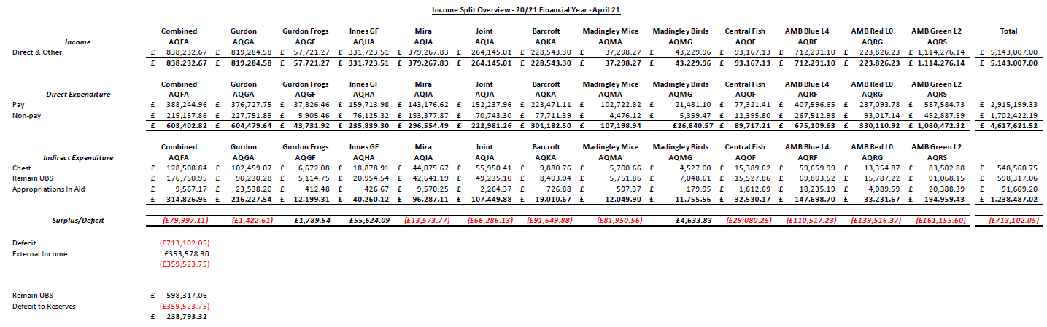

Overall UBS are in a good position going forward despite the impact of the pandemic.

- Staffing Report – Keith Savill

UBS Currently has 7 vacancies, - all Junior Technician and Supervisory Technician posts.
Currently filling a maternity cover Department Manager role.
There have been 16 new starters across the department since the last meeting in February.
UBS currently has 168 employees.
The turnover rate is low.
There is only 1 agency staff member at the moment.

- Capital Projects Report – Keith Savill

The noise issues in the Jeffery Chea building have not been resolved. This is an ED project and they are currently looking into the mitigation of the noise levels with the main contractors and consultants. Currently there is no indication at present as to when this will be resolved.

Aquatics continue to experience an issue with humidity. Estates are due to investigate and report back to UBS. As with the above, ED are currently working to resolve the issues with RH in this area, we have not yet been given a timescale for its resolution.

- Requests for New Space/New Needs (from existing and/or new users) – Keith Savill/Karl Wilson

Nothing to report.

- Establishment Licence Holder Report – Maggie Gentry

The Home Office are looking at a program of change, this will involve major changes over the summer. There are several Home Office meetings with the Establishment Licence holders, Home Office Liaison Contacts and other groups taking place to discuss the changes.

There have been 6 non-compliance incidents since the last meeting.
There have been 52 condition 18 reports. These continue to be for similar reasons such as, weight loss and anesthetic deaths.
UBS currently has 99 PPL’s new or currently being amended.
There are 879 Personal licenses. 72 are going through the PIL review process.
Since the last meeting, UBS have had 5 standing AWERB Committees, 5 Sub-Standing Committees and 3 Extra AWERB Committees.
To try to speed up systems where possible, UBS are in the process of trialing Virtual AWERB assessments and have completed 2 in the last 2 weeks for minor amendments. It is challenging to get replies and comments within the 48 hour time frame, however the process will hopefully be quicker that arranging additional AWERB meetings. The large numbers of PPLs currently in the system means that UBS are taking bookings for the September AWERB meetings.
Non-regulated procedures will now be signed off at Unit level to enable Users to start work quicker rather than waiting for approval from AWERB.

The committee gave thanks to MG for the extra work and efforts being made to accelerate the project Licence application process for Users. There are good routes of communication during this process and the committee re-iterated their willingness to work and discuss with MG to streamline systems for both users and the UBS team

- Substantive User Issues

IT Issues: KS and SEO are experiencing IT issues relating to the UBS User minutes on the UBS website. This is being looked into and a call has been logged with IT to seek further advice.
The University is planning to change and upgrade all internal websites over the next few month and there
will be a transition period to the new UBS website.

Genotyping: AMB is exploring the possibility of doing genotyping in-house for a better use of money and time. KW is looked at a business model for this.

Study Plans/MCMS: The committee discussed study plan templates and potential of having standardized SOPs for common procedures rather than different users having to generate new ones. This would minimize work both for users and the NACWOs. KW reported that UBS are in the process of moving training modules and SOPs into MCMS.
The Committee thanked Mary-Ann Haskings for doing a brilliant job and working really hard to address all
issues and queries raised relating to MCMS. All User feedback in relation to their interactions with MaryAnn
has been very positive.

Aquatics Facilities: There are on-going discussions regarding the Aquatics facilities plan. It has been agreed the PDN facility needs to stay open and Users input is being sought for cost saving ideas. Some costs have been saved by not opening the Fish unit in the JCBC facility.
Committee discussed the increasing costs for Users and the potential reputation risk to the University when costs change mid-grant meaning scientific objectives can no longer be achieved within the awarded budget. BC has written to KW asking him to raise this issue at UBSG.
Action: KW to raise concerns at the next UBSG meeting

Prices: KW informed the Committee that the costing on X5 is not up to date and therefore is required to be manually adjusted. X5 is due to be updated over the summer.
Action – KW to circulate the document containing the correct prices to all PPL holders and departmental administrators.

- Summary Occupancy Figures – Keith Savill

Biofacility | Total Capacity | February 2021 Occupancy | March 2021 Occupancy | April 2021 Occupancy | April 2021 Percentage Occupancy
Gurdon Mice | 5620 | 1877 | 1849 | 1797 | 32
Gurdon Rats | 100 | 0 | 0 | 0 | 0
Gurdon Frogs | 840 | 450 | 425 | 420 | 40
Gleeson Mice | 1880 | 350 | 570 | 766 | 41
AMB Level 4 - SOPF Barrier | 4840 | 2918 | 2856 | 2942 | 61
AMB Level 2 - Experimental Barrier | 4500 | 2953 | 3220 | 3312 | 74
AMB Level 0 - Evaluation Barrier Mice | 1760 | 380 | 322 | 287 | 16
AMB Level 0 – Evaluation Barrier Rats | 60 | 24 | 22 | 25 | 42
AMB Fish | 2396 | 390 | 502 | 387 | 16
CAF - Mice | 3105 | 1500 | 1420 | 1433 | 46
CAF - Rats | 665 | 94 | 106 | 97 | 15
JAF Anatomy - Rodent | 1100 | 187 | 198 | 189 | 17
Mira - Mice | 1840 | 680 | 590 | 612 | 33
Mira - Rats | 270 | 192 | 196 | 184 | 68
Mira - G.Pig | 300 | 48 | 48 | 48 | 16
PDN Fish - 2.8L Tanks | 1944 | 824 | 806 | 777 | 40
PDN Fish - 0.8L Tanks | 160 | 31 | 34 | 35 | 22
Madingley Corvids - Aviary | - | 35 | 35 | 35 | -
Madingley Corvids - Cage | - | 0 | 0 | 0 | -
Madingley Cichlids | 42 | 37 | 39 | 39 | 93
Madingley – Rodent | 200 | 0 | 0 | 0 | 0
Barcroft - Chickens | 336 | 76 | 74 | 71 | 21
Barcroft – Pig | 47 | 3 | 3 | 2 | 4
Barcroft - Sheep | 488 | 146 | 144 | 138 | 28
Innes Marmosets – Psychology | - | 6 | 2 | 2 | -
Innes Marmosets - Anatomy | - | 37 | 36 | 41 | -
Innes Marmosets - Breeding | - | 34 | 34 | 32 | -
Innes Marmosets - Stock | - | 114 | 114 | 109 | -

The figures have been fairly static across all facilities. KS confirmed that total capacity on AMB level 2 would increase now that the testing facility has moved out of the building.

The committee discussed the migration of the rodents from the Joint facility into the CAF over the next 12 months. CAF have plenty of spare capacity to absorb this increase in occupancy. UBS will be writing to users of the Joint facility informing them of this plan.

- AOB

The UBS User minutes and AWERB Committee minutes are available on the UBS website.

This is the last meeting that Jenny Nichols will be attending, the committee thanked Jenny for her contribution to the FOM committee and AWERB.

Date of Future Meetings

Date | Time | Venue
Monday 27th September | 2pm – 4pm | Tbc

