 | Minutes
 | Minutes

University Biomedical Services Facilities Operations and Management Committee

Wednesday 30th September 2020 at 10.00am

Present: Sue Ozanne (Chair), Bill Colledge, Sarah Howlett, Jenny Nichols, Alan Graham, Angeleen Flemming, Howard Baylis, Keith Savill, Karl Wilson, Anne-Marie Farmer, Maggie Gentry, David Williamson, Elisabeth Busch-Nentwich, Hannah Clark, David Belin, Chloe Hodgkisson (minutes)

Apologies: Pietro Mastroeni, Martin Vinnell, Sam Jameson

Action points from the previous minutes;

Minutes from the last meeting on 5th August were approved and will sent to the UBSGS Committee meeting on 28th October.

- Matters arising

The AMB contact list has now been sent to all Users.
KS is working on the AMB FAQ sheet with Kate Tansley and Sally Thomas, there are a few amendments to be made and then it will be circulated.

As requested the rats and mice data will be separated on the next Occupancy data spreadsheet for all facilities.

No more reported issues with accessing the UBS website.

The first UBS Forum is scheduled for 3rd November at 10.30am, on MS Teams. Keith and Karl are finalizing the format. The forum is for anyone who is a University Home Office licence holder. Users will be asked to submit their questions. More details to be circulated prior to the event and a hold the date e-mail will be circulated.

Action point: KW and KS to finalize format and disseminate date to users

The AMB User committee and structure has now been resolved. Sarah Howlett kindly volunteered to be the Chair. It is requested that that only 1 representative from each group should attend User committees.

The space query in the Fish facility is unresolvable there is no separate area for the NACWO and staff.

Action point – KW liaising with Mary-Anne Haskings regarding plans to create the MCMS working group.

- Financial Report – Karl Wilson

- Financial Report – Karl Wilson
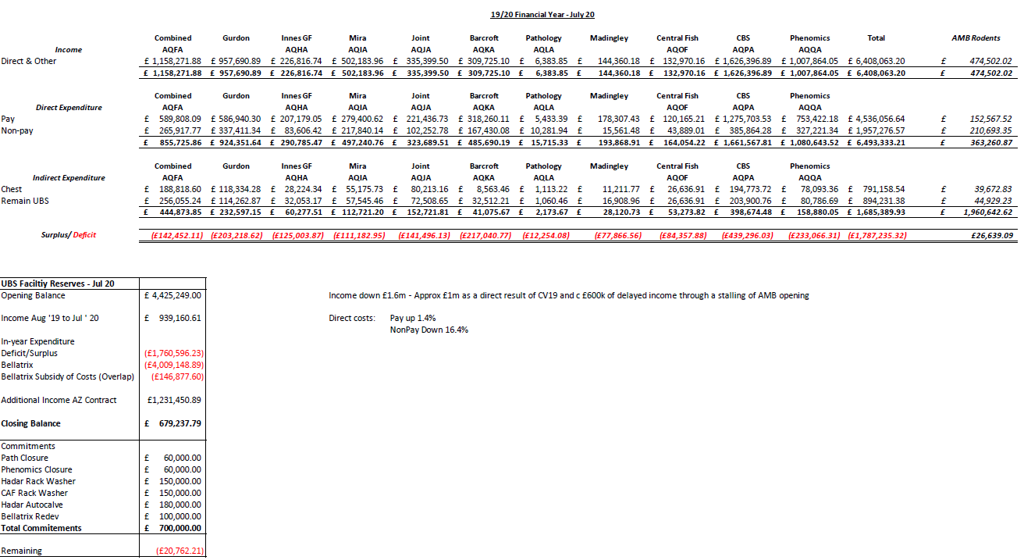

The committee discussed the financial report from July 2020.
Karl outlined that there has been a delay in ramping up activity in the AMB, this is still having an impact on income.
AstraZeneca are continuing to pay for space in AMB which provided approximately £1.2 million of additional income this year. This has helped offset some of the deficit that arose due to the lockdown.

- Staffing Report – Keith Savill

No final staffing report available at the time of the meeting so will be circulated after the meeting and added to the minutes as a post meeting note.
Recruitment is currently on hold apart from internal applicants

KS was confident that current staff and agency staff with the relevant expertise could cover predicted staff sickness/isolation arising due to COVID-19. It was highlighted that there were specific requirements in some facilities (e.g. people working in the Innes facility must have a vaccine for measles) and that it was therefore important to have to date records regarding such requirements and which members of staff were therefore able to work in which facility as part of contingency planning.
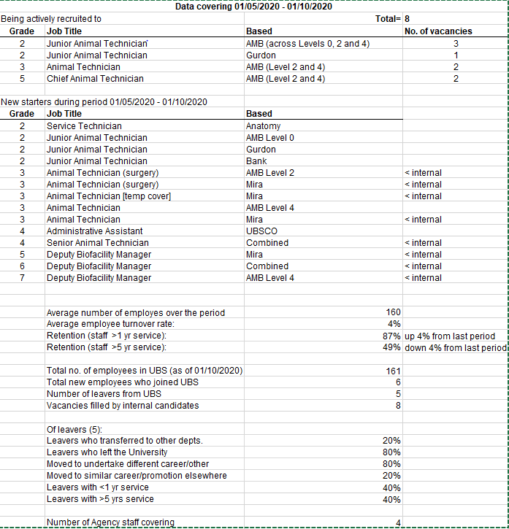
Post meeting note:

- Capital Projects Report – Keith Savill
- Jeffrey Chea Biomedical Centre

The aquatic and rodent areas have yet to be handed over to UBS and until this point we are unable to install any equipment.

Post – meeting note – Progress report rom Estate Division - we are awaiting a change in the filters of the AHU and a re-sizing of the VAV boxes which should hopefully lower the pressure through the ventilation system which the engineers believe is causing the noise issue. Once this is resolved handover of the space will be considered.

- Requests for New Space/New Needs (from existing and/or new users) – Keith Savill/Karl Wilson

There are new Users interested in MIRA

UBS were approached by a company to use space in the Gleeson basement following refurbishment, this
will provide a solid income to open it and give additional future space. Discussions are on-going.

- Establishment Licence Holder Report – Anne-Marie Farmer

User Committees
Researchers were asked to feedback their thoughts regarding Biofacility User meetings going forward. This will include how they are organised and ideas of how to improve attendance at those that have routinely poor attendance.

It was agreed it is important to have the User meetings to share information and give people the chance to
ask questions and for two-way discussions between users and UBS. User committee chairs reported that this was more difficult in a virtual format and generally people were not asking and discussing as much as they would in an in-person meeting. There was some comment that the layout of the agenda could be better.

The Researchers tab is now on the UBS website. There is a question/comment box to contact UBS. SEO asked that any documents added to the website are dated.

Action point – User Committee minutes to be added to the Research area on the UBS Website.

Lessons Learned from COVID-19
The AWERB review of lessons learned from Covid-19 experience will be discussed at the AWERB Operations Committee in October and AWERB Standing Committee in November. The draft review document had been circulated to user committee chairs and A-MF asked for researcher feedback as soon as possible. The Home Office will not inspect this review but will look at documents in relation to Covid and the subsequent lockdown.

The Committee agreed the importance of a plan in place if there is another lockdown and asked that a written document was put in place. It was generally agreed that it is essential to have a UBS wide policy that should be the same across all biofacilities.
It was confirmed that animal staff are considered essential and key workers.

Action point: users to provide feedback on AWERB review document and UBS to prepare contingency planning document

Non-Compliance
There are 3 non-compliances under consideration, the first is due to the PPL holder going over the number of animals permitted to be used, some had near misses due to not understanding how to count animals. AMF is working on a document advising how this can be prevented in future which will be available on the UBS website.
The second is due to a lighting control being set incorrectly following the room being handed back after
being repurposed.
The final one raised was due to a sheep having fractured leg after surgery.

Summary of Project Licenses
There are currently 191 licenses on the UBS worksheet
29 are being amended
61 are new licenses going through the drafting process
88 are dormant

Summary of Personal Licenses:
In 2019 UBS Admin brought the whole PIL process centrally via the Admin Office at Greenwich House
UBS have moved everything onto the central spreadsheet and are writing all the SOPs
TL and MG are currently working through 155 PIL reviews.
Sending thanks to Toni Lund and Chloe Hodgkisson for their help with all these changes it has been a
huge amount of work.

Training Centre update
The HO training, IAT course and Assessors training are all moving online in light of COVID-19
Thanks were conveyed to AMB and MIRA staff for helping out with the invigilating of these courses before
Greenwich House was functional.
The training team are in the process of going through the backlog of exams that did not go ahead during
lockdown. The committee thanked UBS Training Centre Team for all their hard work.

AWERB
The AWERB committee sends thanks to the 12 researchers that sit on the AWERB committee. In addition there are 8 core scientists a rota and 26 specialist scientists coming and giving advice at committees. This is an enormous commitment to AWERB

UBS have a temporary staff member covering maternity leave and working on project Licences. User committee chairs were asked to remind researchers asked to cc AMF, MG, CH and HO Licensing into project Licence emails

- Substantial User matters

All the User minutes are now available on the UBS website.

AMB numbers are going up consistently each month and thanks were sent to Kate Tansley and Sally Thomas for being able to get work running again.
AstraZeneca have 3 animal holding rooms on level 2 of AMB and 4 rooms are still assigned to the testing facility. AstraZeneca are about to start animal work in AMB which will increase the number of individuals requiring access to AMB. This was raised as a concern as the level 2 changing rooms are relatively small and already busy (and queues for access reported) with the large number testing staff coming into AMB.

Action point: KS/KW to advise researchers of shift start and end times of testing staff (new times are: 6am shift start, change over at 3 – 3.30pm and midnight when second shift ends) and UBS Technicians (start at 8am and finish at 4pm) so they can avoid busy times if possible.

Researchers requested clarity in relation to overseas work being checked by AWERB. A-MF explained the new process was introduced in February 2020 and that the AWERB checks are light touch and in place in case there is a Freedom of Information request. The University of Cambridge need to be aware of what collaborations are taking place. Researchers asked to review the overseas collaboration work documentation as they were concerned this was going to cause delays to research.

Action plan: A-MF to discuss concerns further with individual users

User committee chairs thanked the various UBS staff within facilities for their hard work and assistance in restarting working after the lockdown.

AF has been the chair of the Fish User meeting for 10 years so announced that she planned to step down from this role. SEO thanked AF for all her work in the FOM committee. A new chair and deputy chair for this committee were required.

Action – EBN, AF and KS to meet regarding the Chair and Deputy Chair for the Fish joint committee.

Concern raised at Innes regarding the piles of water cascading through the ceiling into offices. There is wall, book and paper damage. This is also a fire risk due to ceiling panels falling down and not being replaced.
Estates are aware of the problem but they have not done anything substantial to fix it.

Action – KW to raise the concern with the new Director of Estates.

- Summary Occupancy Figures – Keith Savill

UBS Biofacilities Occupancy Table – July 2020
Biofacility | Total Capacity | July 2020 Occupancy | August 2020 Occupancy | September 2020 Occupancy | September 2020 Percentage Occupancy
Gurdon Mice | 5620 | 1470 | 1629 | 1631 | 29
Gurdon Rats | 100 | 13 | 10 | 11 | 11
Gurdon Frogs | 840 | 441 | 436 | 428 | 41
AMB Level 4 - SOPF Barrier | 4840 | 2064 | 2342 | 2566 | 53
AMB Level 2 - Experimental Barrier | 2000 | 798 | 1169 | 1449 | 72
AMB Level 0 - Evaluation Barrier Mice | 1760 | 1243 | 1135 | 1134 | 64
AMB Level 0 – Evaluation Barrier Rats | 60 | 0 | 1 | 3 | 5
AMB Fish | 2396 | 544 | 702 | 451 | 19
CAF - Rodent | 3200 | 1731 | 1496 | 1520 | 48
JAF Anatomy - Rodent | 1100 | 100 | 129 | 130 | 12
Mira - Mice | 1840 | 612 | 590 | 620 | 34
Mira - Rats | 270 | 190 | 190 | 200 | 74
Mira - G.Pig | 300 | 0 | 0 | 0 | 0
PDN Fish - 2.8L Tanks | 1944 | 941 | 870 | 880 | 45
PDN Fish - 0.8L Tanks | 160 | 0 | 45 | 42 | 26
Madingley Corvids - Aviary | - | 37 | 35 | 35 | -
Madingley Corvids - Cage | - | 0 | 0 | 0 | -
Madingley Cichlids | 36 | 34 | 34 | 35 | 97
Madingley – Rodent | 200 | 0 | 0 | 0 | 0
Barcroft - Chickens | - | 60 | 152 | 133 | -
Barcroft – Pig | - | 5 | 0 | 0 | -
Barcroft - Sheep | - | 132 | 184 | 206 | -
Innes Marmosets – Psychology | - | 4 | 4 | 4 | -
Innes Marmosets - Anatomy | - | 29 | 25 | 27 | -
Innes Marmosets - Breeding | - | 40 | 34 | 34 | -
Innes Marmosets - Stock | - | 113 | 117 | 117 | -

Request to provide month by month Barcroft occupancy figures.
Action – KS to speak to Matt Nolan and create a working group to work out calculations of occupancy at the Barcroft on a monthly basis.

The Combined facility numbers have plateaued. Gemini Chu has been working hard to allow everyone access. The allocation of space set up in June is working well.

SEO thanked all user chairs for all their efforts during a very challenging time and helping maintaining communication between users and UBS during lockdown.

Date of Future Meetings

Date | Time | Venue
Monday 25th January | 10am – 12pm | Virtual Meeting
Monday 7th June | 11am – 1pm | Tbc
Monday 27th September | 2pm – 4pm | Tbc

