 | Minutes
 | Minutes

University Biomedical Services Facilities Operations and Management Committee

Monday 27th September 2021 at 2pm, on MS Teams

Present: Sue Ozanne (Chair), Bill Colledge, Dino Guissani, Claire Buckley, Kevin Mulvihill, Howard Baylis, Keith Savill, Karl Wilson, Maggie Gentry, Kate Tansley, Debs Flack, Kevin Mulvihill, Munise Merteroglu, David Belin, Sarah Howlett, Chloe Hodgkisson (minutes)

Apologies: Pietro Mastroeni, Martin Vinnell, Sam Jameson, Elisabeth Busch-Nentwich, Hannah Clarke,

Action points from the previous minutes;

Minutes from the last meeting on 7th June 2021 were agreed. Actions discussed and updates provided.

- Matters Arising
Action: KS to check with Sally Thomas if the AMB User FAQ and contact information document has been circulated by e-mail to users. The most recent information is available on the UBS website.

The last UBS User Briefing was held on Friday 24th September 2021There were many more attendees than last term. The briefings will continue on a termly basis. The next one is scheduled for 21st January 2022 at 10am on MS Teams invites will be sent out soon. All User groups are encouraged to attend.

Action: Date of next briefing to be circulated to all PIL and PPL holders and disseminated at next user committee meetings

The noise and humidity issues in Aquatics area of the Jeffery Chea building are still ongoing. The Capella project board have agreed to pay towards resolving the humidity issues. There currently is no timeframe available to resolve this.

Discussions regarding an in-house genotyping service are taking place. Alan Bradley is piloting it, which will then be open to other users and with a view it will become self-sufficient.

All training records are being incorporated into MCMS. There will be drop-in sessions for anyone that has questions regarding MCMS.

X5 was updated with the new costings in July 2021 and this information was circulated to all Users with their monthly bill.

- Chairs Report – Sue Ozanne
The last UBSGS Meeting was on 28th July 2021. There were 5 main items to report on from the meeting:

1. The Joint Animal Facility will close by the end of 2022 (date agreed by UBSG). This has been discussed with the appropriate Users. Discussions with users are being held regarding work moving to CAF. The importance of early communication between UBS and the Users regarding planned changes to facilities was reiterated. BC raised concern regarding the disruption to CAF Users and the impact that it would have on the amount of space available at CAF and recruitment to new lectureship posts to be advertised within the school of biological sciences shortly.

2. The avian work at Madingley is due to finish in summer 2022. The planned future usage is not enough to keep the facility going therefore there are plans to close the facility in 2022. The remaining Cichlid work will be moved to an alternative facility and UBS are in discussions with users.

3. As of October 2022, UBS will have ownership of MCMS. There are ongoing discussions regarding standardising Study Plans and SOP’s and their use within MCMS (see further discussion at later agenda item).

4. Aquatics facilities need to be maintained on the Downing site. The rate for fish has increased from £2.77 to £4.66 per tank. All details are now on X5 for new grants. Existing grants will be honored at their previous rate with inflation.

5. There is an HSE visit planned for December 2021. All users of GM animals are reminded to ensure their GM risk assessment forms are up to date and reviewed. 3 facilities will be visited; AMB Level 2, Aquatics level 0 and Gurdon Institute.

- Financial Report – Karl Wilson
The Committee discussed the finance data for the 20/21 financial year.
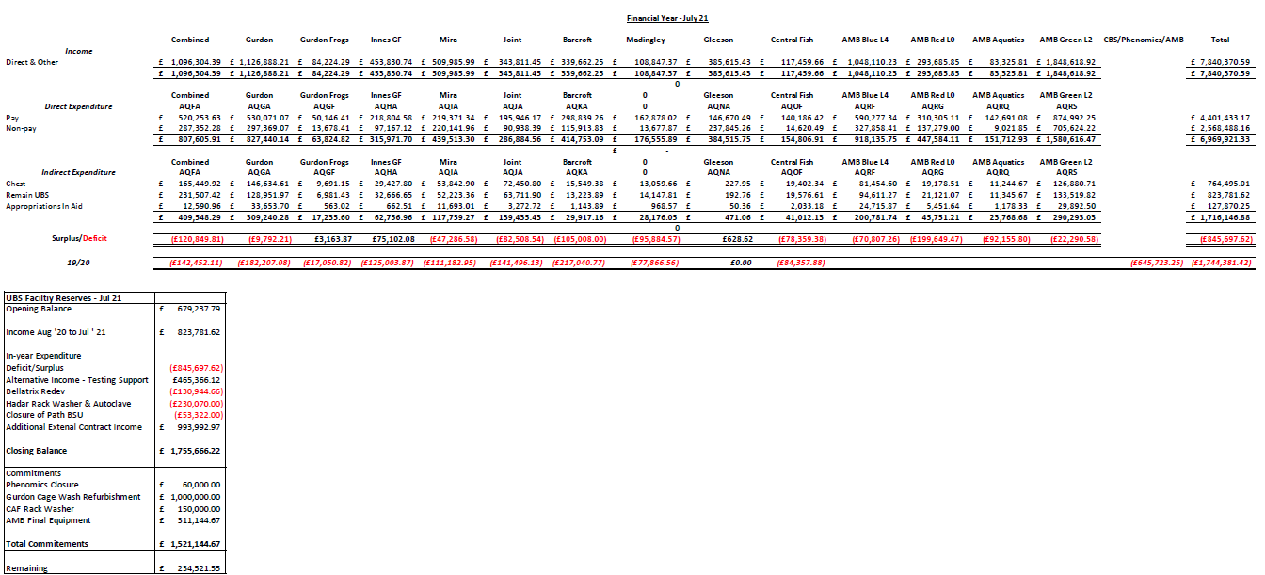

UBS are still seeing the effects of COVID but the income is slowly recovering over time.
The Gurdon unit have seen a significant improvement in their cost recovery, KW thanked Polly Attlesey for focusing on this.
The Gleeson basement facility is now occupied by commercial users and MRC Toxicology since March 2021, this has helped it to break even.
The Gurdon cage wash area is in need of refurbishment. New autoclaves and rackwasher are due to be replaced, the tender is underway, estimated installation late spring 2022.
The income from AZ in the current financial year will be similar to that of last year.

- Staffing Report – Keith Savill
UBS currently has 167 members of staff.
There are 22 vacancies being recruited to.
UBS have had 24 new starters since the last meeting in July, 12 of which have been filled internally.
The staff turnover is 6%.
There are currently 4 agency staff.

- Capital Projects Report – Keith Savill
No additional items for discussion.

- Requests for New Space/New Needs (from existing and/or new users) – Keith Savill/Karl Wilson
Nothing to report.

- Establishment Licence Holder Report – Maggie Gentry
PPLs:
Total live licences, new licences in draft and amendments on the UBS list | Approximately 240
New applications and amendments active in the system | 78
PILs:
There are 887 PILs registered at the University of which 130 are overdue review

AWERB (11th June to 27th September 2021)
Number of AWERB Sub-standing meetings | 4 includes additional ones added
Number of AWERB Standing | 5 includes additional ones added
Number of virtual AWERB meetings | 5 – used for minor and urgent amendments
UBS contacted all PPL holders and asked for help with AWERB meetings. There has been a good response. AWERB are in need of more lay members.

Action: Committee members to let Maggie know if they have suggestions of additional members (especially lay members)

Potential Non-Compliance- Total 5 cases
26/02/21 mouse not having access to water overnight- No further information from the HO received to date
31/03/21 3 pregnant ewe sheep left without food or water overnight. Inspector advice letter received 07/09/21.
23/05/21-AMB Level 2 cold cabinet check not completed– Letter from the HO on the 24/09/2021 Further advice given and no further action
26/05/21- Sheep leg fracture, sham incident 2- HO investigation complete, closure letter received 21/09/21
04/06/21- Mice given High Salt Diet, between “strain” name and “prefix” name, from a terminology merge between the Sanger MCMS database and the UoC MCMS database- Further information provided to the HO 15/09/21

SC18- Total 51 cases:
Commonalities and repeated events:
- Tamoxifen i/p injection
- Irradiation
- Anaesthetic deaths
- Restraint deaths
- immunisation protocol
- COVID-19 vaccination deaths
- head tilt, optical fiber implantation in the brain stem

There is an NVS going on secondment and another going on maternity leave at the end 2021. There will be agency cover and UBS are advertising for an NVS and Trainee NVS.
Sophie Wildman is the new NIO. Debs Flack will move over to Licence Manager along with Kate Tansley. Selina Ballantyne will be joining the team part-time also as Licence Manager.
UBS are working hard to process licences quickly.
UBS Central Office are working in a blended way, some work at home and some in the office. Please contact the team by email and they will arrange a time to call or arrange a Teams meeting.

- Substantive User Issues
All User meeting minutes are on the UBS website and committee were asked to check that they had access to the documentation.

The Committee agreed that both Users and staff need to be made aware regarding any changing arrangements for PPE and social distancing in the Facilities. DB raised the issue that access to holding rooms was still limited to users within the Combined Facility. There are ongoing discussions taking place regarding Covid guidance and restrictions in place within UBS and (as with other departments within the University), there is a need to review and update policies frequently in response to changing University and National Guidance.
Action – David Belin to discuss with Gemini Chu regarding access to the CAF facility, especially access to holding rooms by users.

John Dalton is currently carrying out a review of the Barcroft Centre as Academic Usage is reducing. He will generate a report with potential options for sustainability, including commercial usage and use as a pre-clinical science unit. As part of this review, the Heads of the Clinical School and Biological Sciences will visit the Barcroft on 18th October.,
A continuing theme across all User meetings is Study plans and SOP’s. Users want to share templates instead of having to re-write each time. The existence of approved SOPs for common procedures would also reduce the burden on UBS staff within facilities who approve study plans. The committee recognized the large number of study plans being processed by the units and supported anyway that the process could be streamlined for both users and UBS staff. This would help prevent delays that a number of user

committees report their users are still experiencing with the study plan approval process. UBS will look at what can be done to improve process.

Action: UBS to follow up on standardizing SOPs

MG reported that the UBS Licencing team are already working towards standardsing procedure documentation, to streamline the process through AWERB. These can then be copied and pasted into the Licence where appropriate.

The committee discussed the potential disruption to the animals at AMB caused by the work on the new proposed train station, it is anticipated that the construction will require some mitigation to reduce noise and vibration to an acceptable level.

Action: KS/KW to follow up regarding mitigations planned to minimize effects of the construction

- Summary Occupancy Figures – Keith Savill

Biofacility | Total Capacity | May 2021 Occupancy | June 2021 Occupancy | July 2021 Occupancy | August 2021 Occupancy | Aug 2021 Percentage Occupancy
Gurdon Mice | 5620 | 1796 | 1882 | 1904 | 1914 | 34
Gurdon Rats | 100 | 0 | 0 | 0 | 0 | 0
Gurdon Frogs | 1050 | 522 | 600 | 650 | 700 | 67
Gleeson Mice | 1880 | 870 | 931 | 902 | 951 | 51
AMB Level 4 - SOPF Barrier | 4840 | 2967 | 3079 | 3129 | 3114 | 64
AMB Level 2 - Experimental Barrier | 4500 | 3397 | 3747 | 3693 | 3812 | 85
AMB Level 0 - Evaluation Barrier Mice | 1760 | 354 | 361 | 320 | 301 | 17
AMB Level 0 – Evaluation Barrier Rats | 60 | 34 | 33 | 29 | 24 | 40
AMB Fish | 2396 | 389 | 386 | 392 | 401 | 17
CAF - Mice | 3105 | 1330 | 1298 | 1322 | 1315 | 42
CAF - Rats | 665 | 110 | 81 | 80 | 60 | 9
JAF Anatomy - Rodent | 1100 | 220 | 201 | 204 | 211 | 19
Mira - Mice | 1840 | 560 | 520 | 460 | 380 | 21
Mira - Rats | 270 | 182 | 160 | 152 | 168 | 62
Mira - G.Pig | 300 | 48 | 68 | 68 | 68 | 23
PDN Fish - 2.8L Tanks | 1944 | 762 | 708 | 706 | 676 | 35
PDN Fish - 0.8L Tanks | 168 | 19 | 20 | 16 | 19 | 11
Madingley Corvids - Aviary | - | 35 | 35 | 34 | 33 | -
Madingley Corvids - Cage | - | 0 | 0 | 0 | 0 | -
Madingley Cichlids | 42 | 39 | 40 | 40 | 40 | 95
Madingley – Rodent | 200 | 0 | 0 | 12 | 49 | 45
Barcroft - Chickens | 336 | 47 | 45 | 43 | 17 | 5
Barcroft – Pig | 47 | 4 | 6 | 4 | 0 | 0
Barcroft - Sheep | 488 | 126 | 114 | 106 | 89 | 18
Innes Marmosets – Psychology | - | 6 | 6 | 6 | 6 | -
Innes Marmosets - Anatomy | - | 41 | 42 | 45 | 49 | -
Innes Marmosets - Breeding | - | 30 | 30 | 28 | 27 | -
Innes Marmosets - Stock | - | 103 | 103 | 103 | 96 | -

The majority of facilities are fairly static.
The occupancy in CAF is low compared to pre pandemic levels.
AMB level 2 is increasing its maximum occupancy as a result in the increase in holding space freed up since the covid testing facility departure.

Action: KS to update occupancy sheet with information on AMB level 2 maximum capacity with separate information on cages held by Astra Zeneca.

- AOB
No further items for discussion

Date of Future Meetings
Date | Time | Venue
Monday 24th January 2022 | 10.30am – 12.30pm | MS Teams
Monday 6th June 2022 | 10.30am – 12.30pm | tbc
Monday 26th September 2022 | 10.30am – 12.30pm | tbc

