 | Minutes
 | Minutes

University Biomedical Services Facilities Operations and Management Committee

Monday 24th January 2022 at 10.30am, on MS Teams

Present: Sue Ozanne (Chair), Bill Colledge (WC), Claire Buckley (CB), Howard Baylis (HB), Keith Savill (KS), Karl Wilson (KW), Maggie Gentry (MG), Alan Graham (AG) Kate Tansley (KT), David Belin (DB), Sarah Howlett (SH), Pietro Mastroeni (PM), Martin Vinnell (MV), Sam Jameson (SJ), Hannah Clarke (HC), Milka Sarris (MS), Klaus Okkenhaug (KO) Kevin Takaki (KT) Chloe Hodgkisson (minutes)
Apologies: Dino Giussani,

Action points from the previous minutes;
Minutes from the last meeting on 27th September 2021 were agreed. Actions discussed and updates provided.

- Matters Arising
The HSE visit in December to facilities including AMB was postponed, however the visit will now take place 2-3rd March,

Maggie had received a good response from user to her request for additional members to join the AWERB. She was still looking for additional lay members for both the LAC and AWERB committees.
Action point: Users to let Maggie know if they have additional suggestions for lay members

A new risk assessment and new booking procedure has been set up in the CAF facility, giving ssers more access to holding rooms where necessary.

On 23rd January AMB received a new set of terms from Network rail regarding the mitigations for noise and vibration for the train station work at the Biomedical Campus. KW will provide updates to AMB Users.
KW thanked everyone who had replied to his e-mail regarding the potential impact on their work
Action point – KW to ensure to send updates out to the AMB User groups to keep them informed of progress.

- Chairs Report – Sue Ozanne
The next UBS briefing is scheduled for Friday 11th March at 11am on MS Teams, all PPL and PIL holders are invited. The briefing has been intentionally scheduled a few weeks after the next UBSGS meeting so that UBS can quickly disseminate information back to all Users.

SEO reminded the committee that the termly flow of meetings was User Committee meeting which fed into the the FOM committee meeting which then reported to the UBSGS committee. The scheduling of the UBS User briefing after the UBSG would therefore facilitate timely feedback from that meeting to users.

Report from October 2021 UBSG Meeting:

- In October 2021 the MCMS system transferred its ownership from the Sanger to the University.
- Concern regarding the impact on CAF Users of Users moving over from Anatomy was raised at the UBSGS meeting. UBSG highlighted the importance of all new Users/ new space needs being requested by completion of a space request form which should be submitted to KW and KS at the earliest opportunity.
Action – KW and KS to circulate the UBS space request form to all Users, Heads of Departments and check the item is listed on the school council meetings agenda.
- JCBC committee have agreed to fund the background and humidification works within the aquatics facility. There is no confirmed timeline for this work.
- There are discussions ongoing at AMB regarding re-locating the germ free facility users to a new area and moving AstraZeneca to the original Germ free area. The next step is User consultations. KW updated the committee that there have been some initials meetings, regarding immediate concerns and stage 1 reports to provide outlines and more detailed future planning. Stage 2 will be contacting specific people and start looking at individual needs. KW had no information yet on potential time frame. SEO and SH asked to be kept informed of the progress.
- KW will meet with HB regarding plans for future plans for work with Cichlids.

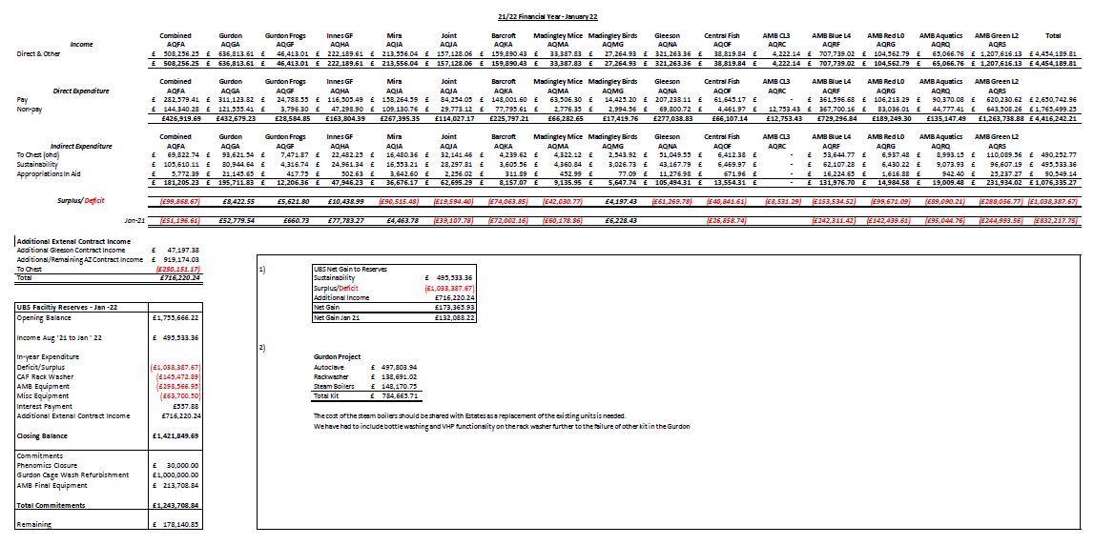
- Financial Report – Karl Wilson

Karl presented data in relation to the Feb 2022 cost review which he had calculated using the cost incurred and activity from August 2020 to July 2021. He also reminded the committee that due to the effect of Covid-19 lockdowns and subsequent reduction in work it was agreed for the Feb 2021 cost review that The University would adopt an inflationary increase rather than the 20% increase that the fEC cost model would have brought about.

Updated Pricing: Feb 22 (example)

Species | Feb-21 | Feb-22 | Increase
fEC - Mice: Standard Cage (3-5) | 10.86 | 12.78 | 117.68%
fEC - IVC Mice: Standard Cage (3-5) | 12.28 | 12.93 | 105.29%
fEC - Rats: Standard Cage (1-3) | 16.64 | 18.07 | 108.59%
Minimum - Mice: Standard Cage (3-5) | 5.99 | 7.87 | 131.39%
Minimum - IVC Mice: Standard Cage (3-5) | 7.86 | 9.33 | 118.70%
Minimum - Rats: Standard Cage (1-3) | 9.43 | 11.65 | 123.54%

Karl reported that this year an increase above inflation was necessary as UBS have already been quoted a real cost increase of c 10% in most major consumables items in 2022. In addition increases to labour costs and difficulty in recruiting means a potential increase of 4-5% in labour costs. He therefore proposed a 3.8 % increase which the committee discussed at length. Karl also reported that the Research office had again confirmed that updating of the X5 will be late again this year and not occur until April/May. The committee flagged this as a concern as it meant that grant submitted between now and then would be under-costed for animals
Overall thoughts were as follows:

- They appreciated that an above inflation rise of 3. 8 % was necessary and recognized that this would be necessary in all future grant applications
- They were concerned that a delay in updating of X5 would result in grants being under-costed.
- They were concerned as to the implications of the rise on existing grants which did not have such a price rise incorporated. Users would therefore not have sufficient funds to cover the work that they needed to do to meet their scientific objectives
- The users queried what happens with the commercial money (e,g, AstraZeneca) and how it comes back to Users.

Need confirm how this affects what has been awarded in existing grants.

Action – SEO to contact Anne Ferguson-Smith, Patrick Maxwell and Anna Philpott regarding updating X5 and to raise points identified by the committee at the next UBSG meeting

- Staffing Report – Keith Savill
UBS currently has 180 employees.
There have been 24 new starters since the last meeting in September, 19 of which are internal transfers.
There are currently 17 vacancies across the department.
15 leavers since the last meeting.
13% of leavers transferred to other facilities.
The staff turnover is 9% which has increased since the last meeting.
UBS currently has 3 agency staff
There was 1 death in service, Andy Durrant AMB Service technician with his funeral on 26th January.

- Capital Projects Report – KS reported that they were stil waiting for Estate Management to take ownership of the JCBC and complete the renovation..

- Requests for New Space/New Needs (from existing and/or new users) – Keith Savill/Karl Wilson
Nothing to report

- Establishment Licence Holder Report – Martin Vinnell and Maggie Gentry
HO change programme: the HO is going through a review of how it operates as a regulator.
This meant that the HO visits are changing. We are already starting to get feedback of what inspections will involve.
The HO audit will be looking at all procedures in place, especially SOP’s. It is thought that one focus of the HO would be water and food maintenance, looking at processes in place across all units to ensure that animals are never without water and food.
All the standard conditions on the PEL, Project Licence holders and Personal Licence holders will be looked at. There will be interviews with individuals, but UBS are unsure of when this will take place and who they will speak too. An email will be sent out to all Licence Holders to explain what the HO would like to discuss when an audit is requested. Any Licence Holders can contact MV and MG directly with any concerns.
Main

There were 4 non-compliance cases since the last meeting, 3 are ongoing, 1 closed.

It was confirmed that Licence drafts are submitted to a HO Inspector central pool and then allocated an inspector. This inspector will then stay with that particular licence until its completion.

- Substantive User Issues
The committee thanked Mary-Ann Haskings for being quick to deal with queries from the Licence holders and maintain regular contacts with all users.

There are plans to advertise for a new post funded from commercial money. This is to gain a 5 year roadmap for UBS. The new post will be speaking to Users and Schools to discuss future work and recruitment for the next 12 – 18 months for all UBS facilities.

Patrick Maxwell, Anne Ferguson-Smith, Anna Philpott and John Dalton. Visited the Barcroft in October 2021 to look at potential options for the site.

The committee asked if there was documentation that they could show their user groups to explain the management and decision making structure within UBS.
Action – KW/KS to email all users and clarify the communication structure of UBS, the meetings and committees that are in place, their purpose and confirm who can be contacted to make decisions at which stage.

- Summary Occupancy Figures – Keith Savill
Biofacility | Total Capacity | October 2021 Occupancy | November 2021 Occupancy | December 2021 Occupancy | December 2021 Percentage Occupancy
Gurdon Mice | 5620 | 1949 | 1977 | 2008 | 36
Gurdon Rats | 100 | 0 | 0 | 0 | 0
Gurdon Frogs | 840 | 547 | 547 | 547 | 52
Gleeson Mice | 1880 | 927 | 1036 | 999 | 53
AMB Level 4 - SOPF Barrier | 4840 | 3051 | 3196 | 3112 | 64
AMB Level 2 - Experimental Barrier | 12762*¹ | 7715 | 7650 | 7654 | 60
AMB Level 0 - Evaluation Barrier Mice | 1760 | 274 | 283 | 221 | 13
AMB Level 0 – Evaluation Barrier Rats | 60 | 40 | 43 | 33 | 55
AMB Fish | 2396 | 374 | 378 | 378 | 16
CAF - Mice | 3105 | 1327 | 1338 | 1330 | 43
CAF - Rats | 665 | 91 | 97 | 50 | 8
JAF Anatomy - Rodent | 1100 | 186 | 192 | 181 | 16
Mira - Mice | 1840 | 486 | 472 | 256 | 14
Mira - Rats | 270 | 172 | 132 | 79 | 29
Mira - G.Pig | 300 | 68 | 68 | 68 | 23
Mira - Rabbits | 32 | 0 | 15 | 15 | 47
PDN Fish - 2.8L Tanks | 1944 | 632 | 583 | 608 | 31
PDN Fish - 0.8L Tanks | 160 | 11 | 31 | 41 | 26
Madingley Corvids - Aviary | - | 33 | 32 | 32 | -
Madingley Corvids - Cage | - | 0 | 0 | 0 | 0
Madingley Cichlids | 42 | 40 | 42 | 42 | 100
Madingley – Rodent | 200 | 42 | 8 | 5 | 3
Barcroft - Chickens | 336 | 17 | 17 | 17 | 5
Barcroft – Pig | 47 | 1 | 0 | 0 | 0
Barcroft - Sheep | 488 | 116 | 158 | 152 | 31
Innes Marmosets – Psychology | - | 6 | 6 | 6 | -
Innes Marmosets - Anatomy | - | 56 | 57 | 57 | -
Innes Marmosets - Breeding | - | 29 | 31 | 30 | -
Innes Marmosets - Stock | - | 95 | 89 | 89 | -
*^{1 –} Increased capacity from July 2021 following the return of Testing Centre to animal holding rooms. Occupancy is reported encompassing 3,500 IVCs allocated to AZ.

Concerns relating to low occupancy in MIRA, Madingley and the Barcroft, UBS are actively working on these areas.
Plans to increase the low occupancy on level 0 of AMB

SEO asked if the AZ allocation could be separated and reported on a different line on the occupancy tables so that occupancy/spare capacity for University users was clear.
Action – KS to separate figures and show percentage of allocated AZ cages at AMB as a separate entity to University User Occupancy.

- AOB
The committee agree that at least the next meeting in June should remain virtual via Teams.

Date of Future Meetings
Date | Time | Venue
Monday 6th June 2022 | 10.30am – 12.30pm | tbc
Monday 26th September 2022 | 10.30am – 12.30pm | tbc

