Date: Thursday 19th September 2024
Time: 10:00am – 12pm
At: Virtual via MS Teams
Our Ref: Doc.UBS.FOM.19.09.24

University Biomedical Services Facilitates Operations and Management Committee

Present: Sue Ozanne (SO)(Chair), Martin Vinnell (MV), Keith Savill (KS), Karl Wilson (KW), David Belin (DB), Angela Roberts (AR), Kate Tansley (KT), Rahul Roychoudhuri (RR), Emilia Santos (ES), Sarah Howlett (SH), Maggie Gentry (MG), William Colledge (BC), Sam Jameson (SJ), Alan Graham (AG), Dino Guissani (DG), Ben Steventon (BS),

Apologies: Omar De Faria Junior,

- Matters Arising
From the meeting held on 18/06/24
Action point: KW to investigate having a recycling bin added to the laptop trolley and check if there is difficulty in having access to printing – Update -There have been no further reports of issues accessing the printers. KW is requesting some prototypes of the recycling bins to be sent to him based on drawings he has already seen.

Action point: RR to send the Gurdon user group survey template – Complete. This was supplied during the meeting. Action point: TMc to remove data from the form and add blank template to the end of the minutes.

Action point: KW to give an update on Estates and follow up on specified projects – Complete. David Robinson from Estates has been assisting with clearing the bag log of maintenance jobs with Equans. This arrangement is working well. The autoclaves in the Gurdon are now up and running. Work in the temperature-controlled room in AMB is progressing.

Action point: KW to ensure users are updated on automated watering system (AWS) and continue to pursue solutions – Complete. There are new valves being trialled with the AWS on L2 in AMB which has so far been successful and there has been reduction on reported incidents. KW is expecting a delivery of 300 new valves, and these will replace the existing ones. If the testing of the 300 valves is successful with weaners and difficult strains, there will be a delivery of 2000 valves per week. This will hopefully reduce AWS incidents.

Action point: -. MG – UBS Licencing are still looking for more AWERB members particularly Lay members. Ongoing.

Action Point: MG to send dates of FOM meeting by email – Complete. 2025 dates have been sent and calendar invites have been sent to the committee.

- Chairs Report:
There are no updates from the chair as the last UBSGS meeting was cancelled.

- Financial Report:
KW discussed the Year End Financial Report. An income line for subsidy is now being included on the report. SO asked if the financial situation at Mira was due to occupancy level. KW confirmed this was the reason. DG asked how the UBS subsidy is calculated. KW informed the committee that this is the money that is reinvested into UBS from external income. WC raised concerns about the deficit at the CAF that will in part because of the reduction in occupancy due to the rederivation programme and breeding occurring in other facilities. WC also raised concerns regarding the plans for the School of Biological Sciences estate and stressed that it is critical that the CAF is maintained and retained as an animal house. He there requested that the following be raised at UBSGS;
“It looks like the preferred option for development of the SBS Estate is going to be a city centre location subject to planning/finance committee and General Board approval. The concern that has been raised by many members of my department is that the CAF is labelled as a “development opportunity” in the initial planning. We have raised this issue at School Level and during the consultation stages for the Estate Planning.
Approximately 40% of the research groups in my department as well as groups in Psychology and Pharmacology rely on the CAF for sophisticated procedural and behavioural work that is not available anywhere else in the University. It is imperative that the CAF is maintained to support this research. I have been trying to get a reassurance on this from the SBS but have only been told that “if you need an animal house, then one will be provided” which does not inspire confidence or allow forward planning in the department for appointment of lecturers who will need this facility. “
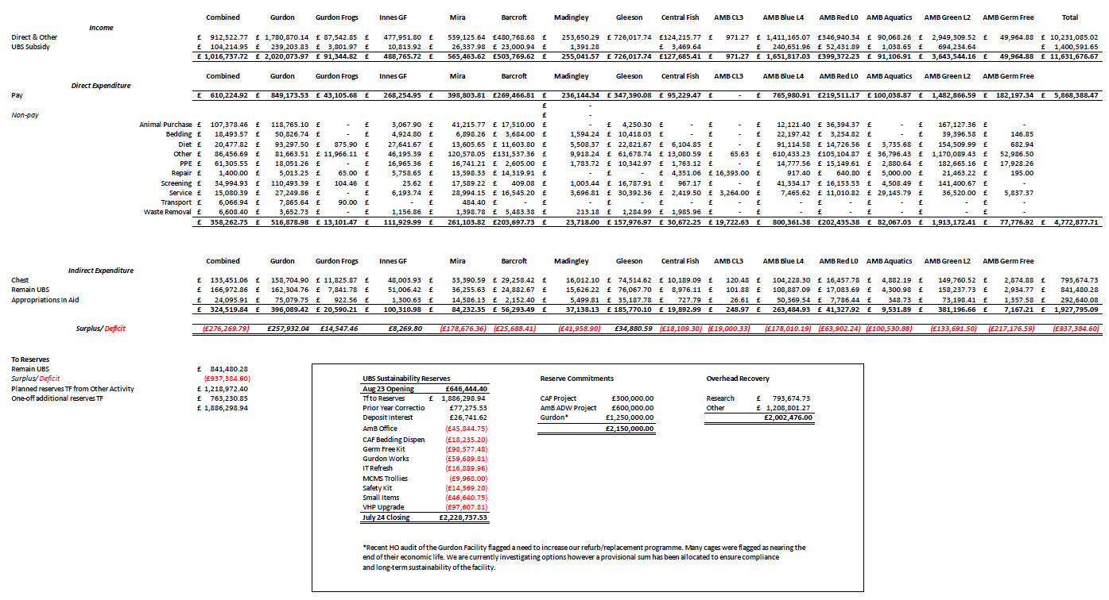
- Staffing Report:
KS discussed the staffing report.
Currently we have.
- 169 members of staff.
- 12 vacancies actively being recruited to. These include, animal technicians, service technicians, a deputy biofacility manager and two NVS.
- 11 new starters. This is a 7% turnover.
- 26 agency staff of which 12 are temp to perm positions.

KW informed the committee that UBS will be launching the junior programme in January 2025.

- Capital Projects Report:
There are currently no capital projects. The aquatics area in JCBC will soon be ready to have spaces designated. There is no update on the JCBC rodent areas.

- Requests for new space:
KS reported that there have not been any new requests for space. There has been an enquiry about using space on CL3 area in AMB for Tuberculosis work. This is going through thorough investigation due to the nature of the research.

- Establishment Licence Holder Report:
MV thanked everyone involved in the recent ASRU audit for their hard work. The task of collating all of the information was a huge job centrally. MV received a very impressive response. The committee thanked MG, KT and the rest of the team involved with this work.

- Governance and Welfare Report:

AWERB update since the last meeting.

Number of AWERB Standing Committees | 3
Number of Sub-Standing Committees | 2
Number of Antibody virtual Committees | 6
Number of Virtual Amendment committees | 5 Used for minor and urgent amendments, NSG some requested by the HO
Number of licences processed through AWERB | 31

Project licence activity as of

Total PPLs at the University | 158
PPLs currently being processed by UBS | 55
Amendments | 15
New applications | 40

Personal Licence activity as of
Total number active PILhs | 764
PIL reviews overdue | 0

Other Animal use as of 06/09/2024:
7 Non-regulated procedure requests have been approved since the last meeting and this new process continues to work well. The form will be reviewed on an annual basis and updated according.

Non-Compliance- Total 3 cases.
Three letters of Inspector Advice received.
- One letter was received by a PIL holder following the limits of the PPL being exceeded due to missed control measures.
- Two letters were received, one by a PPL holder and one by a PIL holder following a failure to act appropriately after discovering the limits of the PPL had been exceeded.

Root Cause Analysis (RCA)
RCA have covered problems such as:
- AM check failure: one case.
- Trapped mice: five cases.
- Missed welfare concern: one case.
- Water and/or diet not provided including dehydration cases: three cases.
- Incorrectly housed: three cases.
- Malocclusion: one case.
- Exceeded licence authority: three cases.

SC18- Total 71 cases for things such as
- Reactions to compounds
- Found dead (unknown causes)
- Procedural error
- Unexpected adverse effect
- Unexpected technical/environmental impacts

Other information:
The ASRU report was received 5th August with some feedback from the site visit held on 24th June. We have been working through their findings, some of which were room designation queries, appropriate signage and low-level concerns of untidy areas and rooms that require some maintenance. Major findings were breeding performance and pre weaning mortality rates at the CAF, inadequate colony management in the Gurdon facility and a designated room out of compliance at AMB due to a repair needed to the floor.
Our response to all the findings is being collated and will be sent back before the due date of 27th September.

- Substantive User Matters:
DG reported that there has been a positive improvement in communications at Barcroft since the new management team from Agenda have been in position. Enquiries have been made for space at the Barcroft from a new user. Scott Gentle recently retired from the University; he will be missed. NVS Michiel Plugge will not longer be the NVS for the Barcroft, Sophie Kimpton will now cover this.

SJ reported there has been minimal feedback from the users regarding the need to fill the vacancy left when SAT moved on to her new position. SJ had asked AMB users for feedback. He had received some positive feedback and constructive suggestions. SH reported she has only heard positive feedback. RR discussed the staff turnover at Gurdon. DB discussed issues around UBS staff changing cages. With current experiments DB and his team are changing the cages every week. UBS staff have not been doing this as the times this needs to be done falls at the same time at UBS staff tea breaks which they have refused to change. DB asked if he and his team continue to carry out the husbandry themselves can an alternative charge be discussed. KW said this is not possible and he is concerned about staff not changing cages due to tea breaks. Support received in the CAF has improved over the years as has communication between users and UBS staff.
Action point DB to email KW further details about cage change issues. KW to follow this up.

- Occupancy Figures:
KT requested that germ free L4 and L4 AZ to the report. KS said this is possible for germ free L4 but not for AZ.

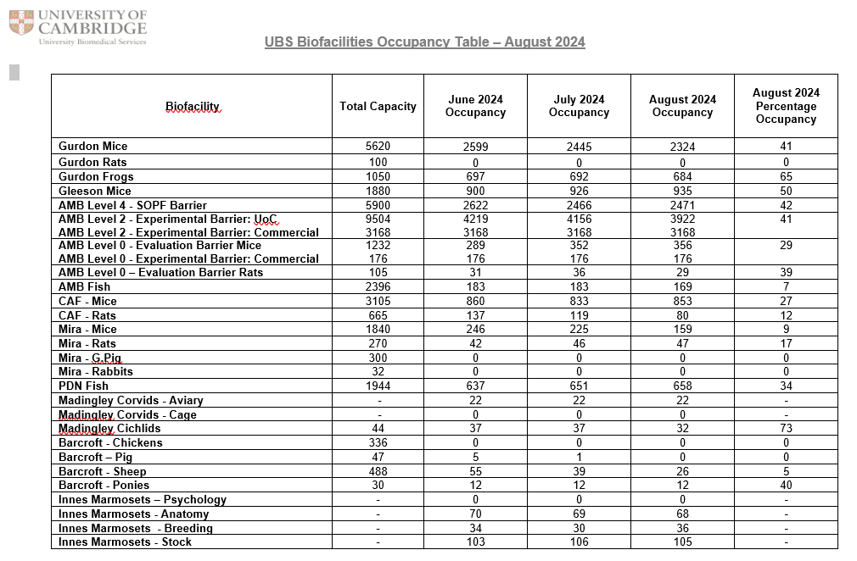

AOB: KW asked that if anyone has any issues please do not wait for a meeting or a survey to be shared. Please discuss this with the appropriate people as soon as you are able.

Dates of future meetings.
Date | Time
4th March 2025 | 10am – 12pm
13th June 2025 | 10am – 12pm
25th November 2025 | 10am – 12pm

