Update of transporting and ordering of mice
November 2023
Fighting
Was the original concern earlier in the year, leading to advice being circulated regarding tips on how to order to reduce fighting in transit.
General overview - AZ Summary:
August | Sept | Oct | Dec
Balb c delivery arrived with tail wounds (CR) | Extra mouse received (CR) | Crate of mice delivered with no hydrogel (JAX) | Wrong strain sent (Balbc instead of C57BL6) (Envigo)
Crate of mice delivered with no hydrogel (JAX) | Mouse received with malocclusion and poor BCS (CR Genoway) | Mouse missing from delivery (CR) | X2 pregnant mice sent (Envigo)
Crate of mice delivered with no hydrogel (JAX) | Mouse missing from order (CR) | X 2 mice delivered with swollen hocks (CR)
Male mice arrived with fight wounds (CR) | Mouse delivered with malocclusion (CR)
Mice delivered with malformed teeth (CR)

Delivery Organisation:
AZ: larger orders arrive at times different to previous arrangement

Food and Water:
AZ: FM and MP have met with JAX to discuss incidences of animals arriving from international travel without any food or water present.

Klebsiella
Janvier no longer claim for their mice to be free of klebsiella, and we have had imports from them found positive for klebsiella (from Barrier room U02). As Klebsiella is excluded from AMB L2, JS is aware to best advise researchers when ordering mice for L2. Janvier is working with James as AMB only order Janvier SOPF now, for L4. Mice and rats into L0 and L2 are from CR.

Malocclusion
Outcome of meeting in August with CR, see below green box: orders would be fulfilled from a different area of CR which seemed to have less malocclusion incidence, and orders to AMB were flagged for an extra check.
This did not appear to be an arrangement extended to all of UBS.
JS met with new area rep end of November 2023, Samantha Taft, to request the arrangement be extended to all UBS facilities.
AMB:
July: 6/450 mice = 1.3% Sept: 3/590 mice = 0.5% Oct: 1/590 mice = 0.17%
Janvier however: Aug: 1/340 mice = 0.29% Otherwise = 0 cases.
Summary: plateau in cases at the moment, good relationship with new rep, spike in cases appears to have passed.
Gurdon: Have had 2 instances since James spoke with CR of malocclusion, and have not had any other issues with ordering or imports
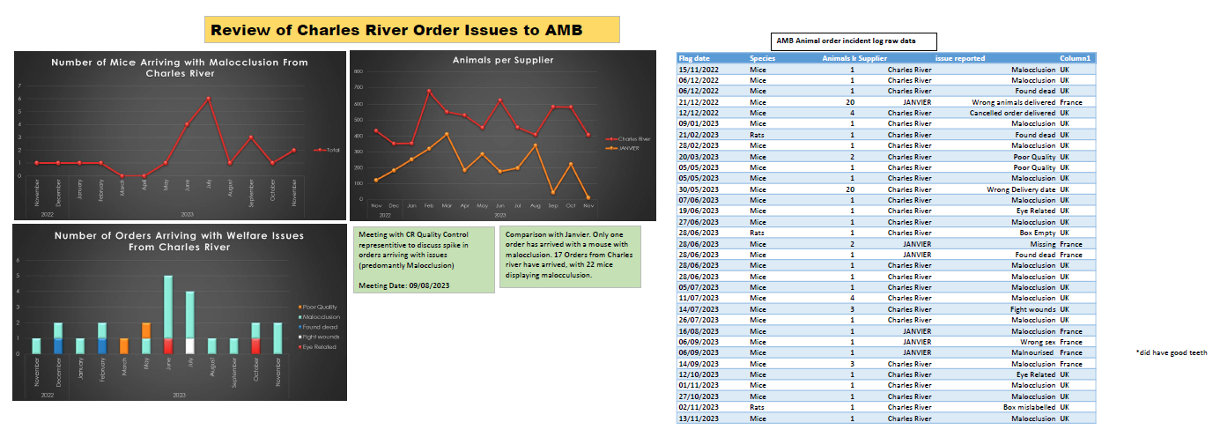

Fulfilling orders
Complaints are being received about CR not being able to fulfil orders:
- K Tuner
  - WT Bl/6J or Bl/6N received with highly variable weights, regularly overgroomed – concerns about quality. Bl/6N are international so come at a premium and a long order time.
  - Ordering mice of a specific gestational age and specific delivery date – for in utero experiments. Repeatedly received pregnant females at incorrect gestational age leading to wastage of mum/ embryos, and unwanted litters.
- PDN
  - Several orders where CR have been unable to fulfil the weight range of rats requested - Lister hooded rats as CR do not have a large colony of this strain. CR reply with an offer of either smaller, or larger than requested, or asking to broaden the weight range – and this can be a few days before delivery. CR ask for age ranges to be ordered or wider weight ranges.
  - CR not having enough stock of C57BL6 mice at the correct age range, this is usually the older ages, so 9 weeks plus. Users do accept younger animals.
  - Young rats being found dead with tumours – appears to have been a very unusual set of cases – stopped now.
AMB researchers are being asked to accept animals with hair loss, from CR. Researchers are accepting theses mice but are requesting a guarantee that that animals are otherwise fit and well, and so far this has seemed to be the case.

Importing into the UK
DEFRA have changed some of the live animal import requirements for animals coming into the UK – both Impex and Barbican as our two most used couriers have confirmed that they are aware of the changes and will instigate them, so that we will not need to make any process changes our end.

