UBS Guidance – Tamoxifen
This document is based on information presented and discussed at the Tamoxifen Workshop held on 31st March 2023, alongside similar guidance produced from a similar event held in 2017. Attendees were from the University of Cambridge, Cancer Research UK Cambridge Institute, MRC Laboratory of Molecular Biology and Babraham Institute and were a mixture of scientists, Named People and animal care staff.
This document is designed to be long-form to better capture the nuances of techniques used. It may be most appropriate to use a search function to find the information you require. The contents of the document is as follows:
Contents
Background and Uses 2
Tamoxifen Preparation 2
Methods of Administration 3
In Diet 3
Oral Gavage 4
Intraperitoneal 5
Subcutaneous 5
Intramuscular 6
Techniques not Recommended 6
Interactions with other Aspects of a Study 7
High Fat Diet 7
Cre Specificity, Leakiness and Recombination Efficiency 7
Obese Animals 8
Neonates 8
Irradiation and Haematopoietic System 8

Background and Uses
Tamoxifen is a selective oestrogen receptor modulator that has been used in people as a treatment and preventative for some types of breast cancer. Tamoxifen non-selectively antagonises oestrogen by binding to oestrogen receptors with greater affinity than endogenous oestrogen, therefore blocking the effects of endogenous oestrogen. Tamoxifen can either activate or suppress cell activity depending on the type of cell it is acting on.
It is also now widely used in biomedical research including to alter gene expression or to allow lineage tracing of cells of interest. Despite the benefits tamoxifen enables there are lots of difficulties encountered with its administration. Therefore, it is crucial that information surrounding the use of tamoxifen is shared to improve both science and welfare outcomes.
Tamoxifen’s action has been exploited in genetically altered cell and mouse models to allow temporal and cell type specific manipulations. There is a suite of reporters, for example Cre and Flp reporters, that can be used to visualise the effects of expression.
This allows cell populations to be labelled and followed over time or to look at gene function via conditional knockout (KO) models. The reporter selected must be appropriate i.e. a Cre reporter won’t show Flp expression. One advantage of tamoxifen inducible models is that gene function can be normal during development and only modulated after tamoxifen is given. This can be exploited to allow normal development and/or overcome embryonic lethality.

Tamoxifen Preparation
Tamoxifen is available as citrate and basic salts, so needs to be dissolved into an oil before administration by most routes. It is widely agreed that corn oil is the best oil to use for this and results in fewer adverse effects than other oils available. Some groups also use a small volume of ethanol to suspend the tamoxifen prior to dissolving it in corn oil, making it easier to dissolve into the oil. This has not been noted to cause extra adverse effects when administered via the intraperitoneal route.
For tamoxifen to be administered the oil needs to be sterile to reduce the risk of peritonitis and other adverse effects. To sterilise the oil the options are to either sterile filter or autoclave it:
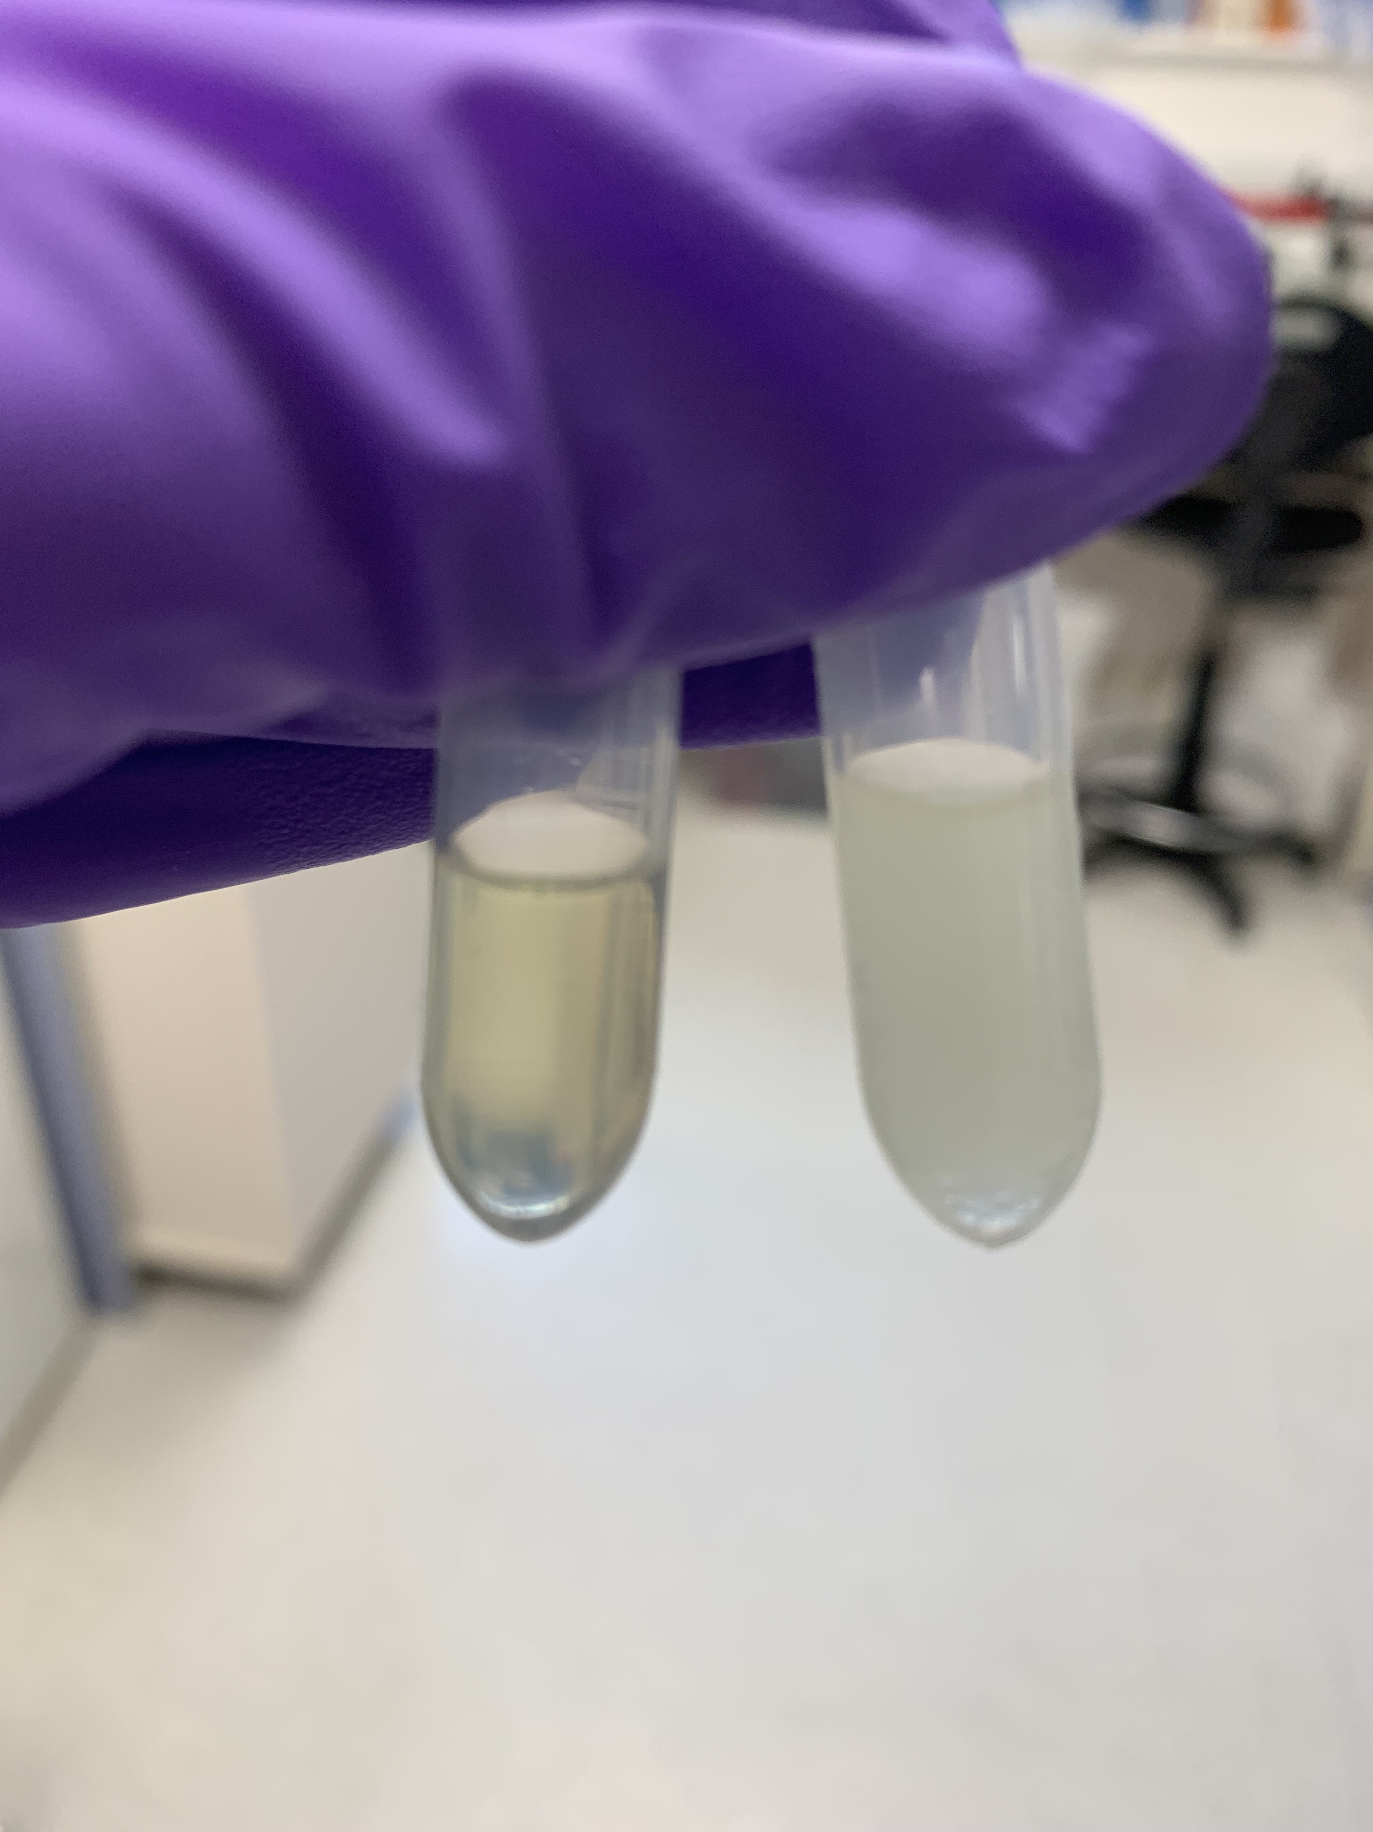
- Sterile Filter: requires oil to be heated, and typically a messy and time consuming process
Fig 1: Buller, 2023. Photo showing a transparent tamoxifen solution on the left which would be appropriate to use, and a cloudy solution on the right which would not be appropriate to use.
- Autoclave: It has been reported that using a brand new glass bottle this was an appropriate method. However when the glass bottle had been cleaned and used a second time the oil became cloudy and could not be used. It is not known what caused the cloudiness – suggested reasons were water contamination, soap or limescale residue. This would require further investigation.
To create the stock solution dissolve the tamoxifen in sterile corn oil in a sonicating water bath for approximately one hour at 37°C. It is recommended to only prepare three millilitres at a time as preparing more in one go takes a very long time to adequately dissolve.
Once the stock solution has been prepared it needs to be stored in the fridge and protected from light. It is possible to freeze tamoxifen stock but will require a suitable method to warm the solution within the animal facility prior to use.
Tamoxifen stock solution needs to be transparent for administration. If it is cloudy it should not be used. The reason for cloudiness may be that the tamoxifen crystals have come out of solution, therefore the solution can be heated to try and re-dissolve the crystals. If the solution then becomes transparent it can be used, if not then a new stock solution should be made. Another reason for cloudiness can be water contamination.

Methods of Administration

In Diet
Giving tamoxifen in the diet is time consuming. Commercial diets are available with sucrose included in the formulation. However the commercial diets still tend to be unpalatable and very hard. Strawberry Nesquik is commonly used to improve the palatability of tamoxifen diet in mash form, but cannot be used with dry diet. Other options discussed for improving palatability are peanut butter, bacon flavour gels and Nutella/chocolate flavoured gels.
It was discussed that animals may be able to be trained to accept tamoxifen solution mixed with a flavouring from a syringe, providing more precise dosing. This would be something to be investigated further in future.
Giving tamoxifen in the diet is often used when tamoxifen needs to be given continuously over an extended period of time. For example it has been found that with ROSA Cre lines that the effect of the gene knockdown with tamoxifen gradually wore off over time and the levels of the gene increase again. In Foxp3-cre systems regulatory T cells are targeted which have a high turnover so to ensure knockdown remains constant administration of tamoxifen is needed, hence use of the diet route.
Groups using the diet route ensure the animals are at least 8 weeks old prior to administration of tamoxifen in the diet and often give tamoxifen diet for 8-12 weeks. It is advised to keep the length of time tamoxifen diet is administered as short as possible. There are a number of different issues with giving tamoxifen in the diet, with various methods used to mitigate them:
- Weight loss: for moderate protocols on project licences the weight loss limit is typically 15%. Animals fed a tamoxifen diet may exceed this so it is very important to ensure that weight loss endpoints used are appropriate and justified within the project licences. It is also important to specify what baseline the weight loss is measured against.
- Body Condition Scoring: this can be used to help interpret weight loss and provide flexibility in some scenarios if no other clinical signs are seen. It is important to ensure that all those involved with the care of the animals understand the body condition scoring system and any other interventions or endpoints used.
- Commercial supply of tamoxifen diet: to obtain commercial tamoxifen diets there can be long lead times of up to 6-8 weeks so careful planning is needed. It is supplied in 1kg bags that need to be refrigerated and have a fairly short shelf life. As the diet quickly becomes bitter when exposed to the air a good method for storing the diet once the 1kg bag is breached is to decant the diet into smaller airtight bags and work through the smaller bags one by one.
- Introducing tamoxifen diet: transitioning straight from standard chow to tamoxifen chow results in the mice not eating the tamoxifen chow. Therefore typically it is best to start with standard chow mash mixed with strawberry Nesquik for a few days to a week prior to starting tamoxifen administration, then switching the standard chow mash for tamoxifen chow mash with strawberry Nesquik
- Producing mash diet: tamoxifen chow pellets are very hard, so soaking them to soften them for mash is very time consuming. These pellets are also difficult and loud to break up in a food processor to create a powder which needs doing within a cabinet in the unit to maintain sterility and therefore can disturb animals. Some groups have had success with requesting diet powder from the supplier and then using this to make up mash.
- Mash Presentation: providing the tamoxifen mash mixture in a petri dish often results in the petri dish being flipped over, walked through and defecated in. A petri dish also may not hold enough of the mash diet for a highly stocked cage. Glass jars (for example jars similar to the Gü dessert jars) are higher edged and heavier so hold more mash and are less likely to be tipped or walked through. It is important to also provide chew sticks alongside mash to keep teeth worn down.
- Refreshing diet: as the diet quickly deteriorates when exposed to air ensure any mash used is changed daily. It is recommended to do this as late in the day as possible so that it is freshest for the active phase of the mice so that it is most palatable when they are most likely to be eating. For pellets that are provided on the floor change these daily, and change pellets in the hopper twice weekly.
- Mitigating adverse effects: mice can become dehydrated when the mash diet is stopped and only pellets are given. To reduce this it is recommended to provide hydrogel from the beginning of the diet change. Even with Nesquik added to enhance palatability weight loss can still be seen. If weight loss starts to approach 15% the tamoxifen mash can be mixed with standard mash to improve the palatability and increase weight until the animal returns to its baseline.
Weaning mice onto tamoxifen pellets takes time and even with the refinements listed above still typically takes 4-5 weeks. A high fat tamoxifen diet is also available and is softer so takes less time to wean onto, typically in the region of 2 weeks.
It has been noted that providing the diet for very long periods e.g. 15-16 months resulted in curvature of the spine.

Oral Gavage
One method of oral gavage dosing was to use a high dose of 300mg/kg of a 30mg/ml solution – therefore 10ml/kg. This was given over 4 consecutive days at 24hours apart. This was advantageous as it allowed precise dosing compared to using diet and resulted in efficient recombination of approximately 70% 3 weeks following dosing. Exact dosing needs to be optimised for each mouse line used.
However the issues with the dosing via oral gavage described above is that it is stressful for the animal and given the need for repeated gavage it is a highly technical procedure and there is risk of mis-dosing. The high dose used means that adverse effects particularly weight loss are likely although hopefully transient. It is important to consider the severity limits of the project licence and ensure they are suitable. Even with this it was estimated that approximately 5% of animals are lost due to the adverse events experienced. This is also a time consuming method.
Weight loss due to oral gavage administration of tamoxifen reached approximately 10% at day 7 following first dose, and then typically recovers 2-3 weeks later.
To refine the oral gavage procedure and mitigate adverse events it is recommended to:
- Acclimatise the animals to the procedure and handling before administering tamoxifen. This was done prior to dosing by performing all parts of the procedure except for the oral gavage each day for a week – so to weigh the animals, scruff them as would be required for oral gavage and place into a different cage before returning them to their home cage.
- For a few days prior to tamoxifen administration provide mashed diet, peanut butter and hydrogel to habituate the animals to these novel items that will provide nutritional support once dosing has begun.
- Ideally animals are weighed daily until they return to their pre-treatment weight.
- In this instance heat pads were provided when an animal reached 7% weight loss but this could be added sooner if desired.
It had previously been noted that mice that lose 2g of weight per day are likely to be found dead. Therefore one group had used this as an endpoint and if a mouse lost over 2g per day it would be culled.

Intraperitoneal
The dosing regime for intraperitoneal dosing was a dose of 80mg/kg of a 20mg/ml solution – therefore 4ml/kg doses were given. This required 8 consecutive daily doses at 24 hours apart and requires optimising for each mouse line used.
The intraperitoneal method allows for precise dosing and smaller volumes to be administered when compared to oral gavage and lower morbidity and mortality was seen compared to oral gavage also. Particularly these seems to be less weight loss associated with this route.
However adverse events are still seen, which include abdominal swelling and scrotal swelling. Daily injections are required with is time consuming and stressful to the animals. There is still risk of loss of animals with intraperitoneal administration. Where the intraperitoneal route needs to be used daily for extended periods it has been found that the amount of tamoxifen and corn oil given was affecting the other dosing required as part of a study. Oil can still be detected in the abdomen for up to six months following administration.
It is not recommended to use intraperitoneal administration in pregnant females as it may lead to dystocia, abortion and foetal abnormalities.

Subcutaneous
To allow for lineage tracing a single dose of 150mg/kg was given, whereas for conditional knockouts this group used 250mg/kg. Oral gavage was not suitable as even with successful dosing marks were made on the oesophagus that causes issues with downstream analysis for those working with oesophageal tissue.
Subcutaneous administration was initially trialled as a refinement over intraperitoneal dosing as it was hoped it would result in a lower severity for the animals with lower risk of internal injury and could be used in pups so would result in less manipulation.
Within the same strain intraperitoneal dosing was compared with subcutaneous dosing at the same dose rates. Subcutaneous dosing resulted in a lower level of recombination within cells of interest but recombination was still enough for the purposes of the work. Similar results were also seen in neonates.
To refine subcutaneous administration in neonates increasing the stock concentration to 50mg/ml allows for a smaller volume to be administered. Insulin syringes are useful for accurate dosing. However in adult mice injected subcutaneously around the neck with 50mg/ml stock wounds developed. Therefore to prevent this a lower concentration of 30mg/ml injected in the flank is used and has not resulted in clinical signs.

Intramuscular
This route of administration has been successfully used in neonates where other routes such as oral gavage or intraperitoneal are more difficult and at higher risk of adverse effects. An SOP for this method is available.
Typically 10 microlitres of tamoxifen solution is injected into the right hind flank either on one occasion or on two consecutive days 24 hours apart when the pups are one day old. It is recommended to use a 30G needle and low resistance syringes given the tamoxifen is dissolved in corn oil. The general procedure is outlined below:
- It is important to mask the scent of the handler, so it is recommended to be double gloved, rub bedding on the hands prior to starting and create a ‘nest’ for the pups to be placed in once the injection has been given by placing bedding on a paper towel.
- Prior to injection ensure the general health of the neonate is checked and that a milk spot is present as if not the pup is unlikely to survive and the mother may not accept it again so should not be dosed.
- To perform the procedure hold the pup between the middle and ring fingers of the non-dominant hand and use the thumb of the same hand to hold down the tail and back legs.
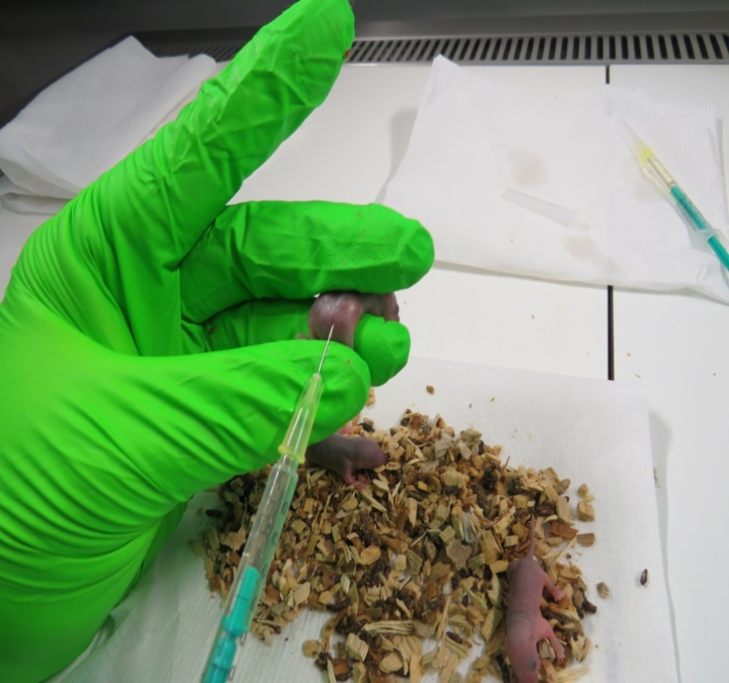
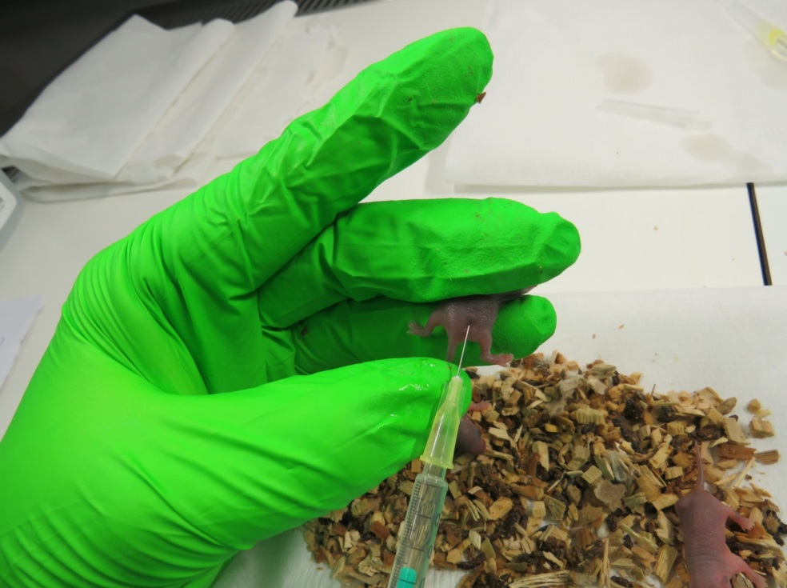
- The needle can then be inserted into the right flank to 3-4mm depth.
Fig 2: Rahrmann, 2023. Photos illustrating steps 4 and 5 of intramuscular injection of neonates procedure.
- Once the tamoxifen has been injected release the thumb holding the back legs but keep the needle in place for a few seconds before removing it. This helps to prevent the tamoxifen from leaking from the injection site and therefore reduces the amount the mother ingests when grooming the pups.
- Once the needle has been removed check for blood from the injection site. If blood is seen then monitor very closely for the next couple of hours.
- Pick up the mother so that hopefully she urinates and drip the urine over the pups to transfer her scent to them and aid with acceptance of the pups following the procedure. Typically the mother quickly rebuilds the nest and accepts the pups.
The group using this procedure has found that there is good efficiency of the tamoxifen and and very low incidence of death associated with this procedure. The only time death is seen is with first litters and even then is rare.

Techniques not Recommended
- Slow Release Pellets: have been found to not always dissolve properly and may be rejected.
- Topical: There have been reports of tumours growing in the mouth following licking of the application area. If mixed with acetone it has been found to dry out the skin.

Interactions with other Aspects of a Study

High Fat Diet
It is not advised to give tamoxifen at the same time as switching to a high fat diet. Groups using both tamoxifen and a high fat diet within the same animals advised that they typically administer tamoxifen first and then change over to a high fat diet at a later stage. This was because the weight loss observed by changing to a high fat diet prior to administering tamoxifen was greater and would often exceed project licence limits.
When diet was switched to a high fat diet at the same time as tamoxifen administration began this seemed to cause aversion to the high fat diet and animals did not eat it. Therefore it is recommended not to change other things at the same time as beginning tamoxifen administration.
High fat diets affect the gut microbiome from approximately 3 weeks of administration. It was asked if this would affect response to tamoxifen. When tamoxifen was administered prior to change to high fat diet no differences had been noted, but it was not known if there were any effects to response when high fat diet was given prior to tamoxifen.

Cre Specificity, Leakiness and Recombination Efficiency
Cre refers to a site-specific recombinase (an enzyme) that recognises a 34 base pair DNA sequence called loxP. When the Cre binds to the loxP region it then causes exchange of DNA at that part of the genome.
Cre can be targeted or randomly inserted in to the genome, both methods can cause a phenotype due to the Cre cassette disrupting gene function at the insertion locus. In both inducible and non-inducible models, typically, only one copy of the Cre cassette is required to bring about the desired effect. One copy is usually preferred over two copies as there is less likely to be a cassette related phenotype. In non-inducible models, it’s good practice to breed the Cre cassette out of the test mice to avoid these phenotypes. Where this isn’t possible, careful consideration should be given to appropriate control genotypes.
There is a relationship between the Cre promotor and Cre activity. For example, with the Sox2Cre model, Cre expression is under control of the Sox2 promotor, this is active in the epiblast at embryonic day 6.5, prior to this time point Cre won’t be expressed even in non-inducible models.
Cre Leakiness refers to the unintended expression of Cre in inducible models i.e. expression without tamoxifen administration. Both Cre activity and leakiness can vary depending on whether the cassette is inherited maternally or paternally. The degree of Cre activity (leakiness) can vary from animal to animal in the same model but some models are more prone to leaky expression. In some models, leakage is associated with age, sex and/or genotype.
Cre/LoxP models tend to have a greater recombination efficiency compared with flp/FRT and Dre/rox systems. Factors effecting recombination efficiency include the orientation of, and distance between, LoxP sites. Efficiency of all Cre types including ubiquitously expressed Cre, can vary between different tissues in the same animal. Some Cres are maternally expressed in the germline and first-generation offspring can inherit the effects of Cre recombination without inheriting the cassette.
Cre specificity refers to tissue specific Cres and the degree to which they are active in the target tissues. Good tissue specific cre models will have a high degree of recombination efficiency at the target site and relatively little or no expression in other tissues.

Obese Animals
In Ob/ob mice that were given tamoxifen at doses calculated from their body weight excessive clinical signs were seen. When these mice were dosed based on the weight of a lean mouse of equivalent age they tolerated the doses well and did not lose weight excessively. Recombination in the Ob/ob mice was equivalent to that of lean mice given the same dose. Therefore it seemed to be better to dose tamoxifen on lean bodyweight rather than actual bodyweight.

Neonates
When administering drugs to neonates it is technically challenging, stressful to the animal and can endanger health. Some considerations of methods used for allowing recombination of neonates:
- Oral gavage: very technically challenging due to the small size of the neonate. This method would require long handling periods and has the potential to cause oesophageal damage.
- Intraperitoneal: there is a risk of organ damage due to the small size of the neonate
- Dosing of mother: this is not always reliable to achieve recombination in the neonates and tamoxifen can lead to dystocia.
Administering tamoxifen to neonates affects reproductive development. In males tamoxifen administration results in an underdeveloped prostate, seminal vesicles and epididymis. Some of these animals are then infertile.

Irradiation and Haematopoietic System
When mice exposed to tamoxifen were then also exposed to sublethal irradiation for haematopoietic recombination the recombination expected following irradiation did not happen. Therefore it was suspected that tamoxifen impairs the differentiation of haematopoietic progenitor cells. Tamoxifen quickly has this effect on these cells, being as little as 3 days following the start of tamoxifen administration. However when on a tamoxifen diet over a long period the differentiated haematopoietic cell counts is not affected. The exception is platelets which underwent a significant reduction when the animals were on a tamoxifen diet.
In mice tamoxifen binds to oestrogen receptor alpha which is different to the pathway in humans. The hierarchy of the cell changes the effect that tamoxifen has on the cell. For example tamoxifen leads to apoptosis of multi-potent progenitor cells (MPPs) but proliferation and renewal of haematopoietic stem cells (HSCs). Tamoxifen has been found to cause production of cells that are heavily reliant on JAK-STAT signalling.
Tamoxifen has been found to reduce the mutant allele burden in a subset of patients with myeloproliferative neoplasms (MPNs). It has direct metabolic effects by causing a stress response as the tamoxifen derivatives accumulate within the mitochondria, inhibiting ATP production by inhibiting mitochondrial complex 1. This then leads to apoptosis in certain cell types. The metabolic effects of tamoxifen may therefore be useful for modulating JAK-STAT signalling and could have uses with certain types of leukaemia.

