SC18s for April 2024
An overview of SC18s and number of animals from Jan 2023 to middle of May 2024
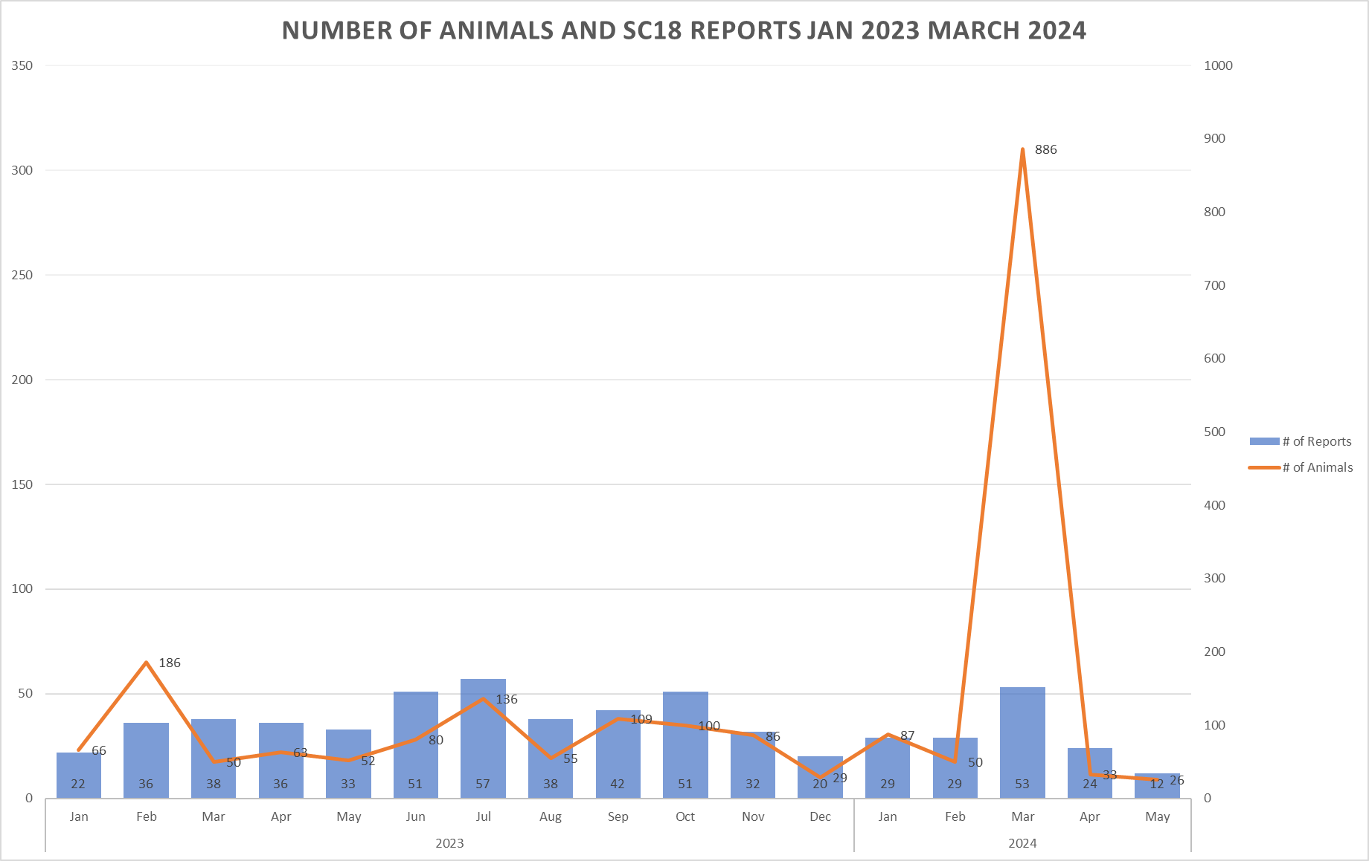Pie chart for April.
