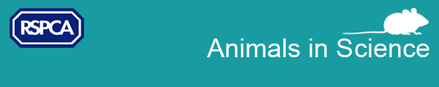

Relaunched website - Focus on Severe Suffering
We are pleased to announce that we have just launched a brand new web resource, focusonseveresuffering.co.uk as part of our ‘Focus on Severe Suffering’ initiative. It sets out information on what can cause ‘severe’ suffering to lab animals, along with practical approaches for reducing - or ideally avoiding - this. There are sections with case studies and reports relating to different research areas, plus information about our past and upcoming events. Another area provides guidance on thinking about an animal’s lifetime experience, and there is a ‘Roadmap’ exercise to help people identify opportunities for avoiding severe suffering in their own institutions. The website will be of particular interest to scientists, animal technologists, vets, regulators, and members of ethics or animal care and use committees.

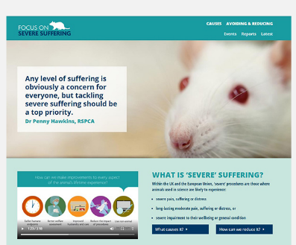
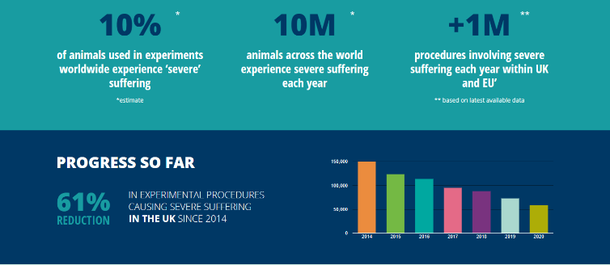
Causes of severe suffering:
- Severe Procedures (with examples and case studies)
- Cumulative severity
- Mortality
With links to Refinement, Welfare Assessment and Humane Endpoints

With a Roadmap, with guidance, and downloads:
- 
- 

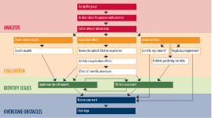

How can we reduce it?
- Approaches to Refinement
  - Humane endpoints
  - Welfare assessments
- Sources of information

Reviewing and considering the lifetime experiences of each animal
- Breeding
- Capture from the wild
- Transport
- Marking for ID
- Genotyping
- Housing
- Husbandry procedures
- Handling and restraint
- Scientific procedures
- Effects of procedures
- Humane Killing
- Rehoming or Release

