Project Licence Retrospective Review

“The overall purpose of retrospective review in the general sense of ‘following the development and outcome of projects’ is, wherever possible, to reduce the harms and increase the benefits of every project at an establishment. The aim is to improve both animal welfare and the quality of science and to help inform future debate on these issues.” [RSPCA and LASA, 2015, Guiding Principles on Good Practice for Animal Welfare and Ethical Review Bodies. A report by the RSPCA Research Animals Department and LASA Education, Training and Ethics Section. (M. Jennings ed.)]

At the University of Cambridge one (or possibly more) of the following will determine when your licence will be requested for review:
- 12 to 6 months before your existing licence is due to expire if you have no plans to write a new licence;
- 15 to 12 months before your existing licence is due to expire if you plan to write a new project licence;
- 3 months before you terminate your licence if you intend to revoke your licence before its due expiry date;
- When there is a change of project licence holder (in this case the person currently holding the licence should complete the retrospective review before the amendment is made to change the project licence holder);
- As determined by the AWERB Standing Committee. The AWERB Standing Committee may decide a licence should be reviewed at a specified time or times based for example on the severity of the work, novelty of the models etc..

The information you provide in or attached to this document must reflect data generated only from work carried out under the licence under review. Please do NOT copy and paste text that appears in your current licence unless requested to do so.

You are not restricted by the size of the text boxes on this form; they are designed to expand to accommodate your text. However please remember that AWERB Standing Committee members which will include your colleagues have to review the information you provide so please be informative and concise and do not include information that is not requested. Please remember to use Plain English, where possible.

If you use abbreviations could you please ensure the first time the abbreviation is used that it is spelt out fully with the abbreviation in brackets.

Thank you.

- General Information:
Project licence holder to complete if
1.1. information provided is incorrect
Name: | Professor Nicola Clayton
Contact details:  Address & tel. | Department of Experimental Psychology  University of Cambridge
Project No. | 80/2519
Project title | Prospective cognition by corvids
Project purpose | To define the extent to which corvids can plan for the long-term future.

Date licence was granted | 13 December 2011
Date of retrospective review/assessment | 06 January 2017

  - Amendments (if applicable):
Provide dates and a summary of all amendments made to this licence (i.e. what each amendment requested and why it was required) since the licence was granted (or if appropriate since the licence was last reviewed).
Please read questions 3.9 and 3.10 – for amendments that apply to this question and either 3.9 or 3.10, please provide the date of the amendment here and a note that further information can be found in Section 3.9 or 3.10.

Amendment applied for on 21 February 2014: Amendment to modify the scrub jays’ diet to investigate the influence of diet manipulations on the jays’ planning ability:

Addition to Part A:

Addition of details of newly started research grant.

Change to Part E, Section 19:

Addition of a new protocol (protocol 2: Dietary Manipulation and Behavioural) testing in which modification of scrub-jay diet is obligatory step and restricted housing is optional. But it otherwise the same as Protocol 1.

Addition to Part D, section 18:

As part of the 3Rs: Refinement, the following has been added:

“Birds maintained on a diet that is altered for experimental reasons may not need to be housed in experimental cages at all times. As such, the birds will be given “rest” periods in large outside aviaries that allow free flight when appropriate."

  - Condition 18 Reports (if applicable):
Provide dates and copies of all Condition 18 reports sent to the Home Office since the licence was granted (or if appropriate since the licence was last reviewed). Copies of any reports should be attached/supplied as separate documents please.

n/a

  - Non-Compliance (if applicable):
Provide the date, a summary of the nature of any non-compliance and the outcome (or if appropriate since the licence was last reviewed).

n/a

  - Compliance Assurance Meetings [CAMs] (if applicable):
Provide the date, a summary of the nature of any CAMs incident and the outcome, if known (or if appropriate since the licence was last reviewed).

n/a

  - Have there been any other issues that have affected the management of this licence that you feel should be taken into consideration, (e.g. equipment failure, absence of key staff, change in the health status of the animal unit etc.)?

Due to restrictions of importing and the lack of quarantine facilities available to us, it was not possible for us to replace the California scrub-jays (Aphelocoma californica) [previously known as Western scrub-jays] that have been lost de to health issues (illness/injuries), which were unrelated to the research.

- Scientific Progress and Benefit Achievements:

- Has your research progressed as you expected?
YES, except last objective as explained in 2.3 NO

- Have you completed the programme of work you described in this licence?
YES, except last objective as explained in 2.3 NO

- Regardless of whether you managed to complete your programme of work, what have you achieved/discovered during the time since this licence was granted? (Please copy your key scientific questions/objectives which appear at the beginning of Part D of your project licence into the box below and against each explain what you have achieved/discovered).

The overall objective is to define the extent to which corvids can plan for the long-term future.
This is an extension of our previous project licence, which asked whether the jays could take action for the future. The results obtained under the previous project licence raised four key questions about the sophistication of the corvids’ planning abilities:

- Do corvids show a preference to plan for some situations and not others or to spend more time planning for one kind of caching event over another event (e.g. the opportunity to cache or recover various food types)?

We have shown the planning abilities of corvids in wide range of situations, supporting the hypothesis that these birds display a very flexible cognitive tool-kit that they employ to quickly adapt to new situations.

Examples:

- Scrub jays will selectively choose which food to cache in which substrate depending on the colour of both the food and the substrate. If the colour of the food matches the food of the substrate, this decreases the probability that the food will be found by potential thieves. To minimise risk of pilferage, scrub jays selectively cached food of different colours in matching substrate when observed by a conspecific.
- Scrub jays can differentiate between problems that they will be able to solve easily and those for which they need special information. If presented with two situations, one in which they will be able to find food easily and one in which they will only be able to find food if they see where another individual has hidden it, the birds will allocate more time to observe the second situation.
- In a series of experiments, we tested the jays’ far-sighted decision-making. In these experiments the jays could choose to cache in locations that would allow them to retrieve the food items earlier over locations that would allow them to retrieve the food items only after a longer delay. In the first of these experiments, the jays showed no preference to cache in a tray associated with a short delay-to-retrieval over trays associated with longer delays. In a follow-up experiment, jays also showed no difference in their caching behaviour between different conditions, in which they were able to cache within a single tray and the delay-to-retrieval was varied. These experiments thus showed that jays were insensitive to the different delays between the caching event and retrieval. Although these results might indicate that because of their dependence on cached food scrub-jays are not very sensitive to temporal discounting (the devaluation of a reward that is received in the far future), alternative accounts of the results cannot be ruled out at present.

- Can corvids make multi step plans when it comes to caching, such as hiding food 1 in place 1 for time 1 and food 2 in place 2 for time 2?

A series of experiments investigated impulsivity in scrub-jays’ retrieval behaviour and whether or not the birds would engage in pre-commitment caching behaviour to prevent early retrieval of caches that could be disadvantageous. To this end, scrub jays were given experience that they will be sated at the first retrieval opportunity and hungry at the second one. If they could use a pre-commitment strategy, they were expected to retrieve fewer caches at the first opportunity in order to have more caches available at the time when they would be retrieving their caches when hungry. These experiments provide no support for pre-commitment strategies in scrub-jays and suggest a potential limit to the birds’ planning abilities.

- Can corvids plan outside of the caching domain, e.g. where to transport tools that they will need to access food later?

A series of experiments investigated the scrub jays’ ability to solve different patterned string tasks, i.e. tasks in which subjects need to plan what string (out of two or more strings) to pull in order to get a reward. In these tasks, the strings differ in their efficiency to deliver the reward. These experiments found that depending on the configuration of the strings, the birds used different rules to solve the task.

The slanted and crossed configurations revealed a reliance on a ‘‘proximity rule’’, that is, a tendency to choose the string-end closest to the reward. When confronted with strings of different lengths attached to rewards at different distances the birds chose according to the reward distance, preferring the reward closest to them, and were sensitive to the movement of the reward, but did not consistently prefer the shorter and therefore more efficient string. Generally, the scrub-jays were successful in tasks where the reward was closest to the string-ends they needed to pull or when string length and reward distance correlated, but the birds had problems when the wrong string-end was closest to the reward or when the food items were in close proximity to each other.

These results show that scrub-jays had a partial understanding of the physical principles underlying string-pulling but relied on simpler strategies such as the proximity rule to solve the tasks.

- Can they plan in social situations, both in competitive and co-operative contexts?
If so, under what circumstances are the birds more likely to co-operate (e.g. are they more likely to co-operate with a mate and compete with rival)?

We investigated the birds’ ability to plan in social situations in different experimental set-ups.

Planning in the context of caching:

- In one set of studies, we found that scrub jays’ cache-protection strategies take into account what a conspecific observer currently mostly wants to eat and that cachers protected caches that are most at risk from being stolen. Here, we manipulated the observer’s current desire for food by pre-feeding them on a specific food (‘specific satiety’), subsequently leading to a decreased desire for the pre-fed food. We found that cachers responded to the observer’s specific satiety and preferentially cached food that the observer was pre-fed and thus was not motivated to pilfer.

We were further able to elucidate the cognitive mechanism that might allow cachers to employ this cache-protection strategy. By testing cachers both when they could see the observer being pre-fed and when they could not see the observer being pre-fed, we were able to show that they employed the cache-protection strategy to the same extent in both situations. Because they did not know what food the observer was pre-fed when they could not see it during the pre-feeding, the likely mechanism allowing the jays to protect their caches in this situation is a response to the observer’s behaviour during the caching event itself.

- In a different set of studies, we investigated whether scrub jays’ cache-protection strategies are sensitive to the direction of gaze of an observing conspecific. To this end, we tested scrub jays’ caching and re-caching behaviour with a conspecific displayed as a looped video on a computer screen – a procedure that allowed us to manipulate the gaze of direction of that conspecific, namely whether it was looking at the cacher or whether it was looking away. We found that the gaze of direction of the observer did not affect the scrub jays’ caching or re-caching behaviour in this context.

In addition, we found no differences between when the video displayed the conspecific, regardless of its gaze direction, and when the video displayed an empty compartment. This is in contrast to live studies, in which we find that scrub jays employ cache-protection strategies when observed by a conspecific but not when they are caching ‘in private’ (i.e. without being observed). These findings indicate that cache-protections are not sensitive to video playback of conspecifics, even though corvids in general and scrub-jays in particular are sensitive to video playback of conspecifics in other contexts. Thus, the behaviour of the conspecific observer during the caching event might present an important cue for the birds.

Planning in a competitive non-caching context:

- We investigated whether scrub jays would approach and eat food more often and faster when a competitor is facing away from them than when a competitor is facing towards them. This research showed that scrub jays can assess a competitor’s attention towards food through the competitors’ body and head orientation and that they can plan their own actions accordingly.

5. What is the impact of diet on corvids’ planning abilities?

A pilot study conducted revealed that data suggested that the planned diet manipulation was unlikely to have the effect in question. Thus, the advantaged of the study were outweighed by the effect that the diet manipulation would have had on other studies that were conducted at the time. Consequently, the planned diet manipulation was not carried out.

- For key scientific questions/objectives you could not complete either fully or partly, please include an explanation as to why you were not able to achieve what you set out to achieve when the licence was granted (reasons could for example include lack of funding, the model took longer to develop, another group published data which meant continuing the work would equate to repeating the work, etc.).

As described in 2.3, we did not carry out the planned manipulation of the birds’ diet to examine the influence of diet onto the birds’ cognitive abilities. As explained in 2.3, this was because a pilot study suggested that there would be no effect and thus the benefits of conducting the manipulation were outweighed by the effect that the diet manipulation would have had on the other studies – this is because we could not increase the number of birds (see also point 1.6).

- At the end of Part C of your licence you described the benefits you believed would be likely to arise from your programme of work. Please explain what benefits have actually been achieved and if appropriate explain how these differ from what you thought you could achieve.

Our programme of work yielded the following benefits:
- Animal models of mental health and brain dysfunction:
Because of their ability to plan for future events as well as remember the past, scrub-jays provide a better model for processes concerning human memory and future planning than other non-human animals models. Our work was able to identify both the extent to which scrub jays could plan for future events as well as limits to this ability. These data will prove valuable for comparison with human studies, in particular where human memory and planning ability has been negatively affected either by age or by injuries.
- Animal welfare:
Out work on the scrub-jays’ cognitive abilities are important in light of how corvids can be kept in captivity, be it for research purposes, or as pets, or in zoos. For example, showing that scrub-jays are sensitive to the gaze direction of humans has implication on how humans should interact with the birds. For example, our research implies that when giving food to the birds, not standing close to it and not looking at the birds will ensure that the birds are eating. It also has implication on how birds’ behaviour could be assessed for different purposes. Our research implies that – unless specifically familiarised with it – the presence of a human might disrupt the birds’ natural behaviour such that observations into the birds’ behaviour need to take this into account.

In Part C of our licence we also listed a further benefit, namely how our work will influence our knowledge of animal and human obesity and its influence on cognitive abilities. Unfortunately, we were not able to carry out the work associated with this benefit (see also points 1.6 and 2.4.

- Specifically if you were unable to address all your key scientific questions/objectives what impact did this have on the benefits arising from your work?

As explained in 2.6 we could not assess the influence of the birds’ diet on their cognitive ability such that we were not able to achieve one of the benefits listed in Section C of our licence.

- Were you able to identify/develop/implement any new scientific or technical developments during the tenure of this licence? YES NO

If so what were these and what benefits did this allow you to achieve?
n/a

- Using the headings below please provide a list of publications and meetings attended where research arising from work undertaken under this licence has been disseminated.

Publications in scientific journals:
- Cheke, L., Thom, J. M. & Clayton, N. S. (2011). Prospective decision making in animals: a potential role for inter-temporal choice in the study of prospective cognition. In: Bar, M. Predictions in the Brain. Chapter 24, 325--354. Oxford University Press.
- Logan, C. J., O’Donnell, S. & Clayton, N. S. (2011). A case of mental time travel in ant-following birds? Behavioral Ecology 22, 1149-1153.
- Seed, A. M., Clayton, N. S., Carruthers, P., Dickinson, A., Glimcher, P., Gunturkun, O., Hampton, R., Kacelnik, A., Shanahan, M., Stevens, J. & Tebbich, S. 2011 Planning, Memory and Decision Making. In: Animal Thinking: Contemporary Issues in Comparative Cognition. Menzel, R. & Fischer, J. (Eds.). Chapter 8. Cambridge University Press, p. 121-147.
- Raby, C. R. & Clayton, N. S. (2012). Episodic memory and planning. In: The Oxford Handbook Of Comparative Evolutionary Psychology, Schackelford, T. & Vonk, J., Eds. Chapter 12, pp. 217-235. Oxford University Press.
- Van Horik, J., Clayton, N. S. & Emery, N. J. (2012), Convergent evolution of cognition in corvids, apes and other animals. In: The Oxford Handbook Of Comparative Evolutionary Psychology, Schackelford, T. & Vonk, J., Eds. Chapter 5, pp. 80-101. Oxford University Press.
- Raby, C. R. & Clayton, N. S. (2012). Episodic-Like Memory in Food-Caching Birds. In: Encyclopedia of the Sciences of Learning, DOI 10.1007/978-1-4419-1428-6, Norbert Seel (Ed.). Springer Science and Business Media LLC.
- Raby, C. R. & Clayton, N. S. (2012). Planning in Birds. In: Encyclopedia of the Sciences of Learning, DOI 10.1007/978-1-4419-1428-6, Norbert Seel (Ed.). Springer Science and Business Media LLC.
- Grodzinski, U., Watanabe, A. & Clayton, N. S. (2012). Peep to pilfer: what scrub-jays like to watch when observing others. Animal Behaviour 83, 1253-60.
- Clayton, N. S. (2012). Corvid Cognition: Feathered Apes. Nature 484, 453-454.
- Thom, J. M. & Clayton, N. S. (2013). Re-caching by Western scrub-jays (Aphelocoma californica) cannot be attributed to stress. Public Library of Science ONE 8, e52936.
- Thom, J. M., Clayton, N. S. & Simons, J. S. (2013). Imagining the future~ a bird’s eye view. The Psychologist 26, 2-5.
- Thom, J. M. & Clayton, N. S. (2014). No evidence of temporal preferences in caching by Western scrub-Jays (Aphelocoma californica). Behavioural Processes 103, 173-179.
- Watanabe, A., Grodzinski, U. & Clayton, N. S. (2013). Western scrub-jays allocate longer observation time to more valuable information. Animal Cognition, 17, 859-867.
- MacLean, E. L., Hare, B., Nunn, C. L., Addessi, E., Amici, F., Anderson, R. C., Aureli, F., Baker, J. M., Bania, A. E., Barnard, A. M., Boogert, N. J., Brannon, E. M., Bray, E. E., Brent, L. J. N., Burkart, J. M., Call, J., Cantlon, J. F., Cheke, L. G., Clayton, N. S., Delgado, M. M., DiVencenti, L. J., Fujita, K., Herrmann, E., Hiramatsu, C., Jacobs, L, F., Jordan, K. E., Laude, J. R., Leimgruber, K. L., Messer, E. J. E., Moura, A. C. de A., Ostojić, L., Picard, A., Platt, M. L., Plotnik, J. M. Range, F., Reader, S. M., Reddy, R. B., Sandel, A. A., Santos, L. R., Scgumann, K., Seed, A.M., Sewall, K. B., Shaw, R. C., Slcoombe, K. E., Su, Y., Takinoto, A., Tan, J., Ruoting T., van Schaik, C. P., Virányi, Z., Visalberghi, E., Wade, J. C., Watanabe, A., Widness, J., Young, J., Zantall, T. R., Zhaom Y. (2014). The Evolution of Self Control. Proceedings of the National Academy of Sciences 111, e2140-e2148.
- Clayton, N. S. (2014). EPS Mid Career Award Lecture. Ways of Thinking: From Crows to Children and Back Again. Quarterly Journal of Experimental Psychology 68, 209-241.
- Thom, J. M. & Clayton, N. S. (2014). Translational research into intertemporal choice: the Western scrub-jay as an animal model for future-thinking. Behavioural Processes 112, 43-48.
- Thom, J. M. & Clayton, N. S. (2015). Route-planning and the comparative study of future-thinking. Frontiers in Comparative Psychology 6.
- Clayton, N. S. (in press). Episodic-Like Memory and Mental Time Travel in Animals. In: Call, J. APA Handbook of Comparative Psychology.
- Watanabe, A. & Clayton. N. S. (2016). Hint-Seeking Behaviour of Western Scrub-Jays in a Metacognition Task. Animal Cognition 1-12.
- Hoffman, M. M., Cheke, L. G. & Clayton, N. S. (2017). Western scrub-jays (Aphelocoma californica) solve multiple-string problems by the spatial relation of string and reward. Animal Cognition 10.1007/s10071-016-1018-x
- Ostojić, L., Legg, E. W., Brecht, K. F., Lange, F., Deininger, C., Mendl M. & Clayton, N. N. S. (2017). Current motivational states of conspecific observers affect cache protection strategies in California scrub-jays and Eurasian jays. Current Biology 27, R51-R53.

Presentations at scientific meetings:

The work conducted under the licence has been presented at the following scientific meetings (listed by presenter, year and meeting/conference/invited talk):

Presented by Katharina Brecht:
2017:
- Is it a Bird? Is it a plane? Detection of biological motion by California scrub-jays. ICPS 2017, Vienna, Austria [Poster]

2016:
- Is it a Bird? Is it a plane? Detection of biological motion by Western scrub-jays. DuCog 2016, Dubrovnik, Croatia [Poster]

2015:
- Sensitivity to Social Cues in Corvids. Talk presented at the Corvid Cognition Meeting, Max-Planck Institute for History of Humanity, Jena, Germany
- Do Western scrub-jays employ cache protection strategies when exposed to an observer simulated by video playback? Poster presented at the 4th Champalimaud Neuroscience Symposium, Lisbon, Portugal
- Do Western Scrub-Jays employ cache-protection strategies when exposed to an observer simulated by video playback? Poster presented at the Social Cognition Meeting, Bangor, Wales
- Western scrub-jays do not employ cache-protection strategies when exposed to an observer simulated by video playback. Talk presented at the International Ethology Conference Behaviour 2015, Cairns, Australia

2013:
- Are Western Scrub Jays able to attribute food preferences to their conspecifics? Conference Talk presented at the 1st EFPSA Conference, Amsterdam, the Netherlands

Presented by Michaela Hofman:
2015:
- Monthly meeting of the Ornithological Society in Bavaria. Munich, Germany.

2014:
- 95th Annual Exhibition of the Cambridge Natural History Society in Cambridge, UK.
- 147th Annual Meeting of the German Ornithologists´ Society, Bielefeld, Germany. Oral presentation.

Presented by Nicola Clayton:
2017:
- Distinguished Lecturer [with Clive WILKINS], Michigan State University

2016:
- Distinguished Lecturer, Columbia University Lecturer, New York
- SAGE Distinguished Lecturer [with Clive WILKINS], University of California Santa Barbara

2015:
- The Medawar Lecture, University College London
- The Captured Thought Lecture series [with Clive WILKINS], Florida University

2014:
- Perry Gilbert Lecturer, University of Cornell

2013:
- Floyd Clarke Lecturer University of Wyoming
- Experimental Psychology Mid-Career Award

2012:
- Philippe Wiener Lecturer, Belgium

2011:
- Sir Hans Sloane Prize, Queen's University Belfast
Presented by Edward Legg:

2015:
- Symposium and talk at the International Ethology Conference Behaviour 2015, Cairns, Australia

Presented by Ljerka Ostojic:
2015:
- Invited talk at the University of Reading

2017:
- Invited talk at the Anglia Ruskin University

Please highlight in bold the publications which contain and meetings at which 3Rs achievements were disseminated.

- Have you engaged with the general public by giving interviews about your work on radio, television, at a public meeting or debate or in a newspaper article? YES NO

If you answered NO: why?

n/a

If you answered YES: how, where (i.e. what medium did you use) and when did you engage with the public, what sort of information did you disseminate and what was the outcome?

Nicola Clayton regularly engages with the public through several types of media, especially through appearances on TV shows and Radio programmes:

Appearances on TV shows:
BBC1 Would I Lie To You 2013, 2017:
Appeared as a mystery guest and explained the main aim of her and her group’s research.

BBC2 Inside The Animal Mind 2015:
This programme consisted of three episodes, one of which concerned intelligence in corvids and featured many studies conducted by Nicola Clayton’s group, including descriptions of the experiments and the main findings. In addition, Nicola Clayton was a ‘super contributor’ for the programme, meaning that she was involved in the scientific aspects of all three episodes.

BBC 1 Attenborough's Curiosities 2015
David Attenborough visited the research group and the facilities in Madingley (see picture 1 and picture 2: Nicola Clayton, David Attenborough and Laura Kelley), and research of the group was featured in the programme.

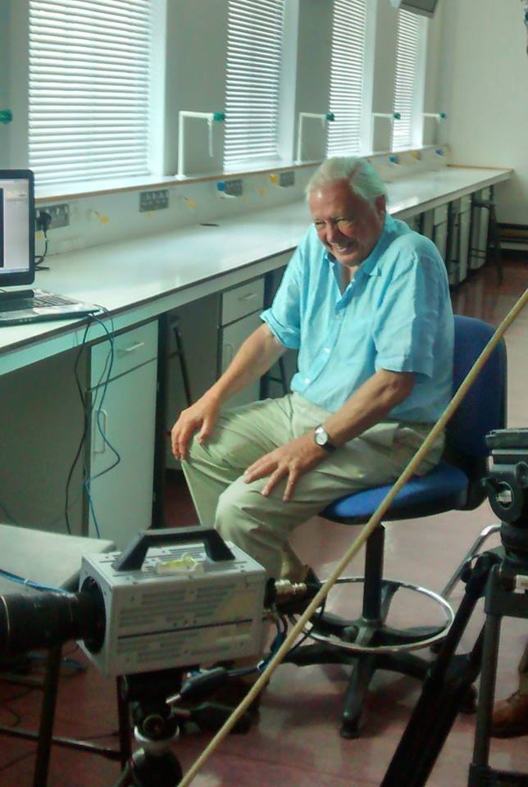

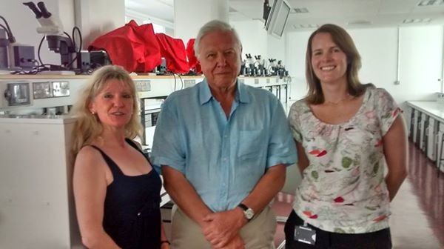

BBC 1 Animal Intelligence 2014
This programme featured some of the group’s research.
BBC 1 The one Show
The One show featured the group’s research in 2012, 2013 and 2016
BBC1 Spring Watch Unsprung 2013
Nicola Clayton talked about integrating science and arts

Appearances on Radio shows:
BBC Radio 4, Bang Goes The Theory, 2011,
BBC Radio 4, The Life Scientific Profile piece 2011
BBC Radio 4, The Today Programme 2014, feature guest
BBC Radio 3, Private Passions 2015, feature guest

Other public outreach activities:
University of Cambridge Science Festival:
Members of the research group (Elsa Loissel, Rachel Crosby, Alison Greggor, Edward Legg, Ljerka Ostojic, Jordan Sandberg as well as internship students: Adina Wagner and Chantal Deininger) present the group’s research at the Cambridge University Science festival. To this end, the group prepares ‘games’ for children of different ages, in which the children are tested on similar tasks that have also been used with the corvids (see pictures below). The children thus learn through first-hand experience what research is being conducted and then later on – either through videos or posters – learn about how the corvids perform on these tasks. This engagement of children (but also their parents) means that i) our research is transparent to a wide audience, ii) we attempt to engage already young children to ask questions about the world around them, and iii) we attempt to raise awareness about the cognition and welfare of birds (but also other non-human species).

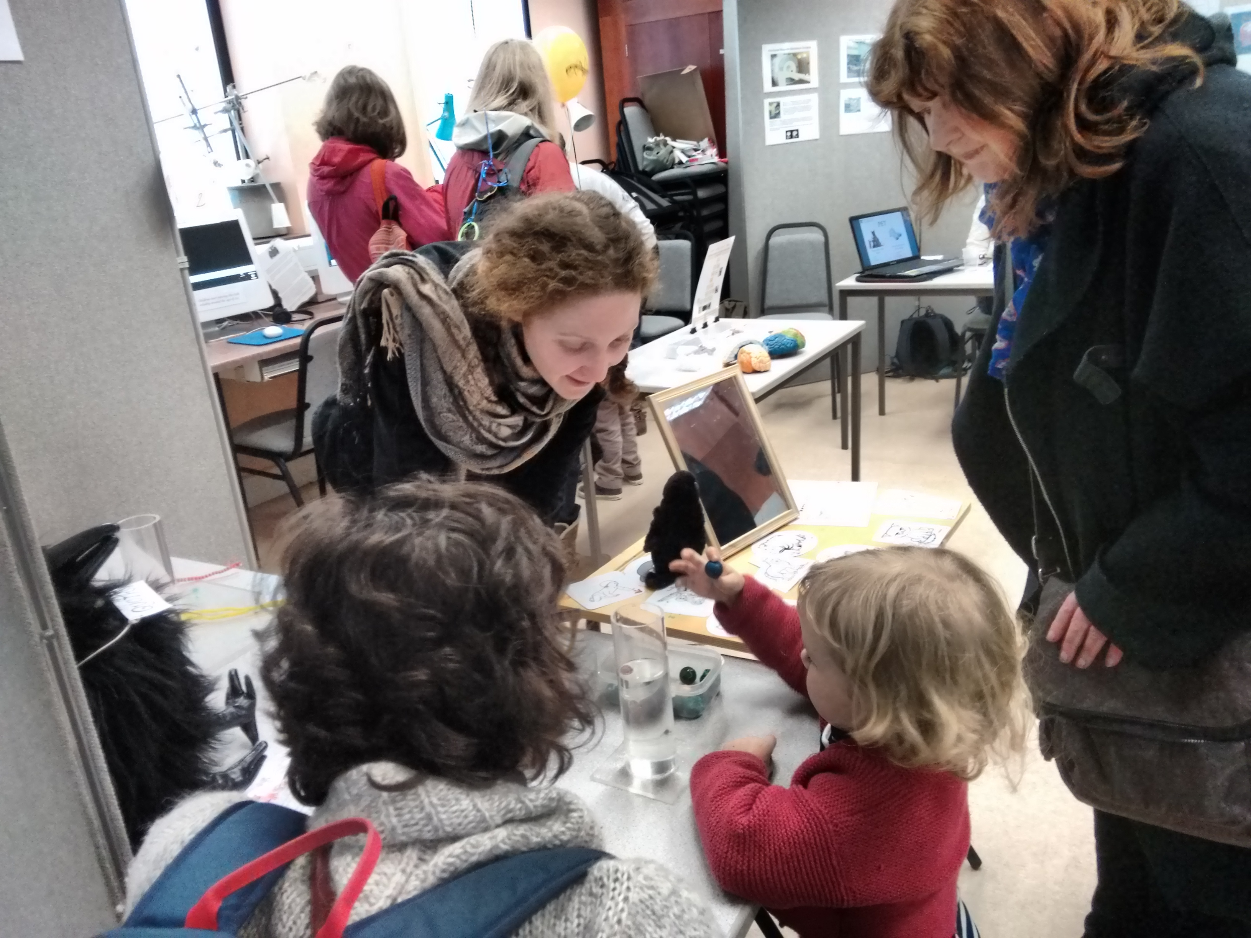

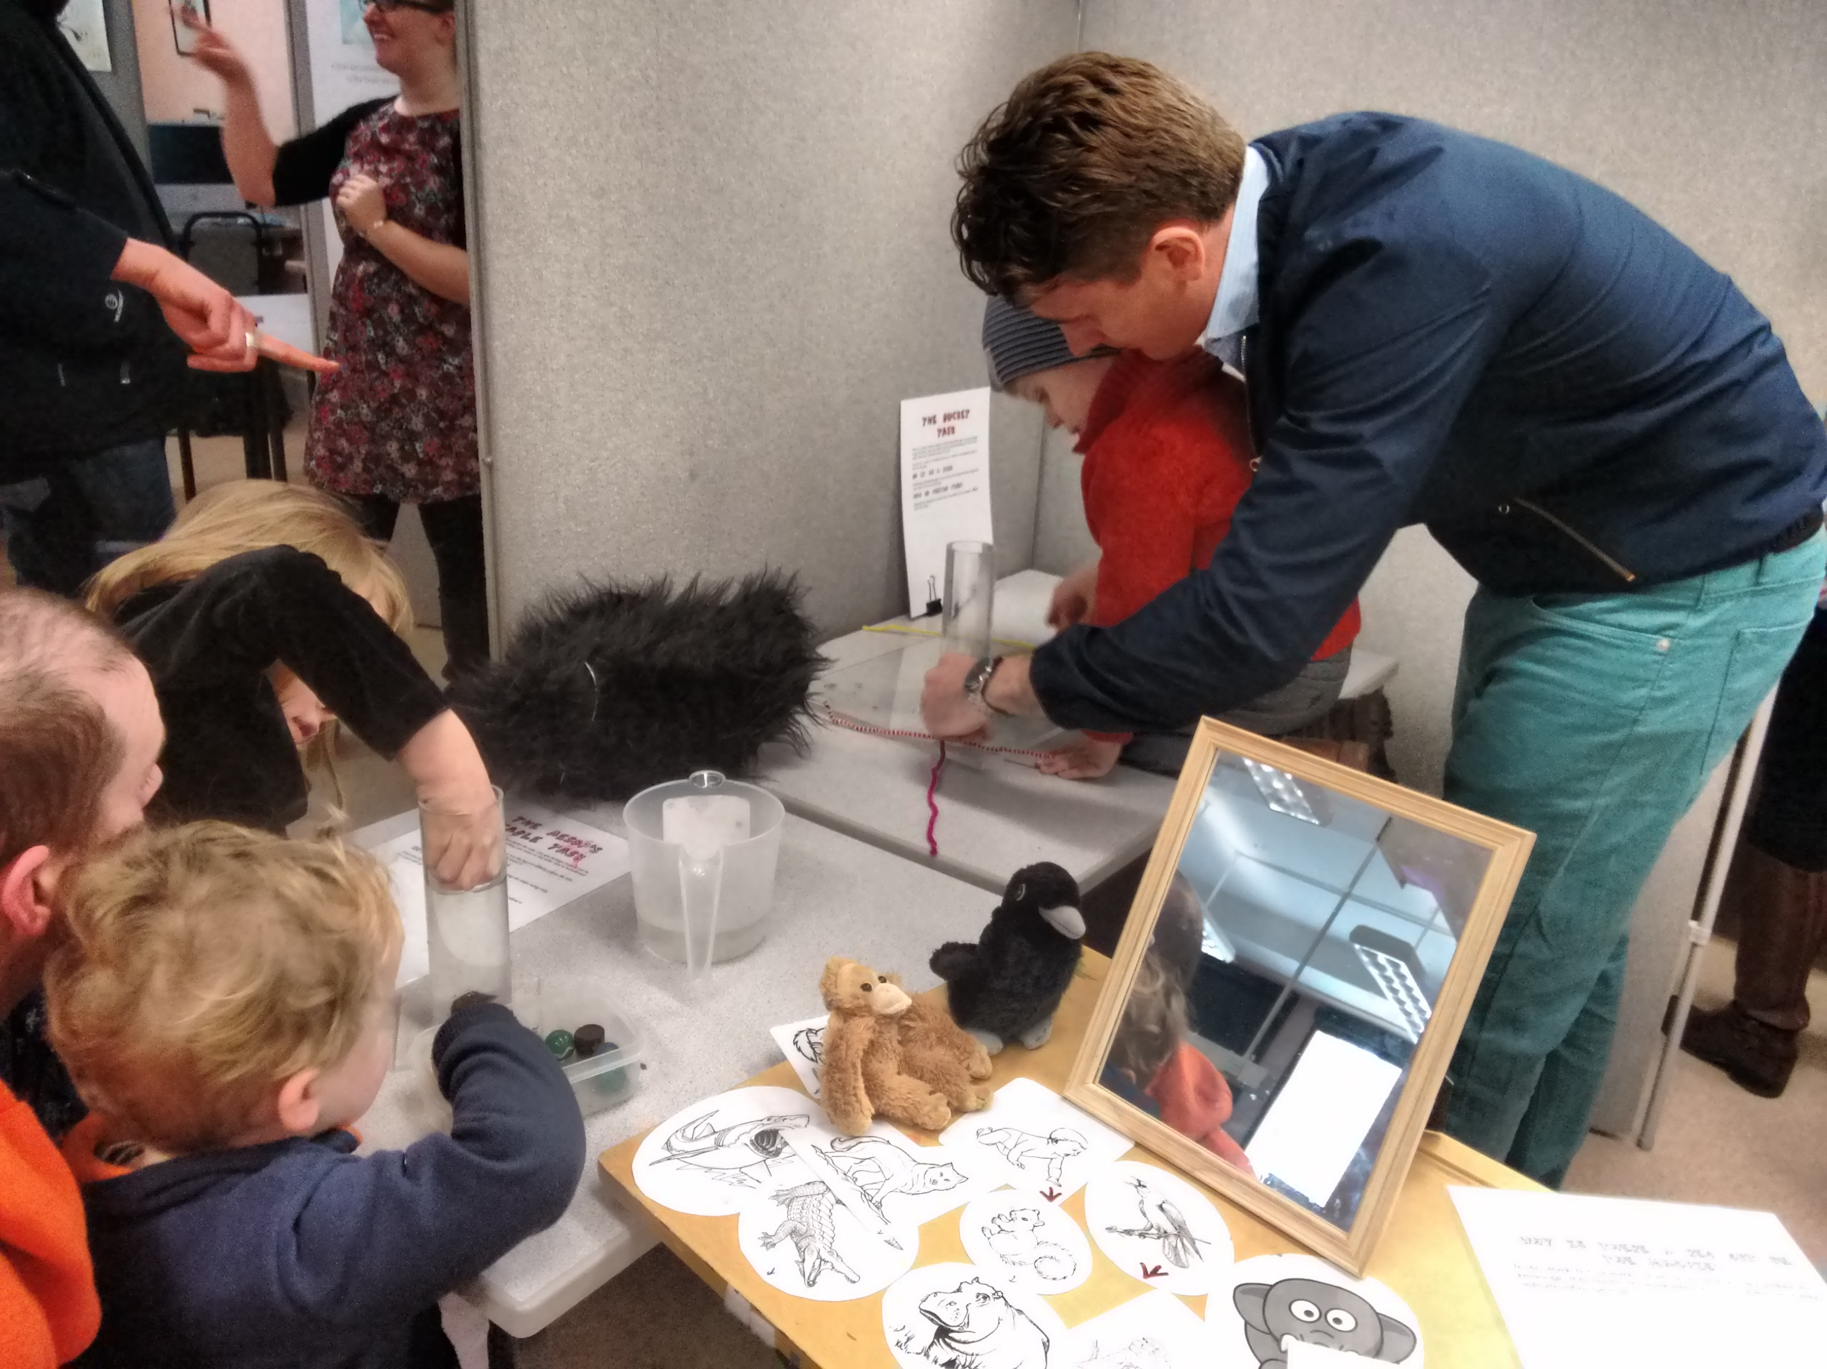

Outreach activities in schools and nurseries:
Members of the research group (Elsa Loissel, Edward Legg and Ljerka Ostojic) regularly organise outreach activities in schools and nurseries. This usually takes the form of different stations at which the children can take part in different tests themselves and also learn about what the birds do in the same/similar situations. Where appropriate (i.e. with older kids) this is accompanied with discussions as to whether or not birds might be clever, how we could know if a non-human animal is clever, etc. We organise these activities either as part of the school’s own initiative (e.g. Ridgefield primary school organises a Science Week during which scientist come and talk to the children about their work) or through little workshops organised with specific teachers directly.

- Animal Welfare/Recorded Harms:

- Using the table below please provide the information requested.
How to complete this table: Return of procedures count animal numbers from 1st January to 31st December. In the table below if your licence was granted part way through the year count year one as the time from when the licence was granted to the 31st December, year two from January to December etc. until the final year for which the report is requested and count from 1st January to the requested report date. You can insert rows as necessary.
Protocol No. | Species | Protocol severity  category | Total est. number | Actual number used | Actual severity recorded*
 |  |  |  |  | Non-recovery | Sub Threshold | Mild | Moderate | Severe
1 | Corvid | Mild | 250 | 2011 |  |  | 100% (20 birds) *,^
 |  |  |  | 2012 |  |  | 100%  (19 birds)  *,^
 |  |  |  | 2013 |  |  | 100%  (14 birds) +
 |  |  |  | 2014 |  |  | 100%  (22 birds)
 |  |  |  | 2015 |  |  | 100%  (7 birds)
 |  |  |  | 2016 |  |  | 100% (5 birds)
 |  |  |  | Total
2 | Corvid | Mild | 20 | n/a due to the fact that we did not carry out the diet manipulation that Protocol 2 refers to (see also question 2.3)
 |  |  |  | Total
COMMENTS TO TABLE:
The reason why the actual severity level of the birds has been assessed as being ‘mild’ is due to the experimental housing that the birds experience during an experimental period. Experimental housing has not lead to any clinical signs in the birds, however the birds may have experienced transient psychological effects due to a change in their housing.

* In 2011 and 2012, the actual severity level was not formally assessed so these cells provide an estimate of the actual severity level.

^ In 2011 and 2012, the HO returns have erroneously included 21 Eurasian jays that were tested under a non-regulated procedure such that the table here contains only the birds that were actually tested under the project licence.

+ In 2015, the Home Office returns have been done by a different person than usual (who was away on maternity leave) and the actual severity levels have been completed erroneously as severe for some birds. This has subsequently been discussed with the NACWO and NVS and it has been agreed that the severity level for this year too should be ‘mild’, such that this is what is reported in the table here.

*If actual severity data has not been formally assigned at the point the Retrospective Review/Assessment is undertaken, these columns can be used to indicate the estimated severity as a percentage for each of the categories.

- Does the information provided in the table reflect the projected incidence of harm provided in the adverse effects for each protocol? If not please indicate where this was not the case and whether the projected level of suffering was more or less than you anticipated when you first wrote the licence. If the severity category for a protocol was amended during the tenure of the licence please include this information in the reasons box.

Protocol number | Severity higher/ same/ lower than anticipated | Reason
1 | Same

- Describe any unexpected adverse effects and include the percentage and the number of animals affected. How were these episodes managed and recorded? If any of these resulted in a Condition 18 report please indicate which were reported under Condition 18 and the date.

n/a

- What percentage (and number) of animals had to be killed or died unexpectedly before the end of the experiment? Please provide a brief summary of each incident by protocol(s) where this occurred.

Protocol No. | % or number of animals killed or unexpectedly found dead
n/a  (see comment in next column) | No animals had to be killed or were found dead due to experimental procedures. 19 animals died or had to be killed due to unrelated veterinary issues during the duration of the licence, but none during experimental work was being carried out.

- Have you re-used animals? YES NO

If so why have you re-used animals and what has been the impact of re-use on the welfare of your animals? Please also provide the species and number of animals re-used by protocol where re-use occurred.

Species | Protocol No. on which animals were/will be retuned as re-used
California scrub-jays (Aphelocoma californica) - previously known as Western scrub-jays | Animals were used on Protocol no. 1  Number of re-uses per year:  1st year (2011): 20*  2nd year (2012): 19*  3rd year (2013): 14  4th year (2014): 22  5th year (2015): 7  6th year (2016): 5  Re-use of the animals did not show any significant impact. Animals received regular assessments and were signed off as fit for re-use by the NVS before each re-use.  Comments:  * In 2011 and 2012, the HO returns have erroneously included 21 Eurasian jays that were tested under a non-regulated procedure such that the table here contains only the birds that were actually tested under the project licence.

- Has there been any animal wastage? YES NO

For example; this may occur when breeding and maintaining genetically altered animals or when animals have been ordered and cannot be used for some technical reason.

Where wastage has occurred, please explain the circumstances and nature of the wastage.
n/a

- Have you been able to refine and/or reduce the impact of contingent harms arising from your use of animals (contingent harms are harms for example that arise from the transportation of animals, single housing animals or housing animals in non-Code of Practice accommodation, etc.). YES NO

Please explain/provide examples.
n/a

- By species and percentage please indicate the source of your animals.

Species | Source | Approx. percentage
California scrub-jays (Aphelocoma californica) – previously known as Western scrub-jays | Taken from wild, hand-raised, imported from the USA | 100%

- During the tenure of the licence have you requested an amendment to increase/decrease animal numbers? YES NO

If so which protocols were amended and were numbers increased or decreased, and by how much?
Protocol No. | Original estimated Number | Amended estimated number

If you have increased or decreased numbers please explain why this was necessary?
No increase or decrease was necessary due to our amendment because the Protocol No. 2 would have involved re-use of birds.

- During the tenure of this licence have you requested an amendment to increase/decrease the severity of any protocols? YES NO

If so which protocols were amended and were the severity categories increased or decreased?
Protocol No. | Original severity category | Amended severity category

If you have increased or decreased the severity category of any of your protocols why was this necessary?
n/a

- 3Rs:

In this section please explain what steps you have taken during the tenure of your licence that resulted in 3Rs gains. This might include working with collaborators to refine your model, changing the anaesthetic regime or equipment, etc. Consider every change you have made and its impact on the 3Rs – even small changes and initiatives can result in 3Rs gains.

- What techniques and/or animal models have you used on your licence (include GA models).

We have used live corvids to assess the cognitive abilities of these animals. To reduce the number of birds used in experiments we – where possible and appropriate – employ within-subject designs and multiple test trials. In addition, we have successfully implemented or continued to implement several husbandry and testing practices to ensure the highest possible welfare for out test animals:
- Training for husbandry and veterinary procedures
- Training in actual behavioural procedures used for testing
- Changes in administering medication
- Use of outside aviaries
- Enrichment
- Health assessments
- Re-homing for birds at the end of the licence
(for details on each of these points see 4.4).

- How successful have these techniques and/or models been?

The practices described above have been highly successful. For example,
- In collaboration with David Williams it has been found that regular catching of the birds leads to an increase in cataracts. A change in the way the birds are weighed – they used to be caught by animal technicians and have now been trained to hop onto a weighing scale (see picture below showing a Eurasian jay on the weighing scale – the came procedure was used with the scrub-jays too) – has resulted in a decline in cataracts seen in the birds.

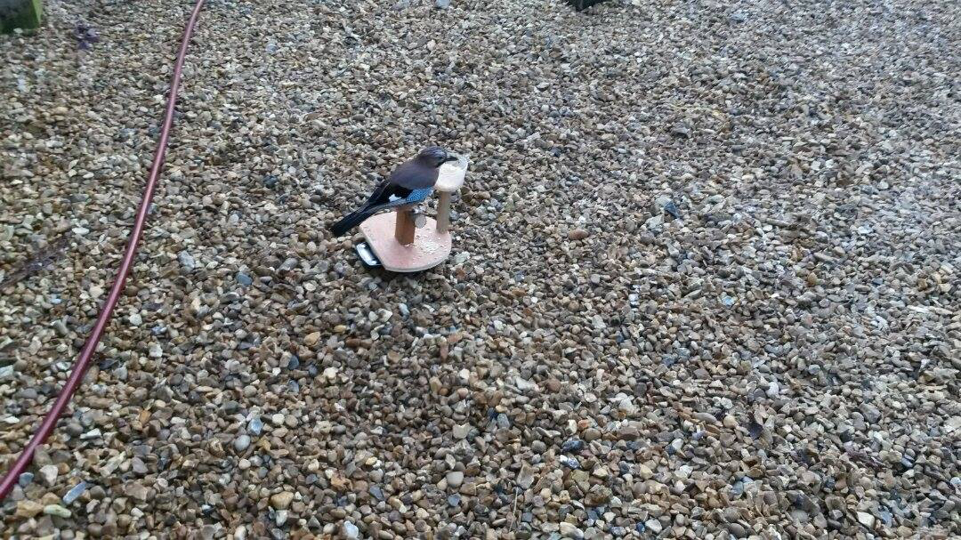

- Training the birds to perform certain behaviours useful for testing, such as hopping between cages or perching at a particular location while an apparatus has been baited, has resulted in more birds being able to be tested, thus reducing the number of birds that are kept for testing but for which no data collection is possible.
- Previously, treatment for parasites required that technicians catch the birds and administer the medication via a syringe. Instead of this, we now administer a different treatment directly into the birds’ food such that no catching and handling the animals is required.
- Previously – similarly to point 3 - any medical treatment required catching and handling the birds. We have been able to train the birds to take food items that had been injected with the medication (in most cases wax moth larvae) such that the birds do not need to be caught.
- Due to regular faecal collections and the change in the way treatment for parasites is given (see point 3), the birds now experience a smaller parasite load.
- Following strict criteria, we were able to find a new home for two scrub-jays at the end of the licence, such that they did not need to be schedule I killed. The below pictures show the two scrub jays in their new home, where they are being cared for by Dr. Caroline Raby, who used to a PhD student in the lab.
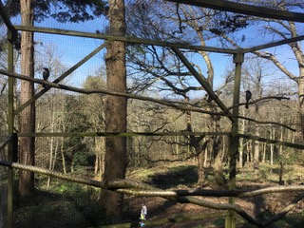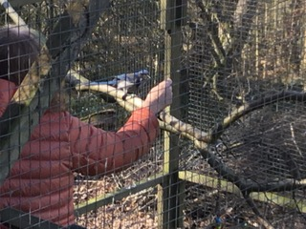

- What limitations, if any, have you encountered? Were you able to overcome these limitations and, if so, how?

- Training the birds on the weighing scale can take a long time, especially when the birds are already relatively old. There was also a lot of variation in how much effort different researchers put into training the birds and how often they weighed the birds. We have implemented a training protocol that is part of our routine testing procedure to ensure that as many birds as possible can be weighed in this way and we have regular data on the birds’ weights.
- When a bird behaves as if it was sick or is injured, it is sometimes difficult to figure out what the best way forward is, i.e. whether catching the bird is the best thing to do or whether it is better not to induce more stress. Together with out NVS, Jo Keeley, we have been working on figuring out the best way forward for each individual case which meant that for some minor injuries (such as a scrape on the bird’s leg) we do not catch the bird if the wound does not need to be cleaned. We have also trained the birds to take food rewards form us whilst standing in close proximity which helps assess whether or the bird needs to be caught.
- The question of whether or not to catch birds for health checks is a difficult one. On the one hand, being caught and handled is stressful for the birds and has also been found to induce cataracts (and occasionally has led to injuries of the birds in the past), on the other hand birds have evolved to ‘hide’ any signs of illness such that they will often show clinical signs only after an illness has progressed quite far. For a few years, we have given birds hands-on health checks once a year and currently we are trying out whether 6-monthly checks would be better – this concerns the birds we still have at the facility, all of which are tested under non-regulated protocols.

The following definitions come from the NC3 Rs website and are included to help you provide information under the most appropriate R below:

Definitions
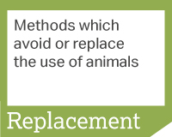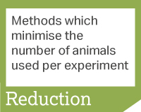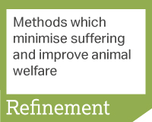
- Have you attempted or been able to refine any of your techniques or models?
YES NO

Please provide a list of techniques or models you have been able to refine and the refinements you have made. Please indicate if you have published or disseminated this information during the tenure of this licence and attach a copy of the publication.
- Training for husbandry and veterinary procedures:

Training:
  - To ensure that husbandry and veterinary procedures cause as little stress for the birds as possible we have trained the birds to take food rewards whilst standing in close proximity to people. This means that a birds’ general appearance can be assessed without handling the bird. In addition to this, we ensure that – when birds are being caught and handled as well as when birds’ overall appearance is being assessed by looking at them – only a minimum number of people are present to reduce any potential stress due to multiple people standing around.
  - Instead of catching birds to be weighed, we have trained the birds to voluntarily hop onto weighing scales to get a food reward.

Catching birds:
When birds do need to get caught whilst in the aviary, we attempt to always have a researcher close the birds in the inside testing compartments in which they are then caught by an experienced technician. In the past this has proven to be the easiest and least stressful way to catch the birds – instead of technicians closing the birds in. Because birds are trained to go into the testing compartments for testing (during which they regularly receive high value food rewards), then enter the testing compartments in anticipation of being tested and not in anticipation of being caught. The first time they then see the net and the technician is just before they are being caught, thus minimising the time that they spend stressed. In addition, we attempt to close only one or two birds in at a time such that birds do not see others being caught. Again, we ensure that a minimum number of people are present. After a bird is released into the aviary again, the researchers go and check on the bird and give it food rewards.

- Training in actual behavioural procedures used for testing

  - Familiarising birds with the testing equipment well before the onset of testing helps ensure that data from as many birds as possible can be collected. We have found that putting equipment in the outside aviaries as a first step helps in this familiarisation, possibly because it allows the birds to approach the equipment in their own time and to first look at it from a far distance. This practice has resulted in more birds being tested than when testing equipment is first presented in indoor testing compartments or cages where the birds cannot fly away for the equipment that far – this indicates that when there is not enough initial flight distance, the birds do not get over their initial neophobia regarding new objects.
  - We have trained the birds to hop between different cages and testing compartments, thus ensuring that birds can be tested in a flexible set-up are not stressed when an experiment requires them to go between cages/compartments.
  - By re-using birds for the different cognitive tests, birds become more and more accustomed to the experimental set-ups and procedures, such that re-use leads to better quality data than if new birds were used every time.
  - By utilising natural behaviours exhibited by the birds such as caching or food-sharing, we are able to design experiments that are rewarding for the birds and encourage them to display species-typical behaviours.

All the above steps help ensure i) that as many of our birds as possible participate in the testing, meaning that birds are not kept for testing purposes but are not used for data collection, and ii) the highest possible quality of our data, meaning that we reduce noise due to birds dropping out of testing because of neophobia or because of a lack of motivation to participate in testing.

- Changes in administering medication

Previously, any medication was given orally to the birds straight from a syringe after the birds were caught. Wherever possible, we now administer medication by injecting wax moth larvae (or other food items) and giving it to the birds, which have been trained on taking the food from us. When medication has a bad taste, we also attempt to increase the probability that the birds will take it by mixing it with sweet squash.

A regular medication that the birds receive is treatment against parasites. In the last couple of year we have changed which medication is being given such that the treatment an now be mixed with the birds’ maintenance diet and thus no catching of the birds is necessary for this any more.

- Use of outside aviaries
The use of outside aviaries between experimental periods ensures that the birds can fly in a larger aviary and that they can experience a more natural environment. In addition, the aviary floor ,which consists of gravel, ensures that the birds can display a very important natural behaviour, namely caching of food.

- Enrichment

Enrichment that the birds receive both in the outside aviaries and in the testing cages/compartments ensures that they can display more naturalistic foraging behaviour. This is because enrichment that we give to the birds typically consists of a ‘foraging object’: an object that the birds need to manipulate in order to get food that is for example placed inside the object. Objects the birds receive for enrichment without food attached to it are usually objects that can be easily picked up and carried around, which is of special important for juvenile birds that naturally exhibit many object manipulation behaviours.

- Health assessments
To monitor the birds’ health, there is a three-step system in place. Firstly, technicians check up on birds twice a day, once in the morning and once in the afternoon. Secondly, the researchers working with the birds check the birds’ general appearance and behaviour before, during and after testing. After testing, researchers note any changes in appearance or behaviour of the birds in a log-book. Thirdly, birds receive regular checks by the NSV – currently we are implementing hands-on checks twice a year.

- Re-homing for birds at the end of the licence
Because out testing protocols are purely behavioural and encourage species-typical behaviours, the birds can be re-homed at the end of the licence. However, given that corvids are long-lived, neophobic and posses highly complex cognitive abilities, it is not easy to find a suitable home for them because they need to be cared for by someone who has experience in training and working with corvids and then also need a suitable aviary. Dr. Caroline Raby, who was Nicola Clayton’s PhD student, had worked with scrub-jays extensively during her PhD but is also experienced in housing different bird species outside of the lab context. Because of that we were very fortunate to have been able to re-home two of the scrub-jays at the end of the licence. To facilitate the birds’ transfer to a new environment, the new owner was given food prepared in advance, as well as food bowls, baths and toys that the birds are familiar with.

We have not published any of the above but Dr Ljerka Ostojic is invited to speak on corvid welfare at the RSPCA/APHA conference in October 2017.

- Do you use systems to monitor the welfare of your experimental animals (e.g. scoring sheet). YES NO

If not, why?
Our protocols do not involve any procedures that are expected to induce clinical signs. We have a log-book to monitor the birds’ welfare that is filled out by the researchers at the end of each testing day and that birds receive regular health checks by the NVS in addition to daily assessment by the animal technicians.

If you do use a welfare monitoring system, what do you use? Did you refine or modify your system during the tenure of your licence and what impact did this have?
n/a

- Were the end points detailed in your project licence appropriate or did you need to modify them during the tenure of your licence?

Please explain.
End points were appropriate.

- What non-schedule 1 methods of killing were authorised in your licence and which of these have you used?

n/a

Were these killing methods the most refined? n/a
Were they the most appropriate for your experimental data? n/a

If you have answered no to either of the above questions please explain. If you were able to refine the way your animals were killed please explain how this was achieved.

n/a

- Have you attempted or been able to replace any of your techniques or models with non-animal alternatives? YES NO

Please explain.
There is no alternative to testing the cognition of corvids using live corvids.

- Have you been able to reduce your animal usage? YES NO

If so how have you achieved this (e.g. through experimental design, changes to the regulated procedures used)?
Through use of within-subject designs and multiple trials per test (where appropriate) to eliminate variance due to noise in the data.

- Have you received awards or funding specifically targeted at the 3Rs? YES NO

If so what was the source of your funding, when did you receive it and what did the funding allow you to achieve?
n/a

- Retrospective Review:

Check list for licensees:
AWERB requires the following documents | Documents sent to AWERB
Completed copy of this form | Yes
Copies of Condition 18 reports (if applicable) | n/a
Copies of 3Rs publications (if applicable) | n/a

For UBS office use only:
 | Date
- Retrospective review form sent to project licence holder | 06/01/17
- Completed retrospective review form received | 31/03/17
3a. 3Rs committee
3b. AWERB Sub Committee
3c. Project Team meeting
- Process completed

----------------------------------------------------------------------------------------------------------------

