Recording Severity of Health Concerns on MCMS
Background
Where the health concern identified is not linked to a procedure the severity of the health concern should not be included in the return of procedures. In order to prevent an incorrect actual severity being recorded due to a non-procedural harm many of the animal facilities record these non-procedural health concerns as ‘sub-threshold’. It has been raised that some technicians feel uneasy about recording extreme but non-procedural health concerns as ‘sub-threshold’. Examples of this would be in cases of severe fight wounds or dehydration.
How is severity recorded on health concerns in your unit currently?
Home Office Guidance and Examples
- Advisory notes on recording and reporting the actual severity of regulated procedures: https://assets.publishing.service.gov.uk/government/uploads/system/uploads/attachment_data/file/276014/NotesActualSeverityReporting.pdf
In section 2.d of resource 1 above it states that non-regulated procedures should not be included in the assessment of actual severity. Examples of these non-regulated procedures include non-experimental agricultural practices e.g. dehorning cattle; non-experimental recognised veterinary practice; recognised husbandry practices e.g. housing on grid floors to allow plug checks; animal identification and schedule 1 methods.
Other examples of non-procedural harms listed include:
- Failure of environmental controls e.g. temperature or humidity
- Disease outbreaks that could affect normal animals
- Fighting injuries not related to the phenotype
- Death or disease from illnesses not related to the procedure, where the morbidity/mortality rate is similar to the background strain
- Incidents that could occur at any time e.g. trapping a tail in the cage lid

- Severity classification of genetically altered animals under the Animals (Scientific Procedures) Act 1986 https://assets.publishing.service.gov.uk/government/uploads/system/uploads/attachment_data/file/785514/asp-severity-classification-of-genetically-altered-animals.pdf
Resource 2 states that harms such as low level neonatal loss or fighting that are not exacerbated by genotype should not be included in the actual severity assessment. This does however require knowledge of the background strain to determine if the harms seen are linked to the genotype or not. Where there is insufficient knowledge of the background strain then the harms must be included in the actual severity assessment.
Resource 2 lists examples of different prospective and actual severities associated with GAA breeding.
What is the current level of understanding of Actual Severity in your unit among users and among techs?
Current MCMS Process
When creating a health concern the following screen appears:
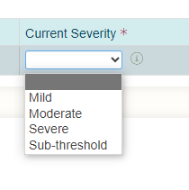
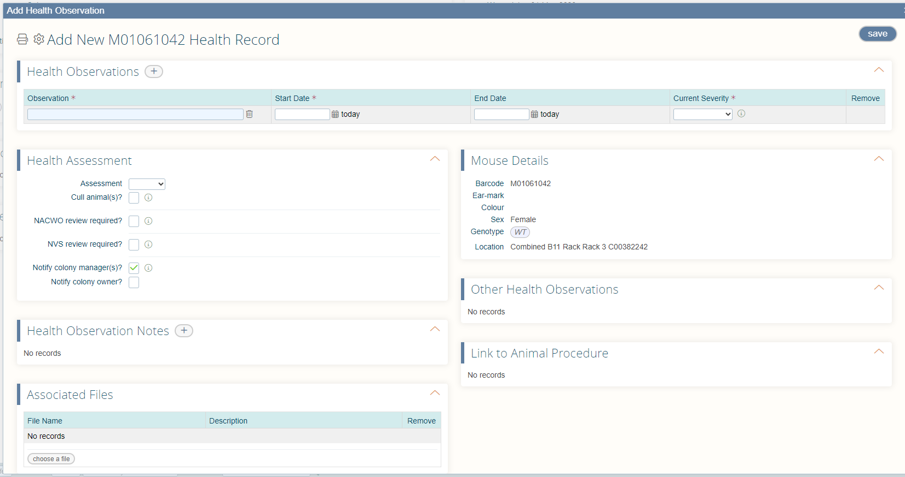Here the technician or user chooses the most relevant option from the list of possible health concerns, assigns a start date and a severity, of which the list gives the options of mild, moderate, severe, sub-threshold.
In some facilities if the health concern is regarded as not being linked to a procedure the severity assigned is advised to be subthreshold as it should not contribute to the actual severity assigned to that animal.
The three fields listed above are mandatory, the following steps are then completed at the discretion of the person creating the health concern:
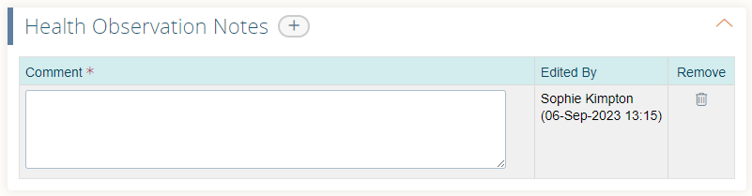
- Comments: There is a field that allows free text comments to be added. Click on the + button next to ‘Health Observation Notes’ to create a new field to type into. Any relevant information can be included here.
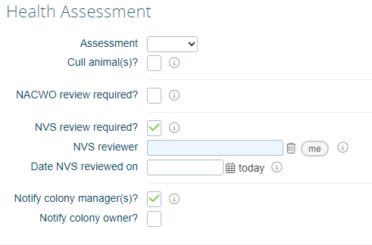
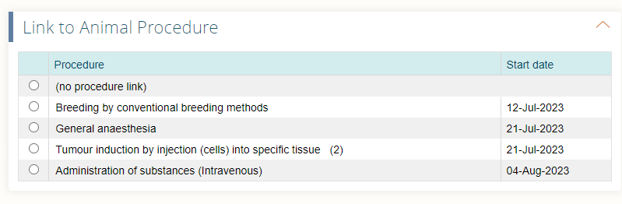
- Link to procedure: A list of all procedures that the animal has undergone appears here, along with an option called ‘no linked procedure’. If the ‘no linked procedure’ option is selected this is not saved by MCMS and will then not appear next time the health concern is edited. If a linked procedure is chosen then that option is saved.
- NACWO/NVS review: These options are currently not widely used, but the NVSs are looking into using these options more to allow advice given to be searchable after a visit. The creator of the health concern can tick that a NACWO or NVS review is required and when the NACWO/NVS comes to review the animal through their login can add in name and date as to who checked the animal and when the review was completed. The report function can then be used to find the relevant records.
Are there any parts of the process you currently follow that you would like to change or do not agree with?
Possible Proposed Actions for MCMS Recording
- Addition of ‘non-procedural’ to severity dropdown list
As described above it is mandatory to assign a severity to the health concern. Rather than listing non-procedural concerns as ‘subthreshold’ another option can be added to the list to allow ‘non-procedural’ to be selected instead. This removes the problem of assigning what would be an extreme non-procedural harm e.g. severe fight wounds from being recorded as subthreshold and not truly capturing what the animal has experienced. However no other severity can be assigned, and any judgement as to the harm the health concern causes would need to be recorded in the comments box.
- Make the linked procedure field mandatory and save when the ‘no link’ option is selected
Currently linking the health concern to a procedure is optional and the function is under-utilised. Number of HCs 2023 and how many are linked to a procedure.
This field could be made mandatory so that a procedure link has to be selected before the health concern can be saved. Alongside this there would need to be an update to MCMS that if the option of ‘no procedure link’ is selected that this is remembered when the health concern is subsequently edited.
This allows for a severity to be recorded alongside recording if the health concern is linked to a procedure or not. However there may then be confusion as to whether or not a health concern is procedure related or not.
Which of the proposed solutions do you feel is best? Or please suggest other other ideas
Guidance to facilitate MCMS recording
- What should I write in the comment section?
It is important to remember that there may be multiple different people reviewing the animal over time and the people that have written comments previously may not be available at the time to ask questions to. Therefore what is in the comments can help to assess if an animal is improving or deteriorating over time. Some useful bits of information to include in the comment are:
- Location: describe where exactly on the animal the issue is. This could include putting left or right, near rump, at base of tail etc.
- Size and number: particularly important for lumps and wounds. Estimate the length of a wound or diameter of a tumour (or even measure it if you are able to), and if there are more than one then state how many wounds or lumps you can see or feel
- Colour: if there are any changes in colour relating to the problem e.g. red, purple, yellow, black
- Descriptors: changes like dry or wet, deep or superficial, shiny or dull,

- Is this procedure related or not?
If it is difficult to decide whether or not something is procedure related or not then based on the Home Office guidance listed above it should be recorded as a procedural harm.
Examples of non-procedural harms are fighting, trapped tails, dehydration, eye conditions and lumps when the animal is not aged or following tumour cell implantation.
Examples of procedural harms include breakdown of a surgical wound, bleeding from an injection site; hunching and piloerection following administration of substances, particularly if they are known to have side effects e.g. tamoxifen.
Other bits of information that can help you decide are if a large proportion of a cohort is affected or if it is an individual animal only and what the procedure was. For example if 10 of 30 mice that were given a subcutaneous injection yesterday have lumps on their neck this is likely to be procedural, but if only one mouse has a lump by the anus a day after a subcutaneous injection it probably isn’t procedural.
Study plans and project licences are also a good source of information as to whether the concern noticed is procedural or not, but if there is uncertainty then a senior technician, NACWO or NVS can be consulted to help with the decision.
Do the points in this section help with adding health concerns on MCMS? Are there other parts that you feel assistance is needed with?
Future Action Points
- Training
To utilise either of the proposed fixes listed above training in actual severity will be required. This can potentially be done in a number of different ways depending on the need:
- Notify relevant groups of the change e.g. the assessors group, trainers group, all animal users, PIL and PPL holders
- Posters can be provided to facilities to show a flowchart of how to assign severity with examples
- Interactive course added to Moodle e.g. pictures or videos of health concerns and multiple choice options of what actions to take, and feedback on the responses.
- Extra information added to PIL course in recognition of ill health and legal modules
- RAT (research animal training) has a severity framework available for those with accounts. Available to PILhs although access will be time limited going forwards.
- Could also be incorporated into NACWO and refresher courses
- Severity framework available through NC3Rs
Please note the options above have not been fully investigated yet, these are suggestions and there may be issues that mean we cannot use a particular approach listed.
- MCMS Guidance
Currently there is a user guide for adding health observations to MCMS. This will be updated depending on outcomes decided.
- SOP and DOPS
Currently the SOP for recording of health observations (SOP 23 - Recognition and reporting animal health check) is being written, so this will be reviewed to ensure it reflects the outcomes decided.
The DOPS that cover identifying health concerns currently have the wording ‘labelling, paperwork and records completed appropriately’ and therefore cover any changes that may be made to the process.
Are there any other actions you feel are needed?

