UNIVERSITY OF CAMBRIDGE AWERB REQUEST

Application for non-regulated use of animals in scientific procedures
(To be completed electronically)

Name of applicant: Maite Bejar
Applicant’s e-mail: mtb48@cam.ac.uk
Applicant’s mobile number: 07759187266
Applicant’s qualifications and experience:
PhD and overall 12 years of working with animals (mice)
PIL holder

Applicant’s professional address (University of Cambridge Department):
Jeffrey Cheah Biomedical Centre, Puddicombe Way, Cambridge CB2 0AW

Name of applicant’s supervisor (if applicable):
Maria Alcolea

Department in which the animal(s) are to be kept (if applicable) or address of the Place Other than Licensed Establishment (POLE) where the work will be undertaken:

Gurdon Institute or AMB

Species, number, sex and strain of animal(s):

Species: mouse
Strain: C57BL6
Sex: either male or female
Number: up to 50 adults (10-12 week old) in six months

The source of the animal(s):
Charles river

Could your work be undertaken using surplus stock animals and if so have you attempted to access surplus stock animals: Yes/ No

If you have answered ‘No’, please explain why:

If you have answered ‘Yes’, which UBS biofacilities have you approached:
Gurdon and AMB facilities.
We would seek for spare surplus adult animals from the facilities when planning the experiment.

Please give details of accommodation in which the animal(s) will be kept:

Mice will be kept in standard IVCs cages.

Will your animals be individually or group housed (if applicable)?

N/A

If individually, why is this necessary, and how long will your animals be individually housed?

If applicable, how will your animals be identified?
N/A

If it is proposed to use animals which are currently under Project Licence authority, please give details (for example, has anything been done to the animals before they are used for this project):

NA

If animals are to be cared for by individuals other than Animal Technicians employed by the University please give details (e.g. qualifications and experience):

NA

Source, amount and duration of funding for this project. Has your funding been peer reviewed and if so, by whom?

Wellcome Trust Sir Henry Dale Fellowship, until 2025

A “regulated procedure” is defined as any experimental or other scientific procedure applied to a protected animal that may have the effect of causing that animal pain, suffering, distress or lasting harm.

“Pain, suffering, distress and lasting harm” encompass any material disturbance to normal health (defined as the physical, mental and social well- being of the Animal). They include disease, injury and physiological or psychological discomfort, whether immediately (such as at the time of an injection) or in the longer term.

Regulated procedures may be acts of commission (such as dosing or sampling) or of deliberate omission (such as withholding food or water).

Why do you believe this research project does not require Project Licence authority under the Animals (Scientific Procedures) Act 1986. Have discussions with the Home Office inspector taken place (if so, please give details):

Animals won’t be subject to any harm or discomfort, they will be used exclusively for tissue collections. We will collect oesophagi, ears and tails of the animals after sacrificing them (project 1, see below). Occasionally we may collect additional tissues as uteri, trachea, lungs, liver or intestine (project 2, see below).

Please provide the scientific background and context for this request.
Project 1: A self-sustaining progenitor cell compartment has been shown to maintain the squamous epithelium of the epidermis and oesophagus. In the epidermis this is supplemented by populations of normally quiescent “reserve” stem cells which are mobilised following injury and contribute to tissue repair after wounding. In the oesophagus there are no quiescent reserve stem cells. The very same progenitor population that maintains the tissue under normal conditions reacquires regenerative stem cell properties in response to tissue injury.
These observations reveal a question of significant relevance for the epithelial stem cell field. Are there any differences in the regenerative potential of tissues harbouring quiescent stem cells (such as the skin), as opposed to those devoid of this population (such as the oesophagus)?

Project 2: Understanding the mechanisms regulating epithelial cell plasticity across different tissues and species holds the key to unveil generic and tissue specific regenerative mechanisms, as well as identify targets of potential relevance for regenerative medicine.
To address this ambitious but critical aspect of epithelial stem cell biology, we will grow different mouse epithelial tissues (oesophagus, biliary tree, endometrium, and airways) under comparable regenerative conditions implementing a unified organoid culture approach. The transcriptional signature
defining organoid-derived cells will be compared at single-cell level among themselves and also to their in vivo counterparts in order to identify shared and specific mechanisms driving epithelial cell plasticity. This study will provide a novel perspective on cell fate decision-making, offering a benchmark to develop shared multi-organ regenerative strategies.

What are the scientific objectives or questions this request aims to address?
The aims of the projects are (1) to understand how stem and progenitor cells adapt their fate in response to injury and environment, and (2) to define a shared set of signaling pathways modulating cell plasticity across epithelial tissues including oesophagus, biliary tree, endometrium and airways.

What scientific outputs do you expect, who will benefit and why?

Cell labelling assays together with the use of targeted inhibitors will allow the characterisation of candidate regulators of cell fate. The basic mechanisms governing cell behaviour in vitro will set up the basis to identify the changes occurring during wound repair and regeneration. Understanding the pathways involved in regeneration will allow us to manipulate them in adult tissue to promote wound healing without scarring.

Killing a protected animal for a scientific purpose at a designated establishment does not require a licence if a method listed in Schedule 1 is used. However, if an alternative method is used, the killing is a regulated procedure and requires personal and project licence authority.
Please describe precisely the Schedule 1 method you intend to use and the secondary method which must be taken to ensure the animal is dead. Guidance on the operation of ASPA (Page 125-126)

Animals will be sacrificed via gentle cervical dislocation and exsanguination. This method is the method of choice used in the Alcolea’s lab for all the experimental procedures that requires the sacrifice of the mice using a schedule1 method without repercussion on the integrity of the tissue.

Please note that animals not subject to the Animals (Scientific Procedures) Act 1986, may be subject to the Protection of Animals Act 1911 and Animal Welfare Act 2006. You may be required to produce relevant authorities and or licences.

Expected duration of the project (Please note for projects or requests for materials that extend beyond 12 months a new application will be required every 12 months).
In relation to the whole project or sourcing request, please provide the planned start and end date.
Start date:
January 2023

End date:

July 2023
If not humanely killed, what will happen to the animals at the termination of the project?
All animals will be used shortly after purchase (a couple of months maximum for adult animals). They will be bought in small batches to avoid having surplus animals.
In case of surplus animals remaining from the experiments they will be offered to other members of the lab or other users.

Please note that if while working with animals you notice any material change in any of your animals or any unexpected adverse effects that are more than minor and transient you must contact a UBS NACWO, NVS and the Director for Governance and Welfare immediately.

Signature of Applicant:  Date: ___12/01/2023

PrintName:_Maite Bejar______________________________________________

Signature of NACWO: 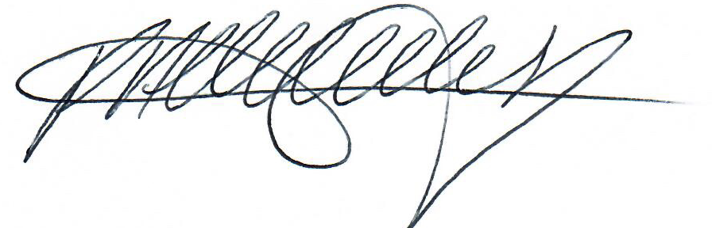 Date: 13/01/23

Print Name: Polly Attlesey____________________________
Signature of NVS: 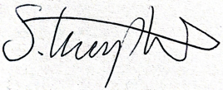 Date: 13/01/2023

Print Name: __________Sophie Kimpton_____________________________

Signature of Chairperson: Date:
of the UBS AWERB Committee

Print Name: _______________________________________________________

Please return this completed form to the Named Animal Care and Welfare Officer (NACWO) for your Department who will progress the application through the AWERB Process.

Please do not arrange to start work or source materials from animals until you have received this form countersigned by the UBS AWERB Chairperson or delegated deputy.

