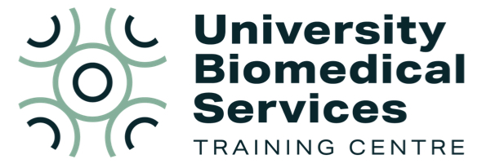
UBS Training Centre Updates

The UBS Training Centre offer advice and assistance with training and competency, in addition to providing training courses.

- If you are experiencing any problems with training and/or assessment within UBS, contact us: ubstraining@admin.cam.ac.uk.

- You can also find some resources on our webpage which may help answer some common queries: Training Centre | University Biomedical Services (UBS)


Staffing Update
Mia Watkins, Training and Competency Supervisor
Mia has recently joined the team to help advise on practical training, assessment, DOPS writing and reviews as well as any MCMS related queries. Mia delivers PIL material as part of her role too, she also has extensive experience with breeding and experimental work. If you need any assistance with training, assessments, DOPS or practical assistance for these areas in facilities, please get in touch.
Home Office Personal Licence courses
From September 2026, we are moving the course exams into the live session’s week, so everything is covered within one week. Those course exams covering advanced anaesthesia and/or surgery will take place on Friday. All others will take place on the Thursday. This means less of a delay for certificates and re-sit exams.
Trainers and Assessors Resource
The Training Centre has put together a central hub for trainers and assessors on Moodle. This resource aims to provide both trainers and assessors with key content to help facilitate training and assessment across UBS bio facilities. For example, assessors can locate registered assessors within UBS, find previous meeting minutes and material, glossary of terms used, useful flow charts etc. We ask that trainers and assessors make the most of this resource and if you think anything needs adding, then to let us know. If you need access to this resource, please contact the training centre at ubstraining@admin.cam.ac.uk
Course: Trainers and Assessors Resource | Moodle
Trainers/Assessors
How to become a Trainer - Researchers are not required to undertake the Train the Trainer course to be able to train, however it is recommended. Users must be competent in the task/method to be able to train those methods. Schedule 1 must only be trained and assessed by UBS staff.
To train as a researcher, you will need to contact the training centre or your researcher assessor to be added as a trainer for that technique, otherwise, you will not be able to add training records on MCMS.
UBS staff are required to undertake the Train the Trainer course to officially train tasks/procedures, they will only be able to train in areas which they are competent in (with an up-to date MCMS competency) and marked as a trainer.
Delivered in self-placed online modules, interactive quizzes, live sessions with opportunity for discussion as well as guidance documents and lesson plans. You will cover modules such as training plan structure, learning styles, constructive feedback and much more.
How to become an Assessor - Research staff can become assessors by completing the Researcher Assessor course.
UBS staff should speak to their manager about whether they can attend the Nominated Assessor course.
This course is designed to enable individuals to effectively assess using DOPS (Direct Observation or Practical Skills), participants will gain necessary skills to evaluate competency effectively and provide meaningful feedback.
Both courses will equip you with the skills, supporting with career development as well as helping with delivery of training/assessment across UBS.
Training and Assessment Webinar
Join us for this free webinar which sets out how training and assessment works within UBS. This webinar is a must for anyone unclear on the current process, or just as a refresher and confirmation you are following the correct procedures. The webinar will consist of a short presentation (approx. 15 minutes), there will be time for any questions.
Home Office Project Licence course
The course is currently undergoing an update, and the new course will be available from September 2026. It will still be offered online and on demand.
Module 6.3 (KD)
Please remember that anyone who isn't a PIL holder but is required to kill animals by a Schedule 1 method, must complete this online, on demand course before commencing practical training.

For further information on any of our courses, please visit our website or contact us at ubstraining@admin.cam.ac.uk.

