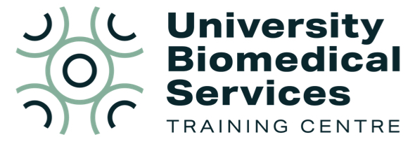
Did you know that UBS have their own dedicated Training Centre?

The UBS Training Centre offer advice and assistance with training and competency, in addition to providing training courses.

- If you are experiencing any problems with training and/or assessment within UBS, contact us: ubstraining@admin.cam.ac.uk.

- You can also find some resources on our webpage which may help answer some common queries: Training Centre | University Biomedical Services (UBS)

Meet the team
Pilar Browne, Head of UBS Training Centre and NTCO
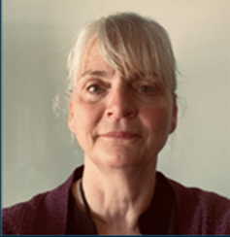
As the Head of the Training Centre and a Named Training and Competency Officer (NTCO), Pilar is exceptionally well placed to advise on any training, competency, or assessment queries. Pilar is also responsible for Home Office training courses, developing new training, and ensuring the smooth running of the Training Centre. As an NTCO, Pilar helps to shape how training and assessment is carried out in UBS and wants to hear if you are experiencing any problems.
Lisa Luke, Apprenticeship Scheme Manager and Training Centre Coordinator

Lisa’s role is focused on technician training and delivering IAT Diplomas and Continuing Professional Development (CPD) courses. She also manages a team of bank technicians who work across UBS biofacilities. Lisa is the current point of contact for DOPS and MCMS within the Training Centre and can advise on training and competency assessments within facilities. If you need help with any aspect of DOPS, training, or assessments, please get in touch.
Claudia Cheadle, Training Administrator
If you’ve ever booked a course with us, chances are you have heard from Claudia! Claudia takes course bookings, books exams, sends out results and certificates, and much, much, more! Claudia can also answer queries about our training courses and assist with any issues you may have.
Upcoming courses – for more dates and courses, please see our website
Researcher Assessor - 5th February 10am-12pm (online live session with pre-reading and final assessments)
For research staff working in UBS facilities, this course satisfies the requirements to assess within UBS. Attendance is still free for the first member of each research group!
Train the Trainer - 5th March 10am-12:30pm (online live session with pre-reading and final assessments)
The next presentation of our very popular course for anyone involved in training others in the animal facility. Learn about teaching theory, inclusive practice, training techniques, session planning, giving feedback, and recording training. This course is encouraged for anyone training within UBS.
PIL Training – monthly, January – March
Our PIL courses run monthly, except for April and August. Courses are available for the following species: Amphibia, avians, cattle, fish, horses, New World primates, pigs, poultry, rabbits, rodents, sheep.
On-demand training – start any time, self-guided study
PIL refresher - Designed to refresh knowledge and maintain currency of qualifications, this course is delivered in a modular format. Only modules that appear on your PIL need to be taken. This means that the route taken is specific to your requirements. The course and exams are completed wholly online.
Function D (EU Module 6.3) - This online course is for anyone who will be carrying out Schedule 1, but not regulated procedures, who has not completed other relevant PIL training. It covers legislation, ethics, biology, recognising ill health, safety and euthanasia modules, but with information specific to, and around, Schedule 1.
PPL course - Completion of the PPL course is mandatory for anyone wishing to become a Project Licence holder under ASPA. This online modular course looks at ethics and welfare, experimental design, project applications and management.
Training and Assessment webinar Join us for this free webinar which sets out how training and assessment works within UBS. This webinar is a must for anyone unclear on the current process, new to animal research within UBS, or anyone who wants to ensure that training and assessment run smoothly within their group.
The webinar will consist of a short presentation (approx. 15 minutes) followed by a Q&A session. Next dates: Tues 13th Jan 10am, Thurs 12th Feb 2pm, Tues 10th Mar 10am.
For further information on any of our courses, please visit our website or contact us at ubstraining@admin.cam.ac.uk.

