

NC3Rs webinar: 3Rs self-assessment tools for research groups and institutions
https://nc3rs.org.uk/events/nc3rs-webinar-3rs-self-assessment-tools-research-groups-and-institutions
These tools provide a framework for collating, tracking and benchmarking 3Rs activities and progress. Voluntary, and confidential. Access is only to the approved Establishment or Team lead user.
- Research Group Tool (RGT)
- Research Institution Tool (RIT)
https://3rsselfassessment.nc3rs.org.uk/
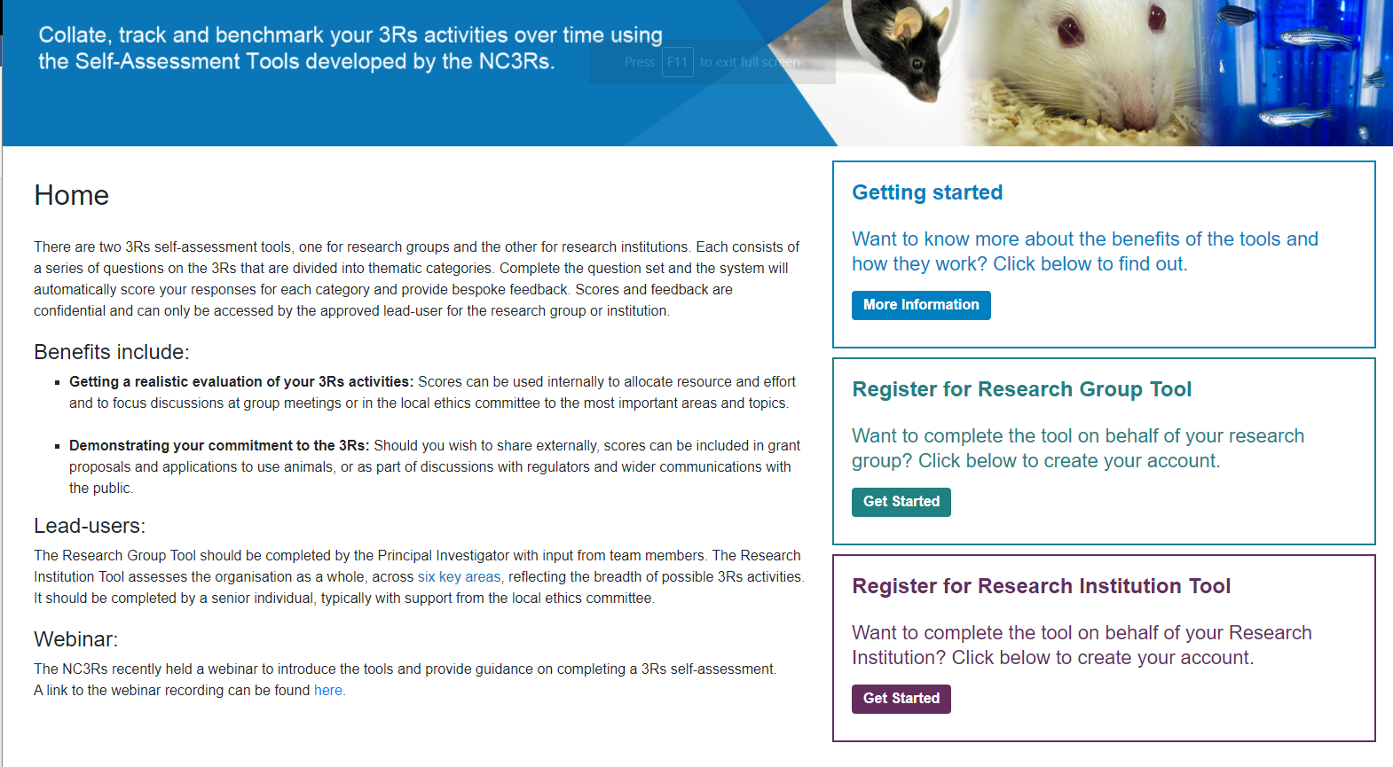
Complete the question sets and the system automatically scores your responses, providing bespoke feedback.
Everyone says they’re “committed to the 3Rs” – and these tools should help document how, demonstrate activity, and highlight what more could be done.

Benefits:
- Focus efforts – scores can be used internally to allocate resources and concentrate discussions (at lab meetings or AWERBs) on the most important 3Rs areas.
- Track progress – the self-assessment process can be repeated, and multiple scores logged over time, to see how 3Rs culture has developed.
- Find out what has worked before – bespoke feedback gives advice and suggestions for improvement.
  - Provides examples of successful initiatives from other institutions.
- Demonstrate commitment to the 3Rs – users may wish to share their scores externally (e.g., grant proposals, applications for approval to use animals, or as part of discussions with regulatory bodies or the public etc).
- Convert policy into practice – a clear and comprehensive method for assessing 3Rs activities in relation to best practice, helping ensure 3Rs policy is reflected in actions.
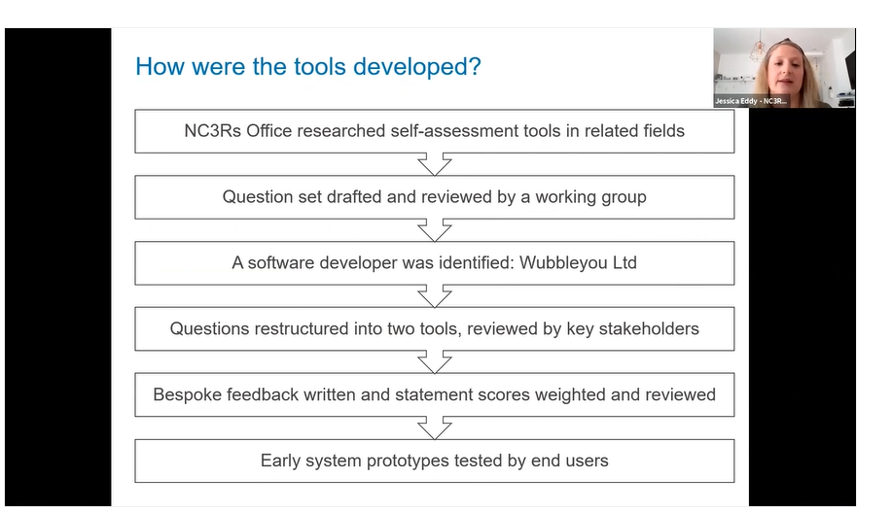
Working group consisted of Named People as well as researchers.
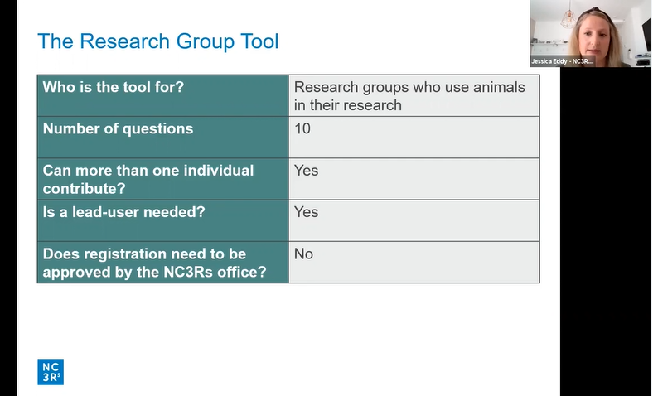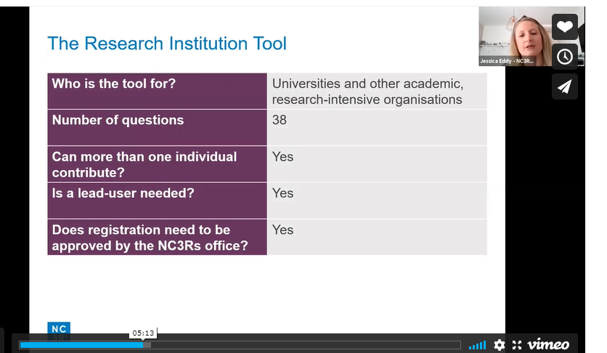
Overarching questions, with supporting statements underneath: Yes/ No/ N/A (mostly), some have free-text options too.
Based for UK users, some international explanation.
Registration to the NC3Rs Office for the RIT is to demonstrate what that person is the most appropriate Lead User for the establishment, to safeguard against people filling out on behalf of an organisation that they are not part of.
The Lead User can then delegate Sub-Users – e.g., PPLh can delegate post-docs, AWERB Chair can delegate Named People, etc.

The Research Group Tool
Example questions:
- Engaging with the 3Rs
  - How engaged is you group with the 3Rs?
    - The 3Rs are regularly discussed in group or sub-group meetings where experiments are planned, ongoing work is discussed, and data is reviews at the end of studies: Y / N
- Developing and implementing 3Rs initiatives
- Reviewing and improving research involving animals
  - Are N numbers justified when determining experiments group sizes for all animal experiments?
    - When undertaking hypothesis-testing studies, your group members perform power calculations to determine the number of animals required per group: Y / N
- Training in the 3Rs
  - Are group members encouraged to attend 3Rs-focused events?
    - Resources are available for all group members to attend at least one 3Rs-focused event every 12 months: Y / N
Feedback:
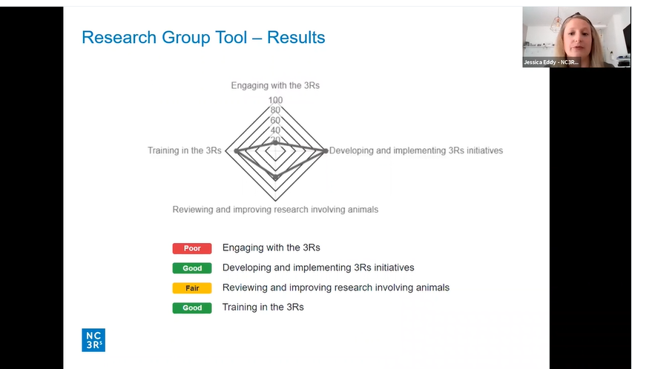
As well as written feedback suggestions, sometimes including links to other resources.

The Research Institution Tool
Example questions:
- Leadership
  - Who has the main responsibility for driving and coordinating 3Rs activities across the institution?
    - The AWERB
    - The Named People
    - An academic 3Rs lead
    - Departmental Champions
  - Is there a coordinated strategy to promote and implement 3Rs across your institution?
    - A strategy has been written… etc
- People
- Research and Infrastructure
  - Is information on 3Rs-focused research funding calls widely disseminated across you institution?
    - The research office (or equivalent) disseminated 3Rs research funding calls across all relevant departments: Y / N
  - Are there mechanisms in place to ensure effective colony management at your institution?
    - All those with day-to-day responsibility for breeding colonies have received training in CM and maintaining GA lines in the past 2 years: Y / N
- Experimental Design and Reporting
  - Do researchers at you institution who undertake work involving animals have access to a biostatistician?
  - Is there an awareness of the NC3Rs Experimental Design Assistant within your institution?
    - Information about the EDA is circulated via email and newsletters: Y / N
- Training
  - Is 3Rs training provided to bioscience postgraduate students not undertaking animal research at you institution?
    - One or more 3Rs sessions are provided as part of a training program for all bioscience postgraduate students: Y / N
  - Does your institution provide all relevant research staff with 3Rs-relevent professional development opportunities?
    - All relevant research staff have the opportunity to attend internal and external 3Rs conferences and workshops: Y / N
- Publications and Wider Dissemination
Feedback
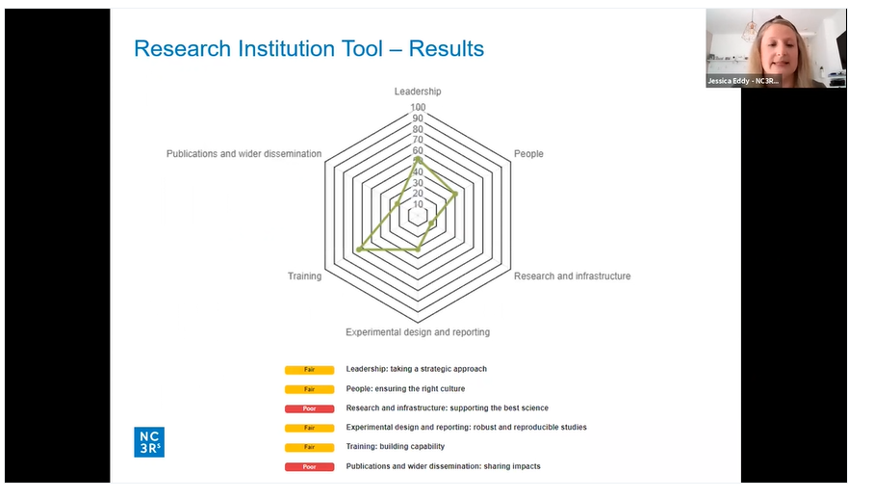
As well as written feedback suggestions, sometimes including links to other resources.
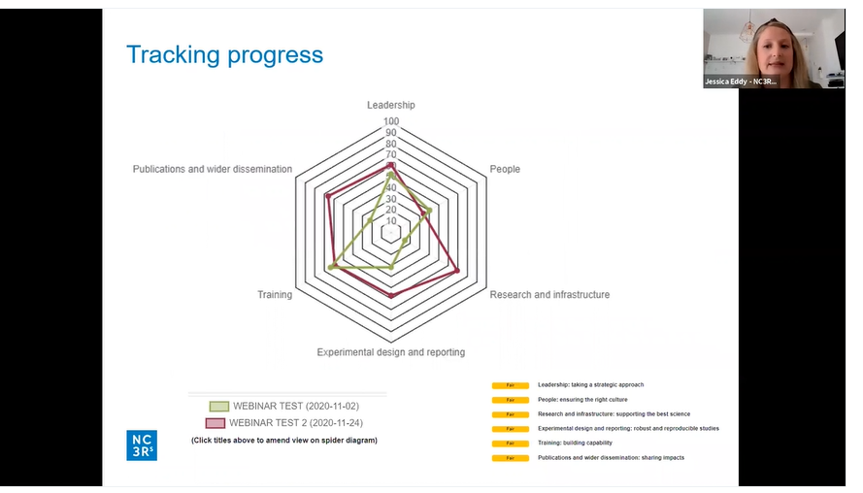

An honest reflection – will help you get the most out of the tool, and to receive appropriate feedback and suggestions. Your answers and results will remain confidential.
Data and confidentiality – NC3Rs can see stats such as use and access, overarching scored enabling whole population benchmarking, and information re feedback/ system failures/ improvements to be made. They cannot see individual answers or inter-user correspondence.
Video tutorials exist in the dashboard area, once logged in.
Self-assessment@nc3rs.org.uk

