MCMS Health Concerns Review
August 2024

Following on from the launch of the amended MCMS Health Concerns list last November 2023 (Appendix 1), their usage has been reviewed over the last 6 months from January 2024 to July 2024 across all UBS units. Comments and suggestions from staff have also been reviewed and informed the proposed changes outlined below.

See Box 1 for the Top 10 most used MCMS Health Concerns across all of UBS from January to July 2024.

- Found Dead
Box 1 – Top 10 used Health Concerns across all of UBS
Jan – Jul 2024
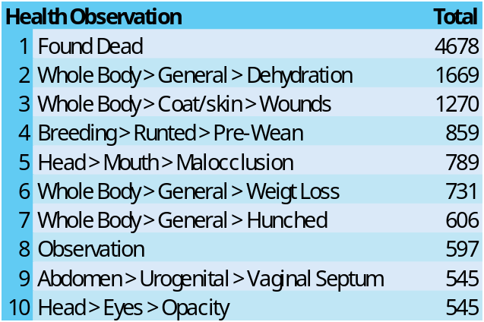
A total of 18,087 Health Concerns were recorded across all UBS Jan-Jul 2024.
This is as expected. Please remember to add comments to this automatically created Health Concern to document any observations or causes of death noted at that time.
Any animal found dead should have a post mortem carried out to check for any abnormalities and assist with SC18 writing.

- Dehydration
This is expected. There is an ongoing project at AMB by the Auto-Watering Working Group to investigate animal care and equipment operation to reduce the number of dehydration cases.

- Wounds
This is as expected and holds no concern for us.
Please remember to add “fighting” to the comments box to make it a searchable feature if the tracking of fighting in a colony is needed.

- Pre-Wean Runted
This is as expected.

- Malocclusion
This has been the topic of investigation by the licencing team over the last year or so. A Moodle training course is in development to help technicians with cases of Malocclusion. Further details are given Section 8.2 of this document.

- Weight Loss
This is as expected.

- Hunched
This is as expected.

- Observation
It was not expected that the option of “Observation” would need to be used so frequently across UBS. The comments made for each Observation Health Concern were reviewed to understand this more:
  - Over a third of these health concerns related to health concerns that already exist in the list
Typically: Hock Swelling, Swollen Abdomen, Piloerection, Hunched, Wounds, Inactive, Runted, Weight loss.
Please use existing health concerns wherever possible and reserve this health concern for when there is no other one appropriate.
  - Malocclusion
Please use the Malocclusion health concern for any abnormality seen in teeth not covered by the ‘missing/broken’ option and use the comments and the severity to explain the situation in more detail.
Please use the new training, coming soon on Moodle.
  - Multiple Signs
Sometimes more than one health concern exists together e.g. piloerection and hunching and weight loss – so please pick the one you are most concerned by and add the other signs seen to the comments, or multiple health concerns can be added to cover multiple signs
TIP: if it’s not clear which to pick, write the comment first and choose whichever term was written first. This can always be changed subsequently.
  - Hydrocephalus/ Domed Head
The reason for not including hydrocephalus as a selectable observation in this list is that while a domed head is very likely to be hydrocephalus, there is a possibility it isn’t and this can’t be determined until post mortem or with imaging. The available options will change from ‘deformed’ to ‘domed’ so to cover suspected hydrocephalus or ‘misshapen’ to cover other head deformities.

  - Other
It became clear from reviewing the comments for ‘observations’ that some terms needed to be updated to ensure they covered what was being seen. These are detailed in the proposed changes below.
- Vaginal Septum
This holds no concern for us. UBS along with the Colony Management Group are looking to provide some guidance of the management of colonies and individuals with vaginal septa.

- Eye Opacities
This is as expected.

Proposal of Health Concerns to be added, removed or changed:
- Additions:
  - Phenotype options:
    - Phenotype > tumour
      - Phenotype > tumour > ulcerated
    - Phenotype > aging
    - Phenotype > other
  - Head > general > swelling
  - Whole body > general > major injury
  - Head > eyes > hair loss
  - Head > general > misshapen
- Changed terms:
From: | To:
Abdomen > anus > Discharge | Abdomen > Anus > Bleeding/ Discharge
Whole Body > General > Emaciated | Whole Body > General > Underconditioned (low BCS)
Head > Ears > Discharge | Head > ears > discharge/bleeding
Abdomen > anus > discharge | Abdomen > anus >discharge/bleeding
Head > mouth > mass on skin | Head >mouth > mass
Head > general > deformed | Head > general > domed
NVS > complication > surgery | Procedure > complication > surgery
NVS > complication > anaesthesia | Procedure > complication > anaesthesia
NVS > complication > procedure | Procedure > complication > minor procedure
Extremities > limbs > swollen hock with wound | Removed from Rat list only
Extremities > limbs > hock wound | Removed from Mouse list only

- To be removed:
  - Extremities > Limbs > Extra Digits
  - Extremities > Limbs > Ulcerated
  - Head > Ears > Absent
  - Whole Body > Mammary Glands > Absent
  - Whole Body > Mammary Glands > Discharge

We ask that this document is reviewed ahead of the AOC meeting scheduled for 20th September 2024, and provide any comments or questions to Sophie and Amelia ahead of or during this meeting.

Appendices

Appendix 1
MCMS Health Observations Infographic July 2023
