From Dean: Using the Comments Feature on MCMS

“The 'Edit cage for comment' image is a screenshot of what you see when you scan a cage label, and I've circled the part saying 'edit'. Once you press edit, you will see the page that I have screenshotted in the attached 'Adding comments to mice' image. You can then press save, and when you print out the label ('Cage card example' image), you can see on the right hand-side in the comments section which mice are ex-breeders (all of them in this case!) and I've also written how many litters each one has had just so I can keep track and make sure they don't exceed six litters in case they were going to be set up again. To find out how many litters each mouse has had, you click on the individual mouse's I.D. and you will go to a page showing all of their information including their mating history (circled in the attached 'Mating history' screenshot). You can then click on each of their previous matings and see how many litters they had as part of each pair”

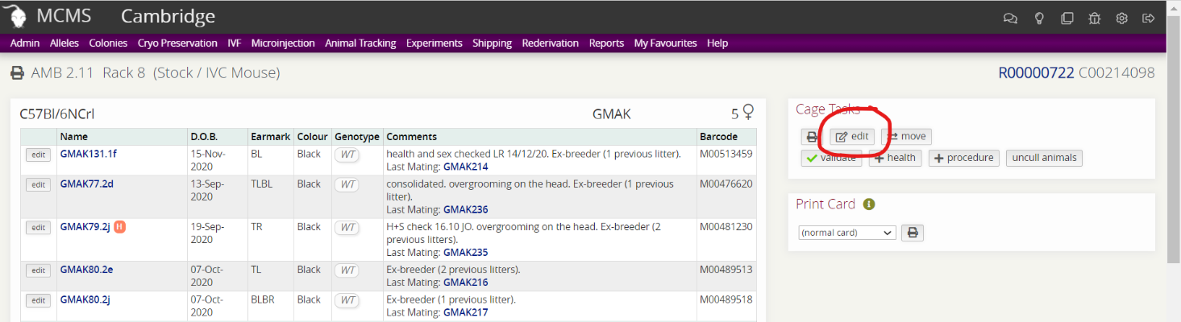
Edit cage for Comment

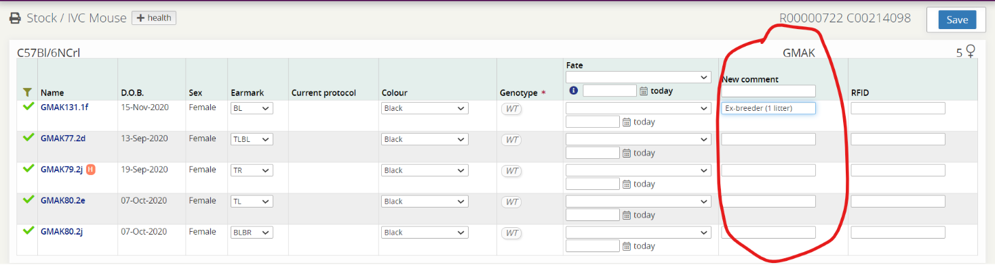
Adding comments to mice

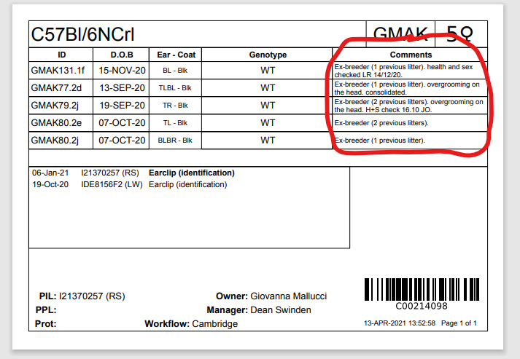
Cage card example image

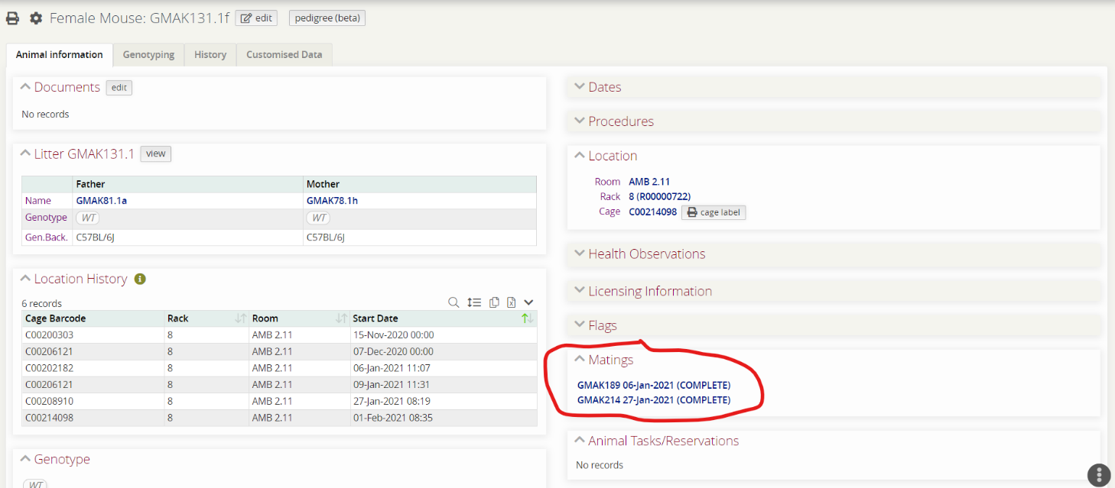
Mating history

