IMproving Preclinical Assessment of Cardioprotective Therapies (IMPACT)
– Small animal acute myocardial infarction network

Sauri Hernandez-Resendiz*^{1,2}, Reinis Vilskersts*^{3,4}, David Aluja^{5,6}, Ioanna Andreadou⁷, Peter Bencsik^{8,9}, Maija Dambrova^{3,4}, Panagiotis Efentakis⁷, Fei Gao², Zoltan Giricz^{8,10}, Javier Inserte^{5,6}, Roisin Kelly-Laubscher¹¹, Attila Kiss¹², Thomas Krieg¹³, Benda Kwak¹⁴, Sandrine Lecour¹⁵, Gary Lopaschuk¹⁶, Michał Mączewski¹⁷, Marta Oknińska¹⁷, Pasquale Pagliaro¹⁸, Bruno Podesser¹², Hiran A. Prag¹³, Marisol Ruiz-Meana^{5,6}, Tamara Szabado⁸, Michał Waszkiewicz¹⁷, Coert Zuurbier¹⁹, Peter Ferdinandy^{8,10**}, Derek J Hausenloy^{1,2,20,21**}

*These two authors made an equal contribution and should be considered joint first authors.
** These 2 authors should be considered joint senior authors.

¹Cardiovascular and Metabolic Disorders Programme, Duke-NUS Medical School, Singapore.
²National Heart Research Institute Singapore, National Heart Centre Singapore, Singapore.
³Laboratory of Pharmaceutical Pharmacology, Latvian Institute of Organic Synthesis, Riga, Latvia.
⁴Department of Pharmaceutical Chemistry, Riga Stradins University, Riga, Latvia.
⁵Vall d’hebron Institut de Recerca (VHIR), Hospital Universitari Vall d’Hebron, Barcelona, Spain.
⁶Centro de Investigación Biomédica en Red Cardiovascular (CIBER-CV), Instituto de Salud Carlos III, Madrid, Spain.
⁷Laboratory of Pharmacology, Faculty of Pharmacy, National and Kapodistrian University of Athens, Athens, Greece.
⁸Department of Pharmacology and Pharmacotherapy, Albert-Szent-Györgyi Medical School, University of Szeged, Szeged, Hungary
⁹Pharmahungary Group, Szeged, Hungary
¹⁰MTA-SE System Pharmacology Research Group, Department of Pharmacology and Pharmacotherapy, Semmelweis University, Budapest, Hungary.
¹¹Dept of Pharmacology and Therapeutics, University College Cork, Ireland
¹²Center for Biomedical Research and Translational Surgery, Medical University of Vienna, Austria
¹³Department of Medicine, University of Cambridge, Cambridge, UK
¹⁴Department of Pathology and Immunology, and Geneva Centre for Inflammation Research, Faculty of Medicine, University of Geneva, Geneva, Switzerland.
¹⁵Cape Heart Institute, Faculty of Health Sciences, University of Cape Town, South Africa
¹⁶Cardiovascular Research Centre, University of Alberta, Edmonton, Canada
¹⁷Department of Clinical Physiology, Centre of Postgraduate Medical Education, Warsaw, Poland.
¹⁸Clinical and Biological Science Department, University of Turin, Italy
¹⁹Amsterdam UMC, Location AMC, Amsterdam Cardiovascular Sciences, Department of Anaesthesiology, Laboratory of Experimental Intensive Care and Anaesthesiology (L.E.I.C.A.), Amsterdam, The Netherlands.
²⁰Yong Loo Lin School of Medicine, National University Singapore, Singapore.
²¹The Hatter Cardiovascular Institute, University College London, London, UK.

Co-Corresponding authors:

Professor Derek J Hausenloy
Cardiovascular & Metabolic Disorders Program
Duke-NUS Medical School
8 College Road,
Singapore 169857
Email derek.hausenloy@duke-nus.edu.sg

Professor Péter Ferdinandy
Department of Pharmacology and Pharmacotherapy,
Semmelweis University,
Nagyvárad tér 4, Budapest, 1089 Hungary
email peter.ferdinandy@pharmahungary.com

Statements and Declarations

Competing Interests:
TK is Chief Medical Officer and Founder of Camoxis Ltd. TK and HAP are in part funded by the British Heart Foundation. P.F. is the founder and CEO and ZG is involved in the management of Pharmahungary Group, a group of R&D companies. DJH has received: consultant fees from Faraday Pharmaceuticals Inc. and Boehringer Ingelheim International GmbH; honoraria from Servier; and research funding from Astra Zeneca, Merck Sharp & Dohme Corp and Novonordisk. All other authors declare no competing interests. In case of industrial interest, Pharmahungary Group will organize multicenter studies involving the selected and validated sites of the current COST action (IG16225) according to the COST action final report.

Abstract

Background
Although many cardioprotective therapies and strategies have been shown to limit infarct size (IS) in pre-clinical animal studies of acute myocardial ischemia/reperfusion injury (IRI), their translation into the clinical setting for patient benefit has been disappointing. A contributing factor to this translational failure is the lack of rigor and reproducibility of the preclinical studies. To address this, we have established the IMproving Preclinical Assessment of Cardioprotective Therapies (IMPACT) small animal multisite acute myocardial infarction (AMI) network with centralized randomization and blinded core laboratory IS analysis and have validated our network with the endogenous cardioprotective strategy of ischemic preconditioning (IPC).

Methods and Results
Seven sites in the COST Innovators Grant (IG16225) network participated in the IMPACT multisite AMI network. Using a centrally generated randomization list, mice and rats were allocated to the control (N=48 mice, N=39 rats) or IPC (N=42 mice, N=36 rats) treatment groups. The control IRI group comprised 45 min (mice) or 30 min (rat) left coronary artery (LCA) occlusion followed by 24h reperfusion. IPC comprised 3 x 5-min alternating cycles of occlusion/reperfusion prior to IRI. IS was determined by a centralized blinded core laboratory. The size of the area-at-risk (AAR) was heterogenous in mice but not among rat sites. Although not all sites showed significant cardioprotection with IPC, the pooled analysis of the five mouse sites showed that IPC significantly reduced IS/AAR by 35% compared with the control (30±16% versus 46±13%; p<0.005), while in the pooled analysis of the four rat sites, IPC significantly reduced IS/AAR by 29% when compared to control (32±19% versus 45±14%; p<0.01).

Conclusion
We have established new IMPACT multisite mice and rats AMI networks with centralized randomization and centralized blinded core laboratory analysis of IS and have demonstrated cardioprotection by IPC. The evaluation of novel cardioprotective therapies in this network may help to increase the reproducibility of cardioprotection studies and the likelihood of translating them into the clinic for patient benefit. However, further studies are needed to take into account the presence of factors such as comorbidities/comedications which are known to confound cardioprotection and may also impact on clinical translation.

Keywords: Ischemic preconditioning; ischemia/reperfusion injury; randomized controlled trial; acute myocardial infarction; multisite network; small animal models.

1. Introduction

Acute myocardial infarction (AMI) and the subsequent heart failure (HF) that often follows are among the leading causes of death and disability in Europe and worldwide. As such, new treatments are needed to reduce myocardial infarct size (termed ‘cardioprotection’), preserve cardiac function, and prevent the onset of HF. Although many therapies have been reported to reduce myocardial infarct size (IS) in preclinical animal acute myocardial ischemia/reperfusion injury (IRI) studies, their translation into the clinical setting for patient benefit has been disappointing [3, 4, 6-8]
A primary obstacle to translating cardioprotective therapies and strategies into clinical practice has been the lack of systematic and robust preclinical evaluation before embarking on clinical testing. Indeed, recent meta-analyses of preclinical studies showed large heterogeneity in the quality of study design and reporting [2, 15]. Moreover, one of these meta-analyses showed a discrepancy between the meta-analysis and a three-center in vivo study [15]. These results underscore the need for randomized controlled multicenter preclinical studies in cardioprotection. To address this, the EU-CARDIOPROTECTION COST Action (CA16225), a network of cardioprotection researchers, has published guidelines aimed at improving the reliability and rigor of preclinical cardioprotection studies [1] and have also introduced the IMproving Preclinical Assessment of Cardioprotective Therapies (IMPACT) criteria, a detailed step-by-step framework aimed at improving the success of translating cardioprotection from pre-clinical animal studies into the clinical setting for patient benefit [12]. One key component of the IMPACT criteria includes evaluating the novel cardioprotective therapy in a small animal AMI network of research centers.
In this study, we have established new mice and rat AMI multisite networks to improve the pre-clinical evaluation of novel cardioprotective therapies in order to advance the clinical translation of cardioprotection and ensure that only the most effective treatments are tested in patients. Due to the lack of a positive control pharmacological agent that has been shown to reduce infarct size in large cohort of patients, we utilized ischemic preconditioning (IPC) [13], a well-established endogenous cardioprotective strategy induced by repeated brief mechanical occlusion and reperfusion of the coronary artery prior to the acute myocardial infarction, to validate our small animal AMI networks.

2. Methods

2.1. The IMPACT small animal network
The IMPACT small animal network was centrally coordinated by an IMPACT working group comprising: (1) the principal investigator (PI) and team members from each of the participating sites who performed the IRI studies; (2) the IMPACT Image Analysis Core Lab (IACL), which performed the centralized core laboratory IS analysis (Latvian Institute of Organic Synthesis, Riga, Latvia); (3) the IMPACT statistical core (Duke-NUS/NHCS, Singapore) who provided the randomization lists to the sites and undertook all the statistical analyses; and (4) external advisors, who were not participants in the network and provided advice to the network.
Prior to beginning the studies for the IMPACT network, each site underwent rigorous quality control assessment of their infarct images by the IMPACT IACL, with individual feedback provided to each site for optimization of the infarct images. Only those sites that passed the quality control process went on to perform the IRI studies for the IMPACT network. Seven sites in the IG16225 network that agreed to participate in the IMPACT small animal multisite AMI network passed the quality control process and participated in the AMI network studies as follows:

Mice-sites (M-S): M-Site 1 - University of Szeged and Pharmahungary Group (Hungary); M-Site 2 - University of Cambridge (Cambridge, UK); M-Site 3 - Vall’Hebron Institut de Recerca (VHIR) (Barcelona, Spain); M-Site 4 - Duke-NUS and NHCS (Singapore); and M-Site 5 - National and Kapodistrian University of Athens (Athens, Greece).

Rats-sites (R-S): R-Site 1 - Semmelweis University and Pharmahungary Group (Budapest, Hungary); R-Site 2 - Duke-NUS and NHCS (Singapore); R-Site 3 at the Latvian Institute of Organic Synthesis (Riga, Latvia); and R-Site 4 - Centre of Postgraduate Medical Education (Warsaw, Poland).

All the participating sites had previously established the mice and/or rat IRI model in their respective laboratories.

2.2. Animals
All experimental protocols conformed to the EU directive 2010/63EU on the protection of animals used for scientific purposes and the Animal Research: Reporting of In Vivo Experiments (ARRIVE) guidelines [14]. The experimental protocols were formally approved by the appropriate national or institutional ethics committees, underscoring our adherence to ethical scientific practices and commitment to the highest standards of reproducibility and transparency.
Male C57BL/6J or C57BL/6N mice (aged 8-14 weeks, body weight ~23-30 g) were kept in specific pathogen-free conditions with unrestricted access to food and water according to local husbandry conditions at each site (Table S1). Male Sprague-Dawley and Wistar rats, aged 8-12 weeks and weighing between ~230-300g, were kept with unrestricted access to food and water according to local husbandry conditions at each site (Table S2).

2.3. IMPACT small animal study protocol
The IMPACT working group drafted the study protocols in which both mice and rats were randomized to one of the following groups according to the centralized randomization list provided by the IMPACT statistical core: (1) Control IRI; and (2) IPC. In the control IRI protocol, mice underwent 45 min and rats underwent 30 min of left coronary artery (LCA) ischemia, each followed by 24 h of reperfusion. In the IPC protocol, both mice and rats underwent three cycles of 5 min of LCA ischemia, interspersed with 5 min reperfusion, immediately before the index IRI. After 24 h of reperfusion, the IS and area-at-risk (AAR) ratio was assessed (Fig. 1).
Predefined exclusion criteria included: failure to induce ischemia with LCA ligation, failure of reperfusion following removal of occlusion, damage to the LCA during needle insertion or occlusion and reperfusion, ventilation problems during surgery, and uncontrolled bleeding. For details of the preoperative preparation procedure, surgical procedure, postsurgical care and analgesia, and measurement of IS at each of the sites please see Tables S3-S8.

2.4. Central measurement of infarct size by the IMPACT Image Analysis Core Lab
The IMPACT IACL analyzed the infarct images from all sites in a blinded fashion using computerized planimetry with Image-Pro Plus version 6.3 (Media Cybernetics). The laboratory measured the IS as the non-TTC-stained area within the left ventricle (LV) AAR and calculated the AAR as the total LV region unstained by Evans blue (EB). Additionally, non-AAR was determined by the EB-stained region and viable myocardium by the TTC-stained area within the AAR. The primary study outcome was the IS/AAR ratio, presented as a percentage of LV. The exclusion criteria for image analysis included an IS/AAR ratio of ≥90% or <10% for IRI-affected hearts or an AAR/LV ratio of <10%.

2.5. Central randomization and statistical analyses by the IMPACT Statistics Core
The IMPACT Statistics Core provided the central randomization list to each site, performed data unblinding following completion of all IRI studies and undertook the statistical analysis for all the IRI studies. A sequence of treatments (Control and IPC) randomly permuted was generated for each center and a central randomization list was provided to each site for 24 animals (N=12 Control, N=12 IPC) to allow for exclusions and mortality. Myocardial AAR, IS and IS/AAR were analyzed separately. Data were tested for normal distribution using the Shapiro-Wilk test. The myocardial AAR, IS, and the ratio of IS/AAR were analyzed using the Wilcoxon rank-sum test and pooled data analysis using two-way ANOVA in STATA version 18. Statistical significance was set at p<0.05.

3. Results

3.1. Study exclusions
Details of animal exclusions based on predefined criteria and mortality are listed in supplementary Tables S9 and S10.

3.2. Cardioprotective efficacy of IPC in IMPACT Mice AMI network
In the pooled analysis of 5 sites there were no significant differences in AAR/LV% between the control and IPC groups (42±17% vs. 43±15%, respectively; p=ns; Fig. 2A) However, there were significant differences in AAR/LV% between sites (P<0.001). IPC significantly reduced IS/AAR% by 35% when compared to control group (30±16% vs. 46±13%, respectively; p<0.005; Fig. 2B). Evaluation of IS/AAR% from the individual sites, 3 sites (M-Sites 2, 3 and 5) showed significant cardioprotection with IPC, with one site (M-Site 4) showing a non-significant reduction in IS, and one site (M-Site 1) failing to show IS reduction with IPC (Fig. 4).

3.3. Cardioprotective efficacy of IPC in IMPACT Rat AMI network
In the pooled analysis of 4 sites there were no significant differences in AAR/LV% between Control and IPC groups (41±11% vs. 39±9%; p=ns; Fig. 3A). IPC was shown to significantly reduce IS/AAR% by 29% when compared to control group in the pooled analysis of 4 sites (32±19% vs. 45±14%, respectively; P<0.01; Fig. 3B). Evaluation of IS/AAR% from the individual sites, 3 sites (R-Sites 1-3) showed significant cardioprotection with IPC, with one site (R-Site 4) failing to show IS reduction with IPC (Fig. 5).

4. Discussion
In this study, we have successfully established mice and rat multisite AMI networks for evaluating the efficacy of novel cardioprotective therapies using centralized randomization and centralized blinded core lab analysis of IS, which should result in improved reliability and reproducibility of preclinical cardioprotection studies. We have demonstrated significant reductions in IS with the established endogenous cardioprotection strategy of IPC [5, 9] when compared to control thereby validating these two small animal AMI networks for testing novel cardioprotective therapies.
This study advances cardioprotection research with the application of a multisite randomized controlled trial design (usually reserved for multicenter clinical trials) to a pre-clinical animal AMI protocol, with: (1) centralized randomization and statistical analysis; (2) rigorous quality control in site selection based on optimization of IS images; (3) centralized and blinded core laboratory IS analysis; and (4) application of a standardized scientific protocol across 8 different sites with pre-defined exclusion criteria.
According to the step-by-step IMPACT criteria for improving the preclinical assessment of the promising cardioprotective interventions prior to their clinical evaluation, once the efficacy of the cardioprotective intervention has been demonstrated in a single-center, small animal IRI model, one should consider testing the intervention in a multicenter validation study in a minimum of 3 centers in at least one species (typically rat or mouse) [12]). The intention would be to validate study reproducibility using a network of research centers working in partnership to undertake small animal IRI studies to evaluate the cardioprotective intervention in a blinded fashion using standardized protocols and centralized core lab analysis of IS. In this regard, the IMPACT mice and rat AMI networks which have been established in this study would be suitable for this purpose.
The concept of a multicenter network of centers for undertaking in vivo preclinical evaluation of novel cardioprotective interventions was first tested in the National Heart, Lung, and Blood Institute (NHLBI)-funded, Consortium for preclinicAl assESsment of cARdioprotective interventions (CAESAR) research network of only 3 sites with capabilities for performing acute myocardial IRI studies in mice, rabbits, and pigs [2, 25, 30,34]. Although the CAESAR consortium managed to demonstrate cardioprotection with IPC [10], it failed to reproduce cardioprotection with pharmacological agents which had been previously shown to be cardioprotective in single-site studies such as nitrite and sildenafil [11]. Due to lack of funding the CAESAR consortium is no longer functioning, but it did succeed in demonstrating the utility of a multicenter network for evaluating reproducibility of novel cardioprotective interventions.
Our IMPACT mice and rat AMI networks established in the current study, differ from the CAESAR consortium in several important areas. The IMPACT AMI network had a larger number of participating sites with 7 sites undertaking mice and/or rats AMI, compared to only 3 sites in the CAESAR consortium undertaking mice, rabbit and pig AMI. In addition, the CAESAR consortium enforced a strict approach to standardization which extended to the animal husbandry protocols (e.g. with the animal diets and housing conditions), whereas in the IMPACT AMI networks we only standardized the IRI protocols and did not standardize animal diets or housing conditions. The effectiveness of novel cardioprotective treatments in preclinical research is influenced by a variety of factors including housing conditions, diet, sex, age, sedation and anesthesia protocols. Within the framework of the IMPACT consortium, critical variables such as sex, age, ischemia time, reperfusion time and IPC protocol were standardized to maintain consistency. Despite variations in rodent strains, housing, diet, and sedation/anesthetic regimens across the seven participating sites, our analysis indicates that these factors did not significantly affect study outcomes, underscoring the robustness of the cardioprotective responses to IPC observed in rodent models of AMI.
It is important to note that AAR had marked differences between the mice sites, but not the rat sites. Mortality rates were also different between sites, from 0% to 40%. The mortality rate for mice randomized to IPC was relatively high compared to the other mice sites at M-Site 1. Results of one mouse site (M-Site 1) and one rat site (R-site 4) did not demonstrate cardioprotection with IPC when compared to control, illustrating the limitations in reproducibility of cardioprotection studies despite strict quality control. The reason for this could not be identified by the available data, but differences in animal strains, size of AAR, the IRI protocol, mortality rate, the anesthesia or analgesia regimens may explain the difference (PMID: 36943315, PMID: 32297702). However, despite some sites not demonstrating cardioprotection with IPC there was a significant reduction in IS with IPC in the pooled analyses, underscoring the value of the multicenter network approach in this field. Although there is no positive control drug that can reproducibly reduce infarct size when administered at reperfusion, we believe that IPC can be used as a positive control intervention to demonstrate cardioprotection. However, the limitations are that the actual mechanisms of IPC-induced protection are not known, other non-IPC-related cardioprotective mechanisms exist, and that the IPC intervention is applied prior to coronary artery occlusion and is not clinically relevant to cardioprotection in AMI patients.
The determination of potential confounding factors in the evaluation of cardioprotective interventions should be guided by the intervention mechanism as well as the resources and facilities at hand. It is advisable for researchers account for variables such as sex, age, prevalent metabolic conditions (e.g., diabetes, hypercholesterolemia), and comedications as recommended by recent guidelines and the IMPACT criteria for improving the reliability and reproducibility in the pre-clinical evaluation of novel cardioprotective therapies [3].
In summary, this study affirms the functionality and effectiveness of the IMPACT network in improving the reproducibility of preclinical evaluation of novel cardioprotective therapies. Our findings provide the foundation for the construction of a robust preclinical consortium. Critically, we share IMPACT protocols and comprehensive, cutting-edge methodologies for precise and consistent IS quantification in various animal models, which can be integrated into research protocols globally. Our work elucidates the crucial role of frameworks like IMPACT in achieving uniformity across studies and underscores the need for meticulous adherence to standardized procedures in different research settings.

5. Acknowledgments
We would like to thank laboratory team members in each of the seven sites for their dedication work and effort.

6. Sources of funding
DJH is supported by the Duke-NUS Signature Research Programme funded by the Ministry of Health, Singapore Ministry of Health’s National Medical Research Council under its Singapore Translational Research Investigator Award (MOH-STaR21jun-0003), Centre Grant scheme (NMRC CG21APR1006), and Collaborative Centre Grant scheme (NMRC/CG21APRC006). M R-M is supported by the Instituto de Salud Carlos III of the Spanish Ministry of Health (FIS PI22/00513). JI is supported by the Instituto de Salud Carlos III of the Spanish Ministry of Health (FIS PI23/00068) and Sociedad Española de Cardiología (SEC/FEC-INV-BAS 22/013). SL is supported by the University of Cape Town and the South African National Research Foundation. RKL received Short Term Mission funding from COST Actions EU-CARDIORPTECTION CA16225 for this project. The Ministry for Innovation and Technology in Hungary provided funding to this study under the 2020-1.1.5-GYORSÍTÓSÁV call programme (2020-1.1.5-GYORSÍTÓSÁV-2021-00011), also supported by Project no. RRF-2.3.1-21-2022-00003 "National Heart Laboratory, Hungary" and by the Hungarian National Scientific Research Fund (OTKA-138223). PB was supported by the János Bolyai Research Scholarships (bo_481_21) of the Hungarian Academy of Sciences and by the ÚNKP-23-5-SZTE-704 New National Excellence Program of the Ministry of Human Capacities. Brenda R. Kwak is supported by the Swiss National Science Foundation (grant numbers 310030_212291/1 and IZCOZ0_189878). This article is based upon work supported by the COST Actions EU-CARDIOPROTECTION CA16225 and IG16225. DJH was the chair and PF was the vice-chair of the COST actions CA16225 and IG16225.

Figure 1 Overview of the experimental protocol used in the IMPACT small animal acute myocardial infarction networks.
For both (A) mice and (B) rats, myocardial infarct size (IS) and the area-at-risk (AAR) were quantified using dual staining of triphenyl tetrazolium chloride (TTC) and Evans blue (EB). The staining process was conducted after 24 h reperfusion following IPC and occlusion of the left coronary artery (LCA). Ischemic preconditioning, IPC; left coronary artery, LCA; Buprenorphine, BP; area-at-risk, AAR; infarct size, IS.

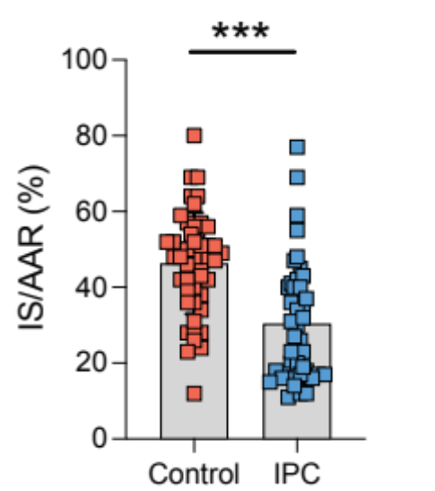
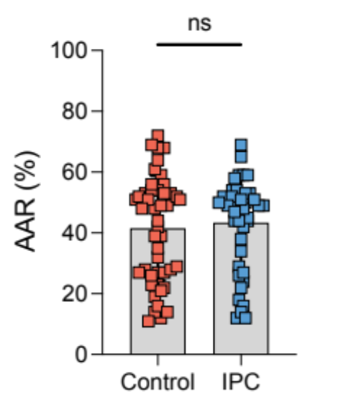
Control
IPC
Front
Back
A)
B)
C)

Figure 2. Pooled analysis of area-at-risk and infarct size in mice hearts
(A) Pooled analysis of mean area-at-risk/left ventricle volume (AAR/LV%) showed no significant difference between control and IPC (p=not significant [ns]).
(B) Pooled analysis of mean infarct size/area-at-risk (IS/AAR%) showed IPC significantly reducing IS/AAR% when compared to control (***p<0.005).
(C) Representative images of myocardial tissue sections dual staining by Evans blue and triphenyl tetrazolium staining from the control and IPC groups showing areas of infarction (white), non-infarcted area-at-risk (red) and non-area-at-risk (blue). ‘Front’ and 'Back' labels refer to the orientation of the tissue sections.
Results are presented as mean ± SD, with significance levels indicated; p=non-significant; ***p<0.005 vs. Control group, Wilcoxon rank.

Control
IPC
Front
Back
A)
B)
C)
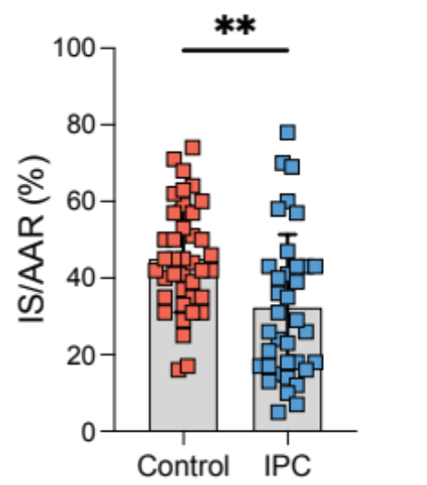
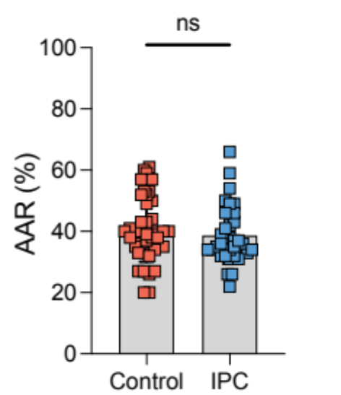

Figure 3. Pooled analysis of area-at-risk and infarct size in rat hearts
(A) Pooled analysis of mean area-at-risk/left ventricle volume (AAR/LV%) showed no significant difference between control and IPC.
(B) Pooled analysis of mean infarct size/area-at-risk (IS/AAR%) showed IPC significantly reducing IS/AAR% when compared to control.
(C) Representative images of myocardial tissue sections dual staining by Evans blue and triphenyl tetrazolium staining from the control and IPC groups showing areas of infarction (white), non-infarcted area-at-risk (red) and non-area-at-risk (blue). ‘Front’ and 'Back' labels refer to the orientation of the tissue sections.
Results are presented as mean ± SD, with significance levels indicated; p=non-significant [ns]; **p<0.01 vs. Control group, Wilcoxon rank.

A)

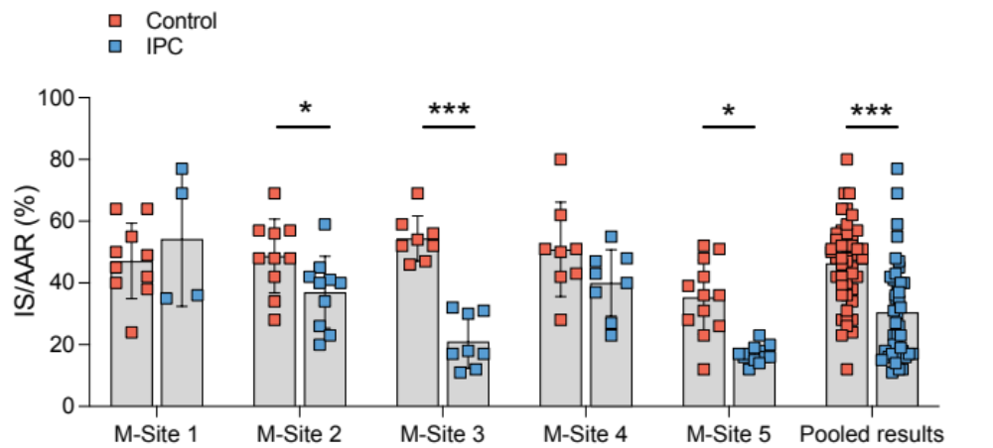

B)

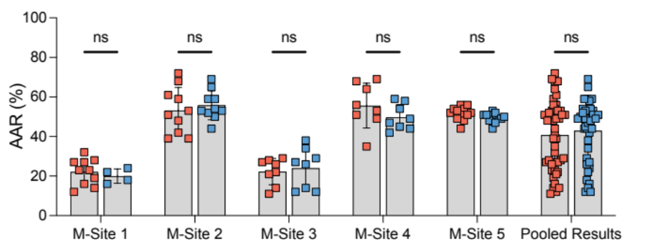

Figure 4. Site-specific analysis of area-at-risk and infarct size in mice hearts
(A) Site-specific analysis of mean infarct size/area-at-risk (IS/AAR%) showed IPC significantly reducing IS/AAR% when compared to control.
(B) Site-specific analysis of mean area-at-risk/left ventricle volume (AAR/LV%) showed no significant difference between control and IPC at each site. However, there were significant differences in AAR/LV% in both control and IPC between the sites (p<0.001 ANOVA).
Results are presented as mean ± SD, with significance levels indicated; *p<0.05, **p<0.01 ***p<0.005 vs. Control group, Wilcoxon rank.

A)

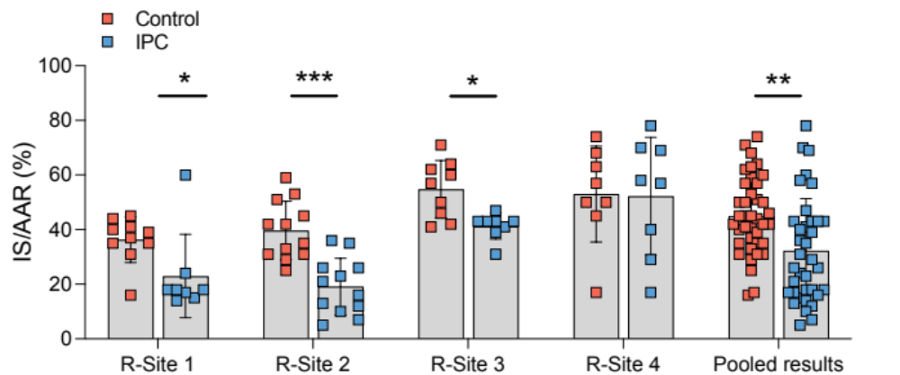

B)

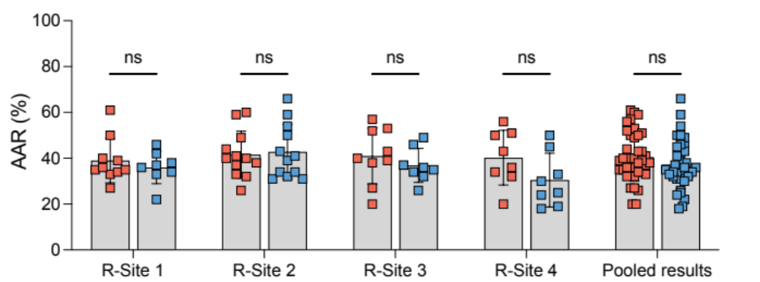

Figure 5. Site-specific analysis of area-at-risk and infarct size in rat hearts
(A) Site-specific analysis of mean infarct size/area-at-risk (IS/AAR%) showed IPC significantly reducing IS/AAR% when compared to control.
(B) Site-specific analysis of mean area-at-risk/left ventricle volume (AAR/LV%) showed no significant differences between control and IPC at each site or between sites.
Results are presented as mean ± SD, with significance levels indicated; *p<0.05, **p<0.01 ***p<0.005 vs. Control group, Wilcoxon rank.

Supplementary Tables

Table S1. Comparative overview of mice, housing conditions and dietary protocols across different study sites.
 | Mouse weight and age during the experiment | Mouse strain | Breeder | Chow,  Producer | Contain soya | Reversed light-dark cycle
M-Site 1 | 23-29 g, 11-12-week old | C57Bl/6N | Charles - River | SAFE® 132, OSAFE | Y | N
M-Site 2 | 25-30 g, 12-14-week old | C57Bl/6J | Charles - River | R105-25, SAFE® | N | N
M-Site 3 | 25-30 g, 12-14-week old | C57Bl/6N | Janvier Labs | SAFE® 150, OSAFE | N | N
M-Site 4 | 24-28 g, 8-10-week old | C57Bl/6J | InVivos | Irradiated Mouse diet (SF00-100) | Y | N
M-Site 5 | ~25 g, 12-14-week old | C57Bl/6J | Inhouse Breeding | Mucedola 4RF22, Mucedola | Y | N

Table S2. Comparative overview of rats, housing conditions and dietary protocols across different study sites.
 | Rat weight and age during the experiment | Rat  strain | Breeder | Chow,  Producer | Contain soya | Reversed light-dark cycle
R-Site 1 | 238-295 g, 8-10-week old | Wistar | Toxicoop | Rat/Mouse Maintenance chow Sniff | Y | N
R-Site 2 | 250 -300 g, 8-10-week old | Sprague-Dawley | InVivos | Irradiated Rat diet (SF00-100) | Y | N
R-Site 3 | 250-300 g, 8-14-week old | Wistar | Envigo | R70 diet Lantmännen | N | N
R-Site 4 | 240-280 g, 8-10-week old | Wistar | Medical University of Bialystok | Standard diet | N | Y

Table S3. Anesthetic protocols and ventilation parameters across different sites in mice.

 | Premedication | Anesthesia | Ventilation parameters | Used gas
M-Site 1 | Buprenorphine 0.05 mg/Kg SC, 10 min before surgery | Isoflurane, 5% induction  1.5-2% maintenance | Volume controlled  RR, 120-150 strokes/min TV, 100-240 µl | 20% oxygen
M-Site 2 | Buprenorphine 0.05 mg/Kg SC, 10 min before surgery | Ketamine, 100 mg/Kg, IP  Xylazine, 10 mg/Kg, IP  Isoflurane | Volume controlled  RR, 120-150 breath/min  TV, 100-240 µl | 20% oxygen
M-Site 3 | None | Pentobarbital, 40 mg/Kg, IP  Ketamine, 50mg/Kg IP  1/3 of the initial dose in needed. | Volume controlled  RR, 133 breath/min  TV, 180 µl  PEEP 3 mbar | 20% oxygen
M-Site 4 | Buprenorphine 0.5 mg/Kg SC 10 min before surgery | Ketamine, 65 mg/Kg, IP  Xylazine, 13 mg/Kg, IP  Isoflurane, 0.5% | RR, 140 breath/min  TV, 160 µl  1% sigh  Breath 20 cmH₂O | Air
M-Site 5 | Buprenorphine 0.075 mg/Kg SC, 10 min before surgery | Ketamine, 65 mg/Kg, IP  Xylazine, 20 mg/Kg, IP | Volume controlled  RR, 200 breath/min  TV, 250 µl | Air
Subcutaneous, SC; intraperitoneal, IP; respiratory rate, RR; tidal volume, TV.

Table S4. Anesthetic protocols and ventilation parameters across different sites in rats.

 | Premedication | Anesthesia | Ventilation parameters | Used gas
R-Site 1 | Buprenorphine 0.05 mg/Kg SC, 15 min before surgery | Pentobarbital, 60 mg/Kg IP | Volume controlled  RR, 74-78 strokes/min  TV, 1.47-1.78 ml | Air
R-Site 2 | Buprenorphine 0.05 – 0.1 mg/Kg SC, 10 min before surgery | Ketamine, 80-100 mg/Kg, IP  Xylazine, 10-20 mg/Kg, IP  Isoflurane, 0.5 - 2% | Volume controlled  RR, 60 breath/min  TV, 3 ml  1% sigh  Breath 20 cmH₂O | Air
R-Site 3 | Atropine, 0.05 mg/Kg, Benzylpenicillin,150 mg/Kg, Buprenorphine, 0.05 mg/Kg SC,  30 min prior to LAD ligation | Ketamine, 100 mg/Kg, IP  Ketamine, 10mg/Kg, IP  Ketamine, 50 mg/Kg, IP (extra if needed) | Volume controlled  RR, 55 strokes/min  TV, 1.5 ml/100 g animal | Air
R-Site 4 | None | Ketamine, 100 mg/Kg, IP  Xylazine, 10 mg/Kg, IP  Isoflurane, 0.5% | Volume controlled  RR, 65 strokes/min  TV, 4.5-5.0 ml | Air
Subcutaneous, SC; intraperitoneal, IP; respiratory rate, RR; tidal volume, TV.

Table S5. Comparative overview of surgical techniques across different sites in mice.

 | Surgery | Parameters monitored during surgery | Suture type for occlusion | Analgesia
M-Site 1 | Thoracotomy by cutting one rib and intercostal muscles | ECG, body temperature | 8-0 Prolene  (polypropylene) | Buprenorphine 0.05 mg/Kg SC
M-Site 2 | Thoracotomy involving the dissection of intercostal muscles | ECG, PiP/PEEP, body temperature | 7-0 prolene, 6.5mm needle, 1/2 circle | Buprenorphine 0.05 mg/Kg SC
M-Site 3 | Thoracotomy involving the dissection of intercostal muscles | ECG, body temperature | 6-0 braided, 9.3mm needle, 3/8 circle | Buprenorphine 0.05 mg/Kg SC
M-Site 4 | Thoracotomy involving the dissection of intercostal muscles | ECG, body temperature, SpO₂, controlled ventilation | 7-0 silk, 9mm needle, 3/8 circle | Buprenorphine 0.05 mg/Kg SC
M-Site 5 | Thoracotomy involving the dissection of intercostal muscles | ECG, PiP/PEEP, body temperature | 6-0 silk, 10mm needle | Buprenorphine 0.075 mg/Kg SC
Electrocardiogram, ECG; Subcutaneous, SC; peak inspiratory pressure, PiP; positive end expiratory pressure, PEEP.

Table S6. Comparative overview of surgical techniques across different sites in rats.

 | Surgery | Parameters monitored during surgery | Suture type for occlusion | Analgesia
R-Site 1 | Thoracotomy involving the dissection of intercostal muscles | ECG, body temperature | 5-0 Prolene | Buprenorphine 0.05 mg/Kg SC
R-Site 2 | Thoracotomy involving the dissection of intercostal muscles | ECG, body temperature, SpO₂, controlled ventilation | 6-0 silk | Buprenorphine 0.05 mg/Kg SC
R-Site 3 | Thoracotomy involving the dissection of intercostal muscles | ECG, body temperature | 5-0 monofilament polypropylene,13mm needle, 1/2 circle | Buprenorphine 0.05 mg/Kg SC
R-Site 4 | Thoracotomy involving the dissection of intercostal muscles | ECG, body temperature, controlled ventilation | 5-0 monofilament polypropylene | Buprenorphine 0.05 mg/Kg SC
Electrocardiogram, ECG; Subcutaneous, SC.

Table S7. Infarct staining details across different sites in mice.

 | Euthanasia | Area-at-risk, procedure
M-Site 1 | Pentobarbital, 90 mg/Kg IP | In vivo, delineation of non-ischemic myocardial tissue was achieved by administering EB dye via apical puncture into the left ventricle.
M-Site 2 | Isoflurane 5% | In vivo, delineation of non-ischemic myocardium by perfusing EB dye through the aorta.
M-Site 3 | Pentobarbital, 100mg/Kg IP | In vivo, delineation of non-ischemic myocardial tissue was achieved by administering EB dye via apical puncture into the left ventricle.
M-Site 4 | Ketamine, 100 mg/Kg  Xylazine, 20 mg/Kg | Ex vivo differentiation of non-ischemic myocardial regions by the perfusion of EB dye during aortic cannulation.
M-Site 5 | Ketamine, 100 mg/Kg IP  Heparin 1000IU/Kg IP  and cervical dislocation | Ex vivo differentiation of non-ischemic myocardial regions by the perfusion of EB dye during aortic cannulation.
Intraperitoneal, IP; Evans blue, EB.

Table S8. Infarct staining details across different sites in rats.

 | Euthanasia | Area-at-risk, procedure
R-Site 1 | Pentobarbital, 60 mg/Kg IP | Ex vivo differentiation of non-ischemic myocardial region using the Langendorff system
R-Site 2 | Ketamine, 100 mg/Kg IP  Xylazine, 20 mg/Kg IP | Ex vivo differentiation of non-ischemic myocardial regions by the perfusion of EB dye during aortic cannulation.
R-Site 3 | Pentobarbital, 100mg/Kg IP  Heparin 1000 IU/Kg IP | Ex vivo differentiation of non-ischemic myocardial regions by the perfusion of EB dye during aortic cannulation.
R-Site 4 | Ketamine, 100 mg/Kg IP  Xylazine, 10 mg/Kg IP | Ex vivo differentiation of non-ischemic myocardial regions by the perfusion of EB dye during aortic cannulation.
Intraperitoneal, IP; Evans blue, EB.

Table S9. Animal exclusions based on pre-defined criteria

 | M-Site 1 | M-Site 2 | M-Site 3 | M-Site 4 | M-Site 5 | R-Site 1 | R-Site 2 | R-Site 3 | R-Site 4
Control | 0 | 0 | 0 | 0 | 0 | 0 | 0 | 0 | 0
IPC | 0 | 0 | 0 | 0 | 0 | 1 | 0 | 1 | 0
Total | 0 | 0 | 0 | 0 | 0 | 1 | 0 | 0 | 0

Table S10. Mortality Rates.

 | M-Site 1 | M-Site 2 | M-Site 3 | M-Site 4 | M-Site 5 | R-Site 1 | R-Site 2 | R-Site 3 | R-Site 4
Control | 2 | 0 | 2 | 0 | 2 | 3 | 0 | 3 | 4
IPC | 8 | 0 | 2 | 0 | 1 | 3 | 0 | 3 | 2
Total | 10 | 5* | 4 | 0 | 3 | 3 | 0 | 6 | 6

* Animal mortality occurred before their allocation to the experimental groups.

References

1. Botker HE, Hausenloy D, Andreadou I, Antonucci S, Boengler K, Davidson SM, Deshwal S, Devaux Y, Di Lisa F, Di Sante M, Efentakis P, Femmino S, Garcia-Dorado D, Giricz Z, Ibanez B, Iliodromitis E, Kaludercic N, Kleinbongard P, Neuhauser M, Ovize M, Pagliaro P, Rahbek-Schmidt M, Ruiz-Meana M, Schluter KD, Schulz R, Skyschally A, Wilder C, Yellon DM, Ferdinandy P, Heusch G (2018) Practical guidelines for rigor and reproducibility in preclinical and clinical studies on cardioprotection. Basic Res Cardiol 113:39 doi:10.1007/s00395-018-0696-8
2. Bromage DI, Pickard JM, Rossello X, Ziff OJ, Burke N, Yellon DM, Davidson SM (2017) Remote ischaemic conditioning reduces infarct size in animal in vivo models of ischaemia-reperfusion injury: a systematic review and meta-analysis. Cardiovasc Res 113:288-297 doi:10.1093/cvr/cvw219
3. Ferdinandy P, Andreadou I, Baxter GF, Botker HE, Davidson SM, Dobrev D, Gersh BJ, Heusch G, Lecour S, Ruiz-Meana M, Zuurbier CJ, Hausenloy DJ, Schulz R (2023) Interaction of Cardiovascular Nonmodifiable Risk Factors, Comorbidities and Comedications With Ischemia/Reperfusion Injury and Cardioprotection by Pharmacological Treatments and Ischemic Conditioning. Pharmacol Rev 75:159-216 doi:10.1124/pharmrev.121.000348
4. Hahn JY, Yu CW, Park HS, Song YB, Kim EK, Lee HJ, Bae JW, Chung WY, Choi SH, Choi JH, Bae JH, An KJ, Park JS, Oh JH, Kim SW, Hwang JY, Ryu JK, Lim DS, Gwon HC (2015) Long-term effects of ischemic postconditioning on clinical outcomes: 1-year follow-up of the POST randomized trial. Am Heart J 169:639-646 doi:10.1016/j.ahj.2015.01.015
5. Hausenloy DJ, Barrabes JA, Botker HE, Davidson SM, Di Lisa F, Downey J, Engstrom T, Ferdinandy P, Carbrera-Fuentes HA, Heusch G, Ibanez B, Iliodromitis EK, Inserte J, Jennings R, Kalia N, Kharbanda R, Lecour S, Marber M, Miura T, Ovize M, Perez-Pinzon MA, Piper HM, Przyklenk K, Schmidt MR, Redington A, Ruiz-Meana M, Vilahur G, Vinten-Johansen J, Yellon DM, Garcia-Dorado D (2016) Ischaemic conditioning and targeting reperfusion injury: a 30 year voyage of discovery. Basic Res Cardiol 111:70 doi:10.1007/s00395-016-0588-8
6. Hausenloy DJ, Heusch G (2019) Translating Cardioprotection for Patient Benefit: The EU-CARDIOPROTECTION COST Action. J Am Coll Cardiol 73:2001-2003 doi:10.1016/j.jacc.2019.03.020
7. Hausenloy DJ, Kharbanda RK, Moller UK, Ramlall M, Aaroe J, Butler R, Bulluck H, Clayton T, Dana A, Dodd M, Engstrom T, Evans R, Lassen JF, Christensen EF, Garcia-Ruiz JM, Gorog DA, Hjort J, Houghton RF, Ibanez B, Knight R, Lippert FK, Lonborg JT, Maeng M, Milasinovic D, More R, Nicholas JM, Jensen LO, Perkins A, Radovanovic N, Rakhit RD, Ravkilde J, Ryding AD, Schmidt MR, Riddervold IS, Sorensen HT, Stankovic G, Varma M, Webb I, Terkelsen CJ, Greenwood JP, Yellon DM, Botker HE, Investigators C-E-P (2019) Effect of remote ischaemic conditioning on clinical outcomes in patients with acute myocardial infarction (CONDI-2/ERIC-PPCI): a single-blind randomised controlled trial. Lancet 394:1415-1424 doi:10.1016/S0140-6736(19)32039-2
8. Heusch G (2017) Critical Issues for the Translation of Cardioprotection. Circ Res 120:1477-1486 doi:10.1161/CIRCRESAHA.117.310820
9. Heusch G (2020) Myocardial ischaemia-reperfusion injury and cardioprotection in perspective. Nat Rev Cardiol 17:773-789 doi:10.1038/s41569-020-0403-y
10. Jones SP, Tang XL, Guo Y, Steenbergen C, Lefer DJ, Kukreja RC, Kong M, Li Q, Bhushan S, Zhu X, Du J, Nong Y, Stowers HL, Kondo K, Hunt GN, Goodchild TT, Orr A, Chang CC, Ockaili R, Salloum FN, Bolli R (2015) The NHLBI-sponsored Consortium for preclinicAl assESsment of cARdioprotective therapies (CAESAR): a new paradigm for rigorous, accurate, and reproducible evaluation of putative infarct-sparing interventions in mice, rabbits, and pigs. Circ Res 116:572-586 doi:10.1161/CIRCRESAHA.116.305462
11. Kukreja R TX, Lefer D, Steenbergen C, Jones S, Guo Y, Li Q, Kong M, Stowers H, Hunt G, Tokita Y, Wu W, Ockaili R, Salloum F, Book M, Du J, Bhushan S, Goodchild T, Chang C, Bolli R (2014) Administration of sildenafil at reperfusion fails to reduce infarct size: results from the CAESAR Cardioprotec- tion Consortium (LB650). FASEB J 28
12. Lecour S, Andreadou I, Botker HE, Davidson SM, Heusch G, Ruiz-Meana M, Schulz R, Zuurbier CJ, Ferdinandy P, Hausenloy DJ, on behalf of the European Union CCAC (2021) IMproving Preclinical Assessment of Cardioprotective Therapies (IMPACT) criteria: guidelines of the EU-CARDIOPROTECTION COST Action. Basic Res Cardiol 116:52 doi:10.1007/s00395-021-00893-5
13. Murry CE, Jennings RB, Reimer KA (1986) Preconditioning with ischemia: a delay of lethal cell injury in ischemic myocardium. Circulation 74:1124-1136 doi:10.1161/01.cir.74.5.1124
14. Percie du Sert N, Hurst V, Ahluwalia A, Alam S, Avey MT, Baker M, Browne WJ, Clark A, Cuthill IC, Dirnagl U, Emerson M, Garner P, Holgate ST, Howells DW, Karp NA, Lazic SE, Lidster K, MacCallum CJ, Macleod M, Pearl EJ, Petersen OH, Rawle F, Reynolds P, Rooney K, Sena ES, Silberberg SD, Steckler T, Wurbel H (2020) The ARRIVE guidelines 2.0: Updated guidelines for reporting animal research. PLoS Biol 18:e3000410 doi:10.1371/journal.pbio.3000410
15. Sayour NV, Brenner GB, Makkos A, Kiss B, Kovacshazi C, Gergely TG, Aukrust SG, Tian H, Zenkl V, Gomori K, Szabados T, Bencsik P, Heinen A, Schulz R, Baxter GF, Zuurbier CJ, Voko Z, Ferdinandy P, Giricz Z (2023) Cardioprotective efficacy of limb remote ischaemic preconditioning in rats: discrepancy between a meta-analysis and a three-centre in vivo study. Cardiovasc Res 119:1336-1351 doi:10.1093/cvr/cvad024

