PPL Standard Condition 18 Report Form

PPL Number | PFF2068BC
Name of PPL Holder | Damiano Barone
Tel no | 07707 391148
Protocol number and title | 3
Severity classification | Moderate
Date severity limit exceeded or considered likely to be exceeded | 21/09/2020

Species | Rat
Number of animals in the study | 23
Number of animals where severity exceeded | 1
Give brief details of how the constraints have been, or are likely to be, breached  Include what happened, the severity classification and any relevant controls and humane endpoints, and ( as appropriate) stage of study, any advice taken ( eg from NACWO/ NVS), likely cause of issue, etc | Surgeries were performed on animals involving the implantation of a microwire array probe into the brain, which was fixed to the surface of the skull using dental cement and steel screws. 23 animals underwent this procedure, through several study plans (with different post-op time points). In all 23 animals, the steel screws were threaded through the skull, and remained flush with the surface of the brain. This procedure is classified as “moderate” under the used PPL. With the exception of this one animal being referred to in this report, all other animals recovered well from the procedure and did not exhibit any significant bleeding or tissue damage that detrimentally affected their welfare.  On 21/09/2020, at approx., 13.00, one of the animals in this study was found dead in the cage at 4 days post-op, 3 days prior to its planned Sch1 day. Having been found dead in the cage, the animal was classified under a “severe” severity, exceeding the severity category established by the PPL. Prior to this day the animal had been healthy and active, similar to its peers under the same programme of work. That morning (at approx. 09.00), however, the animal had been reported by a staff member carrying out routine checks that the animal seemed a bit lethargic. Although this was logged and the experimenter was notified, this did not seem to have an immediate impact on the animal’s welfare, and was considered part of the normal recovery from surgery.  Upon examination of the tissue post-mortem, blood and tissue damage were found on the surface of the brain under one of the skull screws. This screw was found to protrude into the brain by approximately 1mm (as opposed to being flush with the brain, as was the case with the other screws), as seen under morphological examination of the tissue following formalin fixation (picture below). The protruding screw seems to have pierced the dura, and caused subdural bleeding leading to the animal’s death.  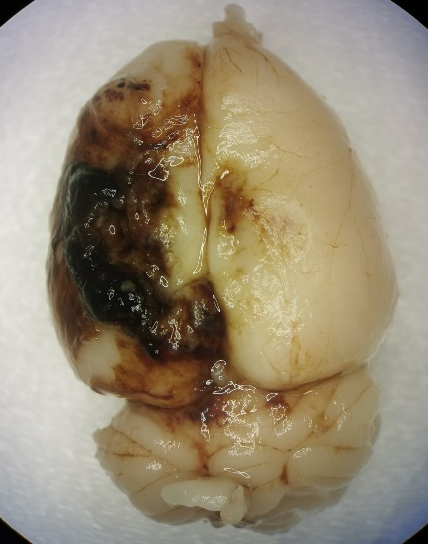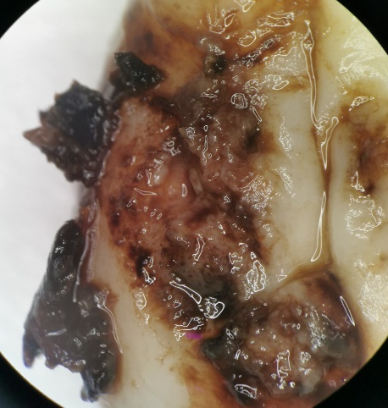  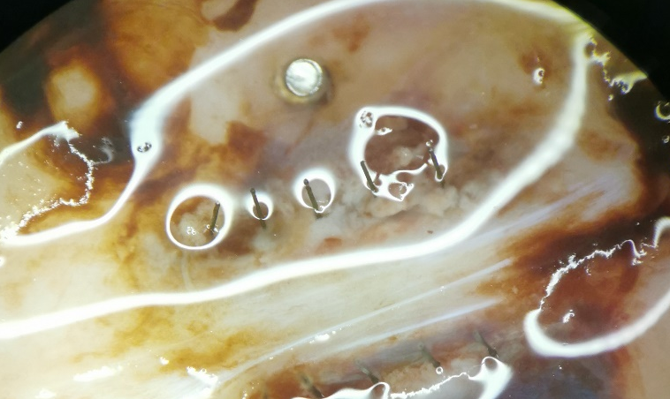  Subdural bleeding observed on the left hemisphere of the (formalin fixed) brain, corresponding to the location of the skull screw (left). Tissue damage visible when blood is removed (right). Inner side of the skull with protruding screw (and the microwire implant) visible (bottom).
Action that has been or will be taken  (e.g. formulation of drug changed, supportive treatment give and animals fully recovered, study design modified). If none, indicate why (e.g. none required as study terminated and won’t be repeated) | All animals undergoing this surgical procedure have screws threaded through the skull in a similar manner to the animal in this report. While these screws cause no tissue damage if properly implanted (i.e. flush with the surface of the brain), accidentally threading a screw deeper into the brain can have a very detrimental effect on the animal’s health.  The scientists involved in these studies will develop a strategy to ensure that screws are implanted at a well-defined and controlled depth into the skull. This will involve measuring the length of screw that must remain outside of the skull in order to ensure that the screw never extends past the inner surface of the skull. This external length of screw will be carefully monitored during future surgical procedures.  In addition to this, all future animals undergoing this or similar surgical procedures will be closely monitored if they show signs of lethargy.

Reported by (name) | Alejandro Carnicer
Date | 22/09/2020
E mail address | ac723@cam.ac.uk
Tel. no | 07707391148

Please name your document:
‘ASRU_establishment name_PPL number_PPLh surname_date_sc18’
and send to your inspector (eg via cjsm) with the subject heading ‘SEVERITY EXCEEDED, PPL XX/XXX

*********************************************************************
For Inspector’s use:

Inspector’s comments
Any remedial action(s) required and any outcomes
Recommendation

Inspector Name
Date

