PPL Standard Condition 18 Notification Form
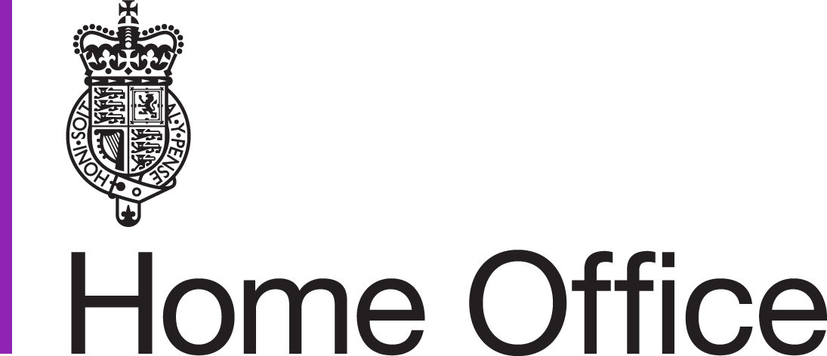
Please use this form to notify the Animals in Science Regulation Unit (ASRU) of procedural-related adverse effects that have exceeded or are likely to exceed the severity limitations or controls described in the project licence. ASRU will use this information to determine whether any further action is required.

Do not use to report:
- adverse effects that are due to non-procedural issues;
- potential non-compliance (report by other means);
- issues without adverse welfare consequences.

If you are in doubt whether or not you need to fill in this form, please contact your assigned Inspector.

Please clearly title your document: ‘ASRU_establishment name_PPL number_PPLh surname_date_sc18’ and send to your Inspector (e.g. using cjsm) with the subject heading ‘PPL SC 18 Notification PPL [Number] – Check Home Office’s Updated Bridging Ways of Working for updated advice on email addresses and subject headings. Cjsm no longer necessary.

Establishment Licence name | University of Cambridge  (Mira Facility)
Establishment Licence number | X81BD37B1
Name of PPL holder | Malak Kawan
PPL number | PFF2068BC
Protocol no | 03B
Protocol title | Brain neural interface device implantation (Rats)
Severity classification | Moderate
1. Date of incident | 12/07/2022
2. Species | Lewis Rat
3. Brief details of study and how the limits or constraints have been breached | My study investigates the foreign body reaction across 28 days to our brain implants that are made of 4 μm thick biocompatible and flexible Parylene sheet coated with neuronal lipid membranes and fibrin hydrogel (experimental group).This group is compared to two other groups: sham surgery (no implant) and a positive control group that generate higher inflammation than our experimental implant, which is made of a stiff ~200 μm Polyethylene terephthalate (PET) (thermoplastic polymer; (4mm by 6mm)). The operation for the study plan was split into 5 days (4 animals each day), grouped by the operation and culling day.  The surgery is done by having 2 craniotomies in both left and right hemisphere to expose the brain cortex. The implant is then directly placed on top of the cortex faced down (hydrogel side) where the skull flap is placed back on and edges are sealed with Silicon. The scalp is sutured discontinuously. All done under isoflurane anaesthesia with regular post-op check-ups and body weighing.  I was alerted by the duty animal technician (12th of July, 2022) to the presence of one rat found dead today ̶ 4 days post-surgery.  According to our records, the animal received the stiff PET implant (positive control) along with 2 more animals. No weight loss had been observed prior to the incident, in fact the rat gained +1.68%. Before Surgery, she weighed 179.0g and prior to the incident, she was 182.0g. We have not observed any issues with the other two animals who received the same PET implant but are monitoring them closely.
4. Have you taken advice from the Named Animal Care and Welfare Officer/Named Veterinary Surgeon/others? | Both the NACWO and NVS have been alerted. The NVS has recommended putting an immediate report together and following up with histology results when they come back.
5. Cause of Problem, if known | A cursory post-mortem has uncovered the presence of blood/damage on the left hemisphere of the animal’s cortex (image below). This is likely caused by the stiff PET implant edges causing this damage on that hemisphere while the rat is freely moving (possibly aggressively scratching or hitting head) after full recovery.  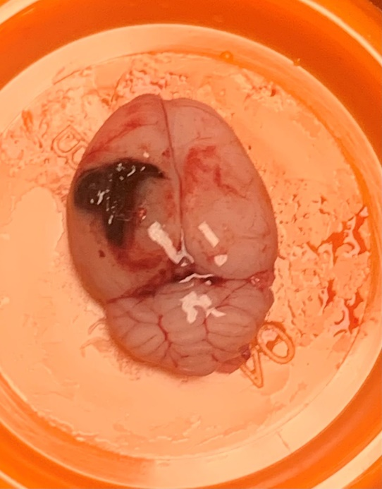  All animals were checked the night prior to the incident and had no visible signs of pain or weight loss, including the animal in question. The rats will be culled at day 28 post-surgery for this study and all will be carefully monitored.  The surgeries were carried out by me, Malak Kawan (PIL I15892309) and my competency records are attached.
6. Action that has been or will be taken  (For example, formulation of drug changed, supportive treatment given, study design modified). If no action needed, indicate why (for example, none required as study has been terminated and will not be repeated) | - We will no longer be using PET material as a positive control implant  - We are cutting our implant size by half as well as the craniotomy windows  - We will add a step of a thin layer of cement after implantation and after the skull flap is placed back on to add structural support to the implant site and avoid unnecessary movement of the implant
7. Reported by (name) | Malak Kawan
8. Date | 12/07/2022

******************************For official use******************************************

Inspector’s comments and recommendations:

Comments and recommendations
Inspector name

Date

