AWERB Species Fact Sheet:  Zebrafish | 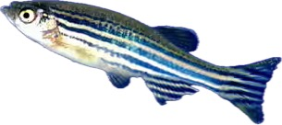

Diet | 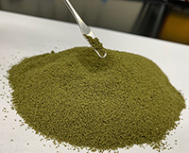  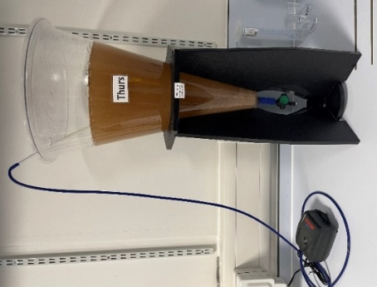  Dry food is provided three times a day for fry (babies), and once per day for adults, this is provided by a small scoop added through a feeding hole in the lid of the tanks. Food is a commercial small granular zebrafish diet.  Live food (brine shrimp) is provided at least once a day as enrichment.
Housing | 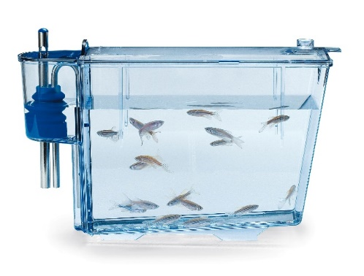  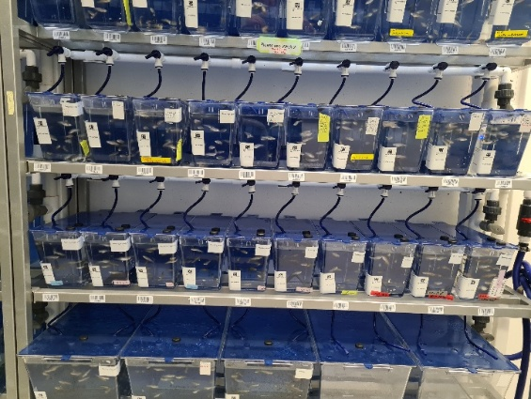  The fish are housed in tanks of various sizes. The size of the tank depends on the number of fish to be housed. There are 3 sizes available. The smallest tanks hold zebrafish fry, middle tanks hold 20 adults, large tanks hold 50 adults. Each tank is fitted with a continuous water flow system. Water enters through a tube at the top of the tank, promoting aeration and creating a current that directs waste toward a back pipe, which helps remove debris from the tank floor like a syphon. The water is then recirculated through a series of filters to maintain cleanliness and optimal water quality.  They are social animals and feel safe in a shoal.  All tanks are blue to reduce light penetration into the tank. Adults are only single housed for a maximum of 2 weeks for identification (genotyping) to take place.
Age | Zebrafish grow from an egg to adult in 10 weeks.  The fish are kept until they are 2 years old or their egg quality/embryo survival has diminished. Some fish are kept for 2.5 years on aging studies.
Enrichment | 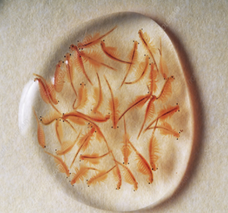  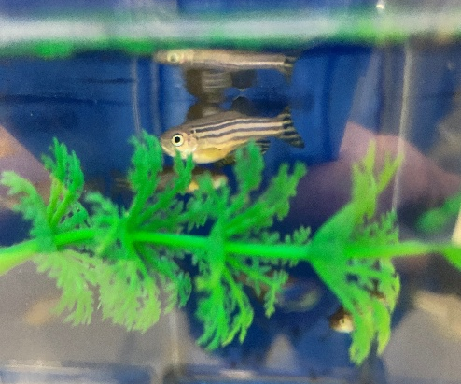  All fish are given brine shrimp, which is provided in a squeeze bottle. A squeeze of the bottle for one second into the tank will provide approx. 1000 brine shrimp per fish. The fish love to chase and hunt the brine shrimp.  They are also given plastic plants which are used to hide in or to break up the eyeline of any dominant fish. It is also useful when there are fewer fish in a tank.
ID | 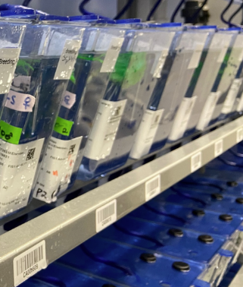  It is not possible to ID individual fish. Instead, the tanks are barcoded, and a database is used. The database holds information such as the strain, number of fish and breeding history.
Research areas | Developmental biology, neurogenerative diseases, tuberculosis, regeneration studies.
Rehoming potential | Good, but due to the high number of zebrafish at the University of Cambridge, only a small percentage are rehomed.
Fun Fact | 84% of genes known to be associated with human disease are found in zebrafish.

