AWERB Species Fact Sheet:  Xenopus | 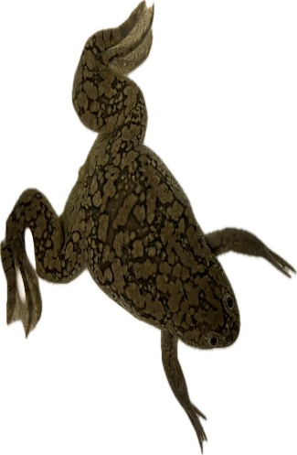

Diet | 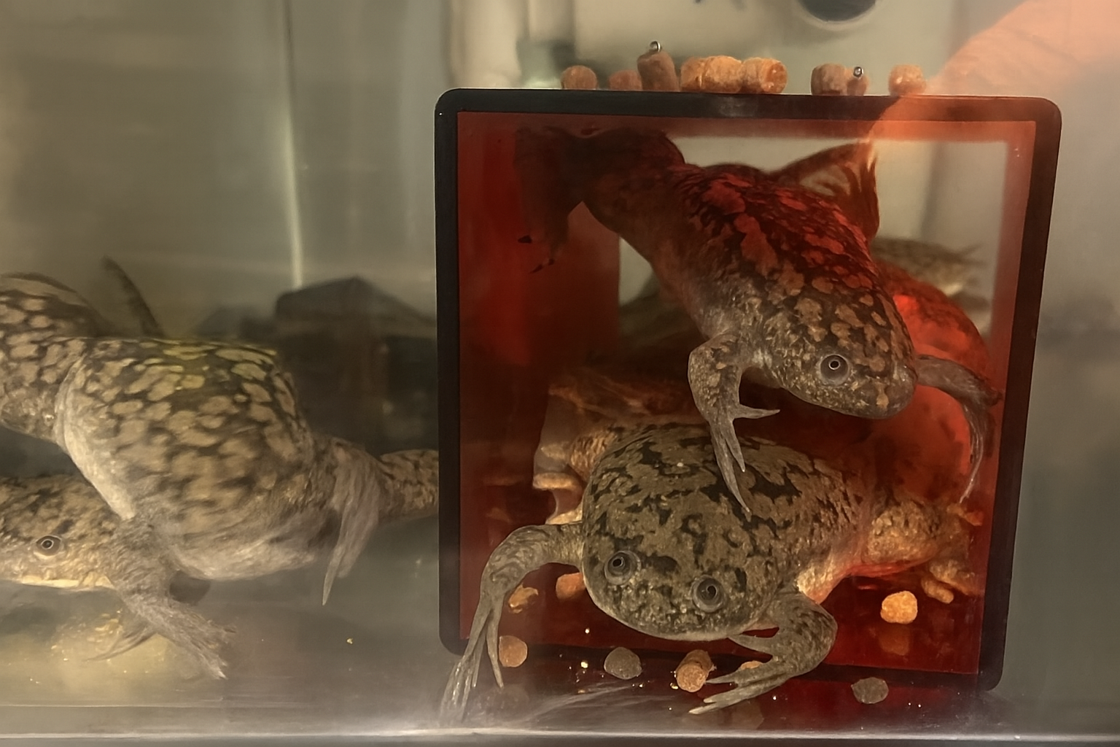  Trout pellets are offered to the frogs three times a week via a feeding hole in the tank lids. Frogs are given as much as they can consume within a 30-minute window. Social interaction plays a key role in stimulating feeding behaviour; frogs feed more readily in groups, a phenomenon known as a “feeding frenzy.” When too few frogs are present, feeding responses may be delayed, increasing the risk of undernourishment.
Enclosure | 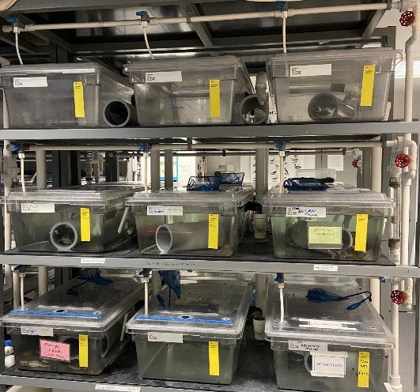  The frogs are housed in 40-litre tanks, each fitted with a continuous water flow system. Water enters through a tube at the top of the tank, promoting aeration and creating a current that directs waste toward a back pipe, which helps remove debris from the tank floor. The water is then recirculated through a series of filters to maintain cleanliness and optimal water quality.
Age | Xenopus hatch approximately two to four days after fertilisation, emerging as motile tadpoles. Metamorphosis into froglets occurs between six weeks and six months, an adaptive trait that enhances survival under varying environmental conditions. Once metamorphosed, frogs take around 12 to 18 months to reach sexual maturity and continue growing for up to five years.  In captivity, Xenopus can live into their 40s, although some females begin to develop heart-related issues, which result in oedema, from around five years of age. In laboratory settings, frogs are typically not kept beyond seven years due to a decline in egg quality.
Enrichment | 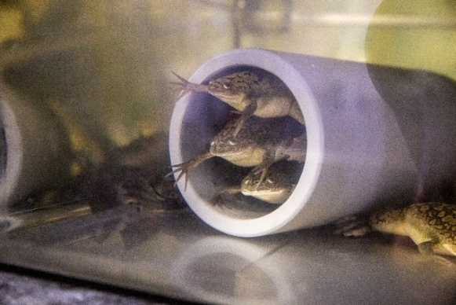  All tanks are equipped with plastic tubes that the frogs use for resting or swimming through. While enrichment is important, it can be challenging to provide due to the tank design and the frogs' naturally inactive behaviour.
ID | 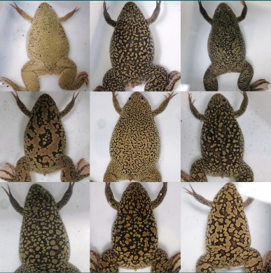  Each frog has a unique back pattern, much like a fingerprint, which can be used for individual identification. To support this, laminated photographs are used as a visual reference for tracking and recognition.
Research areas | Developmental, cell and molecular biology. Cancer research.
Rehoming potential | None. These frogs should not be rehomed due to them being an invasive species. As these frogs can easily live for over 40 years and cause a lot of destruction in local ponds and lakes by eating native species, they are deemed unacceptable to be rehomed.
Fun Fact | Xenopus frogs were the first animal to be cloned. Professor Sir John Gurdon removed the nucleus from a fertilised egg and replaced it with a nucleus of a cell taken from a tadpole’s intestine. The egg then grew into a clone of the doner tadpole creating the first ever cloned animal in 1958.

