AWERB Species Fact Sheet:  Sheep | 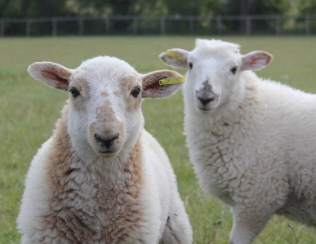

Diet | 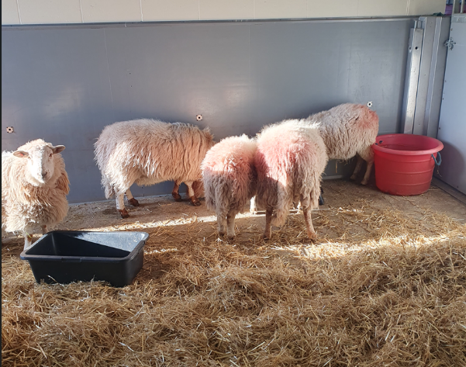  Free grazing of grass, ad lib access to hay. Occasional sheep/ewe nuts.
Housing | 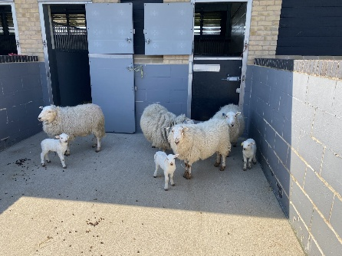  The sheep are kept in a mixture of paddocks and enclosures. The paddocks have trees which are overgrown to provide shelter. The enclosures are a mixture of pens and a barn. The pens range from large which can hold up to 40 sheep and smaller pens for breeding and lambing. The pens are provided with straw for bedding.  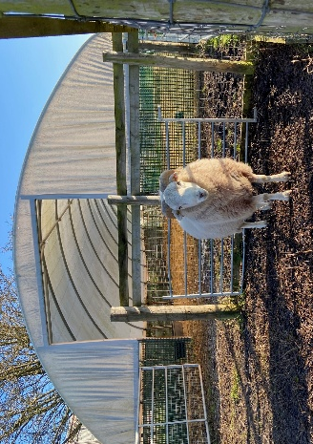
Age | We house sheep of various ages. The oldest stock is 8 years old. Ewes are bought in as proven breeders at 3 to 4 years old, and kept for 2.5 years. They usually produce 1 lamb which is kept for 18 months under study. Sheep can live for 10 years.
Enrichment | 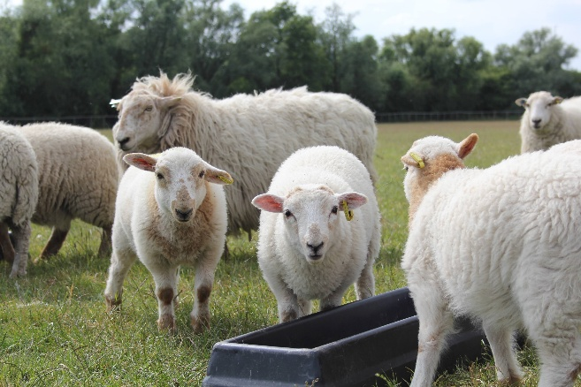  As sheep are grazing herd animals, they mainly require being kept in a herd and being able to move. Paddock rotation and the provision of different qualities of hay such as Timothy is provided as enrichment. Ewe and sheep nuts are also given as an incentive to move the sheep into the barn, or pens.
ID | 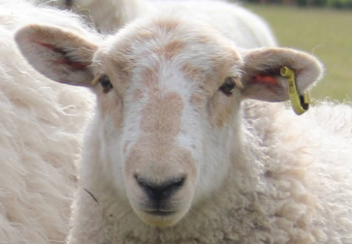  All sheep have the DEFRA requirements of ear tags, as well as facility ear tags.
Research areas | Foetal development and cardiovascular health.
Rehoming potential | Medium. A paddock is required, and they need to be with at least one companion. The land they are to the housed on must be registered as a small holding with DEFRA. The owner must comply with DEFRA rules, particularly in disease outbreaks such as Foot and Mouth.
Fun Fact | A study at the University of Cambridge found that sheep can be trained to recognise human faces from photographic portraits and can even identify the picture of their handler without prior training.

