AWERB Species Fact Sheet:  Rat | 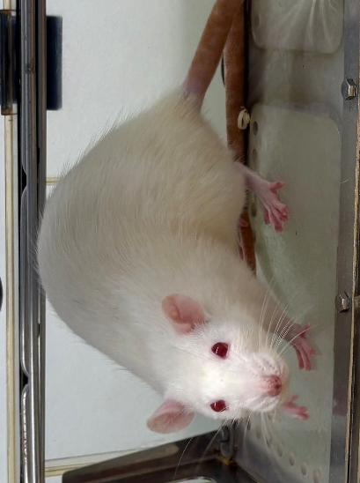

Diet | 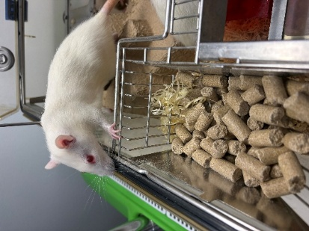  Ad-lib feeding of commercial rat diet. Some rats have auto watering, and others have water bottles depending on the facility.
Housing | 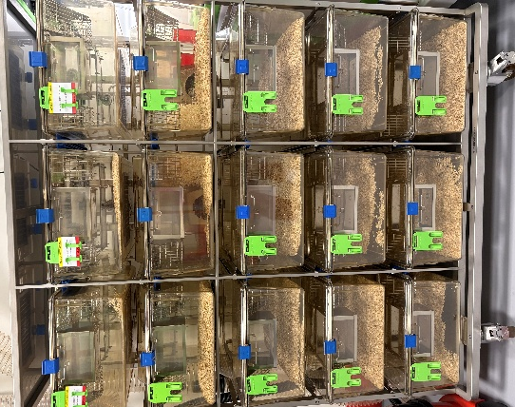  Rats are generally kept in IVCs (individually ventilated cages), and others in open top cages. They are kept at a temperature of 21 to 24C, and humidity of 45-60%. Generally, they all have a substrate of woodchips, and sizzle nest for bedding. Some cages have mezzanines or are “double decker” providing more height.  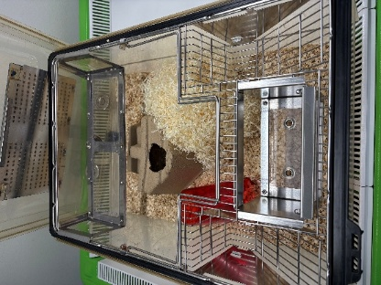
Age | From birth up to 2 years depending on the facility. Some rats are on aging studies so are kept longer. Rats over 15 months are considered aged. Rats can live for 3 to 4 years.
Enrichment | 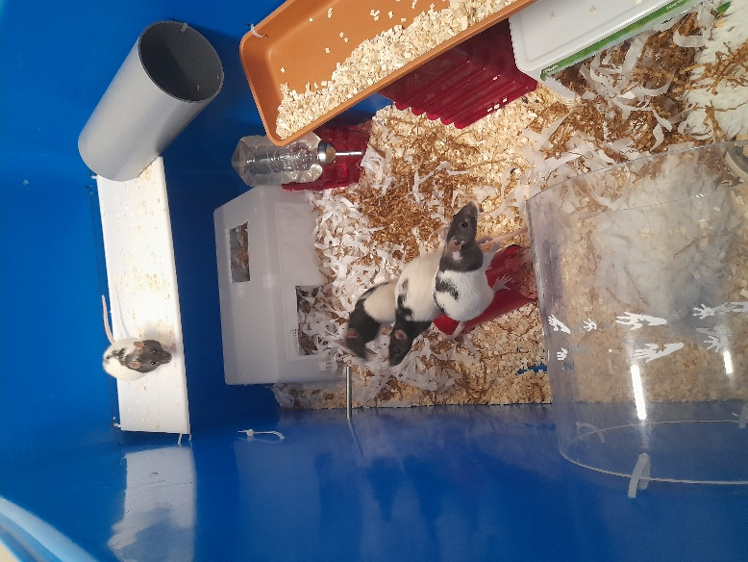  Enrichment varies slightly across UBS depending on the type of housing or study being carried out. Enrichment rotas are in place and consist of providing large chew blocks and balls, elevated hammocks, large cardboard tunnels and corner houses for hiding or chewing, ball pits and play pens, forage mixes of dried nuts and fruit. They are also given transparent red plastic tubes, rats cannot see the colour red so these provide somewhere for them to hide whilst the technician can still see them.  Diet gels may also be given as they really enjoy them. These may be strawberry or bacon flavoured. They also love Nutella.
ID | Depending on the facility, the rats may have ear notches, tail marks, marked fur (if white) or implanted microchips (either in their scruff or flank).
Research areas | Drug tolerability and telemetry studies, stem cell regeneration, dementia, organ repair, behaviour and addictions.
Rehoming potential | 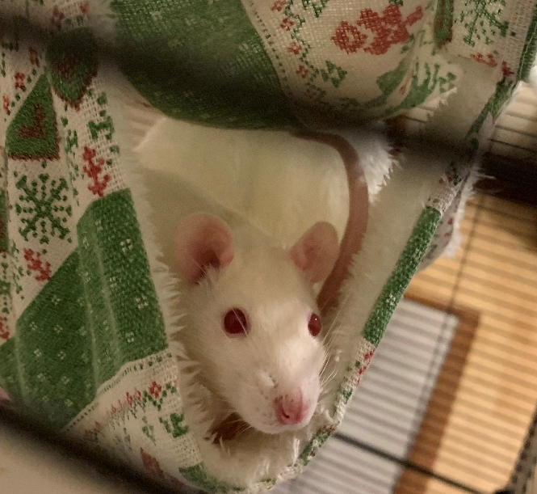  Very good, many rats have been rehomed over the years as they make great pets. Rats that have undergone procedures can be rehomed if they pose no risk to human health or the environment. Examples of rats that have been successfully rehomed after procedures include, those that have been on observational behavioural studies and those that have undergone a single blood sample.
Fun Fact | Domestic rats differ from wild rats. They are calmer and significantly less likely to bite. They can breed earlier than their wild counterparts and produce more offspring. Rats also love to be tickled.

