AWERB Species Fact Sheet:  Pony | 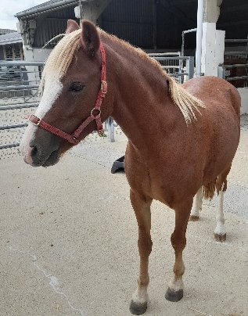

Diet | Ponies have grass grazing with hay given ad lib. When sugars are high in the grass they may be moved to strip grazing (to ensure their consumption is lower) high sugars can cause laminitis (inflammation of the laminae in the foot). Ponies are also given pony nuts and supplements such as balancer which is a low in calories and sugars but contains vitamins, minerals, protein, oil and yeasts they may not be obtaining from their forage. Some ponies may be given additional specific supplements such as Vitamin A if a need is identified from their blood sample results.
Housing | Mostly in paddocks, but may be housed in a barn for quarantine, procedures or if injured. As these are a native British breed, they are well acclimatised to living out rather than stabling. They are kept as a herd as this is important for socialising.  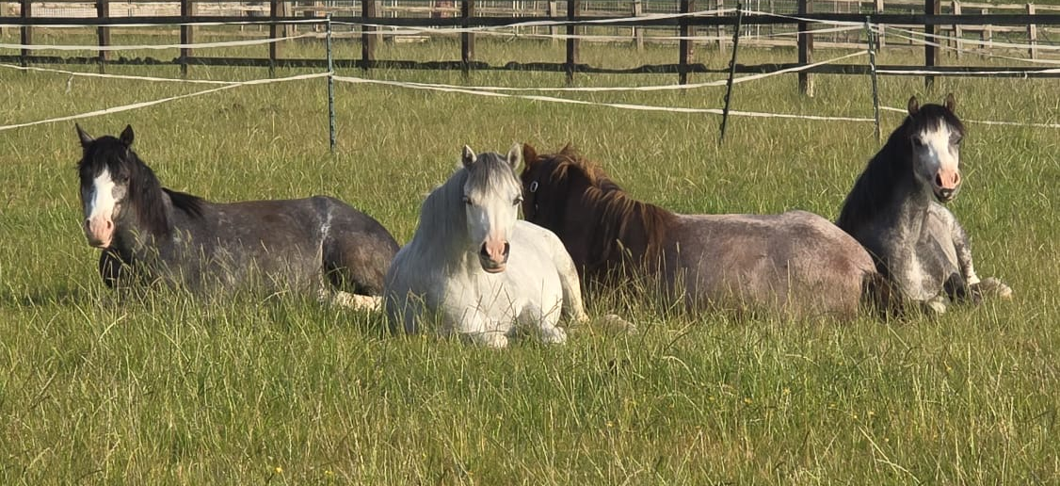
Age | The ponies arrive straight off the Welsh mountains at 6 months old and are kept at UBS for about 18 months. This breed can live for over 30 years.
Enrichment | 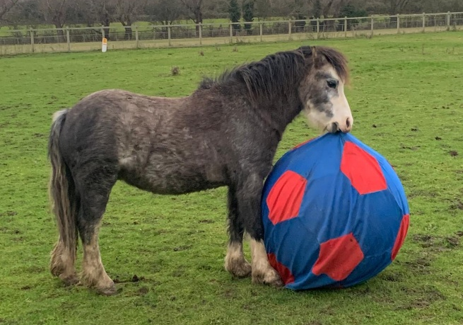  Ponies have an extensive enrichment rota. This can be in the form of treats to squeaky toys. They have balls, feeder puzzles, salt licks, apples and carrots as treats.
ID | Microchips, and given names as there are only a small number of ponies kept at one time, so they can be identifiable by their coats and markings. All ponies also have passports, which is a legal requirement.
Research areas | Vaccine development (equine herpes vaccine)
Rehoming potential | 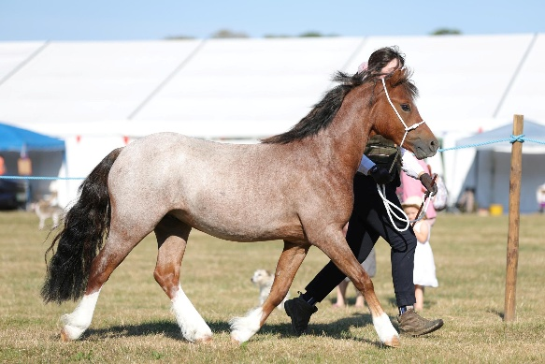  Very good. 100% of control animals can be rehomed. It is currently illegal to rehome vaccinated ponies as it’s a live vaccine, however this is being reviewed.
Fun Fact | Welsh mountain ponies have lived on the Welsh mountains for 1000’s of years. They evolved from prehistoric Celtic ponies. Arabian horses were introduced to Britain in the 11th century and interbred, giving the ponies their characteristic ‘bowl’ shaped head.

