AWERB Species Fact Sheet:  Pig | 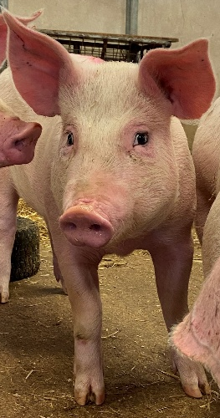

Diet | 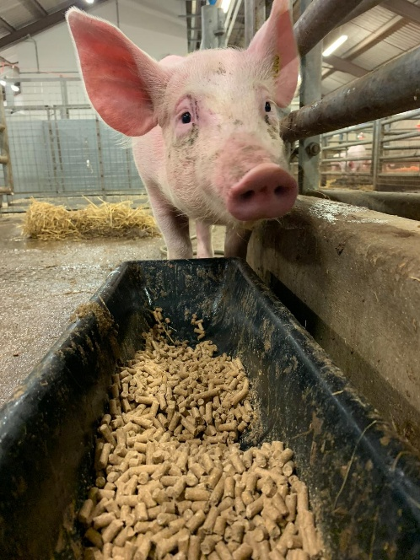  The pigs are fed by their weight twice a day on commercially bought ‘pig nuts’. They also have automatic watering that they can access ad lib.  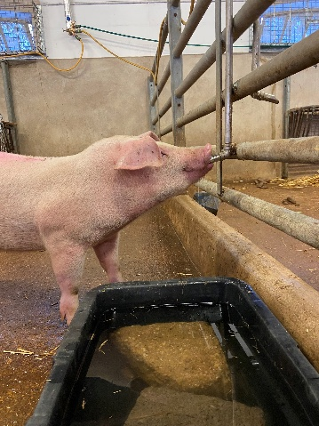
Housing | 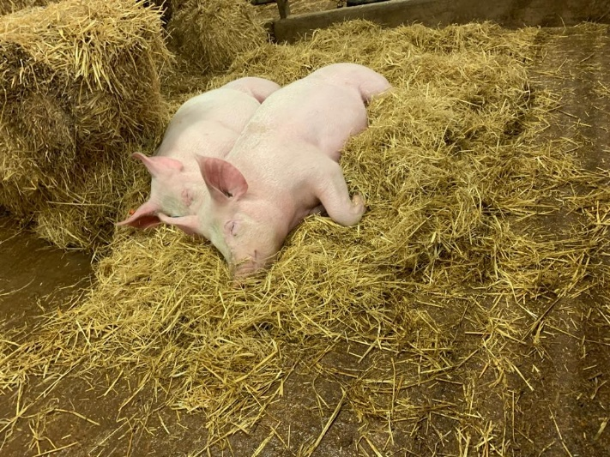  Pigs are housed in large pens inside a barn. There are 2 to 4 pigs to a pen. They have straw and shavings for bedding.
Age | The pigs are aged between 3 to 6 months. They are not kept past this age due to their procedures being Non-Recovery. Pigs can live up to 15 years.
Enrichment | 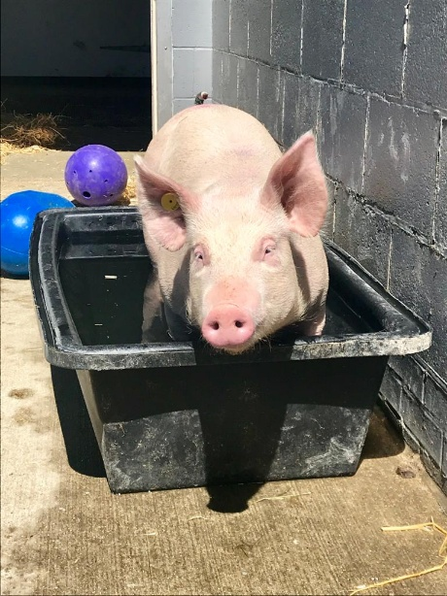  Wallowing pools, pumpkins and watermelons, hanging toys, a mixture of items they can pull apart such as old catalogues. They have an enrichment rota.
ID | 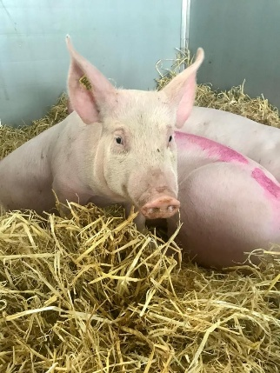  All pigs have the DEFRA requirements of ear tags. They are also marked with agricultural paint such as a blob or line for easy identification.
Research areas | Spinal repair (which is a non-recovery procedure) and medical training. In the future there will be devise testing for implanted osteo fixators.
Rehoming potential | None, due to the current nature of the work being non-recovery.
Fun Fact | Pigs are among the most intelligent animals. They can solve puzzles, learn tricks and even play video games using joysticks.

