AWERB Species Fact Sheet: Naked Mole Rat | 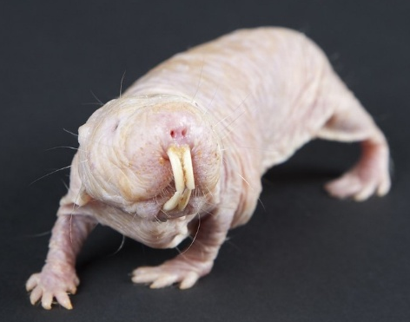

Diet | 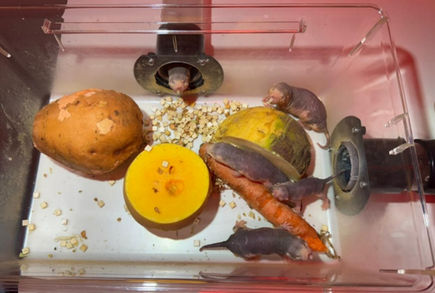  Root vegetables such as carrot, swede, sweet potato, parsnip butternut squash, and sweetcorn.  They do not require fresh water, as they obtain moisture from the vegetables. They are also given a high protein, porridge-like cereal called pro-nutro.
Enclosure | 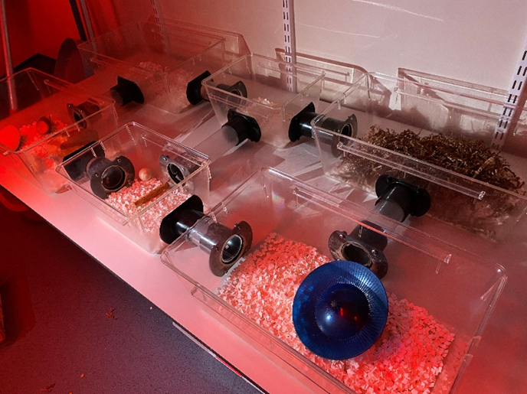  Bespoke cages linked by tubes. Chambers serve different purposes such as toilets, bedroom, dining area, and activity space. The room temperature is maintained at 29–32°C with the chambers’ humidity between 50–70%. A temperature/humidity gauge is placed in the lid of one of their chambers for monitoring.
Age | There are 5 colonies of differing sizes and ages. The largest colonies have over 20 animals and the smallest has under 6. The oldest colonies’ queen and mate were born in 2005. Other colonies were established in 2014 and some, more recently. They can live for well over 30 years, with the oldest recorded individual reaching 39.
Enrichment | 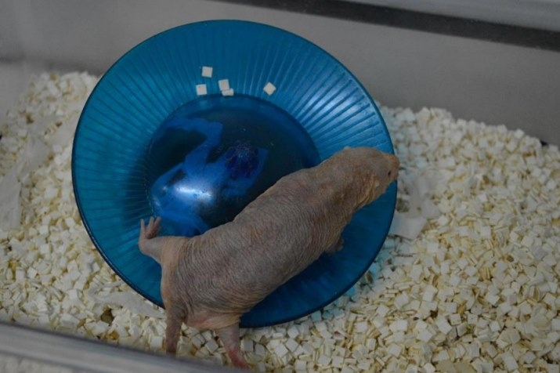  Tubes, wheels, and chew blocks. They also enjoy rearranging their bedding, moving it around. If they are given corn on the cob, they also enjoy removing the husks and using it in their bedding.
Housing | 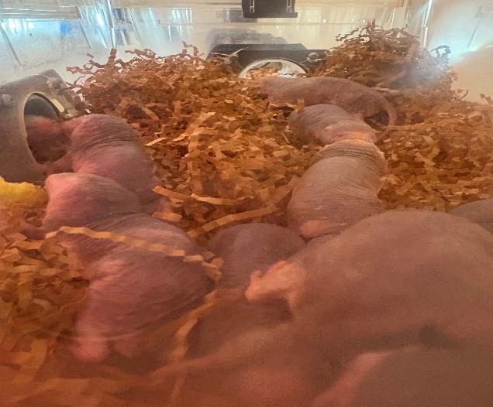  Group housed in colonies with one dominant queen. Bedding is made from cellulose or paper fibre such as Alpha-Dri or Pure-O Cel and further nesting materials are provided like sizzle nest
ID | Microchip embedded under the skin on their back.
Research areas | Cancer, hypoxia resistance, pain studies (they are insensitive to acid), and longevity studies.
Rehoming potential | Low, due to species-specific requirements.
Fun Fact | 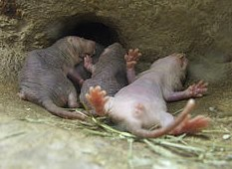  Mole rats often sleep on their backs and can also sleep very deeply and sometimes do not wake even if picked up or poked. Please do not be alarmed, this is normal for them!

