AWERB Species Fact Sheet:  Mice | 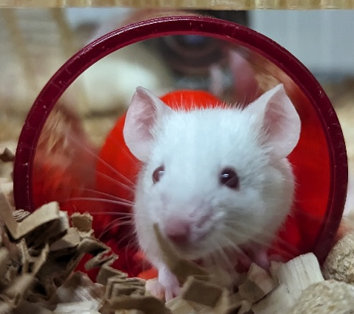

Diet | Commercial mouse diet presented in hoppers for ad lib feeding. Some mice have automatic watering; some have bottles and others have water pouches. It depends on the facility and type of caging they have. Mice may be given supplements such as bacon or strawberry gel after surgery or experimental procedures.
Housing | 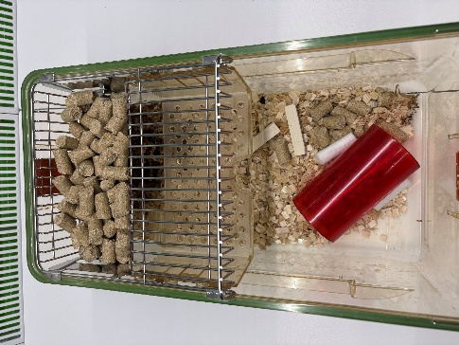  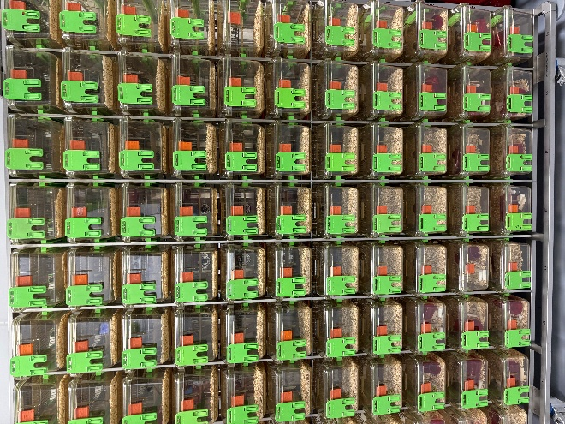  Most of the mice are kept in Individually Ventilated Cages (IVC) (see pictures) These cages plug into the rack where they are sealed and have their own air supply. This creates a level of biosecurity. There is one facility in UBS where mice are kept in open top “conventional” cages which would be like how they would be kept at home as pets. All cages have a woodchip of paper substrate bedding as well as nesting materials. Some facilities have nude mice (those bred to be furless) and are kept on AlphaDry bedding as it’s dust free to protect their eyes, mice that have has surgery are kept on soft white paper bedding so any unexpected bleeding can be easily observed.
Age | 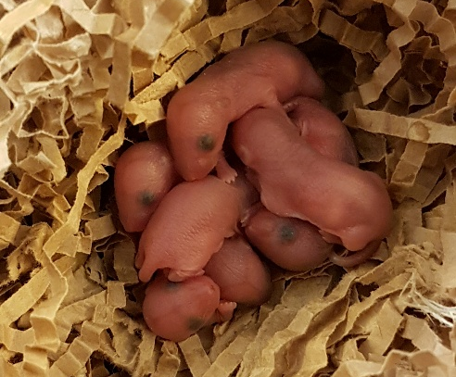  Many mice are bred in-house and can be kept for a varied amount of time. Some mice on ageing studies may live up to two years. Mice are also brought from specialist suppliers at specific ages as per the requirements of the study. Mice can have up to six litters in six months and tend to have an average of six pups at a time. The volume of studies is vast and are performed at various life stages from unborn pubs to aged mice.
Enrichment | 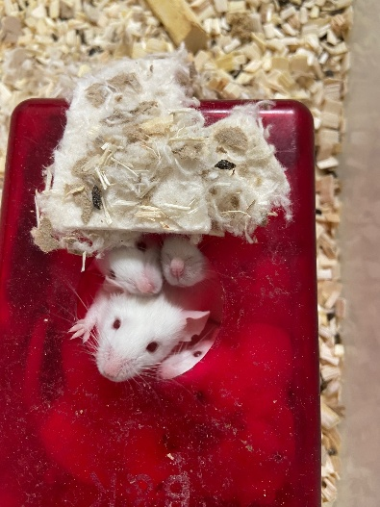  There is a huge variety of enrichment available. Many facilities use an enrichment rota to keep things interesting. Enrichments come in many forms from plastic and cardboard tunnels and hides, to chew blocks, variations of nesting materials to running wheels.  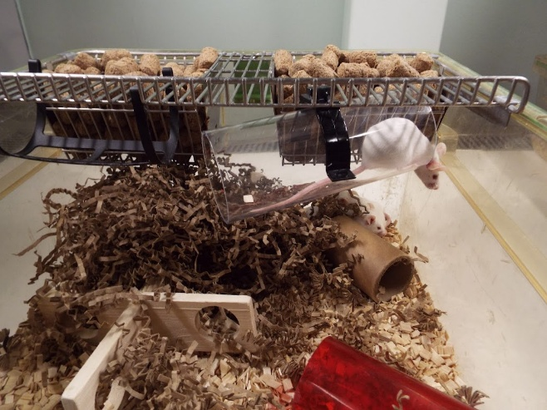
ID | 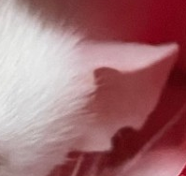  Some mice have ear notches (see photo), or microchips. If the mice are white, their fur can be marked with blue or red non-toxic pens.
Research areas | As mice are the most common animal kept at the University of Cambridge the research areas are vast. From Cardiology to cancer, to autoimmune diseases and neurology to name a few.
Rehoming potential | Good, mice can be rehomed easily. The challenge is finding people who would want them due to their short lives, so this not routinely done. Also, the mice cannot pose any risk to human health or the environment. Many mice across UBS are genetically altered, so these would not be candidates for rehoming, due to the escape risk and then them breeding with wild mice.
Fun Fact | 98% of human genes have a comparable gene in mice. 37 Nobel prizes have been awarded to studies that used mice.

