AWERB Species Fact Sheet: Marmoset | 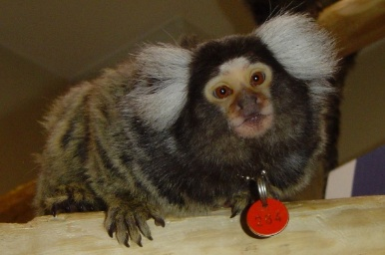
Diet | 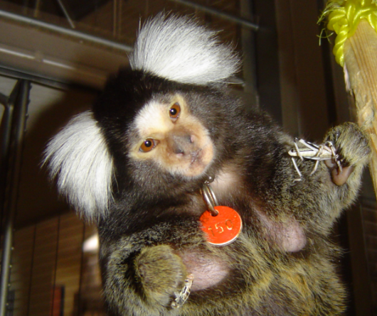  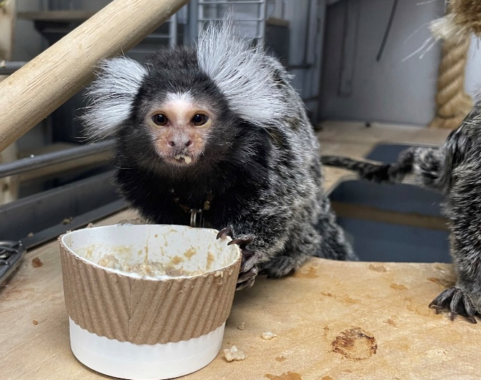  Sandwiches, egg and Complan with a powdered marmoset zoo food, plus added vitamins. In addition, a daily rotation of fruit, banana, apples, pears, and grapes. Once weekly they are also fed live insects, locust and Morio worms which also promotes foraging and hunting behaviour.
Age | 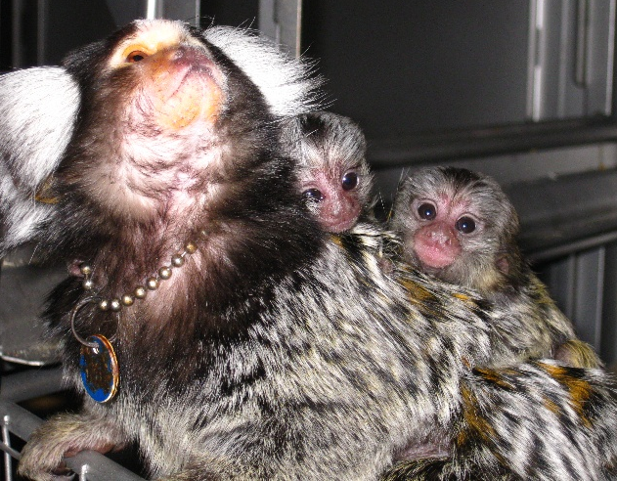  Marmosets and bred in the facility and kept their entire lives. They can live to nearly 20 years old. They give birth to twins which are raised by their aunties and uncles.
Enrichment | 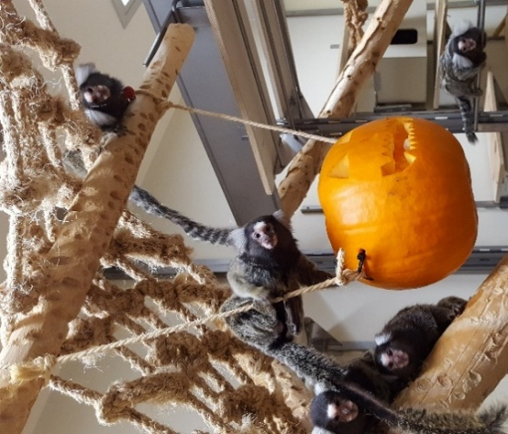  The cage/pens, are highly enriched with wooden poles of various diameters and angles to promote climbing, jumping, and chewing. Ropes and rope ladders promote climbing and jumping but also introduce a degree of uncertainty they would get if jumping or walking along branches. They are given nest boxes for sleeping in as they use tree holes in the wild. The cage is shaped to promote social interaction and height. This allows them to go above human head height which helps to reduce anxiety. They also have a weekly enrichment program where they can try new things or are given items, we know they like; this includes juice lickers, cardboard tubes, hanging boxes or hanging baskets, novel fruits, and presentation of food. They are also given marshmallows as a treat.
Housing | 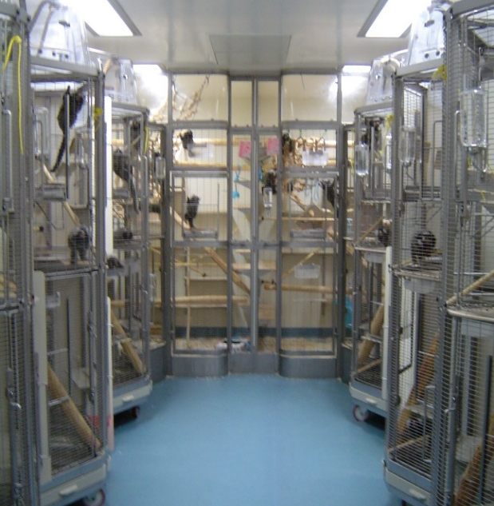  Always at least 2 marmosets are together, and they are never singly housed. Experimental marmosets are kept as male/female pairs. Family groups can have up to 15. They are kept at 24ºC – 25ºC.  Ther is no bedding as such just wood shavings on the pen floor or cage base.  Shape of cages was specifically designed to permit social interaction between neighbours and allow a good line of sight to see the room door to see who is entering which can reduce potential fright and distress. Consideration was given to potential negative interaction between marmoset by designing a removable cage side to protrude slightly reducing the minimum visual distance between neighbours to 40cm. Closer than 40cm can produce aggression or a stress response.
ID | Marmosets wear collars with tags which are numbered and coloured for sex.
Research areas | Neuroscience looking into brain connectivity related to human illness such as anxiety, depression, and OCD.
Rehoming potential | None, due to it being illegal to own these monkeys as pets.
Fun Fact | Never do a paternity test on a marmoset, they are all chimeric and 1 in 100 sperm belong to his brother!

