AWERB Species Fact Sheet:  Guinea Pig | 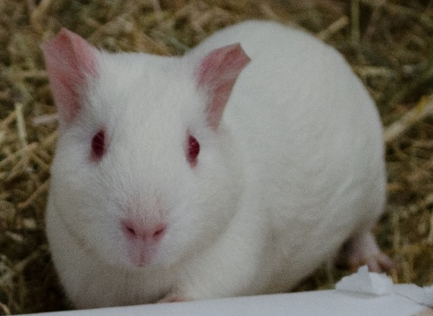

Diet | 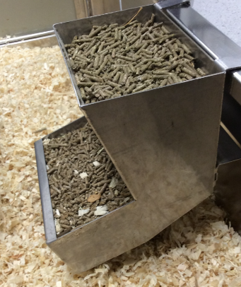  Guinea pigs are fed on a commercial guinea pig diet which includes a vitamin C supplementation. It is essential they have this as they are unable to synthesis it. They are given unlimited hay to feed Ad-lib.  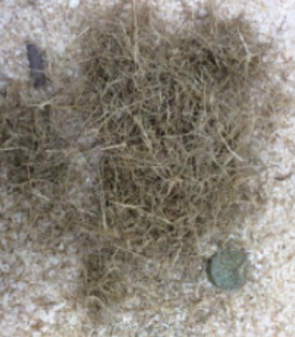
Housing | 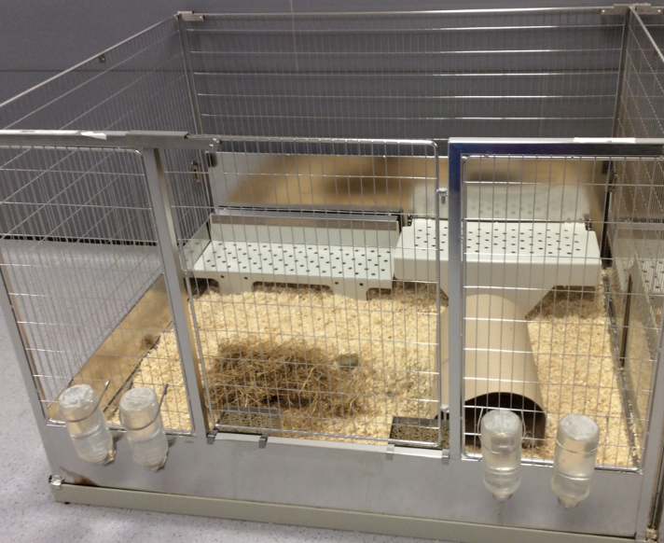  Group housed in floor pens, typically 8 pigs in each pen.  Temperature: 15–21°C.  Bedding: wood shaving with hay for nesting and foraging.  There is a rota in place, primarily for organisation. The guinea pigs are fully cleaned out once a week, and their water bottles are changed weekly (and topped up as needed), food is checked and topped up when needed.  Podcasts are played in the room during the day to help them become accustomed to background noise.
Age | 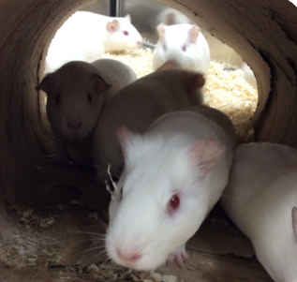  Age range in colony: young adults to ~3 years, they are  Typically kept for up to 9 months (depending on study). Guinepigs can live for around 5 years.
Enrichment | 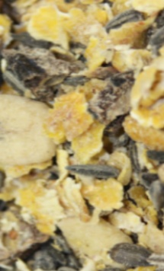  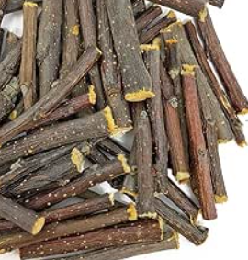  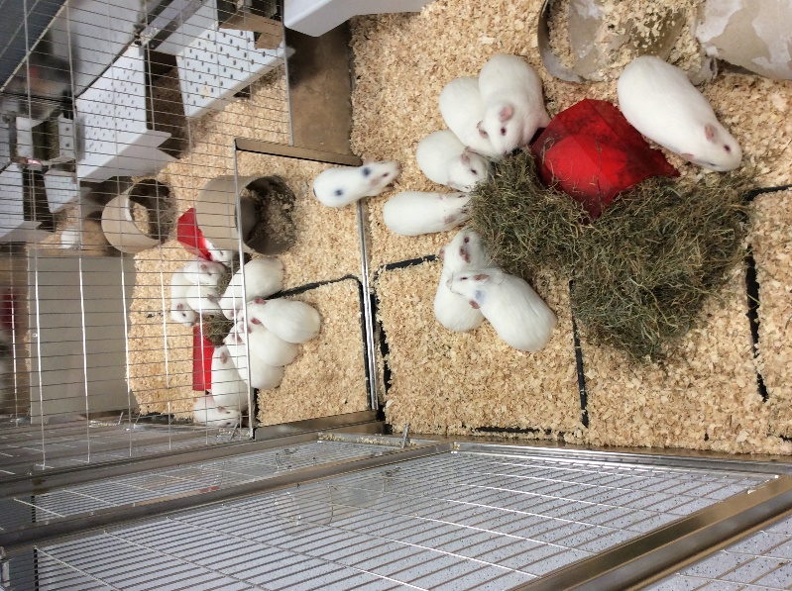  Guineapigs are provided with tunnels and shelters to run through and hide in. All enclosures have shelves that they can either climb on top of or go under. In addition, they have gnawing blocks, apple chew sticks (like those below), and are scatter fed with forage mix to promote foraging behaviour.
ID | 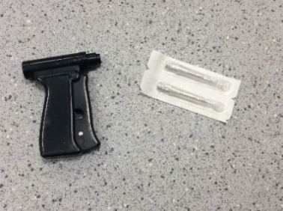  Microchipped. The small chip is placed under the skin of the guinea pig’s flank – and is a microelectronic circuit with a unique identification number (ID). Sometime fur markers are used as well.  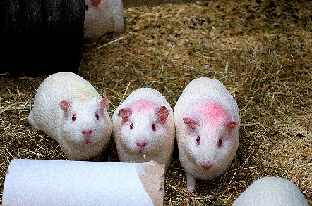
Research areas | Vaccine studies including:  - Trivalent haemorrhagic fever vaccine – targeting Ebola, Marburg, and Lassa fever.  - SARS-CoV-2 (COVID-19) vaccines – including one that progressed to a Phase I human clinical trial.  - Rabies vaccine (Pitman-Moore).
Rehoming potential | Good. Control guineapigs from this facility are often rehomed successfully as there is no risk to human health or the environment. Those that have been challenged with a pathogen are not suitable due to risk.
Fun Fact | Guinea pigs are very vocal and produce a variety of calls — including a distinctive “wheek” when anticipating food.  When guinea pigs are excited, they demonstrate a behaviour called “popcorn” — jumping and twisting in the air.

