AWERB Species Fact Sheet:  Cichlid | 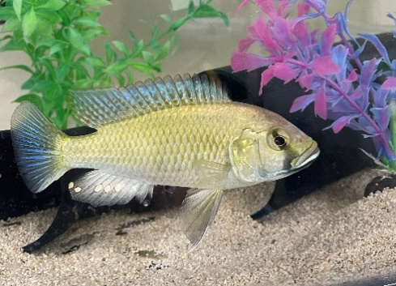

Diet | 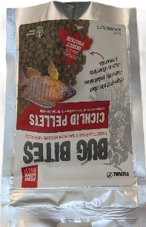  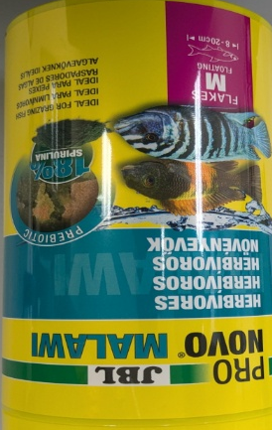  Cichlids are fed Malawi cichlid fish flakes three times a day (twice on the weekend). Once a week they are given “bug bites” instead of flakes.
Housing | The fish are housed in tanks ranging from 40 to 200 litres, with the size determined by the age and number of fish in each group. Every tank is equipped with a filtration system to maintain water quality, and where applicable, sand is added along with environmental enrichment to support natural behaviours.  To ensure adequate oxygenation, air stones are placed in each tank. These serve a dual purpose: they enhance the oxygen levels in the water and act as a contingency should the filters fail during periods when the room is unattended.  As these are temperate fish, the room temperature is carefully maintained between 24°C and 29°C. This helps to keep the water temperature stable, minimising fluctuations that could cause stress.  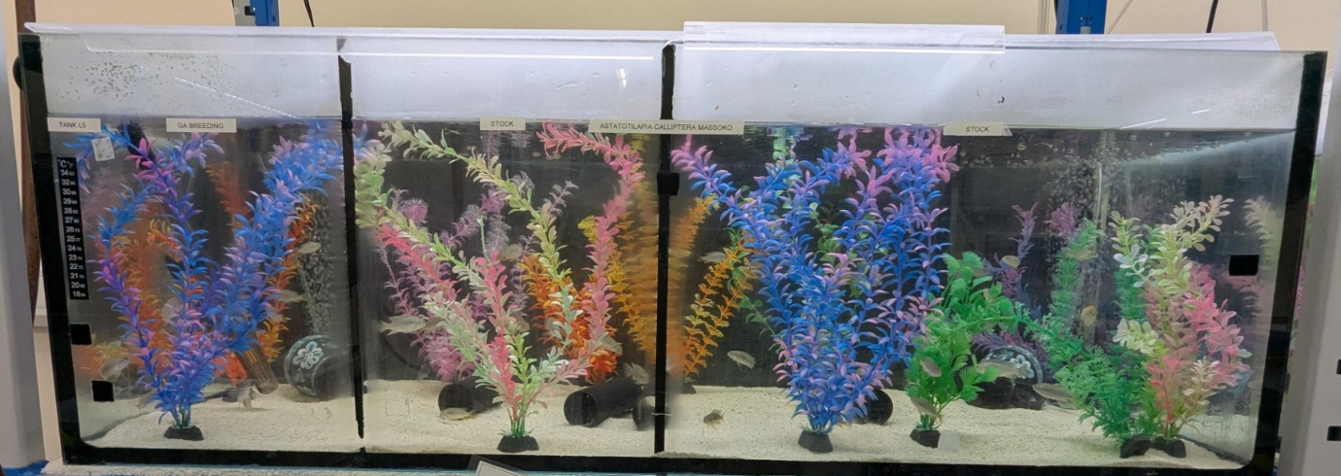
Age | There are a range of ages, from a few months to 5/6 years. There has been a fish that was over 10 years old. They are kept until they start to show age related decline.
Enrichment | All tanks have plastic plants in them; enough to break up the eye line of the dominant fish and give the submissive fish somewhere to hide if there is chasing behaviours in the tank.  Males use pots to conduct their mating rituals in, and females have tunnels to swim through. If there are males and females in a tank both will be offered. Receptacles such as mugs are also given in replacement of the pots if there aren’t enough. These vary in size depending on the size of the males.  Most of the tanks have sand, which the fish will sometimes search through for any hidden food. However, when singly housing males, they tend not to have it, as they do not interact with it.  Bug bites given are also a form of enrichment, as they take a while to be eaten.  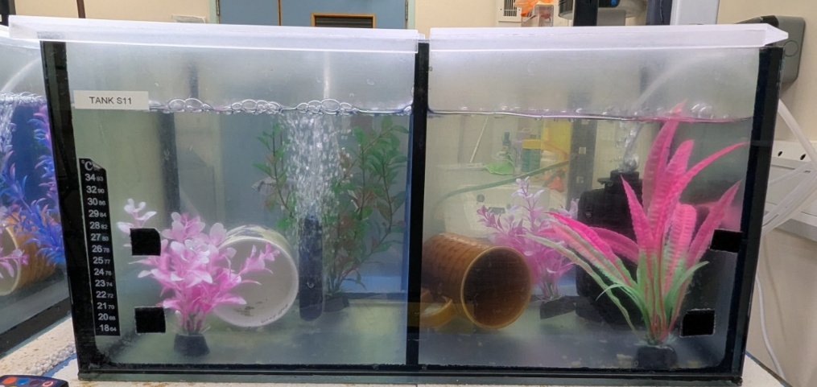
ID | Identifying individual cichlids by their markings is challenging, as the patterns can change rapidly due to the nature of melanophores—the cells responsible for black pigmentation. While relative size may help, it’s unreliable over time. Male fish are somewhat easier to distinguish, but shifting social hierarchies make this inconsistent. In general, fish cannot be individually identified unless they have a visible injury or deformity. Methods like microchipping are unsuitable due to their aquatic environment
Research areas | Evolutionary Development, with phylogenetics (the study of evolutionary relationships among biological entities, often species, individuals, or genes, based on their genetic and observable characteristics) being researched in early embryos and their development.
Rehoming potential | These fish could be rehomed, if they have not been genetically modified.
Fun Fact | When cichlids mouth brood (keep their eggs or newly hatched fry in their mouths), they are generally thought to not eat from the onset until the offspring are able to be safely released from the mouth for short periods of time, however there is known to be some cannibalism if the conditions are not favourable, and this is almost always performed by the female parent.

