AWERB Species Fact Sheet:  Chicken | 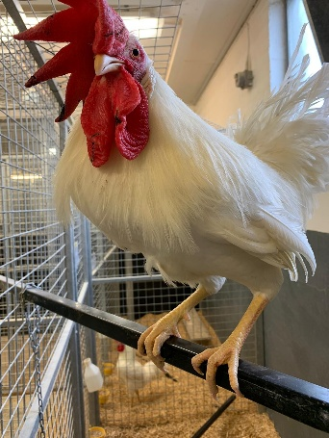

Diet | 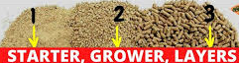  Commercial chicken feed. They are given specific pellet feed dependant on their age (e.g., grower’s crumble (1), then a grower’s pellet (2) and then a layer’s pellet (3). Feed is given adlib.
Housing | Chickens are housed in pens at night which all have perches. Generally, 2 to 4 chickens are housed together, but some can have up to 10. They also have a shared communal area that consists of three rooms that can be subdivided or opened. In the communal area there can be up to 12 together per room. The chickens are let out in the morning to the communal area, then put back into their pens at night. The communal area has lots of enrichment. Perches and nesting boxes are provided throughout.  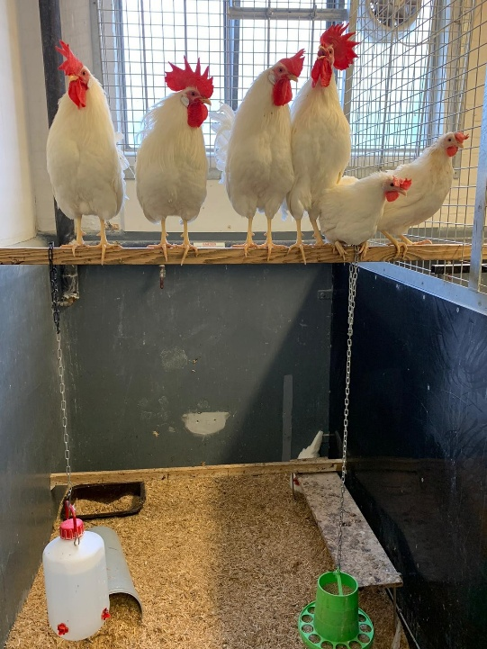
Age | 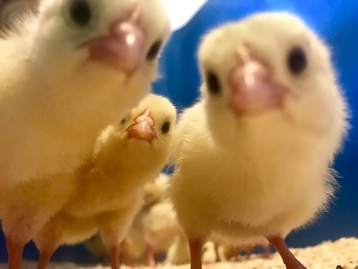  The ages of the chickens kept varies depending on the study. But can be foetal (within the egg) up to 18 months old. Chickens can live for 5 to 10 years.
Enrichment | 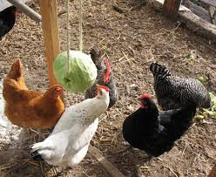  Chickens have an enrichment rota. This consists of foraging for seeds and treats, boxes of shredded paper, shiny CDs, bells and dietary treats. They are also given live insects such as locusts and worms to hunt.  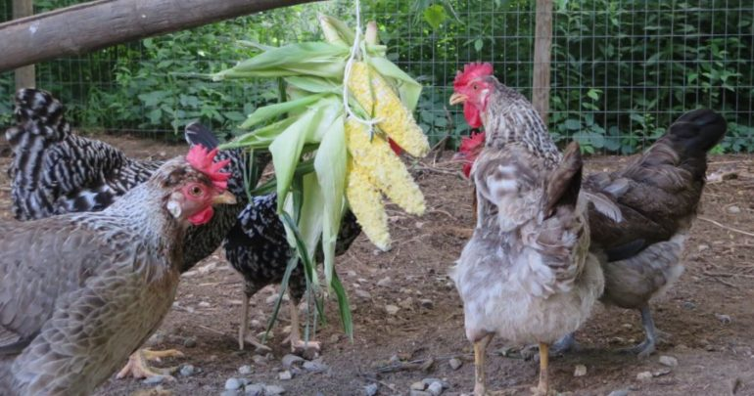
ID | 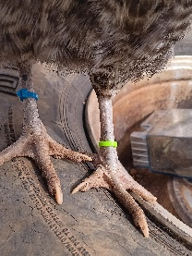  Small plastic bands are placed on their legs with individual numbers, or colour combinations.
Research areas | Antibody production, foetal development and cardiovascular health.
Rehoming potential | Good, if you can find homes. In the past technicians have taken them home.
Fun Fact | Chickens love cooked pasta! Our technicians sometimes offer the hens a small amount of pasta as a treat. Their favourites are Ziti noodles and rigatoni.

