UBS AWERB 3Rs Guidelines:
Guidance and Advice supporting the single use of needles in UBS facilities
Introduction- Animal Welfare and Refinement
Single-use of needles – why?

Durability – re-used needles increase the risk of tissue damage and trauma to the animal
Compromises animal welfare

Sterility – re-used needles are no longer sterile increasing the risk of transfer of pathogens across cohorts
Compromises animal welfare; Introduces unknown variables
Most needles used in medical and biomedical facilities are “single-use” by design – for the purposes of durability and sterility (see Needle Paperwork, and Appendix 1).
Some needles are more durable and so are designed for multiple usage, such as Hamilton needles; these still require re-sterilisation between animals but are not part of this Guidance.

The HO and the NC3Rs, and therefore UBS, are advocating that single-use needles by design are only to be used once – i.e., to be disposed of after entering only one animal – as part of an establishment’s Culture of Care towards their animals (see HO ASRU Annual Report 2018, and NC3Rs blog).

The University of Cambridge AWERB 3Rs Committee would therefore like to pass on these 5 Top Tips to its animal users to help support them in not needing to re-use single-use needles.

5 Top Tips

- Saving on lost injectable volume when changing needles
Needles contain an element of dead space within them, that needs to be emptied before removing the needle, in order to conserve volume:
<pictures demo>
- Low dead-space (LDS) needles
Chose to use needles designed to have a low dead-space:
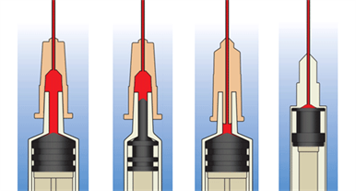
Figure 1: Examples of needle design from the highest dead-space (left) to the lowest dead-space (right). Courtesy of NIHR ARC West
https://arc-w.nihr.ac.uk/research/projects/low-versus-high-dead-space-syringes-user-preferences-and-attitudes/

University suppliers supply XYZ
Pen needles?
- Experimental design – run the animal cohorts in smaller batches
By running studies in smaller batches of animals could result in there being less pressure on the liquid to be injected, such as cultured cells, to need to be distributed as far. Running studies as rolling recruitment rather than bulk studies could help.
- Growing cell cultures
Using multiple layered flasks can increase the surface area available for cell growth, without increasing the footprint in the lab, enabling upscaling of cell production and therefore volume.
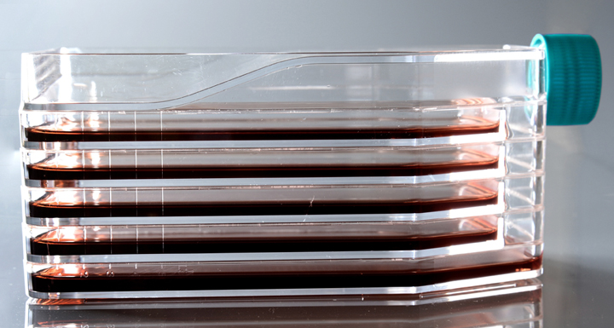
Figure 2: A typical 5-layer cell culture flask, courtesy of www.cell-nest.com
- In-Development new technologies: NC3Rs CRACK-IT Challenge
“Active Needle Technology Ltd aim to develop a device using ultrasonic technology which minimises loss of material to dead space and improves animal welfare.” (See Appendix 4: NC3Rs CRACK-IT Challenge)

Page break
Appendix 1: UBS Re-Use of Needles Poster
Shows the damage incurred by multiple needle uses, confirming the poor durability of single-use needles, when re-used.

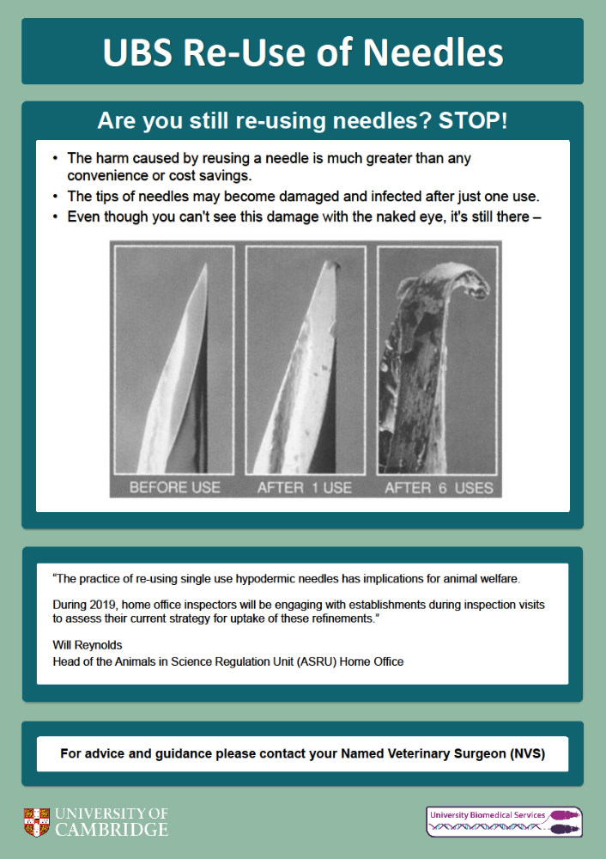

Page break
Appendix 2: HO ASRU Annual Report 2018
https://assets.publishing.service.gov.uk/government/uploads/system/uploads/attachment_data/file/887289/Animals_in_Science_Regulation_Unit_annual_report_2018.pdf

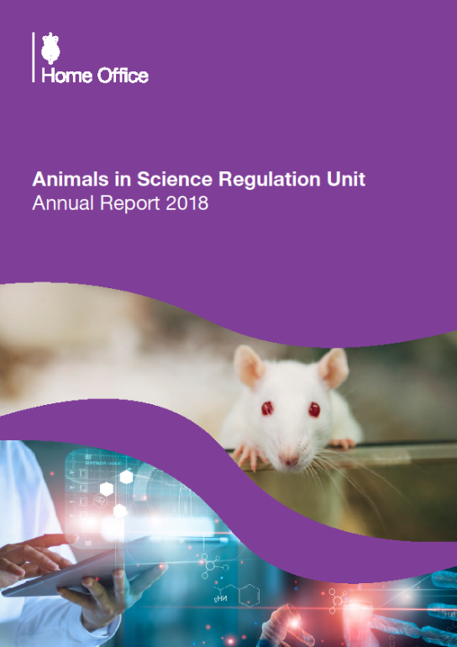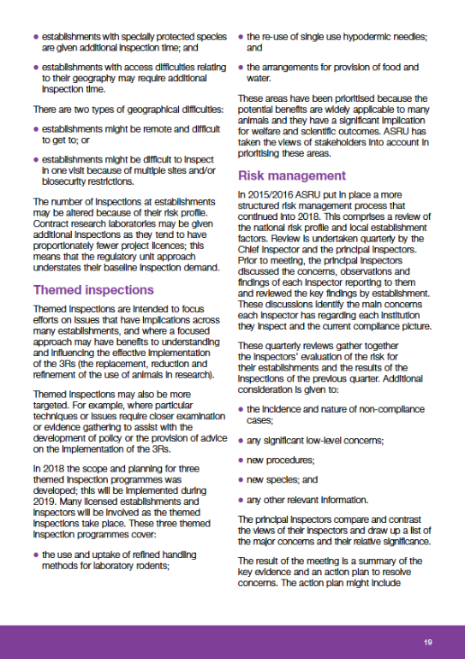

“Themed inspections are intended to… influencing the effective implementation
of the 3Rs…
- the re-use of single use hypodermic needles;
…These areas have been prioritised because the potential benefits are widely applicable to many
animals and they have a significant implication for welfare and scientific outcomes.”

Appendix 3: NC3Rs Blog

https://www.nc3rs.org.uk/reuse-of-needles
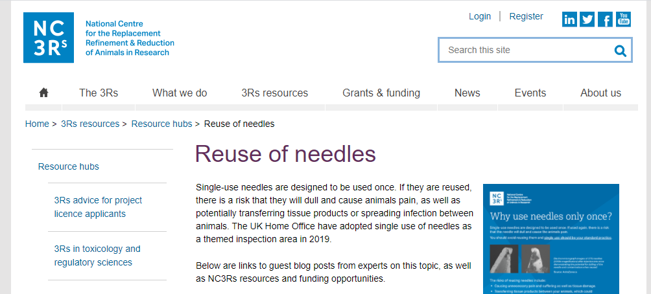 PB
Appendix 4: NC3Rs CRACK-IT Challenge
https://nc3rs.org.uk/sharp-and-point-developing-device-injections-mice-avoids-re-use-needles

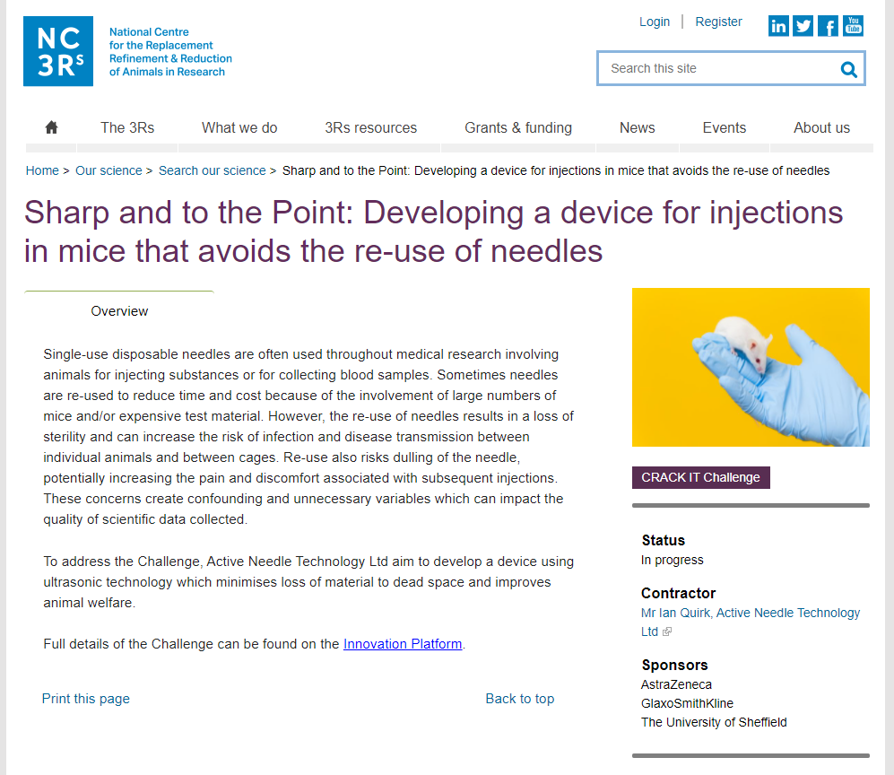

The Challenge has been awarded to http://www.activeneedle.com/ and is currently (August 2021) In Progress.

