Advice based on the Animals (Scientific Procedures) Act 1986
As reviewed and transposed 1 January 2012 and Amended 1 January 2013


University Biomedical Services

University of Cambridge Project Licence Writing Guidance
Version 8.2

This Guide will be updated from time to time to reflect current advice from the Home Office and as the Home Office and University processes evolved from a paper based through to the latest electronic system.
Everyone using this document is advised to check with either Anne-Marie Farmer, Maggie Gentry or the UBS Website to make sure they have the most up to date version.
University Biomedical Services



Table of Contents
Please note the purple headings map onto the sections in ASPeL
Page
Introduction 2
Drafting and the main parts of the project licence. 3
Evolution of project applications 3
Getting started with ASPeL 3
Drafting your new application - Overview of the main sections 7
Explanations, tips, and examples. 8
Introductory details: Project title 8
Non technical summary: Aims 8
Project plan: Action plan: Objectives 8
Non technical summary: Benefits 9
Project plan: Action plan 10
Project plan: Decision Tree/Flow Diagram 10
Protocols: General points 11
Protocols: Breeding and Maintenance of Genetically Altered Animals [GAA] Protocol 13
Protocols: Experimental (Use) Protocols 15
Protocols and Animal experience: Adverse effects 20
Protocols: Summary of Protocols Table 26
Protocols: Experimental design and Protocol justification 26
Non technical summary: General comments 27
Non technical summary: Project harms 27
Non technical summary: Replacement 28
Non technical summary: Reduction 28
Non technical summary: Refinements 29
Project plan: Scientific Background 29
Reference List 30
General advice 31
Project application process 31
Project application time lines 31
Appendix 1: Home Office Advice for using standard GA protocols 37
Appendix 2: Project application: Additional advice 37
Technical details: Experience, Funding and Training 37
Technical details: Experience 37
Technical details: Funding 38
Technical details: Training 38
Length of licences 39
Appendix 3: Project application: Establishment and POLEs 40
Project location: Establishments 40
Project locations: Places other than a licenced establishments (POLEs) 40
Appendix 4: Example Decision Tree/Flow Diagram 42
Appendix 5: Guidelines for maximum dosing volumes and frequencies 44
Appendix 6: Home Office Minimum Standards for Aseptic Surgery 46
Appendix 7: Resourcing of Surgery Technicians for rodent surgery 48
Appendix 8: Responsible use of Anaesthetic agents 51
Appendix 9: The responsible use of Project Licence authorities policy 52
Appendix 10: Annex VIII of European Directive 2010/63/EU 54
Appendix 11: Slides and Guidance notes for presentations to University
of Cambridge AWERB 57
Appendix 12: Common errors in project applications 61
Appendix 13: Suggested members for your UBS Project Support Team and other
useful contacts 62
Appendix 14: Other sources of useful information 63

Introduction

These notes have been complied to help you write your new project application. They have been written based on questions raised by licensees and named persons and advice from the Home Office inspectors. The layout of these notes differently from others you will have seen although you are likely to find comments you have encountered in previous documents.

Before you begin…
Each project application should be written to cover work that can realistically be completed within the time for which the licence will be granted (in most cases 5 years).

You are strongly advised to avoid copying and pasting sections of text or protocols from existing granted licences (if you have one). Instead, you should use the most up to date copies of protocol templates (provided separately) and information you will gathered from the Project Application Drafting Course (PADC). Use these in conjunction with the advice in this document.

In August 2019 the Home Office introduced a new cloud-based licensing system (initially called new ASPeL). This means that you will work on line when drafting your new application. You will still be able to print and save a Word copy but when the time comes to submit your application, you will do this by typing your application directly into the cloud-based ‘form’ (see page 5). In you decide to draft using Word, i.e. not using ASPeL you need to remember there is no way to upload a Word version of your application back into ASPeL.

The layout of this guidance is different from the layout on ASPeL. This is deliberate since a number of licensees have indicated that they find using the ASPeL layout affects the information they provide because the sequence does not naturally fit with the way they think about their work. With this in mind, the body of this document sets out, and focuses primarily on, the main parts of a project application that licensees find most difficulty completing. The information is presented in an order you might find easier to use. When working on-line in ASPeL you can complete sections in whatever order you like.

You are encouraged to complete your Retrospective Review (if you currently hold a granted licence) and the UBS Project Support Team template before you meet with your UBS Project Support Team for the first time. You will find investing time in preparing these documents and in discussion with your Project Support Team BEFORE you begin writing your application worthwhile. Taking the time to plan your application before you even log into ASPeL will also pay dividends in terms of time saved and reduced frustration.

As a project licence holder, writing your project application is your responsibility. In this age of Freedom of Information your licence when granted may be requested by a third party, as in fact several have been recently. If your licence is requested, an agreed redacted version would be released.

It is vitally important that you use your UBS Project Support Team to bounce ideas off and obtain advice from, that you give yourself time to complete the task without rushing and that you pay attention to detail. By doing so, your finished project application should pass smoothly through the Animal Welfare and Ethical Review Body [AWERB] and Home Office processes, and your granted licence provides you with the authorities you require for your research; should be more easily amended if necessary and will reflect well on you and the University.
Drafting the main parts of the project application

Evolution of Project applications:
Historically project applications were drafted and submitted in paper format. In 2012, the Home Office introduced the first electronic portal they called ASPeL. In 2015, this portal was re-developed to include the electronic handling of project licences. This portal remained in use until August 2019 and is now referred to as ‘old ASPeL’ in this document. In August 2019 ‘new ASPeL’ was introduced. New ASPeL is a fully cloud based system and its use is outlined below. At the end of November 2020, the Home Office introduced another major change to the layout of project applications in ASPeL – these notes have been revised to take these changes into account, plus advice we have gathered from comments made by our inspectors on new project applications and amendments.

Those of you who complete tax returns will see similarities between the ASPeL software and that used for tax returns. In the same way that you would prepare before completing your tax return, taking time to get your documents together and your ideas on paper before you log in to ASPeL, will make the task of writing your new application on line much easier.

Explanation 1: The new cloud based ASPeL sets out the sections of the project application using links to each section of the application. Clicking on the links will open each section.
Tip 1: You should start by going to the Introductory details section. In this section, insert the title for your new project application. This will help you identify your draft application next time you log into your ASPeL landing page. This is particularly important if you have more than one application or project licence.
Tip 2: You should complete all the questions in the Introductory details section because for example, this is where you let ASPeL know what species you plan to use and this information is required by ASPeL to autofill later sections of your application.
Tip 3: You can add, delete and change information at any time. However, you should remember that ASPeL auto-saves your work every 5 seconds. There is no ‘undo’ button so anything you change or delete can only be reinstated by typing the information in again.
Tip 4: The cloud-based application ‘form’ has been designed to autocomplete sections of your application, for example your primary establishment availability will be auto-filled based on the ASPeL cloud you log onto to draft your application.
Tip 5: Working on line is likely to prove challenging. Roughing out your ideas for your application on paper before you log into ASPeL will save you time.
Tip 6: Once you have started drafting and when you download a Word version, you may be surprised by the size of the document. Your granted licence will not be as big as the application version because the granted version contains only the authorities necessary in a licence. The Word and pdf application version contains all the information necessary to assess your application. For this reason, the Word and pdf versions of your application are used by your Project Support Team (PST), the AWERB and your inspector when they review your application.

Getting started with ASPeL:
The following information is designed to get you started. When used in conjunction with the Project Application Drafting Course [PADC] slide set, you should have all the information you require to draft your application.

The first step you should take is to log onto ASPeL. If you hold a personal licence [PIL] and/or project licence [PPL] your e-mail details will already be stored in ASPeL, associated with the establishment where your licence(s) is/are granted. If you have more than one e-mail address, you must use the e-mail address that you used when logging into the old version of ASPeL. If you are unsure or cannot remember the e-mail address you used, please e-mail ubsHOLicencing@admin.cam.ac.uk and ask them for the e-mail address to use. If you worked at another establishment and have never had primary availability at the University please contact ubsHOLicencing@admin.cam.ac.uk, copying in Maggie Gentry (mg469@cam.ac.uk) and Kate Tansley (kea30@cam.ac.uk) . However, please first read the advice on this page in the paragraph below the ‘First time logging in’ paragraph.

This link will take you to the ASPeL log in page: https://external.aspel.homeoffice.gov.uk/

The first time you log in you will be asked to create a password. Unlike old ASPeL this password will not expire, so consider keeping a note of it somewhere safe. If you forget your password, you can use the Forgot password link on the ASPeL log in page and follow the instructions to reset your password.

First time logging in
- Please open the link in Chrome or Safari (currently we are finding Chrome more reliable)
- At the bottom of the log in box there is a “register” button, click this and complete your details using your email address and set your own password
- You will be sent a link to verify your e-mail which you will need to follow
- Then return to the log in page and you should be able to log in.

If you have never logged in to ASPeL before or you have logged in from a different establishment, you should send an e-mail to UBS Admin using this e-mail address - ubsHOLicencing@admin.cam.ac.uk. UBS Admin will need to know:
- that you have never logged in before or
- you have logged in before but from a different establishment. In this case, please provide the e-mail address you have used for the other establishment and you will receive a joining e-mail using the e-mail address you provide. If you need to move licences between establishments, it is important that you provide us with the e-mail address for the establishment where your licence has primary availability. You can change your e-mail address at a later date, if you want to move your licences to the University. ASPeL will send you an e-mail invitation which contains a link to follow so you can log into the University ASPeL cloud and set your password (see above). You will need to accept the invitation within 7 working days or it will expire.

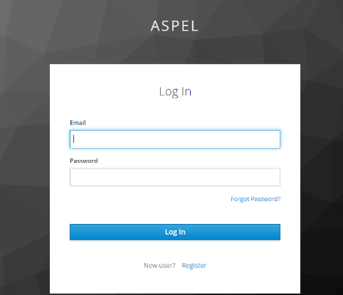
The ASPeL log in screen looks like the screen shot to the right. You will need to type your e-mail address in full followed by your password.

The next screen you see will depend on the permissions you have been assigned. The basic level (which will be used initially for all PILh and PPLhs) will allow you to draft new applications, to see all your active (granted) licences and make amendments to these.

You will also be able to see the names of all the Named people at the University (for example the NVSs and NACWOs).

ASPeL continues to evolve and improve as the Home Office develops this software and adds functionality.
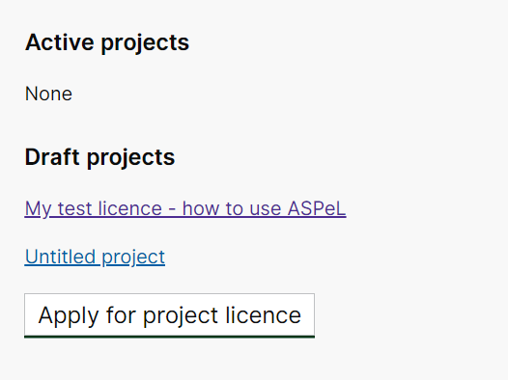

When you are ready to draft your new application log in and from your landing page scroll down until you can see the section heading: Active projects, as illustrated on the left. At the bottom of this section, you will see a button: Apply for project licence. Click on this button and you will be taken to the page illustrated below.

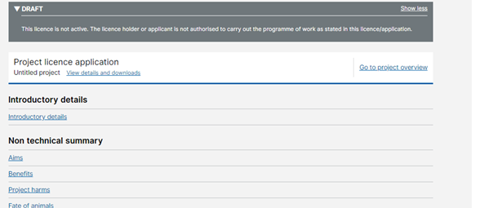
This next page is the page with all the section links needed to complete a new project application. As illustrated, if you click on the Go to project overview link you will arrive at a page where you will see a Download tab. If you click on this tab, you will see the option to export (download) a Word or pdf version of your application or granted licence. Please be aware that if you download a Word version you will not be able to upload it again. You will only be able to copy and paste the information from the exported Word version into the relevant sections of ASPeL.

When you are working with your UBS Project Support Team (PST), you should export your draft as the Word and pdf versions and send both these for comment. Similarly, when you are ready to submit to AWERB, you should export and send both the Word and pdf versions.
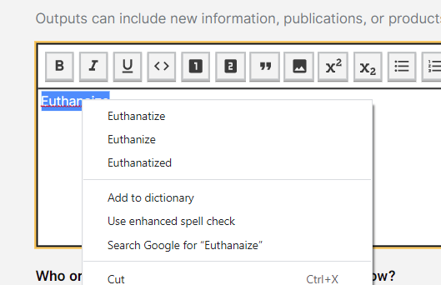
Please use the spell checker embedded in ASPeL to check and correct spelling errors before you export your draft application to send to your PST and AWERB. Incorrectly spelt words should appear underlined. You should right click on underlined words and when you do, you will be given options, as illustrated. If you are only given the American spelling (as illustrated) you should change the dictionary on your computer. Please use English spelling.

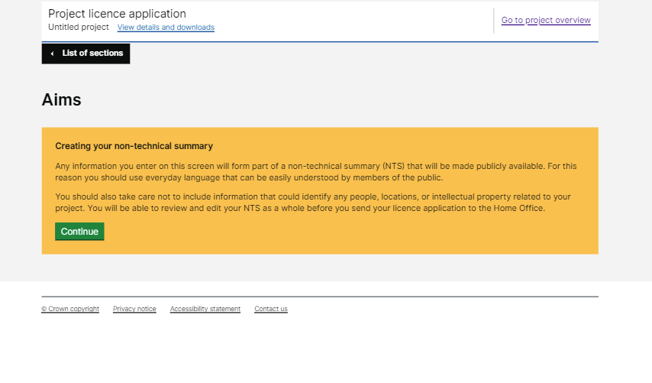
Completing the Introductory Details section has been covered in the Tips above. The next section is the Non technical summary section (NTS). You will need to insert your Aims statement in this section. When you click on the first link: Aims, you will see a yellow box which contains an important message explaining that information provided in this section will auto-generate your NTS. Remember your NTS will be uploaded to the Home Office and University websites, so it is important that you write these sections carefully. The Home Office recommend you aim for a reading and comprehension age of 12 years. The Home Office would also like you to avoid using technical words in your project application title and Aims statement. If this is not possible it is important that any technical words are explained in the boxes in the NTS.

When you click on the Continue button, you will be presented with questions and text boxes to complete (as illustrated on the next below). The size of the text box reflects the amount of text the Home Office expects you to provide – small boxes denote they only want a small amount of text, and larger boxes should contain more information. All boxes on ASPeL will expand as you type into them.
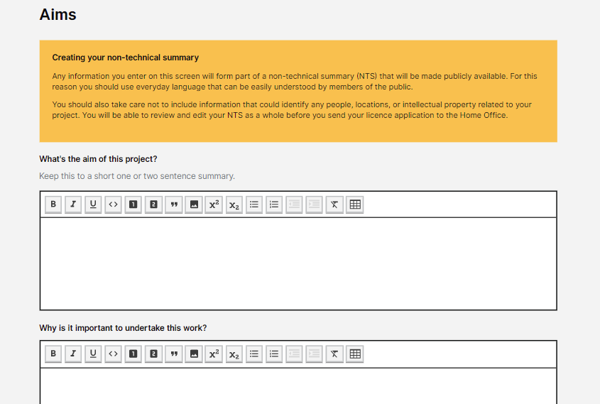
Below some of questions or box headings, as illustrated for the first question on the right, you will see additional advisory text in grey. It is important you read the question/header carefully and these grey advisory prompts too. Please try to answer each questions giving the information requested, no more and no less. You should not need to duplicate/repeat text. If you find yourself doing so, it probably means you have not put information in the correct boxes. The only place where duplication is appropriate is in the Protocol section. In Protocols that authorise similar or the same procedures or adopt the same experimental design approaches for example, it is appropriate to duplicate text across these protocols.

Applicants appear to find providing information in the right boxes one of the most difficult aspect of working with ASPeL. To help you know what questions you might have to answer please refer to the complete set of ASPeL questions which can be found in the ‘Untitled project questions December 2020’ document provided to you when you attended PADC. Do NOT use this word document as the template in which you draft your application.

You are now ready to get started.

Your Project Support Team will be available and will provide further advice at each stage of the drafting process, and as required.

Drafting your new application - Overview of the main sections:

Project Title: Should be short and clear (preferably less than 50 characters).

Aims and objectives of the project:
Aim statement: In one sentence, state the overall aim/purpose of your research.
Research questions/objectives: Used to scope your work. With the resources available to you, you should realistically be able to answer your questions/ address your objectives within the tenure of your licence when granted.

Benefits: Based on your requested licence authorities state only the outputs you expect, who or what will benefit and how from your work.

Protocols:
Protocol steps: Protocol steps detail the procedures/techniques you require for your experiments and adverse effects, if expected for each step.
Only expected adverse effects should be included, described as the clinical signs you expect to see, plus information about how you will control and monitor your animals and the endpoints you require to ensure your work will have the lowest impact on the welfare of your animals, while still generating satisfactory results.
This is the section of the new ASPeL that has changed the most and is one of the sections proving the most challenging to complete.
There are new sections towards the end of each protocol which ask for information about Animal experience, Experimental design and Protocol justification, as they apply to each protocol. The information you provide here should be detailed because these sections replace the information that used to appear in the old Part D: Project Plan.

Action Plan: In the box under the question: How do each of these objectives relate to each other and help you to achieve your aim?, insert your Decision tree/Flow diagram and if appropriate, a brief supporting/explanatory comment. DO NOT be tempted in this section to adopt the old Part D: Project Plan format.
Decision Tree/Flow Diagram: The use of these to pictorially illustrate your programme of work, and remember to include the ex vivo, in vivo and in silico components plus the downstream outputs you expect. Your Decision Tree/Flow Diagram should appear in your Action Plan (see below).

Detailed 3Rs information should be included in each protocol in the Experimental design and Protocol justification sections (i.e. the detail required by your inspector). The Non technical summary [NTS] section should be used to provide the high-level information written in lay terms which will be placed on the Home Office website:
Replacement: Provide information about the ex vivo work or non-regulated species you have considered using or are using, if used how you use these in the context of your work and if by so doing you have or will be able to replace the need for experiments using regulated procedures in future. Remember to include the in vitro and in silico methods you already use or plan to use.
Reduction: Provide information which explains how you intend to ensure your work will use the least number of animals while still delivering satisfactory research data. Explain the experimental design principles you intend to use in detail in each protocol.
Refinements: Provide information explaining why the species and models you have chosen are the most appropriate and how you aim to minimise the impact your work will have on the welfare of your animals while delivering robust scientific data.

Scientific Background: Use this section to set out the scientific context of your research.
Explanations, tips and examples
Be prepared to use an iterative process to draft your title, Aims statement, questions/objectives and benefits. It is hard to get each of these four components right in isolation and on the first attempt. Therefore, be prepared to tweak and change while you work on these sections. Consider starting your drafting using blank sheets of paper. This could include drafting your Flow Diagram.

Introductory details: Project title:
Explanation 1: The title will appear in the public domain. If possible, try not to use technical words. However, if in the title and the Aims statement you cannot avoid the use of technical words, remember to explain what the technical words mean in answers to question elsewhere in the Non-Technical Summary section.
Explanation 2: The title should describe the theme of the work and define the area of interest in a way that will remain valid for the duration of the licence.
Explanation 3: There is no longer a title character limit however, it is sensible to keep your title short.
Tip 1: Your title should be short, clear and reflect the purpose for which you require your licence.
Tip 2: Like your Aims statement, your title cannot be changed once your licence is granted.

Non technical summary: Aims:
Explanation 1: The Aims statement should reflect the project title and should be sufficiently broad to allow your licence to be amended by adding new research questions/objectives or amending existing ones, should this prove necessary during the tenure of your licence.
Tip 1: The Aims statement for those of you who have written licences before equates to the old Purpose statement.
Tip 2: The Aims statement does NOT change during the tenure of the licence.
Tip 3: Your Aims statement should be written as a single sentence (maximum of two) which outlines, at a high level, your research interest.
Tip 4: Your Aims statement should not stray into an explanation about why or what your work will entail.
Tip 5: Don’t forget that together your Aims statement and Benefits will be taken in to consideration by your inspector when undertaking the Harm-Benefit analysis on your application. It is worth taking time to get your statement right.

Project plan: Action plan: Objectives:
Explanation 1: Information provided in this section will not appear in your Non technical summary.
Explanation 2: One of the criteria used to assess licence applications is that there is a realistic expectation that the work requested will be completed within the period for which the licence is requested. For this reason, it is important that you define the scope of your work. If written correctly the research questions/objectives will allow you to have a broad purpose statement because it is your research questions/objectives that provide the scope.
Tip 1: Use the SMART principle [Specific, Measurable, Achievable, Realistic, Time-scaled] to write research questions/objectives.
Tip 2: Research questions/objectives can be amended and new ones added during the tenure of the licence.
Tip 3: AWERB and your inspector will also take into consideration the funding, researcher and/or group expertise and other resources available when reviewing the suitability of your proposed research questions/objectives.
Tip 4: At Cambridge, 15 months before your licence is due to expire you will be asked to complete your Retrospective Review (RR). The University RR template has been designed to capture what you have achieved in just under 4 years. In addition, the RR template used at the University requests information that licensees, who are writing a new application to continue their research, will find extremely helpful. Therefore, if you are a current project licence holder you should complete your Retrospective Review before you begin to write a new application.
Explanation 3: Experience shows that if you try to include everything you think you might require when you initially write your new project application you are more likely to find the granted authorities are not what you require, your granted licence will need to be amended and your licence will be hard to amend.
The Home Office has made it clear that they want to receive smaller, more focused project applications and in return have committed to faster turnaround times when processing new applications and amendments to existing licences.
Tip 5: It is better to limit what you request initially to the research questions/objectives you know you can address and avoid trying to second-guess all the work that you might complete within the next 5 years or the tenure of the licence, if shorter.
Tip 6: You should realistically expect to complete fully each research question/objective within the tenure of your licence.
Tip 7: Do not use broad terms like “cancer”, “nervous system”, “receptors”, or “pathways” in your research questions/objectives, unless you also provide specific scope as well. Therefore, if you are considering or have used these sorts of words in your research questions/objectives, ask yourself the following questions:
- Which types of cancer? What aspects of the disease?
- What elements of the nervous system, with what effects?
- Which receptors in the control of …..?
- Pathways affecting what (patho) physiological processes?
- How many drug targets/ disease mechanism or pathways?
Use your answers to define your research questions/objectives thereby providing scope.
Explanation 4: You should be aware that when your licence is retrospectively reviewed the University AWERB use the answers you provide for your research questions/objectives as the basis against which to judge how successful your work has been. If you have not addressed your research questions/objectives, either partially or totally, the AWERB will expect you to provide a rational explanation as to why this was the case.

Non technical summary: Benefits:
Explanation 1: Information provided in this section will appear in the Non technical summary.
Explanation 2: The information in your benefits section is used as part of the Harm-Benefit analysis carried out by your inspector. Therefore, it is important that your claims realistically reflect the expected output from your experimental work.
Tip 1: On a blank A4 sheet of paper use the following questions to identify your benefits. For each of your research questions/objectives ask:
“What outputs do I expect when I have successfully complete this project?”
The answer(s) to this question should be a list of likely output(s).
From this, you will be able to answer the next question:
“Who or what will benefit from these outputs, and how.”
The answers should be:
- use your answers in the NTS Benefits questions when written in lay language while
- the detail is used in the Protocol: Experimental design section of the application.
Tip 2: If you are working on a disease or class of diseases, you should consider including information about the incidence and impact this/these disease(s) have on the target population, carers, NHS etc., where relevant. This will help to provide context for the lay reader.
Tip 3: If it is relevant, provide a brief insight into what you consider could also be the mid to long-term benefits arising from your work. If this is relevant, you should clearly set this information under headings: short, medium and long-term benefits.
Tip 4: If you are not sure how inspectors conduct a Harm-Benefit Analysis you should read Appendix I of the Guidance to the Act and the Advice note on “Harm-benefits Analysis Process”. Both can be found on the Home Office website:
http://www.gov.uk/guidance/research-and-testing-using-animals.

Project plan: Action plan:
Explanation 1: Information provided in this section will appear in the Non technical summary.
Explanation 2: When you start to complete the Action plan section of your application you will see that ASpeL has auto-filled the Aims statement for your project.
In Part 1 of the Action plan you will be asked to provide:
- your research questions/objectives and
- the explanation about how your research questions/objectives will be used to address the overall aim of your application. This is where you should consider adding your Flow Diagram/Decision Tree or a brief written explanation (see next section).
In Part 2 you will be asked for:
- information about how you will use or develop non-animal alternatives as part of your work and
- a series of questions, which depending on your answers may mean ASPeL will present you with additional questions to answer.
Your Action plan must only cover the information specifically requested. Do not use this section to reproduce what used to appear in the old Part D: Project Plan section of a Project Licence.
Use of Decision Trees/Flow Diagrams:
You may find it helpful to read this advice with Appendix 4 beside you.
Explanation 3: Use these tools to provide an overview of your experimental work. Many people find that a flow diagram/decision tree helps them to organise their thoughts and work structure. In most cases, one of these diagrams may be virtually all that is required in your Action plan (see Tips below).
Tip 1: The Home Office now want you to explain how each of your objectives will be used to address the Aim of your project. One of the easiest ways to address this requirement is through the use of one of these types of diagram.
Tip 2: It therefore pays to take time to sketch out how you plan to undertake your research. This should cover the order in which experiments or components of your work will be undertaken, the inputs required and where possible the outputs you anticipate.
Tip 3: Identify which bits of your work will be undertaken in vitro/ex vivo/in silico and which need to be regulated under the Act. Make both clear on your diagram.
Tip 4: If possible, be clear about which protocols will be used to address each of your research questions/objectives and add this to the diagram.
Tip 5: Make the sequence and inter-relationships of your work clear.
Tip 6: Where possible indicate or explain what criteria will be used before the work progresses to the next step; i.e. the “Go” “No Go” points.
Tip 7: When you are happy with your diagram you might find it helps to write a brief paragraph providing a high-level summary of how you plan to conduct your research or explanation about how your diagram works. Think of this text as the caption to a diagram or table in a publication. This paragraph should be inserted below the Decision Tree/Flow Diagram.
Tip 8: Additional diagrams can be used for different research questions/objectives for large and complex licences and/or where re-use is necessary and/or where animals need to move between protocols in a more complex way (e.g. generational studies). However, when this approach is used, there should be an overarching diagram which illustrates how each component part fits within the whole programme of work.
Tip 9: Decision Trees/Flow Diagrams can now be inserted into the post August 2019 version of ASPeL. This is a major benefit over the previous version of ASPeL. The instructions on how to do this were covered in the Project Application Drafting Course (see slide set).
Tip 10: Insert your Decision Tree/Flow Diagram and summary paragraph into the box headed: How do each of these objectives relate to each other and help you to achieve your aim?
Tip 11: You may need to revisit and revise your diagram as you develop your application, which is why initial drafting on an A4 page or in Power Point is beneficial.

Protocols: General points:
Explanation 1: The term “protocol” denotes a single, or more usually a series of regulated techniques/procedures applied, for a particular experimental or other scientific purpose, to a protected animal. In most cases, a protocol will involve all the regulated procedures applied to the animal until the animal is killed or released from the controls of the Act. Depending on the complexity of your work, you may need one or more protocols.
Explanation 2: Protocols are all about the “WHAT” you will do to your animals.
Tip 1: You will be asked to provide a purpose statement for each protocol; i.e. why you need this protocol. Do not detail what you will do to you animals in this box. If you start with the words ‘The purpose of this protocol is to ….’ you should find you provide the information required.
Explanation 3: Severity: You will be asked to select from a list of prospective severity categories.
Tip 2: You can complete this information after you have drafted the whole protocol and have a clear idea about what will happen to your animals and have had the opportunity to consider possible cumulative harms.
Tip 3: You will be asked what proportion of animals will experience the severity you have chosen. Do not provide an explanation as to why in this box. Instead, keep the explanation for the box that follows.
Explanation 4: Location: The ASPeL cloud you use to log onto to draft your application will be your Primary availability. ASPeL therefore knows your primary availability and will auto-fill the information for this establishment.
Tip 4: If you work at only one availability, you will only have one option in each protocol to check. If you work at more than one establishment, you will need to be registered, using your UofC ASPeL e-mail address on the ASPeL clouds for each of the establishments where you plan to work. Once you have done this, you will need to use the Establishments section of ASPeL to add and complete questions for each establishment.
If you work at more than one establishment, ASPeL will provide you with a list of establishments at which you can work. For each protocol, you will have to check one or more of these options to show where the work will be undertaken.
Explanation 5: Type of animal: The type of animal will appear as a list of options for each protocol. The list is generated by completing the Introductory details section.
Tip 5: This list can be amended either by going to the Introductory details section or clicking the link in the Protocol section which will take you back to the Introductory details section.
Tip 6: Normally different species should appear on different protocols (excluding rodents, which usually appear on the same protocol).
Tip 7: If your research requires a variety of species, you may find it helps to start by listing the species you require beside the list of experiments you plan to undertake, or visa versa. By doing so, you will have a clearer understanding of the protocols you will need to write.
Explanation 6: Life stage: ASPeL will provide you with a list of life stages. Check the box for each life stage you require on the protocol.
Tip 8: Our inspectors have provided the following guidance:
For mice:
- 0-5 days = neonate
- 5 day –weaning = juvenile
- Weaning onwards = adult
If a mouse is capable of ovulating sufficiently for superovulation to be effective, then it can be described as an adult.
Different body systems mature at different rates and the genotype of a mouse may affect that rate of maturation.
Explanation 7: Continued use and Re-use: You will be asked whether your animals will be entering each protocol under Continued use and/or Re-use. The following are examples are of text that you can use or tailor for use in your application:
Example of Continued use text:
Genetically altered animals for use in this protocol may be obtained from:
- This licence: Protocol X (Breeding and maintenance of genetically altered animals (mild)); or
- Other project licences with authority to breed and maintain genetically altered animals of a type authorised in the project, and to provide them for use on other projects.
If you genotype your wild type mice using a regulated procedure before moving them from your breeding and maintenance protocol to an experimental protocol, you should insert ‘and Wild Type controls’ into the statement ‘This licence: Protocol X (Breeding and maintenance ….)’.
Examples of Re-use text:
Wild-type animals that have been genotyped using a regulated method and kept alive under the care of the NVS.

Typically, fish will have been used for gamete collection previously. Fish previously used in this protocol will be allowed to recover for at least 2 weeks after sperm of egg collection before re-use.
Tip 9: If you are unclear about the meaning of Continued and Re-use read the Home Office Advice note “Use, keeping alive and re-use advice note” on the Home Office website: http://www.gov.uk/guidance/research-and-testing-using-animals.
Explanation 8: Genetically altered animals (GAA): ASPeL requires you to provide more detail about the genetically altered strains used, particularly if they express a phenotype. For mild severity GA strains, you only need to indicate at a high level the sorts of GA strains you will use. However, for Moderate GA strains you need to specify the strains you plan to use, say why and how you will minimise the harms associated with each strain.
Tip 10: On protocols of moderate (or severe severity) you are required to detail the GA strain(s) required and why plus information about the likely incidence and expected clinical signs and the endpoints you intend to apply for each GA strain.
Tip 11: If the anticipated phenotype associated incidence, clinical signs and endpoints apply to more than one GA strain you can group the strains and relevant information together thereby reducing duplication.
Tip 12: Phenotype adverse effects information will also be prompted for on all experimental/use protocols where the GA strains are used.
Explanation 9: Protocol steps: In the steps section you will be asked to provide a list of regulated procedures required for your experiment. You will be required to consider whether adverse effects are expected for each step. If so, you should provide information about the expected adverse effects, the control measure and humane endpoints for each step where adverse effects are expected.
Tip 13: For each step, you will be asked whether each step is optional or mandatory.
Tip 14: For optional steps you should now use wording such as: ‘Administration of compounds with action A, or vehicle control will be administered by one of the following routes:..’ You no longer need to use the word ‘may’ or ‘(optional)’ to indicate optional steps.
Tip 15: In experimental protocols the last step will almost always be mandatory because this step will be used to detail all the methods of killing required to obtain your data.
Explanation 10: Fate of animals: This section covers everything that could happen to your animals when they reach the end of the protocol.
Tip 16: This section includes a check box for killing. In the protocol step you will have detailed the methods of killing you require.
Tip 17: If you have included a non-schedule 1 method that requires the killing of conscious animals you will need to provide additional information in this section of the protocol. Do NOT include justification for animals that are under anaesthesia when killed.
Tip 18: For protocols where animals move to other protocols (e.g. Breeding and maintenance protocols) you will need to request continued use on the protocol.
Tip 19: If you want to be able to supply GA animals to other researchers you will need to check the box that says: ‘Continued use on other projects’.
Explanation 11: Animal experience: There is a new section in your protocols where you will be asked to provide information about the experience of your animals while under experimentation.
Tip 20: Do not duplicate the list of steps in this box. Instead, provide an insight into what you expect your animals will experience during an experiment. For example, the expected length of your experiments, number of anaesthetics and where you have optional steps, what combinations of optional steps you intend to use. The second box in this section is to be used to set additional humane endpoints which are expected from the cumulative impact of our procedures on your animals. Do not use this box to iterate what you have already provided in the humane endpoints boxes for the protocol steps.
Explanation 12: Within the body of each protocol ASPeL now requires details of the experimental design principles used and why each protocol is required. This new detailed information replaces the information that used to be provided in the old Part D: Project Plan.
Explanation 13: Each protocol should cover one complete sequence of procedures carried out on an animal from the start to the finish of the experiment, study or production process.
Tip 21: Each protocol each step must provide information about any planned use of anaesthesia, analgesia and other pain relieving methods.
Tip 22: You no longer need to provide a key explaining what the anaesthetic codes mean – this is provided automatically for each protocol in the General constraints section which can be accessed by a link at the top of each protocol.
Explanation 14: One protocol can be used to address more than one objective/answer more than one research question.
Protocols: Breeding and Maintenance of Genetically Altered Animals [GAA] Protocol(s):
Read this section in conjunction with the standard Home Office GAA protocols, which are provided for GA rodents and zebrafish in separate documents.
Explanation 1: It is the production of a foetus beyond the point when it becomes protected and the birth of GA animals that is the regulated procedure NOT the mating.
Explanation 2: The Inspectorate has decided mice can only be maintained on a Breeding and Maintenance protocol up to a maximum age of 15 months. For rats, the maximum age is 18 months.
Explanation 3: It is now well recognised that the majority of GAA breeding and maintenance results in animals that develop no clinical signs (i.e. no phenotype). This has been borne out by the majority of GAA being returned in the Home Office annual statistics (Return of Procedures [ROP]) with an actual severity of sub-threshold or mild.
Tip 1: The default position should be that GAA breeding and maintenance will be undertaken on a mild severity protocol and animals moved to experimental protocols before they develop a phenotype, if a phenotype is expected.
Explanation 4: Where heterozygous breeders are mated and the offspring are expected to develop a phenotype prior to weaning, which is of moderate or severe severity (which should be the exception not the norm) a separate moderate or severe protocol will be required. The parents and the offspring should be on the same protocol. You will be asked at the beginning of the protocol what proportions of animals are expected to reach the Protocol severity and why. The parents, even if they do not develop a phenotype themselves, should remain on this protocol until they are killed.
Tip 2: If you have GAA lines that are expected or known to develop a phenotype while on the Breeding and Maintenance protocol you will require an additional protocol with the relevant severity category to accommodate these animals. Such protocols should be the exception and not the norm and will require additional justification.
Tip 3: If you breed GA animals, remember wild type litter mates can and should be used as wild type controls in your experiments.
Tip 4: Unless you genotype your wild type mice using a regulated procedure, they are not counted in either your prospective protocol animal numbers or returned annually in your ROP.
Tip 5: If you genotype your wild type mice using a regulated procedure the litter mate controls will move to your experimental protocol by continued use because they have undergone a regulated procedure.
Tip 6: If you genotype your wild type mice using a regulated procedure and then do not need them as control animals for an experiment but could use them to produce vasectomised males for example, this would be classified as Re-using these animals.
Tip 7: Remember, if the tissue used to genotype your mice is a bi-product of the identification procedure (e.g. ear notching) this genotyping is not classified as a regulated procedure. Where tissue from the identification method is used for genotyping the wild type mice remain as stock animals and move onto the experimental protocol as such (i.e. not by continued use).
Tip 8: In the case of zebrafish, where anaesthesia is required in order to obtain the genotype sample, all anaesthetised fish will have undergone a regulated procedure (i.e. anaesthesia).
Explanation 5: Experimental procedures must NOT be included on Breeding and Maintenance protocols.
Tip 9: You will be allowed to non-Schedule 1 kill your animals for the experimental use of tissues in vitro.
Tip 10: Gene inducing and deleting agents, should no longer be included on the Breeding and Maintenance protocol.
Tip 11: Gene inducing and deleting agents should be included only on experimental (use) protocols. If they are included on the Breeding and Maintenance protocol their use should cause no more than mild clinical signs and the reason for their inclusion must be justified. For example, there are rare situations where GAA lines can only be maintained if a gene inducing agent (normally not tamoxifen) is administered to the pregnant dam and where this is the case a separate bespoke protocol will be required.
Tip 12: Labelling agents should only appear on experimental (use) protocols and not included on Breeding and Maintenance protocols.
Tip 13: The Home Office no longer considers the removal of tail tips for genotyping as the most refined method. The University AWERB has also decided that this method should not be used. If you require this method of tissue collection for genotyping your animals you will be expected to scientifically justify its use.
Explanation 6: The use of ex-breeding stock in experimental protocols is not classified as Re-use because the act of breeding is not a regulated procedure. It is the production of GAA offspring that is regulated.
Tip 14: GAA ex-breeders will move by Continued use to each experimental protocol.
Tip 15: Ex-breeding stock mice used for this purpose should be under 15 months of age. If this is not the case, the experimental protocol onto which they are moved must include an ageing step and age related adverse effects, control measures and humane endpoints.
Tip 16: When using ex-breeders in experiments check first that no regulated procedures (e.g. a regulated method of genotyping) have been undertaken before you use them. If you are at all unsure always check with your NVS, or NACWO, who will be able to provide further advice.
Protocols: Experimental (Use) Protocols:
Explanation 1: The experimental (use) protocols detail the procedures you require for your experiments. A protocol is a list of numbered, broadly chronological, steps carried out for a single purpose.
Explanation 2: As a general rule, experiments should not be designed which require animals to move from one protocol to another – exceptions do occur and should be discussed with your Project Support Team and sometimes with your inspector.
Tip 1: When drafting protocols on paper, number each of your experimental stages/procedures as they will appear in the numbered steps in the protocol. This will enable you to get the order clear before you start using ASPeL.
Tip 2: Procedures should be listed in the chronological order in which they will be used. Flexibility can be introduced by using words or phrases such as “At any time”, “On more than one occasion”.
Tip 3: ASPeL will allow you to reorder steps if you accidently get them out of order.
Tip 4: Each protocol should have at least one mandatory step and this step usually dictates the protocol severity category.
Tip 5: If a protocol contains all optional steps (except the terminal step) then you must explain under the heading Animal experience how the combination of optional steps will be used. This is achieved by providing examples of animal experiments. This information must be included in the box under the heading of Summarise the typical experience or end-to-end scenario for an animal being used in this protocol.
Tip 6: The only optional step should not be the terminal (killing) step unless the protocol is classified as Non-recovery, and all the optional steps preceding killing are under terminal anaesthesia.
Tip 7: If steps need to be repeated this must be clearly stated, otherwise it will be assumed that a step will be performed once on each animal, unless the step is optional. To indicate a step may be repeated use a phrase such as “On more than one occasion” in the Protocol step and remember to explain the impact repeating the step will have on animal experience by providing this information Animal experience as explained above.
Explanation 3: Procedures below the threshold for regulation do not need to be listed as protocol steps, but you should briefly include information about their used in Animal experience section.
Tip 8: Be aware that repeating a non-regulated procedure (e.g. repeated short periods of single housing/separation from cohorts or repeated short periods of food restriction) may result in cumulative suffering which would render the use of the non-regulated procedure(s) regulated. This would occur when the sum of the non-regulated procedure use is deemed to cause pain, suffering, distress and lasting harm above the minimum threshold (the minimum threshold has been set in the Act as equivalent to the insertion of a hypodermic needle according to good veterinary practice). If you are in any doubt, discuss how you propose to use non-regulated procedures with your UBS Project Support Team and local Home Office inspector.
Tip 9: The reason why non-regulated procedures are required should be addressed in answers to questions in the Protocol justification section.
Explanation 4: It is no longer acceptable to group models together on one protocol where the severity of each model is different. Each model should appear on a separate protocol (see Note 1) and the justification for each model should be provided in each protocol under the heading of Protocol justification.

Note 1:
Example: If you have three different tumour models, each with a different severity classification, which are induced using three different routes of administration, each model should appear on a separate protocol, where the route of administration may be the only step that differs. The requirement to use each model must be justified in the relevant Protocol justification section.
Tip 10: Where different procedures are used to induce the same model or disease condition and where the adverse effects are the same, it is acceptable to include these on the same protocol. For example: the induction of disease X using either a GA model or by dietary modification could both be authorised on the same protocol if the severity of each is the same.
Explanation 5: Inspectors would prefer to see a larger number of short, simple protocols on a licence rather than fewer long complicated protocols with lots of optional steps. This is because simpler protocols provide greater clarity and are therefore easier to assess.
Tip 11: Remember you ASPeL prompts for information about what a typical experiment will entail and for end-to-end scenarios. This is much more difficult on protocol with lots of optional steps.
Tip 12: The maximum number of protocols on a licence should not exceed 30. Licences with a lot of complex protocols are more difficult to write, assess and manage.
Explanation 6: You may require flexibility in a protocol when you are developing a model or optimising experimental design.
Tip 13: When flexibility is added to protocols you must explain clearly how these “flexible”/optional steps will be used – as explained above this is achieved by providing information in the Animal experience section.
Tip 14: You may find it helps to include a Flow Diagram/Decision Tree in the Animal experience section of complex protocols. However, the use of simple protocols is preferable.
Tip 15: You must make it clear where steps are not applicable to certain animals or life stages requested for use on a protocol (e.g. neonates or pregnant dams).
Tip 16: If a step needs to be undertaken more than once provide, in the box where you describe the procedures, the maximum and if significantly different the typical number of times the step will be repeated.
Tip 17: Where you require more than one type of technique, e.g. administration by the intramuscular, intravenous, subcutaneous routes this should be set out as bullet pointed sub-steps within the step (see Example 1).

Example 1:
(At any time) Transgene inducing or deleting agents or control substances will be administered alone or in combination, continuously or intermittently by one or more of the following routes:
  - In diet or drinking water (AA)
  - Subcutaneous (AA)
  - Intraperitoneal (AA)
  - Via a previously implanted subcutaneous slow release device (AA), see step XX [You will require another step where you implant the device (AB)].
  - Topical application (AA)
Tip 18: Where anaesthesia is required provide appropriate anaesthetic code(s) in brackets at the end of the step or sub-step, whichever is relevant (see Example 1).
Tip 19: Specifying anaesthesia in protocol steps: There is no need to say “under recovery anaesthesia” if AB appears in the step and similarly “under terminal anaesthesia” if AC appears in the step.
Tip 20: Where the administration of anaesthesia or analgesia (e.g. for restraint) is the regulated procedure then the use of the anaesthesia or analgesia should appear as a separate step in the protocol.
Explanation 7: Detailed information about surgery is not required in the protocol (e.g. skin preparation, position of incisions, wound closure). However, where any aspect of the surgery could or will impact the severity of the surgery, this should be clearly detailed in the step (e.g. partial hepatectomy via laparotomy).
Explanation 8: Administration of substances via minipumps requires two steps (same principle can apply to other procedures e.g. implanting cannula and their use):
Tip 21: There should be a minipump surgical implantation step, and this should be separate from where the substances are administered and the anaesthetic code for the implantation step will be (AB).
Tip 22: The administration of the substance via the minipump will be an infusion while the animal is conscious. This means the administration is included as a sub-step in the relevant administration step and should say ‘(x) via minipump (AA) previous implanted in step Y’. Where (x) is the sub-step number and Y is the step where the minipump is implanted.
Tip 23: Small minipumps can be non-surgically implanted once on a mild severity protocol.
Tip 24: If you need to remove and replace minipumps this can only be undertaken on a protocol with a Moderate severity, because of cumulative harm.
Explanation 9: Inspectors now require dose volumes and frequencies to be included within each relevant protocol. This can be achieved by either providing the information in a protocol step or where a number of steps authorise substance administration this should be detailed as a table in the Protocol justification section in the box How will you determine an appropriate dosing regimen?
Tip 25: For each protocol, only request the routes and the maximum dose volumes you require.
Tip 26: Use the maximum dose volume and frequencies detailed in Appendix 5 as a guide, if necessary. Other published standard volume guidance can be found in Diehel et at (2001) Appl Toxicol 21, 15-23 and Handbook of Laboratory Animal Management and Welfare by Wolfensohn and Lloyd.
Tip 27: Dose volume and frequency information will count towards the harms side of the Harm:Benefit equation, therefore if you do not need the maxima in Appendix 5, ask for lower.
Tip 28: If it is necessary to administer larger volumes and/or at higher frequencies than quoted in Appendix 5, while still commensurate with the severity category of the protocol, you are required to provide the maximum volume/frequency in the protocol step. You will also be required to provide additional justification (i.e. why this is the only way to obtain scientifically valid data) in the Protocol justification section.
Tip 29: The inspectorate have advised that Hydrodynamic Tail Vein injection [HTV] should only be undertaken under anaesthesia.
Explanation 10: If you are administering “substances” inspectors expect to see clearly, in each protocol step, what types of substance you intend to use, for each purpose and whether vehicle control is required.
Tip 30: Inspectors require different type(s) of substance, given for different purposes to appear in different steps in a protocol. This means for example, drugs to treat and cause disease, labelling agents and imaging agents must all appear in different steps.
Tip 31: Where you know your substances are unlikely to result in adverse effects you only need to mention the groups of substances/drugs that you intend to use (e.g. anticancer drugs, gene modifiers, labelling agents, non-ulcerative adjuvants) along with why they are used.
Tip 32: If you are working with substances that you know will cause adverse effects in their own right these substances must be specified in the relevant protocol step (e.g. streptozotocin [STZ], lipopolysaccharide [LPS], Freunds Complete Adjuvant [FCA]). The adverse effects arising from these substances and the control measures AND the humane endpoints must appear clearly for the step in the boxes that appear when you respond ‘Yes’ to the question: Do you expect this step to have adverse effects for the animal that are more than mild and transient?
Explanation 11: If you implant identichips under recovery anaesthesia, this is a regulated procedure because anaesthesia is used. If the chip is suitably small and can be implanted without anaesthesia and without cause pain and distress their use, as a means of identification/marking, is not regulated even if the chip provides additional data (e.g. body temperature).
Explanation 12: If you require imaging, inspectors expect to be able to determine whether you will be using invasive and/or non-invasive methods.
Tip 33: If invasive and non-invasive imaging methods are required these should be detailed in separate steps in the protocol.
Tip 34: If imaging agents are required, the routes of administration and their use should appear in the imaging step, in conjunction with relevant anaesthetic code(s).
Tip 35: In steps where imaging is repeated you are expected to provide the imaging frequency and the maximum number of times an animal will be imaged. If the maximum number times you will image is different from the typical number, provide both pieces of information.
Tip 36: Repeated imaging over a short period will have more than a mild and transient impact on your animals. Where repeated imaging is required the following example text (see Example 2), which is designed to minimise this impact, can be used in the control and monitoring box.
Example 2:
Imaging will only be repeated providing that the animal has fully revoked from the previous imaging session; i.e. eating, drinking normally and appropriately socialising.
Explanation 13: In addition to ‘Blood sampling from a superficial blood vessel’, inspectors will expect to see the maximum percentage of the total blood volume that will be withdrawn and whether anaesthesia is required (see Example 3).
Example 3:
Blood sampling from a superficial blood vessel (AA/AB)
No more than 10% of total blood volume in 24hrs and 15% of total blood volume in any 28-day period.
Explanation 14: Exsanguination (AC): When requested the primary purpose must be to obtain as much blood as possible and in so doing result in the death of the animal. However, killing an animal by withdrawing blood from the heart is not always possible and for this reason death must be confirmed by a secondary method, e.g. cervical dislocation and this must be stated.
Tip 37: Exsanguination (AC) is a non-Schedule 1 method of killing. The thorax must NOT be opened in order to visualise the heart because to do so would constitute a surgical procedure under terminal anaesthesia. If you need to open the chest to exsanguinate (AC) this must be specified in the protocol step.
Tip 38: Exsanguination (AC) should be by cardiac puncture where the needle is inserted through the skin.
Explanation 15: Withdrawal of a blood sample under terminal anaesthesia should be used when the taking of the blood sample is not intended to result in the death of the animal from hypovolemia. In this case, the animal will require killing by either a Schedule 1 or a non-Schedule 1 method specified in another step on the protocol.
Explanation 16: Perfusion: How you specify perfusion as a non-Schedule 1 method of killing is important.
Tip 39: If you intend to use perfusion fixation the procedure is specified as ‘Perfusion fixation (AC)’. This method can include the flushing of blood from the body before the fixative is perfused and kills the animal.
Tip 40: If you intend to perfuse using buffered in order to obtain Brain slices for example, this is specified as ‘Perfusion without fixative (AC) followed by confirmation of death by a method in Schedule 1’.
Explanation 17: The fate of animals at the end of each experimental (use) protocol should be death. There are a few exceptions, for example: the production of surgically prepared animals. In the latter exceptional cases, the animals will be moved using ‘Continued Use’. There will also be some circumstances where animals may be Re-Used (see above).
Explanation 18: Ageing animals is not regulated unless you need to keep animals that develop age related conditions for a scientific purpose.
Tip 41: If your ageing animals are wild type, are not from a Breeding and Maintenance protocol and if they have not undergone any regulated procedure, they do not need to be on a project licence so long as they are killed by a Schedule 1 method before or immediately before they begin to develop any age related clinical signs.
Tip 42: The arbitrary age at which the Home Office considers mice aged is 15 months because normally up to 99% of animals are expected to live to this age without developing age related abnormalities. However, strain differences should to be taken into consideration.
Tip 43: Some strains of rats remain healthy until 18 months of age, particularly if food is restricted to no less than 85% of normal adult body weight. Ageing rats using this method of food restriction is not regulated.
Explanation 19: Ageing studies should be undertaken preferably on a specific ageing protocol or where justified on a phenotyping protocol. Adding an ageing step may also be required on some experimental protocols. In all cases, the expected adverse effects must be provided for the protocol step, with information provided about how the animals will be monitored and adverse effects controlled plus clear humane endpoints.
Tip 44: Under the heading of Experimental design in each protocol where you plan to age animals you are required to explain why you need ageing animals and how you plan to use them in the protocol.
Explanation 20: Regulated behavioural tests should be detailed in the protocol but non-regulated behavioural tests should be mentioned and how they are used, explained in the Animal experience section of each relevant protocol.
Tip 45: In behavioural studies involving treadmills DO NOT request the use of electric shock to motivate the animals to run – your inspector is likely to reject all such requests.
Tip 46: Non-regulated behavioural tests now include the rota rod test and elevated maze, so long as the tests are undertaken in a way that would not result in adverse welfare or harm to the animals.
Explanation 22: It is probably not worth requesting the retro-orbital administration of substances or withdrawal of blood by this route because your inspector is likely to reject all such requests.
Protocols: Steps and Animal experience: Adverse Effects:
Explanation 1: The information in the Steps and Animal experience sections should be different. The adverse effects information for a Step should be specific to the step, while the adverse effects and associated humane endpoints provided in the Animal experience box should take into consideration cumulative adverse effects or the humane endpoints for a protocol where there are no or few adverse effects provide in the steps.
The adverse effects entered in the Animal experience section should, if possible, not be a duplicate of the information provided in the steps. Instead, use this section to cover cumulative effects or general expected adverse effects and endpoints required to ensure the animal suffering does not exceed to severity limit set for the protocol.
Explanation 2: For each Protocol step only answer ‘Yes’ to the question: Do you expect this step to have adverse effects for animals that are more than mild and transient?, where you expect the procedures/techniques, either on their own or the outcome there of, will cause adverse effects. This means you only answer ‘Yes’ if a procedure in a step is expected to have an adverse impact on the health or welfare of your animals.
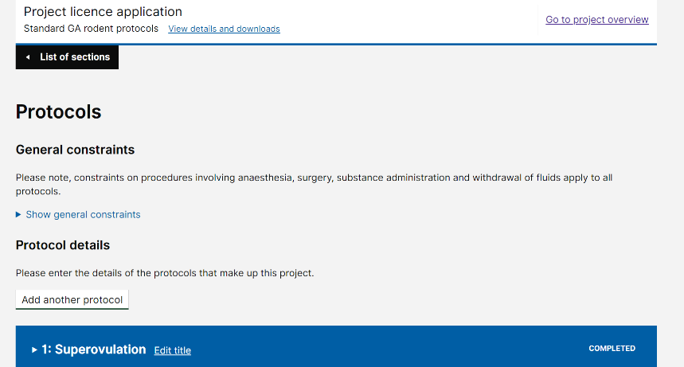
Explanation 3: If adverse effects are not expected, for example following vasectomy surgery, do not answer ‘Yes’ to this question. General constraints are attached to each protocol (see screen shot), they provide legal authorities that apply to every protocol. This means that all you need to do is add ‘See General constraints’ in the Describe the general humane endpoints that you will apply during the protocol box, where it is appropriate to do so.
Tip 1: For each step where you have answered ‘Yes’, you must complete the boxes that appear. Only provide information relevant to the step. For example, if your step is to authorise the implantation of tumour cells by subcutaneous injection and growth of the tumour you would answer ‘Yes’ if you expect the tumour grow the cause more than mild and transient adverse effects. If the step authorised only the injection of the tumour cells subcutaneously the answer would be ‘No’ but in this example you would need to describe the impact of the tumour growth and detail appropriate humane endpoints in the Animal experience section.
It is therefore vitally important that you consider the authorities requested in each step.
Tip 2: Three other examples:
For a surgical step to implant a cannula into the brain: If you expect adverse effects arising from the surgery, only cover the adverse effects relevant to the surgery and immediate post-surgery if they are different from those in the Protocol: General constraints.
For a surgical step where you administer a toxin either directly or via a temporary cannula into the brain and you expect the toxin to cause a lesion that adversely impacts on the animal, you would answer ‘Yes’. You would then address the questions that appear.
For a step where you administer substances via a previously implanted cannula only cover expected adverse effects arising from the administration of the substances. If no adverse effects are expected from the substances administered, you answer ‘No’ to the administration step question.
Explanation 4: Use the questions to guide the information required.
Tip 3: On all mild severity protocols, animals must be killed as soon as possible, and no later than a maximum of 24hrs after being found with clinical signs if the adverse effects are expected to resolve and are not affecting the welfare of the animals too much.
Tip 4: Do not list generic adverse effects. Instead, think carefully about what you are doing to your animals and the impact this will have on their wellbeing (see Example 1).
Example 1:
What are the likely adverse effect of this step?
Lameness is expected in the operated leg in all animals after surgery.
How will you monitor for, control, and limit these adverse effects?
Gait will be assessed by gently walking each animal and analgesics will be given post-surgery for as long as gait changes are observed.
What are the humane endpoints for this step?
Any animal not responding to analgesia will be killed and any animal requiring analgesia for more than 7 days and not showing improved gait will be killed.
Tip 5: Always provide a detail description of the signs that are expected (e.g. redness and swelling) and NOT the possible cause (e.g. inflammation).
Explanation 5: Think carefully about how you describe your adverse clinical signs and the endpoints you set. It is essential that your endpoints are appropriate and clear. For example, an endpoint such as “Animals will be killed if ulceration of tumours occurs” may not be appropriate where tumours are very small and where the ulceration is expected to heal rapidly.
Explanation 6: Unless all work is carried out under terminal anaesthesia, every protocol must have at least one specified humane endpoint or combination of adverse effects at which point the experiment will be terminated. No animal must knowingly be allowed to progress beyond this point – endpoints are legally binding.
Tip 6: It is NOT sufficient to say “moderate clinical signs are expected”; you must describe what you expect to see and when your work will be stopped should these signs occur.
Tip 7: Do not always opt for the highest level of suffering allowed for the protocol severity classification. Instead, for each step consider if scientifically you require adverse effects to occur and how far these need to progress in order to get your scientific data. Endpoints for steps can be set lower than permitted by the protocol severity classification.
Tip 8: Do NOT answer ‘Yes’ to the step question and then in the first box say adverse effects are expected to be no more than mild and transient or are not expected. If you find you want to say this, the answer to the step adverse effects question should be ‘No’.
Tip 9: Always include the likely incidence of adverse effects, when known.
Tip 10: When describing incidence, you can use terminology developed by the National Health Service: Rare (<0.1%), Uncommon (0.1 to 1.0%), Common (1.0 to 10%), All (>10%). However, if you know the incidence it would be better to state your own data.
Tip 11: Do NOT state the obvious. For example, “When work is carried out under terminal anaesthesia the level of anaesthesia will be maintained at a sufficient depth for the animal to feel no pain”. This information belongs as the answer to the question in the Protocol details section: Why are you proposing this severity category?
Tip 12: If you plan to use, or already use score sheets, do not include the actual score sheet as part of the licence because it might require refining in the light of experience gained when using your licence. However, you should refer to and cover their use in the box about how you plan to monitor for, control and limit adverse effects.
Tip 13: If you use score sheets, and you provide a score that is a humane endpoint, you must provide information about the scale used in your score sheet. For example, ‘The score sheet we use has a scale from 0 to 5 where 0 equates to no clinical signs and 5 the maximum.’ This means that if you state your humane endpoint is 3, anyone reviewing your application will understand that you are not allowing your animals to progress beyond halfway toward maximum suffering. It is always a good idea to share your score sheets with AWERB and your inspector.
Explanation 7: Currently the death of pups within the first 5 days of birth can be considered as reaching an actual severity of Mild, unless you know otherwise. If pups die after 5 days, you must try to assess whether the severity that they experienced before death was moderate or severe, and assign prospective protocol severity accordingly. If you are not able to assess the severity experience leading up to death, animals found dead must be classified as severe.
Tip 14: Deaths on Breeding and Maintenance protocols. Where the pre-weaning mortality is expected it should not exceed the level expected in the background strain. In the absence of any other data: if death is expected to exceed this level this will require the protocol on which this strain is bred and maintained to have a prospective “severe” classification. You are advised to seek advice from your UBS Project Support Team and, they will advise and help you contact your local inspector, if necessary.
Explanation 8: If you expect animals to die while undergoing an experiment you must indicate what proportion you expect will die, at what stage in the experiment and whether suffering is anticipated prior to death. Spontaneous death cannot be considered an acceptable endpoint and should be avoided whenever possible. However, if deaths are expected and unavoidable you must make the expected level and frequency clear.
Tip 15: Where death is expected, you must explain what measures you will take to minimise the risk of your animals dying (e.g. increased monitoring at critical time points in the experiment). Remember death as an end point must always be avoided, where possible.
Tip 16: No mice must remain on a mild breeding protocol beyond the age of 15 months. If they stay on the protocol and deaths occur, these deaths are likely to be classified as severe (unless they have been observed or determined to be otherwise). Losses of animals at less than 15 months of age are only considered in the moderate or severe category if they are more than expected for the background strain.
Explanation 9: If adverse effects are not expected, or are not detailed in the protocol, and when you start an experiment they occur, you must immediately notify your NACWO and NVS and they will help you to complete a PPL standard condition 18 (SC18) report. At least a preliminary report must be sent to your inspector within 72hrs of the incident. You should then follow Tips 17 and 18 below.
Tip 17: When unexpected adverse effects occur during an experiment these should be recorded and discussed immediately with your NVS and the NACWO, who will provide advice. Under some circumstances (i.e. husbandry related incidents), you may not need to complete a SC 18 report.
For further information about SC18 reporting, visit the Home Office website:
https://assets.publishing.service.gov.uk/government/uploads/system/uploads/attachment_data/file/734630/establishment-licence-holder-newsletter-august-2018.pdf
Tip 18: After you have investigated the cause of the unexpected adverse effect(s) and they are expected and required the next time you do the same type of experiment; you must amend your licence.
Tip 19: When you know the substances you use will produce known adverse effects then each substance must be detailed in the relevant Protocol step(s) with a description of the expected clinical signs and incidence; how animals will be monitored and the effect controlled; and appropriately specified and clear humane endpoints provided. The justification for the use, and why no other substance is appropriate for your research, must be provided in the box at the end of the Protocol justification section for each protocol where the substance(s) is/are required.
Explanation 10: Tamoxifen is known to cause adverse effects by certain routes (e.g. in the diet), and under certain circumstances (e.g. genetic construct).
Tip 20: Where tamoxifen adverse effects are anticipated the incidence, anticipated adverse effects and humane endpoints must be specified. You will also be expected to explain how animals will be monitored and how you will control the impact of the use of this drug.
Explanation 11: Weight loss as the humane endpoint. Weight loss can occur for a variety of reasons. In some cases, weight loss can provide a good humane endpoint. However, this not always the case. For this reason, you should consider whether using weight loss as one of your humane endpoints very carefully and on a case by case basis. This should include thinking about why your animals are expected to lose weight. Then you should set humane endpoints that are realistic and reflect the cause of the weight loss and scientific need.
Tip 21: The baseline against which the percentage weight loss will be measured must be specified (e.g. age matched controls, maximum weight, weight at the start of a treatment, etc.). Think carefully about which base line you use.
Tip 22: Post-operative animals may not drink and therefore can lose up to 15% of pre-operative weight due to dehydration. So long as this reverses promptly after surgery, when the animal is able to eat and drink, this is part of the standard weight loss within the adverse effects expected post-surgery. However, if you are regularly recording weight loss of this magnitude you must consult your NVS because there are likely to be refinements to the way your animals are prepared for surgery and after surgery that could be introduced to avoid this level of weight loss.
Tip 23: Rate or speed of weight loss is as important as the percentage of weight loss and should be included as part of the weight loss description when weight loss is an anticipated adverse effect.
Tip 24: If an animal suddenly loses 15% of its body weight versus age matched controls, for no apparent reason, contact your NVS because immediate action should be taken since this is likely to indicate that the animal’s wellbeing is being seriously compromised. If this is not expected and not detailed in your licence, you will need to complete a SC18 report and submit at least the initial notification to your inspector within 72hrs.
Tip 25: The appearance of other clinical signs in conjunction with weight loss normally means that there is an underlying cause and this type of weight loss should be taken more seriously than when weight loss that occurs gradually and when other clinical signs are not observed.
Explanation 12: Inspectors expect all licensees, where it is relevant to do so, to set the maximum weight loss at 15% of total body weight measured against (insert the baseline against which this will be measured) in adult animals on moderate severity protocols. The expectation is that weight loss should have stabilised or started to recover within 24hrs of returning the animals to more easily accessible and enriched diet. If not, animals must be killed and a post mortem undertaken to find out why this occurred. In animals where no other clinical signs are observed when weight loss occurs, your inspector may allow your animals to be kept alive for a little longer, but closely monitored. However, advice needs to be sought quickly from your inspector. Neither you nor your NVS can make this decision.
Tip 26: Weight loss in obese animals is less likely to affect the welfare of your animals however, it is important to consult your NVS before deciding and setting protocol humane endpoints for obese animals.
Tip 27: In most circumstances, consideration should be given to using Body Condition Scoring (BCS) rather than weight loss. Where you do so, you must provide the scale used on the BSC sheet used, as well as the score at which action will be taken.
Tip 28: In all cases where a weight limit humane endpoint has been reached and the animal is valuable scientifically and you are unsure whether the animal should be killed, you should contact your inspector. Your NVS will help you to do this.
Explanation 13: Inspectors expect all surgery to be undertaken to the highest possible standards of asepsis, which will include the use of drapes [Appendix 6]. See Protocol: General constraints, which appear at the start of each protocol.
Tip 29: For some terminal preparations, draping may not be necessary. Not using drapes must be discussed, and agreed with your NVS, on a case-by-case basis. In some terminal experiments, the introduction of bacterial contamination could adversely affect the scientific validity of the data produced.
Tip 30: You can insert reference to published guidelines in the relevant steps for each Protocol under the heading: How will you monitor for, control, and limit any of these adverse effects? For example, you could quote the LASA Guidance on Aseptic Surgery (2017) in the Protocol step addressing the question in bold. You should not however include reference to the Home Office Minimum Standards of Aseptic Surgery because these are now part of each Protocol: General constraints.
Tip 31: The Home Office inspectors, when they observe surgery, expect licensees to be compliant with at least the Home Office Minimum Standards of Aseptic Surgery [Appendix 6]. Failure to comply with these minimum standards is highly likely to trigger a request from the inspector to stop undertaking surgical procedures until you have undergone retraining and reassessment. In addition, you might find that poor attention to aseptic technique results in a non-compliance.
Tip 32: Since poor surgical technique and lack of attention to aseptic technique will affect experimental data, the University expects all surgery to be undertaken to the highest standards possible and encourages all surgeons to work to and adopt the principles laid out in the LASA Guidance on Aseptic Surgery (2017) (https://www.lasa.co.uk/wp-content/uploads/2018/05/Aseptic-Surgery.pdf).
Tip 33: Make sure you are familiar with the University policy on the “Resourcing of surgical technicians for rodent surgery” and on the “Responsible use of anaesthetic agents” (see Appendix 7 and 8 respectively).
Tip 34: If surgery is undertaken in more than one step on a protocol, you must repeat relevant information for each step. If different measures or endpoints are required, then include different information in each step. Provide information which includes expected clinical signs, likely incidence and the humane endpoints that you will apply for each type of surgery where they are in addition to those in the Protocol: General constraints.
Tip 35: If adverse effects are NOT anticipated following surgery, answer ‘No’ to the step question about adverse effects. In the Animal experience section for the protocol you should refer to the Protocol: General constraints and if appropriate, provide specific additional information which is tailored to what you are doing.
Tip 36: When surgical techniques are required remember to provide information about adverse effects which arise from:
- conducting the surgery, as well as
- those resulting from the surgery.
Remember, depending on what you are doing this information may need to appear in different places.
Explanation 14: Project licence standard condition 17 requires the use of analgesia for painful procedures and post-operatively. If the use of analgesia would compromise you data, you MUST make this clear in your application. Where this applies to your work, you must explain what other measures you will use to mitigate the effects of painful procedures.
Explanation 15: Mild severity protocols: This category should be assigned where only mild or only very minor clinical signs of short duration are expected in your animals. This should be stated at the beginning of the box headed: Why are you proposing this severity category?, which appears under the protocol section heading: Protocol details. The threshold for mild severity equates to the insertion of a hypodermic needle in accordance with good veterinary practice.
Explanation 16: Moderate severity would normally equate to an animal being unwell for part of the time, which usually would not exceed 24 hours. Moderate severity occur when animals are exposed to repeated mild procedures so it is important to remember cumulative effects.
Tip 37: Colitis and arthritis models are unlikely to be considered mild unless the experiment finishes before any clinical signs are evident. Arthritis protocols will also be categorised as either moderate or severe if animals have to be kept with clinical signs for up to 24 hours or up to or more than 48 hours respectively.
Explanation 17: Non-Recovery protocols: This prospective severity category is for animals that undergo an experiment entirely under non-recovery anaesthesia and/or are killed by a non-Schedule 1 method having not undergone any other regulated procedures.
Tip 37: Non-Recovery experiments must NOT be embedded within mild, moderate or severe protocols.
Explanation 18: If you have a GAA that moves onto a Non-Recovery experimental protocol from a moderate or severe category Breeding and Maintenance protocol after it has started to develop a moderate/severe phenotype, the actual severity that is recorded for HO annual statistical purposes [ROP] will be dictated by the level of suffering experienced by the animal BEFORE it entered the Non-Recovery protocol.
Tip 38: WT or GAAs (in the latter case that have not developed a phenotype) that are moved onto a Non-Recovery experimental protocol would be returned in your ROP data with an actual severity of Non-Recovery.
Tip 39: Authority to kill purchased WT animals using a non-Schedule 1 killing requires a Non-Recovery protocol.
Tip 40: GA mice and their WT littermates that are killed by a non-Schedule 1 method, and have not undergone any procedures, should be killed on the Breeding and maintenance protocol on which they are bred.
Explanation 19: Never say that endpoints will be determined by the NVS and/or NACWO. You must detail all relevant expected adverse effects and provide clear endpoints in your licence. The NVS and NACWO can provide you with advice about the health and welfare of your animals and will help you to make decisions; they are not employed to set your endpoints once your licence is granted. A project licence is a legal document providing you with the authority to cause harm to animals for a scientific purpose. Your licence is a contract between you and the Secretary of State (SoS). It is not a contract between the NVS or NACWO and the SoS. Where appropriate, you can indicate when the advice of the NVS and NACWO will be sought.
Explanation 20: Do not quote published guidance as your humane endpoints in your Protocol Step adverse effects sections. For example, do NOT say “end points will be in accordance with the ICR Guidelines”. Instead, inspectors require a description of the clinical signs you anticipate your animals will show and a clear indication as to the humane endpoints you will apply to achieve scientifically valid data while minimising the harms to your animals.
Explanation 21: Your inspector will use information provided from all your Protocol sections when weighing Harms against Benefits.
Explanation 22: The questions: What proportion of animals will experience this severity? and Why are you proposing this severity category?, which appear under the heading Protocol details, is where you provide an overview of the proportion of animals you expect and require to reach the proposed Protocol severity category/classification. Examples of what might cause moderate severity include: a surgery step that means all animals will reach moderate severity or a series of mild procedures, which together mean that a proportion of your animals will experience adverse effects of moderate severity. Whatever the cause, the procedure(s) and anticipated proportion of animals affected should be provided.
Explanation 23: Be aware the overall severity estimates you provide will become part of your license authorities. Therefore, you should think carefully about the figures you provide.
Tip 41: Once your licence is granted, if you find that the estimates requested in your project application were incorrect, you should apply to amend your licence.
Tip 42: Your default position should always be the lowest possible severity category/classification required to obtain your scientific data. Wherever possible you should increase the frequency of monitoring and kill animals as soon as possible. If unexpectedly animals cannot be killed, before they suffer or die (thereby exceeding the severity constraints authorised by the protocol), send a SC18 notification to your inspector and contact your NVS and NACWO for advice about how best to investigate the cause.
Tip 43: Remember that if an adverse effect occurs that is not specified in the adverse effects for the step or has exceed those that are specified for the step, licence authorities will have been exceeded, even if the severity category/classification for the protocol is severe.
Explanation 24: When assessing your project application your inspector may advise you change the severity category/classification of a protocol if they disagree with your suggestion. When this occurs, your inspector will have determined this based on the information you have provided.
Tip 44: Further information about determining severity can be found in Annex VIII of European Directive 2010/63/EU [Appendix 10].
You can find two additional European pdf documents if you click on the link: http://ec.europa.eu/environment/chemicals/lab_animals/interpretation_en.htm. Currently Home Office Guidance on the Act 2014 section 5.12 covers information on severity categories and refers readers to Appendix G in the same document, which iterates Annex VIII of the EU Directive. In due course, the Home Office intends to publish further advice, on their website, about how to determine severity prospectively. At present the only additional Home Office severity advice pertains to determining Actual Severity and can be found at:
https://www.gov.uk/government/uploads/system/uploads/attachment_data/file/276014/NotesActualSeverityReporting.pdf
and https://www.gov.uk/government/uploads/system/uploads/attachment_data/file/276015/AdviceSeverityAssessmentGA.pdf.
Protocols: Summary of Protocols Table:
Explanation 1: The Protocol Summary table is designed to provide an overview of your protocols.
Explanation 2: Currently this table is not generated when you export/download a Word version of your application from ASPeL. This table will appear in the draft pdf version of your applicaiton (see Tip 1).
Tip 1: When you are submitting draft applications to your UBS Project Support Team and AWERB please download and send both the Word and pdf versions.
Tip 2: Currently, your UBS Project Support Team and AWERB will always require the Word version of your application.
Tip 3: Note the number of animals specified on a Protocol is now the maximum number and not the estimated number. This means exceeding by any amount is likely to result in a non-compliance.
Tip 4: The Mouse Colony Management Software (MCMS) is designed to help you to keep track of your animal numbers. This software will generate reports. One will provide the number of animals used to date on each of your protocols. This report should be used to use to ensure that you do not exceed the protocol maximum numbers requested. The second report produced by MCMS provides the data you require each year to complete your Return of Procedures (ROP).
Tip 5: Once your licence has been granted, remember to monitor numbers regularly and seek an amendment to your licence before you exceed your maximum numbers. Remember you need to allow time for an amendment to be processed.
Protocols: Experimental design and Protocol justification:
Explanation 1: These are new sections in each protocol and the information provided must be tailored to each protocol.
Tip 1: Be careful to read each of question carefully and only provide the information requested. At least two questions appear to be asking for the similar information. However, this is not the case, these questions ask for subtly different information.
Tip 2: If you find you are duplicating information in boxes in these sections of a protocol, it probably means you have provided information in the wrong place.
Tip 3: It is in these two sections of the protocol where you provide, in much more detail, the information that used to appear in the old Part D: Project plan.
Tip 4: Applicants find these two sections the most difficult to complete. In each section, the questions are designed to sequentially build up the information the inspector requires to assess your application.

Non technical summary: General comments:
Explanation 1: This summary will appear on the Home Office and University of Cambridge websites so must not contain any information that identifies people, places or intellectual property.
Tip 1: Write the sections in ASPeL where it alerts you to the fact that the information will appear in your NTS using plain English pitched at a reading age of 12 years.
Tip 2: Use short sentences and simple words. If you use technical words make sure you explain what they mean. Try to avoid using abbreviations and symbols.
Tip 3: When completed, ask someone who does not know your work to read your NTS and explain to you what your science is about, what benefits are likely to arise from your research and what harms your animals will experience.
Tip 4: If you require help, some of the AWERB lay members have offered their assistance.

Non technical summary: Project harms:
Explanation 1: It is in this section you explain to the lay reader why you need to use the types of animals you use. In addition, you should explain to them what you intend to do to your animals and the effect(s) this will have on their health and wellbeing.
Tip 1: It is important to be honest and provide sufficient detail.
Tip 2: Do not use technical words. Instead, try to explain what you do to your animals and the expected effects. Write using plain simple words and short sentences.
Tip 3: The lay reader will not understand what ‘mild’, ‘moderate’ or ‘severe’ severity mean. Instead, explain what you will be doing to your animals and/or the likely harms.
Tip 4: For the last question provide the information set out using the following format:
Mouse: Mild 90%
Mouse: Moderate 10%
Rat: Mild 100%
Do not include any explanatory text in this last box.

Non technical summary: Replacement:
Do NOT use these three sections to provide detail, because the information will appear in the public domain so needs to written so it can be easily understood by someone with a reading age of 12 years. The detailed 3Rs information, which your inspector requires, belongs in the each of your Protocols.
Explanation 1: This heading should be used to explain what other in vitro/ex vivo/in silico techniques you either already use or plan to use. You will be prompted by the following headings:
- Why do you need to use animals to achieve the aim of your project;
- Which non-animal alternatives did you consider for use in this project;
- Why were they not suitable?
Tip 1: In some cases, replacement methods may only be suitable to answer part of your research question. This is perfectly acceptable, and you should provide information about what you are able to use.
Tip 2: It should be clear that you have investigated all possible means of replacing the use of animals in your work.
Tip 3: It is essential to complete up to the minute searches to ensure non-animal techniques have not been published or used previously or recently. During 2016, UBS began work on the University of Cambridge UBS 3Rs Search Tool. This portal appears on the UBS website (http://www.ubs.admin.cam.ac.uk/3rs/3rs-search-tool) and will be continually updated and improved.

Non technical summary: Reduction:
Explanation 1: Under this heading, explain any plans you have to reduce the number of animals you use. You will be prompted by the following headings:
- Enter the estimated number of animals of each type used in this project;
Tip 1: This will be the sum of all the animals detailed on each protocol, which is why this is an estimate and not maximum number.
Tip 2: ASPeL will automatically provide you with the list of species for which you need to provide this information.
- How have you estimated the number of animals you will use;
Tip 3: Using lay language explain the principles of your experimental design strategies and why these have been chosen.
Tip 4: Explain where you obtain statistical and experimental design advice. This is where you can quote guidance documents etc. (see Tips 6, 9 and 10 below).
Tip 5: Consider demonstrating that you have considered:
- how you will optimise GA colony management;
- if you plan to use pilot studies and if so, how they will be used;
- if you plan to use computer modelling and if so how it will be used; and if not, why computer modelling is not appropriate;
- how you will use tissue and animal sharing schemes and if used, explain what you do; and if not, why this is not possible
Tip 6: You may find the NC3Rs Experimental Design Assistant (EDA) helpful, and if so, you can mention this. The tool can be found at: http://www.nc3rs.org.uk/experimental-design-assistant-eda.
Tip 7: It should be clear that you have investigated all possible means to reduce the use of animals in your work. For example, if you have considered and/or use Data and Tissue banks or Human Cohort data, mention this in this section.
Tip 8: Consult a bio-statistician/ If you do not have the necessary training and expertise yourself or in your team/department, it is perfectly acceptable to say you will seek this advice. If you need help, consider contacting the University Statistics Laboratory. They provide a free advice service.
Tip 9: You should also be familiar with and refer to the PERPARE guidelines when designing experiments. These guidelines can be found at: https://norecopa.no/prepare.
Tip 10: You should confirm that you will conduct your experiments in such a way that you will be able to publish according to the ARRIVE guidelines (or explain why not). These guidelines can be found at: https://arriveguidelines.org.

Non technical summary: Refinement:
Explanation 1: Under this section, you will be prompted for information under the following headings:
- Which animal models and methods will you use during this project;
- Why can’t you use animals that are less sentient;
- How will you stay informed about advances in the 3Rs, and implement these advances effectively, during the project;
- How will you refine the procedures you’re using to minimise the welfare costs (harms) for the animals;
- What published best practice guidance will you follow to ensure experiments are conducted in the most refined way?
Tip 1: Your NVS, NACWO and UBS Named Information Officer [NIO] are excellent sources of advice and information.
Tip 2: It should be clear that you have investigated all possible means of refining your work.
You should visit the University, NC3Rs and RSPCA websites:
University website: http://www.ubs.admin.cam.ac.uk/user
UBS website: UBS 3Rs Search Tool: http://www.ubs.admin.cam.ac.uk/3rs/3rs-search-tool
NC3Rs website: http://www.nc3rs.org.uk.
RSPCA website: http://science.rspca.org.uk/sciencegroup/researchanimals.
Explanation 2: The Home Office expects peri-operative analgesia will be administered, and continued after surgery, for as long as required to alleviate pain. Failure to do so could result in a non-compliance.
Tip 3: Including a high-level explanation about how pain will be monitored and controlled, and how adequate pain relief is provided.

Project plan: Scientific background:
Explanation 1: This information will not appear in the Non-Technical summary which means you can use technical words and concepts.
Explanation 2: The Scientific Background is where you provide the context for your new application (i.e. what is the unmet medical/veterinary need, what fundamental scientific data is required on which future scientific discoveries rely, etc.). You should set out to briefly explain the current state of research in the area in which you work and how your work fits.
Therefore, ensure your Background is specific and relevant to the purpose for which you require your licence – for this reason this section should NOT just be a detailed overview of the field of research.
Tip 1: This part can be treated in the same way as the introduction to a scientific paper.
Tip 2: For a disease-based licence explain the severity and prevalence of the condition, any available treatments and why further research is required. Do consider providing disease impact information where relevant.
Tip 3: Try to avoid the use of acronyms (abbreviations). If you have to use them, make sure they are defined each one the first time it is used. If you use a lot of acronyms repeatedly throughout your application, consider developing a table which sets out each acronym and what it means. Insert this table in one of the boxes in the Scientific Background. This will make reading your application easier for those less familiar with your subject.
Tip 4: You should demonstrate that you are aware of current research undertaken by other research groups working in your area and quote relevant and current published literature.
Tip 5: When thinking about context also consider whether any of your previous in vivo or ex vivo work is relevant and if so, include reference to this work.
Tip 6: If your project application is required to continue current or previously licensed work or un-licenced research, summarise how data from this previous work has led to the need for or informed your new project application.
Tip 7: You will be asked whether your application will be for regulatory or non-regulatory drug testing and screening applications. Answering ‘Yes’ to these questions will direct you to other boxes that you will need to complete.
Tip 8: You will also be asked if your project is required to provide a service (e.g. antibody production) or produce animals (e.g. GA animals) for other projects. If you answer ‘Yes’ to this question, you will again be directed to other boxes that you will need to complete.
Tip 9: If your application is for a service licence for your research group you should answer ‘No’ to the question about providing a service to others.
Explanation 2: The final question in this section asks if you need to transfer animals from your current licence (or another licence) when it expires to your new licence when granted. If you answer ‘Yes’ you must provide the project licence number AND expiry date.
Tip 10: It is important to provide the licence number and expiry date because the Home Office will use this information to determine if, and when, licence authority continuation is required and if this cannot be met, will advise you of this fact.
Tip 11: Completing this section does not guarantee continuation of licence authorities will be achieved.
Reference List (note references are no longer requested in ASPeL however, if you quote references in your Scientific Background, add a brief list [preferably no more that 10]):
Explanation 3: Your reference list should contain all the references that you quote in the Background to your licence.
Tip 12: Most if not all references should have been published within the last 5 years.
Tip 13: You might find it helpful to number the references and use the numbers as appropriate in the body of the Scientific Background.
Tip 14: Do not just quote your own work. Unless you are the only person working in a particular area of science, you should demonstrate to AWERB and your inspector that you are aware of the research published by others.
Tip 15: In your reference list indicate your publications by highlighting your surname in bold or by underline.
Tip 16: If you are not an author on a paper and want to indicate the paper has come from your group, you can do this with an asterisk next to the reference and then explain what the asterisk means as a footnote below the reference list.
Tip 17: It is preferable to avoid the use of et al and instead provide the full list of authors. However, in some research fields papers attract a large number of authors and where this occurs give the first six authors followed by et al and at the end of the list explain that where et al appears after 6 authors the list of authors is extensive.

General advice
When your project application is ready for submission to the University AWERB, you will receive a slide template on which to model your presentation for the committee. The slides and guidance on how to use the slides, are reproduced in Appendix 11. This appendix has been included because licensees told us they would have found having access to the questions on these slides helpful when they were drafting their new project application.

Project application processes
- A Chief Inspector stated in August 2016 that inspectors would be available to provide advice to licensees drafting project applications. However, the Chief Inspector said this advice would only be provided on ONE occasion.
- At a meeting in June 2017, the University inspectors said they would no longer comment on draft project applications before applications were considered by the University AWERB. This appears to be changing and access to your inspector can be arranged if this is considered appropriate.
Project application time lines
- The starting point for your new application, regardless of whether the application is to continue a programme of work or not should be a meeting with either the UBS Director for Governance and Welfare (Process C meeting) or Licence Manager. If you currently hold a licence at the University, you will receive an e-mail from one of them suggesting this meeting. This is triggered when your Retrospective Review template is sent to you 15 months before the expiry of your current licence. They will explain to you the UBS process and support UBS offers while you draft your new application.
If this is your first project application, when you contact UBS Admin you will be assigned to either the UBS Director Governance and Welfare or Licence Manager and one of them will contact you to set up your Process C meeting.
- If your application is to continue work, you should complete and send to your UBS Project Support Team a copy of your completed Retrospective Review and a completed copy of the Project Support Team meeting template. The latter will have been provided after you meet with either the Director or Licence Manager. There is no overlap in the information requested. Licensees who have completed these documents say that doing so helped inform their new project application.
If you have not held a project licence before or one at the University, you will be asked to complete the UBS Project Support Team meeting template.
To maximise the benefits completing these documents provide, they should be sent to your UBS Project Support Team two (2) weeks before your UBS Project Support Team meeting (Process H meeting).
- You will be booked onto the Project Application Drafting Course [PADC], where you will be provided with a detailed explanation about what needs to be in a new project application and where to provide the information. This course will also explain the basis of using the Home Office ASPeL application software.
- You are responsible for producing a good quality first draft of your new application using the materials provided in this guide, during PADC and on the Home Office website. UBS staff are available to provide advice, but cannot play an integral part in actually drafting your application. Any questions your UBS Project Support Team cannot answer can be forwarded to your inspector. Secure e-mail dialogue with your inspector should be either via the UBS Director for Governance and Welfare, or Licence Manager.
- Your UBS Project Support Team will provide comment on your first draft, and where necessary, will advise you to prepare a second draft. If your first draft is very good then your Team members should not need to provide further comment prior to the submission of a pre-AWERB version of your application. The pre-AWERB version will be reviewed by UBS Director or Licence Manager not on your UBS Project Support Team. During periods of peak workloads, the NVSs undertake pre-AWERB checks to keep work moving through the process.
- Your draft application may need to undergo more than one draft. On each occasion, your Project Support Team will provide comment. Only when your Project Support Team feel your application is ready for AWERB will it be submitted for its final pre-AWERB check.
Please note: Based on the length of the downloaded Word version of your application:
- for applications up to 200 pages your Project Support Team will provide comment within 10 working days.
- for applications over 200 pages they will require 15 working days.
Since the drafting of a new project application takes time, it worth taking time and care to produce a good quality first draft because this will save you time in the long term.
- As soon as either the UBS Director for Governance and Welfare or Licence Manager is aware your licence is ready for submission to AWERB they will book your application into the next available AWERB meeting, and notify you of the date.
- You will be asked to confirm attendance and that you will submit your application by a specified date. The submission date is set to allow enough time for committee members to consider each application before they meet.
- It is very rare that a project application returns to AWERB. However, this is no unknown.
- Expect poorly drafted applications to be rejected by your UBS Project Support Team. A poor application draft should never reach AWERB.
- You can expect any recommendations from the AWERB committee within 5 working days of the meeting.
Your inspector will be sent a copy of your AWERB recommendations.
- After you have addressed the AWERB recommendations, you are responsible for submitting your application via ASPeL. Your will be provided with advice about how this is done at the end of the document providing your AWERB recommendations.
- The Establishment licence holder has to endorse your application before it can go to your inspector.
- Your first electronic submission must be as a draft to the inspector.
- The inspector will usually provide further advice, and it is your responsibility to amend your draft application as requested before final submission.
- Once your inspector has indicated your application can be submitted as a ‘Complete and Correct’ or for granting you must be prepared to allow your inspector 40 working days to assess your application. Remember that if after submitting what you thought was a complete and correct/final application your inspector deems this not to be the case your inspector will return your application with the reason(s) why it has been returned. If they decide your applications is not complete and correct, and return it to you, this will reset the clock so the next time they receive your application they will have a further 40 days in which to consider your application.
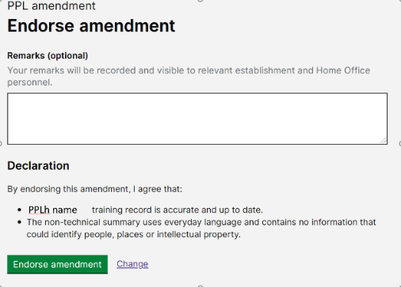
- The establishment licence holder has to endorse every new applications (and amendment). In order to do this a declaration (see the screen shot to the right) has to be completed: In the remarks box the inspector will be informed about the facility where the majority, if not all, of your in vivo work will be undertaken and any other relevant information your inspector should know.
In the Technical details section of the application you will be asked to check and say if your training records are up to date. Before your application is endorsed it is this record that will be checked.
NOTE: It is more important than ever that you work with your UBS Project Support Team and through a maximum of two draft iterations produce a high quality draft that can be sent for the pre-AWERB check prior to AWERB and then on to your inspector. Due to work commitments, expecting to receive comments on multiple drafts from inspectors and UBS staff is no longer an option.
Where you require continuity of licence authority your inspector will expect to see a draft of your licence about 3 months before your current licence expires.
UBS tracks the movement of all new project applications from when the need for a new application is identified. Information about the data collected, the application handling process and the PPL Tracker used by UBS, is published in the UBS AWERB Handbook (see Appendix 14).
Below is an excerpt from the 2019-20 AWERB Annual Report:
The information included in this graph is based on applications that had been through AWERB by the end of June 2020 and were either granted or submitted to the Home Office when this data was analysed. Data was not available for all applications for some tasks.
The PPL Tracker for new project applications has identified three clear stages where delays occurred in the process:
- The first and longest delays occur in the earliest stages of the application process. You can see this occurs between when the researcher first meets with either the Director for Governance and Welfare or Licence Manager, to when they attend the Project Application Drafting Course (PADC), to setting up the UBS Project Support Team meeting and submission of their first draft to their Project Support Team ([Tasks 1 to 3]).
- The second occurs during the in-house drafting phase.
During this reporting year, these delays reduced but it has started to be obvious that when a good first draft is produced the delays during this phase are reduced.
Similarly, it is becoming clear that the number of drafts an application undergoes adds significantly to the processing time and that a good first quality draft usually equates with a reduced number of drafts.
- Finally, there appears to be a correlation between whether a person has previously written a project application and the ease with which they draft a new application using the new software introduce by the Home Office in August 2019. The radical restructuring of the Project Application Drafting Course and this PPL writing guide aim to address delays arising from this cause.
Number of working days
Task 1 – Time from meeting with D/DDGW to PADC training
Task 2 – Time from PADC training to PST meeting
Task 3 – Time taken from PST meeting to submitting draft 1
Task 4 – Time taken by PST members to comment on draft 1
Task 5 – Time taken to submit draft 2
Task 6 – Time taken by PST members to comment on draft 2
Task 7 – Time taken from receipt of application to AWERB meeting
Task 8 – Time taken to send AWERB comments
Task 9 – Time taken by applicant to submit to Home Office
Task 10 – Time taken by Home Office to provide comments
Task 11 – Time from receipt complete and correct version to granting
Project Licence processing times
by process task 2019/20
Appendix 1: Home Office Advice for using Standard GA protocols (also see new HO advice issued in January 2021)
Key points: Standard GA mouse breeding protocols

The standard protocols for GA mouse breeding have been updated, using refined approaches and formatted according to the current version of ASPeL.
- These protocols are intended to cover the needs of most users who create new lines of GAA and bred established lines. They are intended to be copied into project applications as required.
They provide for routine breeding and maintenance (B&M) of most strains of GA mice (and other species with modification) and should not be changed.
Where non-standard procedures are required for specific strains or circumstances, use a bespoke protocol for that specific strain.
- Breeding should always be carried out under the lowest appropriate severity protocol, not under the highest severity of any strain that might be bred, i.e. most should be on a Mild protocol. An additional Moderate or rarely even a Severe protocol may be needed to cover specific strains for some users.
However, thought should be given to the appropriateness of maintaining animals showing moderate or severe effects on a breeding protocol. Preferably animals should be killed before suffering adverse effects if they are not going to be used, or they should be transferred to the protocol on which they will be used and for which the harmful phenotype is required.
“Stock animals” suffering adverse effects is not justifiable.
Do not use “just in case” higher severity protocols. If a moderate protocol is needed must name the strain or groups of strains required, and give specific endpoints for these strains appropriate to the breeding protocol, not experimental end points. The standard Mild protocol provides for unexpected adverse effects of scientific interest, while still requiring low severity to be maintained.
- We have removed laparotomy from the vasectomy protocol, as we cannot think of any justification for using this compared to the more refined scrotal approach.
- We have referred to non-regulated biopsy methods on the B&M protocol for clarity.
- Removal of the tip of tail for genotyping is not usually the most refined method. If it is required then a record should be kept of the scientific reason and made available to the Home Office on request.
- We have added a max. age of 15 months for maintenance of animals on a B&M protocol (mice).
- There are no additional steps on the B&M protocol (i.e. no imaging or other phenotyping techniques).
- The breeding protocol is for breeding of genetically altered animals; it is understood that wild types may be produced on this protocol, though the aim is not the breeding of wild type mice. All wild type mice are stock animals unless they are genotyped using a regulated procedure.
- Phenotyping should be carried out on a separate final use protocol. In the unusual situations where phenotyping has to be carried out prior to final use this should be on either a bespoke B&M protocol or included in the final use protocol. Do not cater for such unusual scenarios by adding steps to the standard B&M protocol; similarly for deliberate ageing of animals.
- We have removed induction of conditional gene expression from the B&M protocol for two reasons:
- It is rarely used on B&M and virtually always forms part of the experiment, so should be on the final protocol;
- The use of tamoxifen may be associated with adverse effects that are not compatible with mild protocols in many situations.
In the rare situations where GA lines are maintained on a gene inducing agent (invariably doxycycline, not Tamoxifen) a bespoke protocol should be used.
- Note that transport of live animals as sentinels to diagnostic laboratories has been removed. This practice is discouraged and tissues should be sent instead. If there is a specific need for live GA sentinels then please ensure you follow the guidance provided in the Advice Note on re-homing and setting free.
- We cannot provide a standard Moderate breeding protocol, as these should be tailored to the actual genetic alterations involved.
A template for moderate (or severe) B&M is included.
Note that endpoints should be related to a breeding and maintenance protocol, and are likely to be less severe than may be required on the final use protocol.

Appendix 2: Project application: Additional advice

Technical details:
Your relevant Experience, Funding and Training:
Explanation 1: Project Licence standard condition 1 says: “The licence holder is responsible for the overall implementation of the programme of work specified in this licence and for ensuring the programme of work is carried out in compliance with the conditions of the licence.”
Tip 1: To address Explanation 1 you may find considering the questions below help you to formulate the answers required in the boxes on new ASPeL and will be used by the inspector when assessing whether you will be able to comply with this condition:
Question 1: What is your position in the field e.g. are you head of a research group?
Question 2: Why are you/What makes you the best person to hold the licence?
Question 3: Have you published any papers in this area of work and since when?
Question 4: Is this a new project or is this new licence required to continue work currently being undertaken on an expiring project licence? If relevant, how long have you held a UK project licence and/or a UK personal licence?
Question 5: If you have not held a project licence in the UK, have you carried out any experimental work in animals anywhere else? If so, where and for how long?
Question 6: How long have you worked with laboratory animals and in which species?
Question 7: Are you competent at experimental design and data analysis? If not, how will you address this?
Question 8: How will others help manage the project (new ASPeL will use this information in the same way the ‘deputy PPLh’ information was used previously).
Question 9: Are you able to carry out the licensed procedures as detailed in this project application? Can you supervise personal licensees who will work under this licence? If you are not competent in some or all of the procedures you are applying for, how will you and your staff be trained and assessed?
Tip 2: If you have previously helped to manage a project licence, (e.g. acted as a “deputy” project licence holder), include this information.
Tip 3: If you have completed the University Quinquennial/Refresher training within the last 5 years include this information with the date when you last undertook this training.
Tip 4: If this is your first project application, you will need to complete both personal and project licence Home Office training. If you currently hold a personal licence, your training and experience will be taken into consideration. Discuss training needs with your Project Support Team and a Named Training and Competency Officer [NTCO].
Explanation 2: You do not need to hold a personal licence to hold a project licence.
Tip 5: If you have held or hold a project licence which does not authorise a species or Category C procedures, and you require these in your new application, you will have to complete additional training before your new licence can be granted with these included.
Tip 6: Previous training will always expire after 5 years unless you can provide evidence that you have maintained your competence. This is best demonstrated by keeping your Training and Competency records up to date and attending Refresher training when advised to do so. UBS will send you a reminder when Refresher training is required.
Tip 7: Before submitting a new application on ASPeL check your ASPeL training record and update if necessary.

Technical details: Experience:
Explanation 1: The experience section is where you provide your inspector and AWERB with information which supports why you are the most suitable person to hold the licence when granted. The information you provide will not appear in the public domain and should therefore be appropriately detailed, and relevant to the application you are writing.
Tip 1: Read the questions carefully and only provide the information requested.

Tip 2: It is often easier to leave these sections until last because they are the easiest to complete!

Technical details: Funding:
Explanation 1: If full funding is not secured when applying for a licence, your inspector will expect to be told what work could not be undertaken and the impact this would have on the likely benefits arising from the project if the funding does not materialise.
Tip 1: There is an ASPeL question which asks what grants and funds you have available for this project. You should provide the breakdown of funding – i.e. total amount and amount available for in vivo studies as well as who provided the funding, when it starts and ends.
Tip 2: You will be asked whether or not your grants been peer reviewed and if so, who or which organisations reviewed your grant application(s).
Tip 3: You may need to apply for additional funding before the end of this licence and where this is the case and if you have a good funding record, you should make this clear.
Tip 4: If appropriate, if you have recently applied for one or more grants, you should include this information.

Technical details: Training:
In ASPeL your personal licence training records should already be stored on the system and you should not be required to provide this information again. The exception will be if you have never held an electronic project licence, you do not currently hold a personal licence and have not since the introduction of electronic licencing, or you have never held a personal licence in the UK.
Even if your personal licence details are available on new ASPeL, if you are writing a new project application or an amendment to a granted licence, in order to endorse your request your training records will be checked one of the UBS Home Office Contact Liaison Officers [HOLC] before your licence application can be endorsed. If the necessary information is not available, they will not be able to endorse your application and this will cause a delay in forwarding your application to the Home Office.
Explanation 1: You must be able to demonstrate that you have the knowledge relating to the species of animal that will be used and the appropriate education and training so that you can design programmes of work.
You do NOT have to be a personal licence holder to hold a project licence.
Tip 1: On the basis of your previous experience you may be able to apply for exemption from training. For further information, read Chapter 9 of the Home Office Guidance and the Advice note ‘Training for licence applicants: Information to supplement Guidance Chapter 9’. A copy of the latter can be obtained from the UBS website (see Appendix 14).
Tip 2: Contact either a UBS Named Training and Competency Officer [NTCO] or the UBS Training Centre if you have any questions about training (see Appendix 13 for names and contact details).
Tip 3: Remember that if you have surgical procedures on your project licence and have not undertaken Home Office module PILC training or in the last 5 years held a project licence authorising surgical procedures, you will be required to complete PILC before you submit an application requesting surgical procedures.
Tip 4: Module training certificates remain valid for 5 years. If you cannot demonstrate that you have retained your expertise (demonstrated through up to date training and competence records) or produce relevant training certificates dated within the last 5 years, expect to undertake further training.
Explanation 2: The Home Office module training requirements were revised in 2013 to align with EU requirements. Therefore, where previously the modules were referred to as modules 1 to 5 these have been replaced by new nomenclature. Check your training certificates and use the information that appears on your certificates to complete your training records.
Tip 5: You are required to keep contemporaneous Training and Competency records. UBS has purchased software (CamTral) to help you comply with this legal requirement. If you require further information about CamTral please contact the UBS Training Centre. In due course for rodent users, Training and Competence records will be moved over to the MCMS software.
Tip 6: Important: You must click on the Training tab in new ASPeL and answer the questions.

Length of project licences:
Explanation 1: In accordance with the Act, project licences can only be granted for a maximum of 5 years.
Tip 1: You can apply for a licence for less than 5 years and then if you require further time you can apply to amend your licence to extend it up to the maximum total time of 5 years.
Tip 2: After 5 years, your licence will expire at midnight on the expiry date. You cannot request an extension to your licence past 5 years.
Tip 3: There is no such thing as a ‘Renewal Licence’. All licence applications are new applications and should be for a new 5-year programme of work.
Explanation 2: Please remember:
If your current licence expires before you have another licence in place to continue your work the following will occur:
- You will be advised not to start any experiment that cannot be completed before the expiry of your current licence;
- Any animals on an experiment that is being conducted at the time your current licence expires (because at the time it was deemed realistic that a new licence would be in place) will have to be killed because there will be no licence authority to protect them;
- Breeding animals must be separated at least 3 weeks before the expiry date to ensure no GA offspring are born after the expiry of your licence and
- Any non-breeding animals on your Breeding and Maintenance protocol may be transferred to the care of the NVS, if they agree. However, any animal under NVS care that develops any clinical signs will have to be killed immediately.

Appendix 3: Project applications: Establishment and POLEs

Project location: Establishments:
Explanation 1: The University of Cambridge holds a registered 2C (PEL) licence.
The original (old) Establishment Licence number was: 80/2802
The ASPeL Establishment number for the University of Cambridge is: X81BD37B1.
Tip 1: If you are drafting your new application working on the University of Cambridge ASPeL cloud, ASPeL will already have this information on the system so you do not need to provide this information.
Explanation 2: All UBS biofacilities are covered by the University Establishment Licence (PEL), which means you can work in any UBS biofacility where you have been given space. Your project licence will not need to be amended to detail each UBS biofacility or if you change the facility you use.
Explanation 3: If you need additional availability at any other UK establishment discuss this with your UBS Project Support Team and they will advise how this is achieved.
For all applications for additional availability, you must start by being invited to join each establishment’s ASPeL cloud using your University ASPeL e-mail address.
Tip 2: Your licence will be considered by the AWERB for each establishment, unless a reciprocal AWERB process arrangement is in place. If you are in any doubt, contact your UBS Project Support Team for advice.
Tip 3: If you require additional availability, this may delay the processing of your application.
Tip 4: You will need to explain why each additional availability is required and nominate someone who can supervise the work at the additional availability.
For example: ‘Imaging equipment required for experiments carried out under Protocol X of this licence is currently not available at the University of Cambridge.’
Explanation 4: The inspector will use information from this section in their Harm:Benefit analysis. The information will help them decide the likelihood of success (availability of equipment and expertise) vs the likelihood of harm (movement of animals between establishments).
Tip 5: For animals that have undergone regulated procedures before transfer. Please be aware the University AWERB Standing committee will probably want to see and review the Standard Operating Procedure (SOP) for the movement of animals being transferred.

Project location: Places other than a Licenced Establishment (POLEs):
Explanation 1: POLEs are places such as inland waterways, forests and farms.
Tip 1: The location of a POLE MUST appear in your project application, which when granted will have primary availability at the University of Cambridge, even if none of your research is undertaken in any of the designated UBS biofacilties.
Tip 2: You must explain how the inspector will be provided access to the site; e.g. how they can obtain advice from the land owner/farmer.
Explanation 2: If you have requested a POLE on your licence, you must carefully check your granted licence for any additional condition(s) the inspector may apply. All additional POLE conditions should be agreed with you, by your inspector, before the licence is granted. Additional POLE related condition(s) for example, will specify how you will notify your inspector before you start working or when you will be working at a POLE for ongoing experiments.
Explanation 3: When you answer ‘Yes’ to whether you require work to be undertaken at a POLE, you will find additional questions appear in ASPeL. In these, you will need to provide a robust scientific justification for working at a POLE.
Tip 3: If some of your research is not undertaken at the POLE(s), you should take extra care that you correctly assign the protocol locations. Each of your protocols has a Protocol details section where you include this information.
Tip 4: If you need to move animals between a POLE and the establishment or between POLEs, you must explain and justify:
- why you need to move animals,
- how you will ensure that your animals will be in a suitable condition to travel,
- what arrangements will be made to assure the welfare of your animals during transport, particularly if they are being moved during the course of a series of regulated procedures.
Tip 5: Additional advice can be found in the Home Office Advice note on ‘Working with animals taken from the wild’ via this link:
https://assets.publishing.service.gov.uk/government/uploads/system/uploads/attachment_data/file/660242/working-with-wild-animals-160706.pdf.

Appendix 4: Example Decision Trees/Flow Diagrams

Fundamental/Academic Licence:
Selection of candidate genes using in vitro screening and other molecular biology techniques
Determination of the metastasis-promoting/suppressing activity of the candidate genes.
Effects of promoter and suppressor genes on malignant characteristics of prostate cancer cells
Non-regulated
Regulated
(this project)
Is there a difference in expression in benign & malignant prostate cell lines?
Does the candidate gene have promotive or inhibitory activity in a proper cell model?
>1,000
<10
Can malignant progression of metastatic prostate cancer cells be reversed by interfering with the activities of the identified genes?
Can androgen sensitivity of malignant cells be restored through interference with the activities of the novel metastasis-related genes?
Protocol 1
Protocol 2
Effects of expressing androgen-sensitivity inducing genes on malignant characteristics of prostate cancer cells
Protocol 3
<5
1 or 2

Key to understanding the Flow Diagram.
Red text = Abridged scientific questions.
Black text = Experimental methodology.
Green text = Protocol number.
Grey text = Numbers of genes targets at each stage.
Black arrows illustrate the sequence of gene testing.
Blue dotted line shows the divide between non-regulated and regulated work undertaken under the licence.

You should consider providing a brief narrative in your Action plan which summaries your work in the context of the diagram. Copy and paste your diagram and accompanying summary into your Action plan in the box asking about how your objectives relate to one another.

Drug Discovery Licence:
Primary evaluation in vitro in cell lines and recombinant systems
Evaluation in isolated tissues, organs and blood samples
Assessment of potency (target proteins) in vivo & PK profile
Haemodynamic studies in terminally anaesthetised animals
Compound evaluation in disease models
Non-regulated
Regulated
(this project)
Which compounds interact with the target?
Which compounds are most efficacious?
>100,000
<100
30 - 50
10 - 20
<10
High potency & suitable PK profile?
Ability of compound to modulate BP?
Ability of compound to lower BP?
Pre-clinical development
Other PPLs
1 - 3
Protocol 1
Protocol 2
Protocol 3

Key to understanding the Decision Tree.
Red text = Abridged scientific questions.
Black text = Experimental methodology.
Green text = Protocol number.
Grey text = Numbers of compounds at each stage.
Thick black arrows illustrate the sequence of steps most compounds will take and the thin black arrows illustrate an alternative route which may be more appropriate under certain circumstances.
Blue dotted line shows the divide between non-regulated and regulated work undertaken under the licence.
Purple dotted line shows the divide between this licence and work undertaken either on other project licences or in clinical trials.

You should consider providing a brief narrative in your Action plan which summaries your work in the context of the diagram. Copy and paste your diagram and accompanying summary into your Action plan in the box asking about how your objectives relate to one another.

Appendix 5: Guidelines for maximum dosing volumes and frequencies
Below are maximum volumes and numbers of injections by different routes that are normally well tolerated, assuming the substance being injected is non-toxic and of a suitable pH for the route of administration. This excludes administration for rehydration, anaesthesia or analgesia.

MOUSE | Daily max. volume  [ml/kg] | Max. No./day  <10 days | Max. No./day  >10 days | Max. No.
s/c | 20 ml/kg | 3 | 2 | 24
i/p | 20 ml/kg | 2 | 1 | 30
i/m | 0.05ml/site, multiple sites.  0.1 ml on one occasion | 2 | 1 | 6
i/v bolus | 10 ml/kg | 2 | 1 | 14
i/v or i/a injection, slow | 0.8 ml over 2 min | 2 | 1 | 14
i/v infusion, constant | 0.04 ml/min
oral gavage | 20 ml/kg | 3 | 2 | 30
i/n | 50µl | 3 |  | 60
i/d | 0.05 ml/site | 1(2 sites) |  | 5
Intratumour | 0.1 ml

RAT | Daily max. volume  [ml/kg] | Max. No./day  <7 days | Max. No./day  >7 days | Max. No.
s/c | 10 ml/kg | 3 | 2 | 24
i/p | 10 ml/kg | 2 | 1 | 24
i/m | 0.1 ml/site, multiple sites. 0.2 ml on one occasion | 2 | 1 | 6
i/v bolus | 5 ml/kg  10 ml/kg* | 2 | 1 | 14
i/v or i/a injection, slow | 5 ml over 2 min | 2 | 1 | 14
i/v infusion, constant | 0.2 ml/min
oral gavage | 20 ml/kg | 2 | 1
i/n | 1ml/kg | 3 |  | 60
i/d | 0.1 ml/site | 1(2 sites) |  | 5
Intratumour | 0.1 ml

Where s/c = subcutaneous, i/p = intraperitoneal, i/m = intramuscular, i/v = intravenous, i/a = intra-arterial, i/n = intranasal and i/d = intradermal.

N.B. Project licence Standard Condition 4 requires the use of the least severe methods necessary to achieve scientific objectives. This overrides the upper limits specified in any project licence. If fewer injections are sufficient, then administering the maximum in this table would be a breach of Condition 4 of your project licence.

The contents of this table have been compiled based on information sourced from:
- Guidelines for the welfare and use of animals in cancer research. P Workman et al; British Journal of Cancer (2010) 102, 1555-1577.
- Refining procedures for the administration of substances. Report of the BVAAWF/FRAME/RSPCA/UFAW Joint Working Group on Refinement. Laboratory Animals (2001) 35, 1-41.
- A good practice guide to the administration of substances and removal of blood, including routes and volumes. K-H Diehl et al, Journal of Applied Toxicology, 21, 15-23 (2001).
- Guideline limit volumes for dosing animals in the preclinical stage of safety evaluation. RM Hull. Human & Experimental Toxicology (1995) 14, 305-307.
- LASA Good Practice Guidelines; Administration of Substances. October 1998.
- Administration of substances to laboratory animals: Equipment considerations, vehicle selection, and solute preparation. Turner P et al, Journal of the American Association for Laboratory Animal Science, 2011 (50) 614-627.
- ARN-509: a novel antiandrogen for prostate cancer treatment. Clegg NJ et al. Cancer Res. 2012 Mar 15;72(6):1494-503
- Communication from Steve Ryder, Home Office Inspector.

Appendix 6: Home Office Minimum Standards for Aseptic Surgery

1. Instruments
- Instruments must be sterile (autoclaved) before starting aseptic surgery
- Use a fresh set for each animal
- If a fresh set is not available for batch surgery then a method of sterilising instruments between each animal must be in place

2. Consumables
- All consumables (e.g. swabs, needles, suture materials) must be sterile and used within their stated expiry dates

3. Animal preparation
- Clip and prep the animal for surgery in a separate place from the operating field
- Clip and disinfect the incision site adequately using organic iodine or chlorhexidine solutions. Avoid alcohol as a disinfectant
- Always cover the animal and bench with sterile drapes

4. Surgeon preparation
- Use a clean gown (preferably sterile) or cover-all
- Consider the use of protective, clean head coverings
- Wash your hands and use sterile gloves – ensuring that they remain sterile as you put them on

5. During Surgery
- Do not touch anything that is not sterile with sterile surgical gloves
- Only put down instruments on the sterile drape
- If you need to touch a non-sterile surface, e.g. anaesthetic machine, either change gloves immediately afterwards or use a sterile swab and immediately discard it

Minimum Standards for Aseptic Surgery
 |  | 
Plan | - Have all your surgical equipment ready in advance  - If in doubt consult the NVS or NACWO before starting any surgery | - Do not arrive unprepared and expect everything to be available and ready
Instruments | - Use sterilised surgical instruments and consumables for each animal | - Alcohol/chlorhexidine does NOT sterilise the instruments  - Do not put sterile instruments down onto the bench
Animal Preparation | - Prepare the skin of the animal adequately  - Use sterile drapes | - Alcohol is ineffective for skin preparation  - Don’t contaminate the sterile field with non-sterile items
Surgeon | - Wear a clean, gown or coverall  - Wash your hands  - Wear sterile gloves and change them if they become contaminated or punctured | - DO NOT touch non-sterile surfaces after gloving up. This includes the fur of the animal, anaesthetic machine, consumables and your phone!  - Do not allow the suture material to drag over a non-sterile surface

Appendix 7: Positioning paper: Resourcing of surgical technicians for rodent surgery – August 2016 amended.
In all animal units within the University of Cambridge where rodent surgical procedures are carried out specially trained animal technicians [surgical technicians] are employed. These staff are trained to provide a consistent and efficient specialist support function to researchers. Although initially resisted the benefits from working with surgical technicians are now widely acknowledged by those who use their services.
The Home Office produced the attached Minimum Standards of Aseptic Surgery for Rodents guide. This clearly states the minimum standards they consider acceptable when surgical procedures are undertaken. The Home Office has stated that these are not standards to aspire to but are the minimum standards inspectors would expect to encounter. Home Office thematic inspections include a focus on inspecting surgical procedures. If standards are found to be below their minimum standards surgery is likely to be stopped and further measures may be taken.
From 1st October 2015, UBS assumed full responsibility for all University bio-facilities. In so doing UBS has assumed full responsibility for setting up and maintaining each surgical suite to the standards required by the Home Office for aseptic surgical procedures. This means UBS has committed to providing:
- clean and well maintained surgical suites (this includes not only daily setting up and cleaning down the surgery and surgical stations but also repair and redecoration when required),
- core equipment such as autoclaves and anaesthetic machines that require regular servicing,
- essential consumables (e.g. gowns, gloves, swabs, q-tips, drapes, suture materials, needles and syringes), equipment (e.g. basic surgical kits, operating microscopes, scales) and drugs (e.g. anaesthetic and analgesic agents, antibiotics, tissue glue, eye ointment) as required by the majority of researchers who use the facility.
Centralising services will enable the UBS to provide a standardised service across the University and will facilitate central purchasing of services and consumables which, through unified equipment service agreements and bulk purchasing of consumables, should result in better prices which can be passed on to research groups. However UBS is mindful that different facilities support different types of research work. This means that, while there will be provision of a basic standard facility (surgical stations equipped with anaesthetic machines), some of the more specialised equipment, drugs and consumables will need to be tailored to the major type of research work undertaken in each UBS unit. For example, some surgical suites will have stereotaxic frames as standard equipment and others will not. Researchers should therefore expect to supply any equipment, drugs or consumables that are specifically required for their research. If researchers ask UBS staff to purchase non-standard equipment, drugs or consumables, that other users do not require, they should expect to be invoiced accordingly.

UBS will provide surgical technicians who will be available to:
- Setup and maintain the surgical suite ready for researchers (e.g. all equipment is present and working, ensure anaesthetic and analgesia drugs and sterile equipment packs are available, the workspace is properly prepared and the post-operative equipment is available and functioning),
- Collect or arrange the movement of animals requiring surgery from the holding room,
- Prepare animals before surgery (in some units this includes administering premedication, induction of anaesthesia and the administration of analgesics, clipping and skin preparation prior to moving the animal to the surgery),
- Assist the surgeon prepare for surgery – for example help with gowning,
- Open bags of sterile instruments/materials avoiding their contamination so the surgeon does not need to interrupt their work or touch non sterile items which would require that they re-glove,
- Clean, bag and sterilise equipment throughout the day ensuring a constant supply of sterile equipment,
- Adjust non sterile equipment such as anaesthetic equipment and help to monitor the depth of anaesthesia and undertake routine procedures (e.g. vasectomies),
- Monitor animals during the recovery period and provide additional support as necessary.

It was clear from the user consultation exercise in the first half of 2016 that some research groups felt there should be some flexibility in the use of surgical technicians and cautioned against making their use mandatory. The University expects researchers to ensure at least the Home Office minimum standards are attained at all times work. This is the reason time and effort has been given to training and supplying good facilities and trained surgery technicians. With both these points in mind the proposal has been revised.
Surgical technicians will still be available in each unit; however researchers will have the choice of using their services or not. If surgical technicians are not available or are not required by a researcher, the researcher must be assisted by another person who has completed the University aseptic surgery training, unless an NVS has determined otherwise. That person must be either known to the Unit NACWO or Unit surgical technician as competent or can demonstrate through their records that they have been signed off as competent to undertake aseptic surgical procedures.
The University also accepts that, on occasion, some researchers need to work out of normal working hours, the procedure being undertaken or the researcher’s technical expertise means that an assistant is not required. The University is prepared to consider, on a case by case basis, cases where researchers believe this applies. Therefore if a researcher believes the surgical procedure can be undertaken without assistance they must contact the NVS before starting the procedure alone for the first time. The NVS will be responsible for determining whether the researcher has the expertise and the procedure can be undertaken aseptically by one person. In cases where the NVS is satisfied that the procedure can be undertaken alone and by the researcher making the request, the NVS will provide the research worker with a written statement to this effect. When working out of hours the researcher must also comply with the Unit SOP for out of hours/lone working and the University “The Responsible Use of Anaesthetic Agents” policy.
When booking surgery space researchers will be asked to indicate whether or not they require surgical technician assistance. If the surgery technician is not required the name of the person who will be assisting must be provided or and that person will be expected to complete all the tasks listed in bullet points 1 to 8 above. If the researcher plans to work alone they must provide the copy of the signed NVS statement and must undertake to complete all the tasks listed in the bullet points 1 to 8 above. If during surgery, where a researcher has opted not to use the surgery technician but then finds they require the assistance of the surgical technician the researcher should expect to be invoiced for the use of the surgery technician.
Surgery Charges from February 2019 (always check X5 for the latest costings)
Research groups can opt to use their own staff, in accordance with this policy, as an alternative to a staffed service (surgery technician) to maintain asepsis.

Surgery (Rodent) | Staffed (1 Tech) | Unstaffed
1st Hour | £41.57 | £33.15
Remaining Hours | £24.15 | £7.30

UBS staff will be responsible for setting up and cleaning down after surgery to ensure consistent maintenance of the sterile surgical areas. Currently this is unmaintainable without the funding for these staff. In the above table this time has been included in the “Unstaffed” charges.

10/08/2016
X5 surgery charges updated February 2019
Agreed and signed off by Dr M Vinnell and the UBS Directors on 19th August 2016 in accordance with 22nd July 2016 UBSGSC meeting action.
For the most recent costs check the UBS Website under X5 costings.
Appendix 8: The responsible use of anaesthetic agents
Following several incidents UBS advises users of UBS animal facilities that the following policy has been agreed.

- Gaseous anaesthesia must not be routinely used/administered in any University designated facility by anyone working alone in a surgical area/room, at any time. Work must be scheduled so that a UBS Surgery Technician or other suitably competent individual is present to oversee/operate/monitor the gaseous anaesthetic equipment while surgery is undertaken. If the Named Veterinary Surgeon [NVS] has determined that the procedure can be undertaken alone, the researcher must comply with the University “Resourcing of surgical technicians for rodent surgery” position paper and if working out of hours, the Unit SOP for out of hours/lone working.. For interpretation of this policy in exceptional circumstances, please seek advice from the NVS.

The policy also applies to non-surgical procedures undertaken in designated procedure rooms/areas. A competent UBS staff member or a colleague must be alerted to when the researcher arrives and leaves the facility if the researcher is working alone and using gaseous anaesthesia.

- Gaseous anaesthetic agents must not be used by or in an area where a known expectant mother is working.

- Injectable anaesthetic agents may be used where they are a justifiable alternative only and not on the basis of convenience for the researcher to work around 1 and 2 above. If a researcher intends to use injectable anaesthetic agents, where previously a gaseous anaesthetic agent was used, the researcher must justify on scientific grounds to the NVS why changing the anaesthetic used is appropriate and how it accords with the principles of the 3R’s.

- The use of anaesthetic reversal agents, after administering injectable anaesthetic agents, to hasten recovery can be beneficial for the welfare of the animal but is not acceptable on the basis of researcher’s time constraints. When anaesthetic reversal agents are used they should be integral to the anaesthetic regime. The use of anaesthetic reversal agents must always be used following NVS advice.

10/08/2016

Agreed and signed off by Dr M Vinnell and the UBS Directors on 19th August 2016 in accordance with 22nd July 2016 UBSGSC meeting action.

Appendix 9: The responsible use of Project Licence authorities policy
A project licence is issued by the Home Office and provides authority for the performance of regulated procedures on animals by personal licence holders.
Position statement
Everyone holding a Home Office licence issued under the Animal (Scientific Procedures) Act 1986 is required to comply with this Act. The establishment licence Holder is required to provide the mechanisms and infrastructure necessary to support researcher compliance and each researcher is expected to bear full responsibility for the appropriate use of and compliance with granted Home Office licence authorities and conditions.

The responsibilities of the establishment licence holder and project licence holder are detailed below:
Responsibilities of the establishment holder:
- The establishment licence holder is the Named Person Responsible for Compliance so has agreed to assume overall responsibility to the Home Office for compliance with the terms and conditions of their establishment licence.
- The University and establishment licence holder, through University Biomedical Services, provide the facilities and governance procedures appropriate to support animal research at an establishment of the size and complexity of the University of Cambridge.
- The establishment licence holder discharges his duties under this Act by regularly reviewing the standards of all facilities plus the effectiveness of internal governance procedures and compliance with policies.
Responsibilities of the project licence holder:
The project licence holder must:
- Adhere to Standard Conditions attached to their licence. A copy of which can be found attached to the “Red Seal” copy of their granted licence or in the Home Office Guidance on the Operation of the Act, page 108-110.
https://www.gov.uk/government/uploads/system/uploads/attachment_data/file/291350/Guidance_on_the_Operation_of_ASPA.pdf
- Adhere to any additional conditions attached to their licence. When applied, additional conditions will be found on the second of the “Red Seal” pages at the beginning of a granted licence.
- Complete a Retrospective Assessment of a licence if requested by the Home Office. Every project licence holder should check the first of the “Red Seal” pages of their licence to see if a Retrospective Assessment is required. Remember a Retrospective Assessment can also be requested by the Home Office when a licence is amended.
- Take full responsibility for the adherence to the licence authorities granted in their project licence. The purpose for which a licence is granted and can be used is set out in Part D of each granted licence. Part D also details the authorised objectives/key scientific questions and Project Plan (the what, how and why), all of which are specific to a licence. The protocols set out the regulated procedures authorised to achieve the purpose for which the licence has been granted. In addition each protocol details the likely adverse effects and authorised humane and scientific end points. Every project licence holder is responsible for the overall implementation of all licence authorities. Failure to do so can result in non-compliance.

Rational:
- It is no longer considered appropriate for project licences to be “piggy backed” by a researcher or research group because of a time constraint (e.g. expired project licence) or as a way of avoiding writing and taking responsibility for holding a project licence for in vivo research. Where collaboration between researchers and research groups involves the use of in vivo research the researcher who does not hold the project licence to be used must justify, in writing to the establishment licence holder, why using their project licence is appropriate. A copy of each request will be retained on the project licence file held at UBS for the tenure of the licence.
“Piggy backing” is defined as the use of project licence authorities by a researcher or research group not primarily associated with the researcher or research group to whom the licence has been granted.

- Researchers and research groups are expected and required to make the necessary arrangements for their own project licence(s).

The responsible use of project licence authorities policy:
Researchers and research groups undertaking regulated in vivo work at the University of Cambridge must apply for, manage and work under the authority of their own Project Licence(s) and in accordance with UBS governance procedures and policies. This policy is not intended to prevent research collaborations and the legitimate sharing of project licence authorities.

Dr Martin Vinnell
Establishment Licence Holder
28/03/2017

Appendix 10: Annex VIII of European Directive 2010/63/EU

SEVERITY CLASSIFICATION OF PROCEDURES

The severity of a procedure shall be determined by the degree of pain, suffering, distress or lasting harm expected to be experienced by an individual animal during the course of the procedure.

Section I: Severity categories
Non-recovery:
Procedures which are performed entirely under general anaesthesia from which the animal shall not recover consciousness shall be classified as ‘non-recovery’.

Mild:
Procedures on animals as a result of which the animals are likely to experience short-term mild pain, suffering or distress, as well as procedures with no significant impairment of the well-being or general condition of the animals shall be classified as ‘mild’.

Moderate:
Procedures on animals as a result of which the animals are likely to experience short-term moderate pain, suffering or distress, or long-lasting mild pain, suffering or distress as well as procedures that are likely to cause moderate impairment of the well-being or general condition of the animals shall be classified as ‘moderate’.

Severe:
Procedures on animals as a result of which the animals are likely to experience severe pain, suffering or distress, or long- lasting moderate pain, suffering or distress as well as procedures, that are likely to cause severe impairment of the well- being or general condition of the animals shall be classified as ‘severe’.

Section II: Assignment criteria
The assignment of the severity category shall take into account any intervention or manipulation of an animal within a defined procedure. It shall be based on the most severe effects likely to be experienced by an individual animal after applying all appropriate refinement techniques.
When assigning a procedure to a particular category, the type of procedure and a number of other factors shall be taken into account. All these factors shall be considered on a case-by-case basis.
The factors related to the procedure shall include:
— type of manipulation, handling,
— nature of pain, suffering, distress or lasting harm caused by (all elements of) the procedure, and its intensity, the duration, frequency and multiplicity of techniques employed,
— cumulative suffering within a procedure,
— prevention from expressing natural behaviour including restrictions on the housing, husbandry and care standards.

Examples are given in Section III of procedures assigned to each of the severity categories on the basis of factors related to the type of the procedure alone. They shall provide the first indication as to what classification would be the most appropriate for a certain type of procedure. However, for the purposes of the final severity classification of the procedure, the following additional factors, assessed on a case-by-case basis, shall also be taken into account:
— type of species and genotype,
— maturity, age and gender of the animal,
— training experience of the animal with respect to the procedure,
— if the animal is to be reused, the actual severity of the previous procedures,
— the methods used to reduce or eliminate pain, suffering and distress, including refinement of housing, husbandry and care conditions,
— humane end-points.

Section III:
Examples of different types of procedure assigned to each of the severity categories on the basis of factors related to the type of the procedure
1. Mild:
(a) administration of anaesthesia except for the sole purpose of killing;
(b) pharmacokinetic study where a single dose is administered and a limited number of blood samples are taken (totalling < 10 % of circulating volume) and the substance is not expected to cause any detectable adverse effect;
(c) non-invasive imaging of animals (e.g. MRI) with appropriate sedation or anaesthesia;
(d) superficial procedures, e.g. ear and tail biopsies, non-surgical subcutaneous implantation of mini-pumps and transponders;
(e) application of external telemetry devices that cause only minor impairment to the animals or minor interference with normal activity and behaviour;
(f) administration of substances by subcutaneous, intramuscular, intraperitoneal routes, gavage and intravenously via superficial blood vessels, where the substance has no more than mild impact on the animal, and the volumes are within appropriate limits for the size and species of the animal;
(g) induction of tumours, or spontaneous tumours, that cause no detectable clinical adverse effects (e.g. small, subcutaneous, non-invasive nodules);
(h) breeding of genetically altered animals, which is expected to result in a phenotype with mild effects;
(i) feeding of modified diets, that do not meet all of the animals’ nutritional needs and are expected to cause mild clinical abnormality within the time-scale of the study;
(j) short-term (< 24h) restraint in metabolic cages;
(k) studies involving short-term deprivation of social partners, short-term solitary caging of adult rats or mice of sociable strains;
(l) models which expose animals to noxious stimuli which are briefly associated with mild pain, suffering or distress, and which the animals can successfully avoid;
(m) a combination or accumulation of the following examples may result in classification as ‘mild’:
(i) assessing body composition by non-invasive measures and with minimal restraint;
(ii) monitoring ECG with non-invasive techniques with minimal or no restraint of habituated animals;
(iii) application of external telemetry devices that are expected to cause no impairment to socially adapted animals and do not interfere with normal activity and behaviour;
(iv) breeding genetically altered animals which are expected to have no clinically detectable adverse phenotype;
(v) adding inert markers in the diet to follow passage of digesta;
(vi) withdrawal of food for < 24h in adult rats;
(vii) open field testing.
2. Moderate:
(a) frequent application of test substances which produce moderate clinical effects, and withdrawal of blood samples (> 10 % of circulating volume) in a conscious animal within a few days without volume replacement;
(b) acute dose-range finding studies, chronic toxicity/carcinogenicity tests, with non-lethal end-points;
(c) surgery under general anaesthesia and appropriate analgesia, associated with post surgical pain, suffering or impairment of general condition. Examples include: thoracotomy, craniotomy, laparotomy, orchidectomy, lymphadenectomy, thyroidectomy, orthopaedic surgery with effective stabilisation and wound management, organ transplantation with effective management of rejection, surgical implantation of catheters, or biomedical devices (e.g. telemetry transmitters, minipumps etc.);
(d) models of induction of tumours, or spontaneous tumours, that are expected to cause moderate pain or distress or moderate interference with normal behaviour;
(e) irradiation or chemotherapy with a sublethal dose, or with an otherwise lethal dose but with reconstitution of the immune system. Adverse effects would be expected to be mild or moderate and would be short-lived (< 5 days);
(f) breeding of genetically altered animals which are expected to result in a phenotype with moderate effects;
(g) creation of genetically altered animals through surgical procedures;
(h) use of metabolic cages involving moderate restriction of movement over a prolonged period (up to 5 days);
(i) studies with modified diets that do not meet all of the animals’ nutritional needs and are expected to cause moderate clinical abnormality within the time-scale of the study; (j) withdrawal of food for 48 hours in adult rats;
(k) evoking escape and avoidance reactions where the animal is unable to escape or avoid the stimulus, and are expected to result in moderate distress.
3. Severe:
(a) toxicity testing where death is the end-point, or fatalities are to be expected and severe pathophysiological states are induced. For example, single dose acute toxicity testing (see OECD testing guidelines);
(b) testing of device where failure may cause severe pain, distress or death of the animal (e.g. cardiac assist devices);
(c) vaccine potency testing characterised by persistent impairment of the animal’s condition, progressive disease leading to death, associated with long-lasting moderate pain, distress or suffering;
(d) irradiation or chemotherapy with a lethal dose without reconstitution of the immune system, or reconstitution with production of graft versus host disease;
(e) models with induction of tumours, or with spontaneous tumours, that are expected to cause progressive lethal disease associated with long-lasting moderate pain, distress or suffering. For example tumours causing cachexia, invasive bone tumours, tumours resulting in metastatic spread, and tumours that are allowed to ulcerate;
(f) surgical and other interventions in animals under general anaesthesia which are expected to result in severe or persistent moderate postoperative pain, suffering or distress or severe and persistent impairment of the general condition of the animals. Production of unstable fractures, thoracotomy without adequate analgesia, or trauma to produce multiple organ failure;
(g) organ transplantation where organ rejection is likely to lead to severe distress or impairment of the general condition of the animals (e.g. xenotransplantation);
(h) breeding animals with genetic disorders that are expected to experience severe and persistent impairment of general condition, for example Huntington’s disease, Muscular dystrophy, chronic relapsing neuritis models
(i) use of metabolic cages involving severe restriction of movement over a prolonged period;
(j) inescapable electric shock (e.g. to produce learned helplessness);
(k) complete isolation for prolonged periods of social species e.g. dogs and non-human primates;
(l) immobilisation stress to induce gastric ulcers or cardiac failure in rats;
(m) forced swim or exercise tests with exhaustion as the end-point.

EN 20.10.2010 Official Journal of the European Union L 276/79

Appendix 11: Slides and Guidance notes for presentations to University of Cambridge AWERB

Please note that slides 2 and 3 are retrospective, and ask about the work that you and your group have done on the project licence leading up to this one, or if you have not previously held a project licence you should explain what has brought you to the point where you now require one. Slide 4 and the slides that follow are prospective, and ask about the work you plan to do on the project application that is being reviewed. The slides are designed so that you should not repeat any information.

You should expect your presentation to take no more than 10 minutes.

Slide 1: Title slide
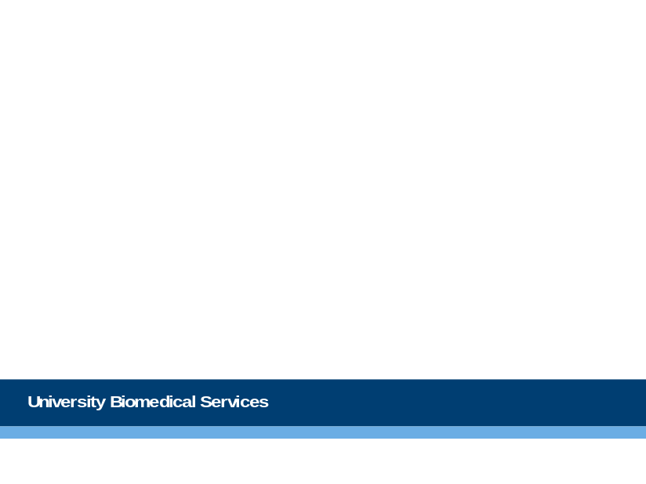
Slide 2: Lead-up/ Retrospective review of previous work - science
The British Medical Journal asks authors to state briefly ‘what this paper adds’. Using examples based on papers you have published and presentations you have given arising from your last 5 years work, briefly explain to us what discovery/discoveries you have made. Finally explain which of these you are most proud of or regard as most important and why.

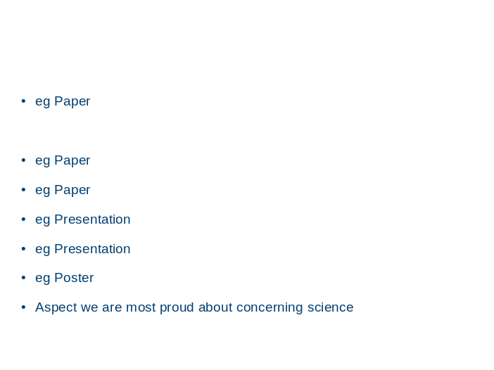

Slide 3: Lead-up/ Retrospective review of previous work – animal welfare and 3Rs
Tell us how in the last 5 years you were able to improve the welfare of your animals: you may like to do this using the 3Rs headings. Then please indicate the one improvement which in your opinion had the greatest impact. How have you disseminated this to other scientists and animal technicians?

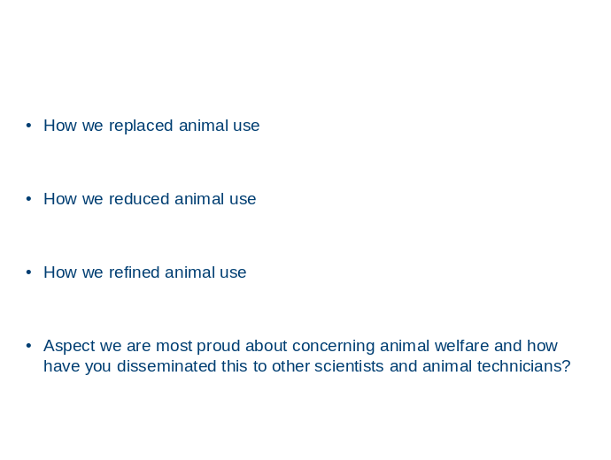

Slide 4: In relation to your new application: Hypothesis, aim, research design
Hypothesis and aim: Please briefly explain the hypothesis underpinning the work you plan to do under the authorities requested in your new application, then tell us what success would look like at the end of this licence.

Research design: How will your hypothesis testing work be controlled? Will animals act as their own controls, (e.g. before and after)? Or will wild types or similar GM animals be the controls? If similar animals, will they be randomly assigned to your experimental groups? Will the people assessing the animals be unaware of whether they are test or control animals?
If you do not plan to use controls, randomise the allocation or use masked assessors, please explain why not.
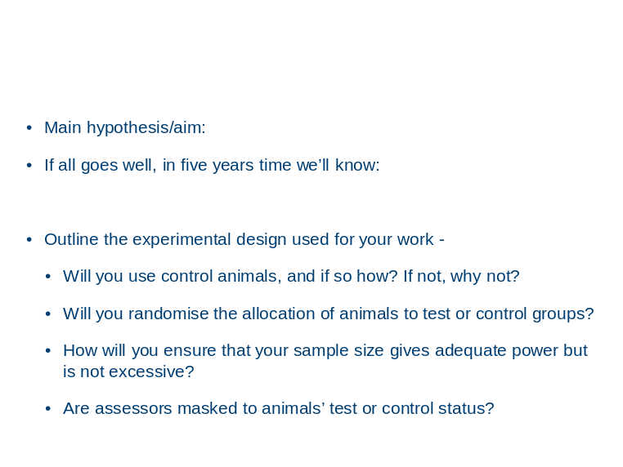

Slide 5: In relation to your new application: Science key to understanding this application; funding; conflicts of interest
What are the key scientific concepts from your own or others’ work that we need to know in order to understand this application?
Please briefly tell us the important relevant concepts.

Give detail, please, on the amount and source of your funding for the full time span of this work, or your concrete plans to gain additional funding. Please only include funds that will be used to cover costs involving animal experiments.

Explain any conflict of interest you have about this work

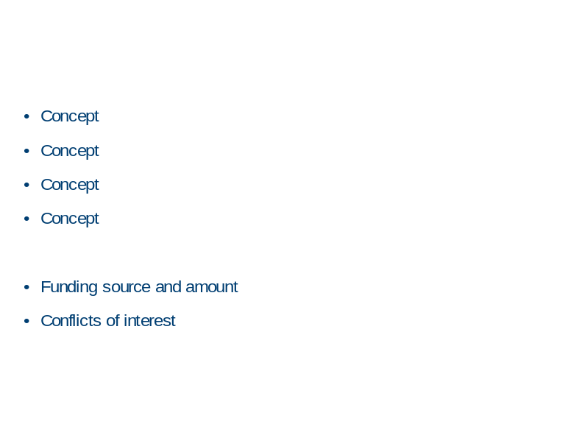

Slide 6: In relation to your new application: Potential benefits and harms
Please tell us the benefits that you believe will arise from your new work. For example this could be specific fundamental scientific data which is necessary before it can be applied or the incidence and prevalence rates in the UK of the pathologies to which your work relates. Indicate in broad terms the impact of the diseases on peoples’ quality and length of life, and the effectiveness of current treatments. (The ‘Oxford Handbooks’ series for clinical doctors is a useful source of estimates).

Then summarise how many animals of which species you have requested in in this new project application and in broad terms what impact you anticipate your work will have on their welfare. If your work is likely to result in prolonged moderate or severe suffering please explain why this is necessary and how long animals will need to undergo the procedures which result in this level of suffering.

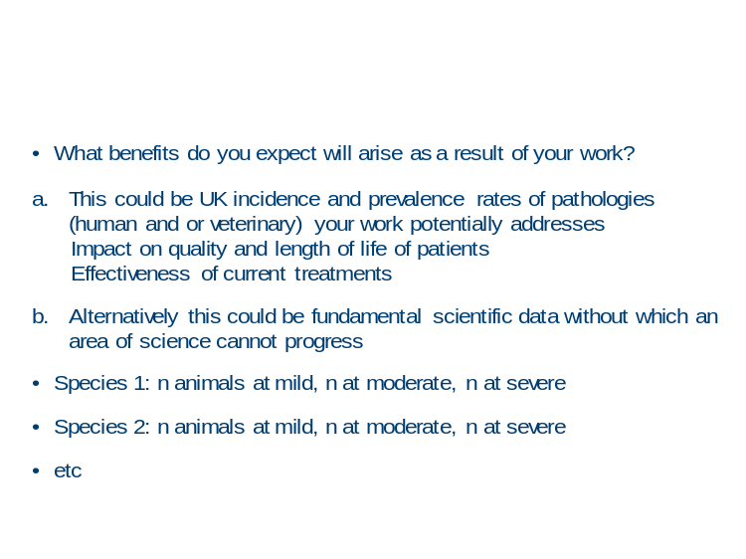

Slide 7: In relation to your new application: 3Rs
Please tell us how you are addressing or plan to address the 3Rs in the work described in you project application. Where it is relevant please indicate new initiatives you plan to introduce.
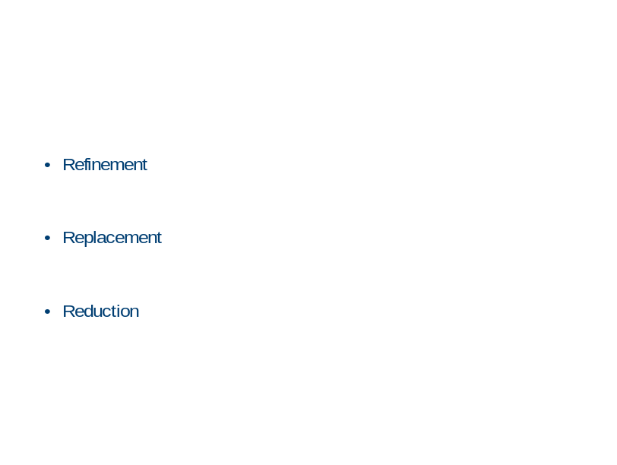

Slide 8: In relation to your new application: Quality of life: husbandry issues
You are required under the Animals (Scientific Procedures) Act 1986 to reduce as far as possible the impact your procedures have on the quality of life of the animals on which you will be working. The AWERB Standing Committee is tasked with improving where possible the welfare of the experimental animals used in regulated procedures at the University. On this slide please describe any procedures you require which will negatively impact on the wellbeing of your experimental animals and what steps you intend to take to mitigate or minimise these effects. You may find it helpful to ask the animal care staff who look after your animals currently (if relevant) to work with you to develop ideas to improve husbandry, handling, training and procedures. Tell us about planned innovations: use some or all of the headings on the slide, and delete the others.

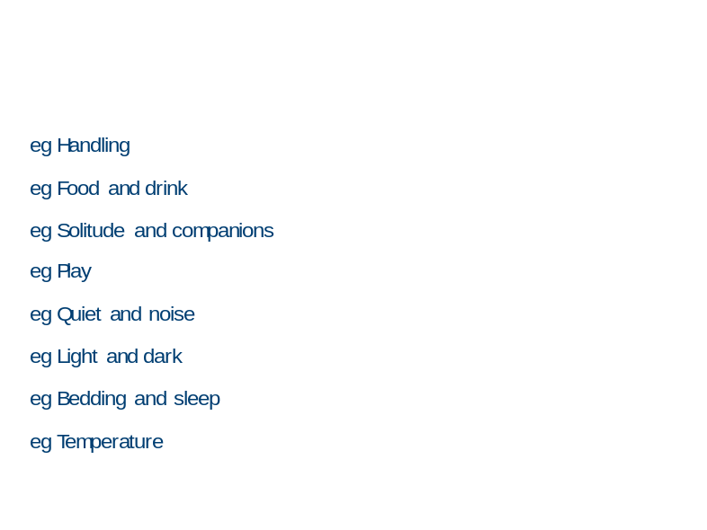

Please note: If you decide to duplicate slides please make sure your presentation will not exceed 10 minutes. More than one new project application will normally be considered at an AWERB meeting and agenda items are required to run to time.

Appendix 12: Common errors in project applications
[Amended to reflect for example the new sections of the new ASPeL application ‘form’.]
Note the following common errors in application forms:
- In Action Plan, how the key questions/objectives are used to address the aim of the licence, is not clear.
- The justification for the choice of model, together with the choice of species and the consideration with non-animal and less severe alternatives, is lacking in answers to questions in the Protocols.
- Consideration of reduction, refinement and replacement is not adequately handled.
- The research questions/objectives set out in your Purpose/Aim statement are too vague and non-specific and the benefits are not realistically linked to the research questions/objectives.
- The Scientific Background fails to take account of the progress of others in the topic, previous achievements and to identify clearly what needs to be discovered.
- The protocols contain information in the wrong place and in some cases insufficient information and the use of protocols steps is not clear.
- Adverse effects are not clearly defined and/or are not quantifiable.
- Clear end-points are not set in relation to predicted adverse effects.
- The difference between re-use and continued use of animals is not appreciated.
- Amendments are offered without an explanation or with an inadequate explanation or justification.

Appendix 13: Suggested members for you UBS Project Support Team and other useful contacts

Project Licence holder: Yourself
Members of the research team: Should include personal licence holders and researchers involved with your work. You can also involve members of the animal care staff in the unit if you work closely with them. Note however, these people will not be asked by UBS to comment on your application.

Director for Governance and Welfare:
Maggie Gentry 01223 769389 mg469@cam.ac.uk

Licence Manager/Named Training and Competence Officer (NTCO)

Kate Tansley 07515642367 kea30@cam.ac.uk

Named Veterinary Surgeon (NVS):
Jo Keeley 07774 017404 jo.keeley@admin.cam.ac.uk
Henri Bertrand 07943 508366 henri.bertrand@admin.cam.ac.uk
Michiel Plugge 07943 524140 michiel.plugge@admin.cam.ac.uk
Amelia Phillips 07753 709274 amelia.phillips@admin.cam.ac.uk

Named Animal Care and Welfare Officer (NACWO):
Combined Facility Gemini Chu 01223 766785 gcb25@cam.ac.uk
Combined Fish Tomasz Dyl 01223 768038 tkd24@cam.ac.uk
Anatomy: Alan Graham 01223 333319 ajg40@cam.ac.uk
Mira Building Chris Brown 01223 339265 cjb224@cam.ac.uk
Innes Building Colin Windle 01223 339013 cpw24@cam.ac.uk
Barcroft Centre Matt Nolan 01223 766128 mjn53@cam.ac.uk
Madingley Maggie Dinsdale 01223 747315 mmd31@cam.ac.uk
Gurdon Rodents Polly Attlesey 01223 763476 pja30@cam.ac.uk
Gurdon Frogs Therese Jones 01223 334087 tj222@cam.ac.uk
Gleeson Building Sarah Stone 01223 336698 sjs203@cam.ac.uk
AMB Sally Thomas 01223 336762 sat55@cam.ac.uk
Julie Glide 01223 330103 Js951@cam.ac.uk
Fallon Miller 01223 330262 fm304@cam.ac.uk
Holly Bloy 01223 654328 hb343@cam.ac.uk
Becca Westwood 01223 330358 raw56@cam.ac.uk
JCBC/AMB Fish Nicola Goodwin 01223 766843 ntg22@cam.ac.uk
Named Information Officer and Compliance Support Officer (NIO)
Debs Flack 01223 748864 debs.flack@admin.cam.ac.uk

Other useful contacts:
Training School Manager and Named Training and Competence Officer (NTCO):
Pilar Browne 01223 339901 pilar.browne@admin.cam.ac.uk

Establishment Licence holder:
Martin Vinnell 01223 339512 martin.vinnell@admin.cam.ac.uk

Operations Director: Karl Wilson 01223 766904 karl.wilson@admin.cam.ac.uk
Facilities Director: Keith Savill 01223 336765 kds30@cam.ac.uk
Deputy Directors Operations and Facilities:
Alan Graham 01223 766785 ajg40@cam.ac.uk
Sam Jameson 01223 760269 slj36@cscr.cam.ac.uk

UBS HO Licencing staff/University Biomedical Services Contact Officers (UBSCO):
Training Sarah George 01223 339908 sarah.george@admin.cam.ac.uk
PILs Toni Lund 01223 339904 ubsHOLicencing@cam.ac.uk
PPLs Fiona Cooper 01223 339900 fiona.cooper@admin.cam.ac.uk
Appendix 14: Other sources of Useful Information:
Advice notes and guiding principles documents can be found on the following websites.
Tip 1: These sites are updated regularly so you should always check that you have the current version of any document you use.

University Biomedical Services website: http://www.ubs.admin.cam.ac.uk/.
You will require Raven account to access all the information on this website.
Examples of what is available:
UBS Policies.
AWERB Handbook.
UBS 3Rs Search Tool.
Home Office Advice Note: Training for licence applicants: Information to supplement Guidance Chapter 9.

Home Office website: https://www.gov.uk/guidance/research-and-testing-using-animals
Guidance on the Operation of ASPA.
Advice Notes:
Harm-Benefit Analysis Process.
Use, keeping alive and re-use.
Working with animals taken from the wild.
Rehoming and setting free.
Standard condition 18.
Laboratory Animals Science Association website: https://www.lasa.co.uk

NC3R’s: http://www.nc3rs.org.uk

RSPCA: http://www.rspca.org.uk/sciencegroup/researchanimals

Understanding Animal Research (UAR): http://www.understandinganimalresearch.org.uk/

